**Small-Town Murder-Mystery Series Fools Readers**

**With Numerous Plot Twists & Turns**

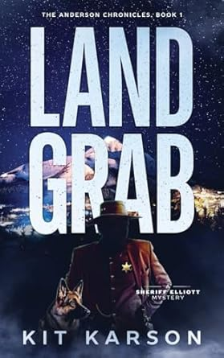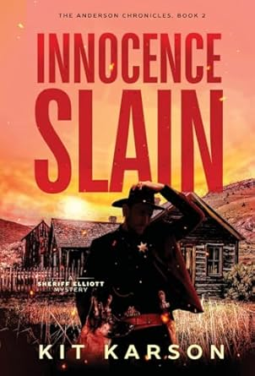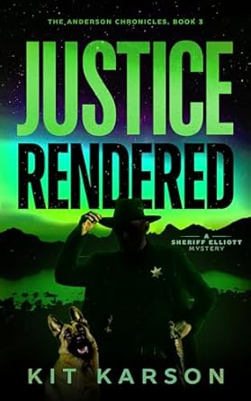

**

“*Land Grab* is a captivating murder mystery that overflows with suspense and intrigue as you unravel the secrets hidden within the pages of this well-crafted book. Every turn of the page holds a fresh surprise, and every chapter leaves you craving for more.  Kit Karson has mastered the craft of writing. This book proves she has the talent for weaving intricate plots and delivering high-suspense scenes that will keep you on the edge of your seat. This book promises to provide thrills and chills like never seen. Get ready to immerse yourself in a story that will challenge your mind and captivate your imagination. Dive into the pages and experience the magic of storytelling.” ***-- Midwest Book Review* on *Land Grab***

All too often, today’s murder mystery books are written more like a frenetic big-city thriller, sometimes with international plot lines and high body counts. But a new series of murder mysteries penned by a fifth-generation Montana woman brings back the traditional kind of procedural detective story that provides an authentic, gripping series.

Author Kit Karson’s books revolve around a small-town sheriff, each unfolding as a plot-twisting whodunnit. Her page-turning series has been described by readers as being filled with greed, gossip, and intrigue — and as books simply can’t be put down. The books are set in a charming but remote part of the country that allows for a certain pace and manner of dialogue that invites readers in.

“The small Montana town of Anderson might seem like a quaint summer vacation for families” says Kit, “but theft, murder, and suspense hide between sapphire mines and the unique characters that live there. I want readers to be captivated by the wonders of these stories and yearn for more when you've finished a book.”

**Kit is available, in an interview, to discuss the following:**

* What makes a murder mystery series set in the mountains in the west intriguing
* The critical elements to crafting a whodunit series around a local town sheriff
* What today’s trends are for mystery books
* Why even killers are not necessarily all bad – and do-gooders are not always good
* How big-city crime dramas are a lot different than small-town murder mysteries
* What turned a medical lab technician into a crime author

“I have always been fascinated with mysteries and thrillers,” says Karson. “I am meticulous in my research and writing, interviewing members of law enforcement, reading up on the law, even reading the police penal codebook. I strive to deliver authentic stories that ordinary people can see themselves wrapped up in.”

**Land Grab: Book 1 --** A grisly murder shatters the tranquility of a small Montana town. Arriving early one morning to open for business, the baker’s wife walks into a bloody scene, a body, and a missing husband. Later that afternoon, a beloved town patriarch and sapphire dealer is found hanging from the balcony in his historic mansion. On first observation, it looks like suicide. An autopsy points to murder. Further investigation reveals the victim’s inventory of valuable sapphires is missing. Are the two deaths related? An invasion of Russian Mafia thugs and a string of threatening notes complicate matters. Sheriff Peter Elliott and his crew, more familiar with wayward cows and drunken brawls, dust off their investigative skills and hurry to solve the case before more town folk fall victim.

﻿

**Innocence Slain: Book 2 --** Young women have gone missing and unmissed, until the wrong one disappears.  The tranquility of tiny Anderson Montana is once again shattered when pampered Stacey Nichols disappears after a quarrel with her boyfriend. Clues are few and flimsy, but newly hired deputy, Birdie Bradshaw, has more than a professional interest in the case. Digging through old records, she uncovers evidence of similar disappearances going back decades. While a battered Stacey plots ways to escape her abusive abductor, Anderson deputies struggle to unravel the mystery of her disappearance. Sheriff Peter Elliott faces a ticking clock, self-doubt, and bad press in his race to find Stacey before it's too late.

﻿**Justice Rendered: Book 3 --** One murdered, one missing, and an entire town full of suspects. Scrappers find the body of a much-despised junk man, covered in grass clippings and a rogue kiddie pool, at the local dump. In the process of the murder investigation, Sheriff Peter Elliott discovers the residents of Stone County, Montana are hiding a shameful secret. An antique serving fork points the way to a world of greed and betrayal. Nothing is off the table, including the murder of Peter and his deputies and the team risks losing one of their own as they get closer to the truth.

**Nefarious Intent: Book 4 --** In the shadow of murder, secrets come to light. Holiday festivities in tiny Anderson, Montana take an unexpected turn when a welfare check becomes a murder investigation. Stone County deputy Tom Edwards discovers the frozen corpses of a local couple bound to chairs at their home in the Moonlight Mountains. The couple’s son and daughter-in-law soon go missing, the only clue a puddle of blood. A tragic bus accident and embezzled church funds add suspects and complicate motives. Stone County Sheriff Peter Elliott and his crew are once again faced with more suspects than clues and an increasingly hostile press in their struggle to solve these murders.

**Savage Malice: Book 5 --** “Cults, government conspiracies, and UFOs,” said Peter. “We’ve had some interesting cases, but this is one for the books.” Warm spring days take a chilling turn when local rancher, Seth Geary, discovers the mutilated body of his ranch hand alongside the carcasses of several slaughtered cows. Notably missing from the scene is his younger brother, Andrew. As theories swirl and a group of UFO chasers descend upon the town, the investigation takes a dark turn. Sheriff Peter Elliott uncovers sinister cult symbols painted in blood at an abandoned cabin near the crime scene. Peter Elliott, the small town sheriff known for his unbreakable resolve, is faced with his toughest case yet. Considered the unsolvable crime, cattle mutilation is tied to murder. With emotions running high in Anderson, Montana, Sheriff Elliott is determined to uncover the truth and bring justice to the victims.

**Media Contact: Brian Feinblum 914-462-2038** [**brianfeinblum@gmail.com**](mailto:brianfeinblum@gmail.com)

**Kit Karson**

**Biography**

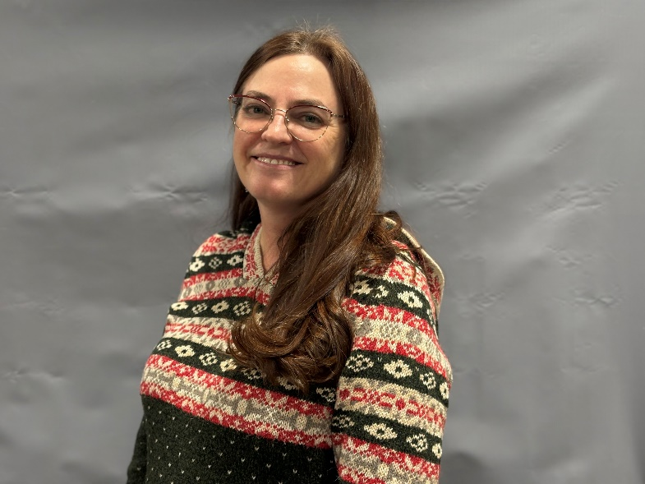Kit Karson is the author of a series of four small-town, murder-mystery books, *The Anderson Chronicles: A Sheriff Elliott Mystery*.

She was born and raised in the mountains of western Montana, where her ancestors lived and are buried. She spent her childhood traipsing around forests, streams, and meadows, either on foot or horseback, exploring, fishing, and shooting.

To this day, the fifth-generation Montanan, lives in those beautiful mountains with her beloved husband and their pets, the wild birds, rabbits, chipmunks, squirrels, and any other creature that wanders across their path.

Earlier in life, she learned how to play the violin and fiddled with a local group that played before a senior center, nursing home, and an assisted living facility. Later, she taught herself how to can food, and even won a purple ribbon at a county fair for her canned apple pie filling. More recently, she and her husband bought gold-panning equipment and wandered across streams and rivers in search of nuggets that have yet to materialize.

Her entire career of 32 years has been spent under a microscope, holding positions as a medical technologist and a laboratory manager for various medical, hospital, and health care labs. She is currently a laboratory director at Granite County Medical Center.

She earned a Master of Science from University of North Dakota. She also earned a BS degree in medical technology from Trinity School of Medical Technology in ND, and a BS in professional microbiology from Montana State University in Bozeman, MT.

She resides in Elliston, Montana.

For more information, please see: [www.kitkarson.com](http://www.kitkarson.com/).

**Kit Karson**

**Q & A**

***The Anderson Chronicles:***

***A Sheriff Elliott Mystery***

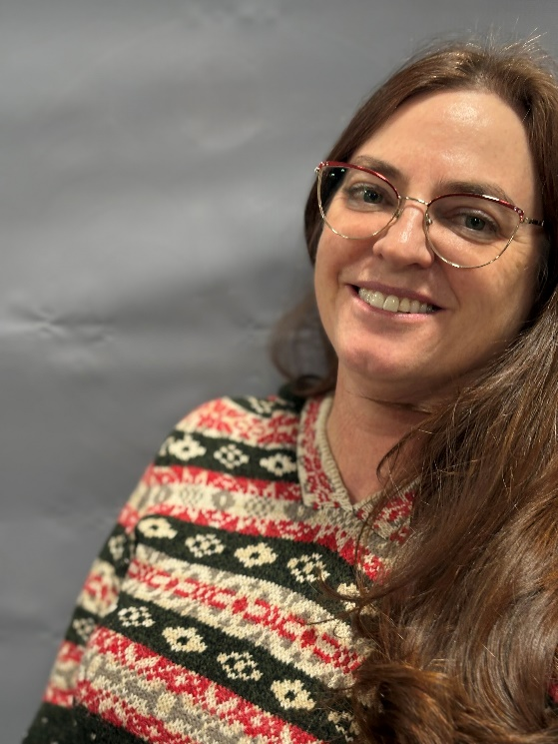

1. **Kit, what inspired you to write your series of mysteries, *The Anderson Chronicles*?**

I had the desire to write a novel and leaned toward thrillers but struggled with exactly what I wanted to do. People say, ‘write what you know’ and I would think ‘I really don’t know much, at least anything interesting enough for a novel.’ An addendum to that advice should be ‘write what you love.’ While reading through the Hamish Macbeth and Agatha Raisin series by author M.C. Beaton, I had my epiphany. I love reading mysteries, especially series where we get to know and love the characters. Hamish Macbeth is based in the Scottish Highlands and Agatha Raisin in based in the English Cotswolds because those are the areas where MC Beaton lived and knew well. I have spent my life in small-town Montana. It made sense to base my novels here.

1. **Take us through the four books. What was the first one, *Land Grab*, about?**

All four books are based in a small western Montana town called Anderson. Land Grab opens with the body of the local dairy man found in a grisly murder scene in the bakery and the baker is missing. Later that day, a beloved town patriarch and sapphire dealer is found hanging from his balcony. Eventually, valuable sapphires are found missing from his inventory. In the middle of all that, the Russian mob is in town trying to gain control of prime real estate with a plan of building a high-end resort. The dairy man had been receiving threatening notes and was being harassed by a neighboring rancher in a land dispute. Sheriff Elliott and his deputies struggle to solve both cases as well as find a connection between them.

1. **What about the sequel, Innocence Slain**

Innocence Slain deals with the abduction of a young woman, Stacy Nichols, and her fight for survival while Sheriff Peter Elliott and his deputies struggle to find her before it’s too late. A new deputy, Birdie Bradshaw, comes into law enforcement because of the disappearance of a friend years

earlier and attempts to connect that disappearance with the disappearance of Stacy Nichols and several other women who have gone missing from Anderson through the years.

1. **How about Justice Rendered?**

Justice Rendered focuses on the murder of Fred, a slovenly toad of a man who runs a ‘perpetual garage sale’ in Anderson. During the investigation, the sheriff and his team discover that Fred operates an antiques theft ring and several people in town have either been victims or participated by selling him antiques. The questions of course is who killed him and why. Would the theft of family heirlooms be worth murdering someone over?

1. **The latest installment, *Nefarious Intent*, is about what?**

In Nefarious Intent, an older couple, Frank and Alice, are found tied to kitchen chairs in their home on the mountain and left to freeze to death. Later, their son and his wife are found missing from their home with nothing but a pool of blood left as a clue. There are several possible motives for the murders. Frank was a bus driver blamed for an accident that resulted in the death of three young boys. Alice was accused of embezzling money from the church coffers. Their son Tony seems to be an innocent, but his wife is a greedy social climber. Would she have killed her in-laws for money?

1. **All of your titles consist of two words. How do you manage to find just the right combo of so few words to declare your title?**

It’s tough. I don’t title the book until after it’s finished, then I brainstorm the main theme of the book and narrow it down to two words. I look on Amazon for books with that name, because I don’t want to use something that is already over-used, and the first title idea usually is. Then, I get out the thesaurus and look for alternatives to the original words. I keep mixing up words, looking for combinations that sound good together and then checking them against titles on Amazon. Sometimes I have to go back and rethink the original word choices. Eventually something clicks.

1. **The common thread to your books seems to revolve around greed and of course murder. Are these inevitable features or aspects of certain kinds of people?**

People hear the word ‘greed’ and think ‘money,’ but greed can cover so many different things. In Land Grab, we saw a family cause problems because a gluttonous boy ate his lunch and then demanded someone else’s. The same boy accused an innocent person of stealing a sapphire from his pail of gravel because he wanted to have the biggest stone. The Russians in the same story wanted the land for their own financial gain and a rancher only desired a piece of property because he thought it belonged to him, not because he gained anything by controlling it. We see characters in the other books treat people badly in an effort to enhance their own desired situation, such as lazy Fred the junk man in Justice Rendered. You wouldn’t think of him as necessarily a greedy person, but his greed is in his desire for a life without work.

1. **Your stories have been referred to as “mountain mysteries,” taking place in western Montana. You are a fifth-generation Montanan. What is it about that setting that makes for a good story?**

There’s such an aura of romance and mystery surrounding the west, especially in the mountains. So many secrets of days gone by can lay hidden in abandoned mines, and under the ruins of mountain cabins. Outlaws and lawmen, cowboys and Indians, even the women of the west were tough and resourceful. I’ve personally been told stories of bodies that were never found, and murderers who are never caught. In my own family, there’s a true story of multiple murders committed by family members. My great-great grandmother and her sons were arrested but eventually set free. They got away with murder. In one case the body was never found. The only proof to the murder was that my great-great uncle admitted to it while drinking heavily in a local bar.

1. **You show small town life through the eyes of one who lives it. How do your stories differ from ones that may take place in big cities, like LA, NYC, or Chicago?**

Life in a small town is so much more intimate than in a city. If you’re one person in a 1,000 people versus one person in 200,000 or even 2 million, it’s harder to stay under the radar. There’s a country song with a line that says, “Everyone dies famous in a small town.” It could say “Everyone lives famous in a small town.” Our paparazzi is everyone in town. Law enforcement is also handled differently in a small town. The local sheriff will often know a criminal personally and be able to deal with a situation before it escalates.

1. **What, if anything, poses a challenge to writing these books?**

I always wish for more time. Besides a full-time job outside of writing, I self-publish, which is really a misnomer in that I have a professional editor, designer, and marketer as well as several beta readers. I couldn’t do this by myself, but even with all this help, writing and publishing is another full-time job. With the actual writing, I do a lot of research because I want my books to be realistic, but I enjoy the research so don’t think of that as a challenge.

1. **How would you describe your writing style?**

I tend toward direct dialog and realistic settings. With dialog, I imagine the character as a real person and strive to have them speak and act how that person would. I read the dialog out loud to make sure it sounds legitimate. There’s always a touch of humor at appropriate times. Humor is such an important part of real life. Colorful descriptions help the reader imagine being right there in the scene. It would be a shame not to bring out the natural beauty of Montana and the rustic settings of a small town. A fast paced, smooth flow, and surprise endings are always a must in murder mysteries.

1. **You seem to balance a good pace of action combined with authentic dialogue and a number of plot twists. Where did your storytelling ability evolve from?**

I’ve been an avid reader for as far back as I can remember so, in a sense, have been in training studying other author storytellers most of my life. I’ve also been writing real-life short stories for family and friends for years, so it was a natural progression into fiction. Writing short stories taught me to pace the narrative and lead to the surprise ending. For fiction, I have an active imagination. I’m able to play out scenes in my head and sometimes act out physical action so I know the scenes are realistic. I read the dialog out loud to make sure it sounds legitimate.

1. **What kind of person is your crime-solver, Sheriff Elliott?**

Peter was led into law enforcement by the unsolved murder of his parents when he was a young boy. That experience gave him a strong sense of justice. He was raised in Anderson, so everyone in town knows and trusts him. As Sheriff, he’s learned to play the part people expect with the cowboy hat and blue jeans. His professional, yet dressed down look helps victims, witnesses, and criminals feel comfortable talking to him. With his only experience in crime solving being in a small town, he struggles with the murder investigations that drop in his lap, but he’s bright and intuitive, and willing to use the abilities of his deputies and the people around him to help solve crimes.

1. **If your books were turned into a Netflix series, who would play the sheriff and some of your characters?**

Peter Elliott: Jake Gyllenhaal

Angus: Cameron Monaghan

Nancy May: Goldie Hawn

1. **You are very meticulous about the research that you do for your books. Is it true that you once spent several hours researching the accuracy of just one line in one of your books?**

More than once. I often spend hours researching subjects that only have a small part in the book. For example, I spent quite a bit of time researching antiques, including antique forks while writing Justice Rendered to make sure I described the murder weapon accurately. I have multiple books on forensics and Police procedure that I refer to for crime scene investigation, and The Handbook of Montana Criminal and Traffic Laws for citing statutes. I spend time looking into both modern and period clothing to describe a vest, dress, or hat someone is wearing. Sometimes I do get sucked into tangents, but it’s all interesting.

1. **You have a science-filled medical laboratory career. Does any of that play a role in your writings?**

Laboratory work is meticulous and detail oriented. Mistakes can literally mean life or death to a patient, so everything needs to be exact. This has been good training for writing in that I strive for accurate details in my stories. I also have that scientific background which helps in the forensic aspects of solving murders. Knowing what is happening to a victim medically, such as Stacy Nichols in Innocence Slain, helps keep the pacing realistic.

1. **Another theme that pops across some of your books is that of abuse. Why does that seem to make it into your stories?**

Abuse is so much a part of real life, physical, emotional, financial. Not to generalize, because not everyone is evil, but people treat each other horribly. Elder abuse is rampant in families and usually has to do with money. Grandpa needs to be in a nursing home, but the kids, or even grandkids, don’t want to sell the house or ranch or dip into their inheritance to pay the cost, so grandpa isn’t cared for properly. I’ve witnessed too many times woman who are physically and emotionally abused by a husband and yet don’t press charges and go right back into the situation. If they do leave one abuser, they’ll hook up with another one just like him. Parents abuse children, children abuse other children. It’s an endless cycle.

1. **You say that everyone has secrets, and even in a small town, where everyone knows each other, they really don’t know each other. This plays out in your books. So, what are some examples of these secrets?**

People play a part in society, but no one really knows what goes on behind closed doors. A well-respected leader in a community may go home every night and beat his wife. Children are sexually abused. I knew a woman once who was a closet alcoholic. She was so ashamed of her addiction; she would hide in her basement to drink. Not even her closest friends knew until one day she fell down the stairs and someone eventually found her.

Secrets can also be positive. People may live as paupers and when they die, you find out they have millions in the bank. Or others may do endless charity work, but only behind the scenes and don’t take credit for it.

1. **You seem to show many characters in an honest light – no one is perfect, and a few are evil. If all of us can be at least a little bad, how do we control it so that we don’t cross the line like the murderers in your stories?**

Everyone has a different story and different motivations. Many people are raised in homes where they are taught right from wrong and carry that through their lives. Is everyone capable of murder? Probably not. People are too complex to put everyone in the same box. Mental illness comes to mind. Psychopaths and sociopaths either ignore the line or don’t see it. Some are products of their environment, and others are born that way. What drives them to murder? Like in my books, the murderers all have different motivations. The psychology of murders will have to be my next deep research project.

1. **I understand that last summer you and your husband bought gold-panning equipment and wandered through a variety of streams and rivers, learning how to pan gold. You find any nuggets?**

Not yet, dang it, but it’s really about having a new experience and learning new things. I was researching gold mining in Montana and decided I needed to experience what the men of the gold rush days went through. Fool’s gold really is shiny and deceptive, but we learned to tell the difference. While I was writing Land Grab, I went to the local sapphire mine and learned how to sift through buckets of gravel for sapphires. I also had my brother-in-law, a master fly-fisherman, teach me how to fly fish so I could talk about it in the story. A few years ago, I went to a ‘paint and sip’ party and discovered I had a bit of a talent for painting, so I asked an artist friend of mine to give me painting lessons. Before that, I learned how to play the violin (fiddle), and would go to the nursing homes and assisted living centers with a few locals and play music. It was a lot of fun. The point is, there’s always something new to learn. My husband says life is never boring around me.

1. ***Midwest Book Reviews* said you “mastered the craft of writing” and that you have “the talent for weaving will keep you on the edge of your seat.” Does that surprise you, considering you didn’t take to writing novels until just a year ago, -- with no formal training?** Yes, although people close to me have been telling me for decades that I should write a book, so there must have been clues of a not-so-hidden talent. In my home as a child, there was a plaque on the wall that said, ‘A singer can always find a song.’ In the same sense, a writer can always find a story to tell, and the words just naturally flow. I love to write and feel the words coming together and falling into place. I don’t think that is something that can be taught and trained so much as a natural inclination. I’ve had to learn some of the rules of writing, but those fill-in as I go along.

**Sample Of Book Reviews**

“Intriguing whodunnit mixed with politics and mafia crimes.”

***-- Publishers Weekly Book Life* on *Land Grab***

"An engaging mystery set in an especially rugged atmosphere.

**--*Indies Today* on *Land Grab***

Gems + Land + Small Town + Murder. Readers will keep turning one more page.”

**--Shelly Burton *Land Grab***

“The story includes a good smattering of red herrings to keep us uncertain about how the murder unfolded…. I enjoyed this book and recommend it to readers who appreciate a good mystery in a small-town setting with an earnest team of investigators and an eccentric cast of inhabitants. While the murder victim might not be a sympathetic character that the reader can feel invested in, the author has created an intriguing story with many likeable characters and a town that has heart. We cheer on the deputies as they struggle through the challenges and life-threatening situations that they face. In the end, we want a win for the team.

--**5-Star Amazon Review on *Justice Rendered***

“*Nefarious Intent* by Kit Karson hooked me from the first page until the end.“

**-- Alma Boucher, Readers' Favorite on *Nefarious Intent***

“I could not put this book down.”

**--Ellen Holland on *Land Grab***

“From the first page I was hooked. I just loved it!

**--Karen Ward on *Innocence Slain***

“This book is a page-turner right to the last word.”

**--Shirley Cornelius on *Innocence Slain***

“Kit Karson does it again. The latest offering of the Anderson Chronicles expertly weaves murder and motives in an engaging mystery that will keep you guessing.”

**--Ronda Polhamus on *Justice Rendered***

“This gripping whodunnit will hook you from cover to cover. Kit Karson's *Nefarious Intent* is a must-read for lovers of mystery murder novels.,, This is an incredible stand-alone installment in the Anderson Chronicles. I loved it. I'm on my way to get the rest.”  
**- Keith Mbuya, Readers' Favorite on *Nefarious Intent***  
“Greed, gossip, and intrigue abound in Kit Karson's fast-paced mystery, making it appealing to lovers of murder mysteries.”  
**- Mimie Odigwe, Readers' Favorite on *Nefarious Intent***