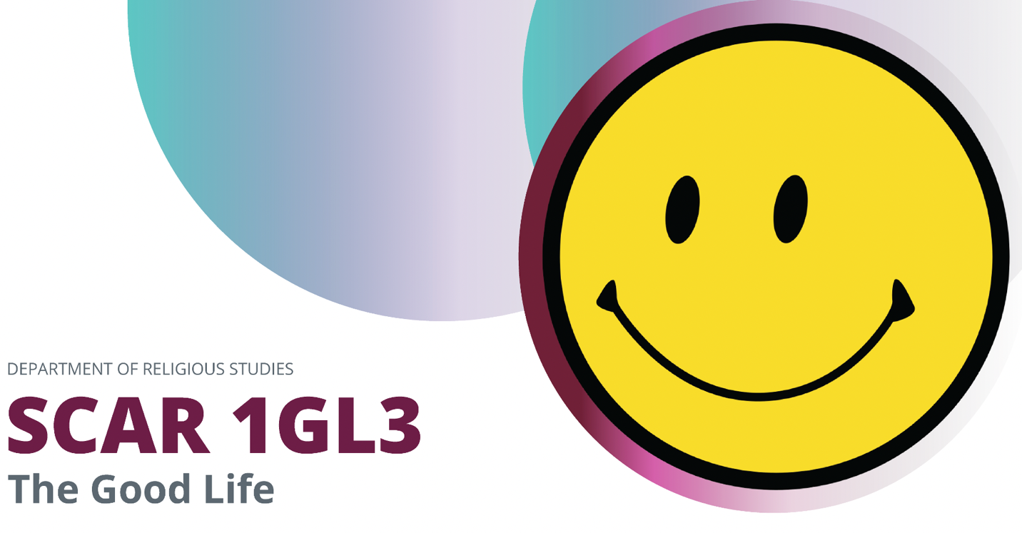

Dr. Matthew Thiessen
McMaster University
Fall 2024

Tutorials

Time: Monday, 10.30-11.20am
TA: Syeda Zahid

Time: Monday, 10.30-11.20am
TA: Eduardo Folster Eli

Time: Tuesday, 2.30-3.20pm
TA: Amir Salehi

Time: Tuesday, 2.30-3.20pm
TA: Kyle Schofield

Email Policy
Unless it is an emergency, I ask you to begin setting boundaries for yourself around emails by emailing your TAs and me during working hours (roughly 8am-5pm) Monday-Friday.

The Good Life explores fundamental questions related to living a meaningful and valuable human life through the lenses of different religious and non-religious traditions. Through lectures, videos, podcasts, readings, guest speakers, and small-group discussions, students will explore the diverse ways in which religions approach the question of the meaning of life. Students will examine the major concepts and themes associated with the purpose and meaning of human existence, including the nature of humanity, belief and nonbelief in God, the problem of evil, and the afterlife.

Course Objective
- Students will gain a deeper understanding of a variety of major religious traditions and their respective views on what it means to live well.
- Students will develop critical thinking skills and the ability to analyze and evaluate complex religious concepts and ideas.
- Students will be equipped with a framework for engaging in conversation with people of different traditions (religious and non-religious) to navigate the complex multicultural landscape of both Canada and the world.
- Students will reflect broadly on their own lives, educational goals, and aspirations for the future, in light of the course content.

Course Readings
- Meghan Sullivan and Paul Blaschko, The Good Life Method: Reasoning Through the Big Questions of Happiness, Faith, and Meaning (Penguin, 2022)
- William Strunk, Jr. and E. B. White, The Elements of Style.
- Readings uploaded to Avenue to Learn (A2L) or linked below.

Assignments
- Participation: critical to the meaningful and lasting success of higher education is regular, prepared, and engaged class attendance. Students will be required to read materials before class and prepare a response sheet with three comments and three questions (unless otherwise directed) based on the reading. There are 20 assigned response sheets throughout the term. Response sheets must be handed in in person at the start of each lecture. (30%). Due Date: see class schedule for when each response sheet is due.
- Personal Reflection: In keeping with the focus of this course, students will type up a two-page, double-spaced personal reflection on what they consider to be the meaning of life, how they know they are living a life worth living, and how their university and career aspirations connect to these larger questions. (10%). Due Date: Friday, September 13, on A2L.
- Elements of Style Book Interaction: Write a 1.5-2 page, double-spaced reaction to The Elements of Style. What areas of writing do you struggle with? What did you learn in this book? How will it improve your writing? Paper will be graded for grammar and spelling, and evidence of an accurate understanding of the book. (10%). Due Date: Friday, October 4, on A2L.
- Obituary Exercise: Students will write a 400-word obituary for themselves, imagining a close friend or relative who writes about them at the end of their lives in a way they hope someone will one day write about them after they have lived the life they currently aspire to. This will require reading some obituaries and getting a sense of what elements usually make up an obituary. (10%). Due Date: Friday October 25, on A2L.
- The Good Life Method Book Review: Write a two-page, double-spaced critical reflection on Sullivan’s and Blashko’s Good Life Method. Paper will be graded for grammar and spelling, and evidence of an accurate understanding of the book. (15%). Due Date: Tuesday, November 26, on A2L.
- What is My Good Life? Assignment: Students will submit a 5-6 page, double-spaced, account of what they currently believe a good life to be. This is a highly personal reflection that is much more important than any grade they will receive on this assignment (or in the course), and so the grade they are assigned should in no way be considered indicative of the value or meaningfulness of their answers. Nonetheless, the grade will be assigned on the basis of how well the answer interacts meaningfully with and is enriched by the various course readings, lectures, guest speakers, tutorials, podcasts, etc. Students should be explicit as to how their own account of a good life relates to their own religious (or non-religious) tradition. Additionally, they should interact with at least one other religious (or non-religious) tradition that they do not adhere to in a respectful way, noting what they appreciate and what they disagree with. (25%). Due Date: Thursday, December 5, on A2L.

Class Schedule
Week One: Introduction
Tuesday, September 3: What is the Good Life?
- Carefully read the syllabus twice before class to be sure you understand what to expect and what will be expected of you!
Thursday, September 5: The Goods of the University and Religious Studies
- Brief Intro: Marybeth Druery, Student Open Circle
- Read: The Good Life Method, “Introduction”
- Read Leonard Swidler, “The Dialogue Decalogue” (Link here)
- Hand in Response Sheet on “Dialogue Decalogue” and how it should influence your interactions in this course
Tutorial: No Tutorial

Week Two: Fundamental Questions
Tuesday, September 10: Who Are You?
- Read Genesis 1 (Link here)
- Read The Haudenosaunee Creation Story (Link here)
- Hand in Response Sheet to two assigned creation stories. How do they relate to your own beliefs about what humanity is?
Thursday, September 12: Who Do You Answer To?
- Read: “Who Do You Answer To?” (A2L)
- Read: The Good Life Method, “Desire the Truth”
- Hand in Response Sheet to The Good Life Method, “Desire the Truth”

Tutorial: What Do You Want from University?

Week Three: Psychological Approaches
Tuesday, September 17: Positive Psychology
- Positive Psychology (Guest Speaker: Dr. Sophia Melanson Ricciardone)
- Read: “What Is the Good Life & How To Attain It” (Link here)
- Hand in Response Sheet to “What Is The Good Life & How To Attain It”
Thursday, September 19: Generosity
- Read: The Good Life Method, “Take Responsibility”
- Hand in Response Sheet to The Good Life Method, “Take Responsibility”

Tutorial: Is the Good Life a Formula?

Week Four: Ancient Philosophy
There will be no classes or tutorial this week, but students will be required to do the following on their own time:
- Read: Wikipedia entry on Nicomachean Ethics (Link here)
- Watch “Aristotle on Life - The Big Picture” (Kanopy)
- Watch “Aristotle – The Highest Good” (Kanopy)
- Watch “Aristotle – The Happy Life” (Kanopy)

Week Five: Sikhism
Tuesday, October 1: Sikhism
- Guest Speaker: Gurratan Singh, former MPP of Brampton East
- Read Wikipedia Entry on Sikhism (Link here)
- Hand in Response Sheet to Sikhism Wikipedia Entry
Thursday, October 3: What’s Your Vocation?
- Read: The Good Life Method, “Contemplate Your Purpose”
- Hand in Response Sheet to The Good Life Method, “Contemplate Your Purpose”

Tutorial: The Good Life and Politics: What is the Nature of Public Service?

Week Six: Islam
Tuesday, October 8: Islam
- Guest Speaker: Dr. Liyakat Takim
- Read Wikipedia Entry on Islam (Link here)
- Hand in Response Sheet to Islam Wikipedia Entry
Thursday, October 10: Feasting and Fasting
- Read: The Good Life Method, “Wonder about God”
- Hand in Response Sheet to The Good Life Method, “Wonder about God”
Tutorial: The Pursuit and Limits of Pleasure
- Read: Wallace, “A Supposedly Fun Thing” (A2L)

Week Seven: MID-TERM RECESS

Week Eight: Death
Tuesday, October 22: We’re All Going to Die
- Read “Why I Hope to Die at 75” (Link here)
- Read: The Good Life Method, ”Prepare for Death”
- Hand in Response Sheet to The Good Life Method, ”Prepare for Death”
Thursday, October 24: Is There An Afterlife and does it Matter?
- Read “The Transhumanist Party” (Link here)
- Hand in Response Sheet to “Transhumanity Party”

Tutorial: Workshopping Obituaries
- Search the internet for an example or two of what you think are good obituaries. Bring them to tutorial to discuss

Week Nine: Christianity
Tuesday, October 29: Christianity: What is Love?
- Read: The Good Life Method, “Love Attentively”
- Hand in Response Sheet to The Good Life Method, “Love Attentively”
Thursday, October 31: Christianity
- Guest Speaker: Marlice Simon, Ecumenical Chaplain
- Read Wikipedia Entry on Christianity (Link here)
- Hand in Response Sheet to Christianity Wikipedia Entry

Tutorial: What Do We Owe Our “Enemies”?

Week Ten: Buddhism
Tuesday, November 5: Limitations
- Read: The Good Life Method, “Live Generously”
- Hand in Response Sheet to The Good Life Method, “Live Generously”
Thursday, November 7: Buddhism
- Guest Speaker: Dr. Mark Rowe
- Read Wikipedia Entry on Buddhism (Link here)
Hand in Response Sheet to Buddhism Wikipedia Entry

Tutorial: Listen to Boredom and Our Modern World and discuss in tutorial. https://podcasts.apple.com/us/podcast/what-boredom-means-cultivating-attention-leisure-for/id1505076294?i=1000623036709

Week Eleven: Judaism
Tuesday, November 12: Work and Rest
- Read: Heschel, The Sabbath, 1-32; 95-101 (A2L)
- Hand in Response Sheet to Heschel, The Sabbath
- Read The Good Life Method, “Work with Integrity”
Thursday, November 14: Judaism
- Guest Speaker: Rabbi Micah Streiffer (joining us via Zoom)
- Read Wikipedia Entry on Judaism (Link here)
- Hand in Response Sheet to Judaism Wikipedia Entry

Tutorial: To prepare for tutorial, listen to the following podcast: Rabbi Sacks – Everything is Holy: https://podcasts.apple.com/us/podcast/rabbi-sacks-on-etching-everyday-existence-with/id1505076294?i=1000498576937. Discuss in tutorial.

Week Twelve: Failure and Suffering
Tuesday, November 19: Failure and Forgiveness
- Read: “The Science of Failing Well” (Link here)
- Read: Helwa, “Repentance” (A2L)
- Hand in Response to “The Science of Failing Well” and “Repentance”
Thursday, November 21: Suffering and the Good Life
- Read: The Good Life Method, “Struggle with Suffering”
- Hand in Response Sheet to The Good Life Method, “Struggle with Suffering”

Tutorial: How Does the Good Life Feel?

Week Thirteen: No Class
Tuesday, November 26: Turn in The Good Life Method Review via A2L

Week Fourteen: Conclusions
Tuesday, December 3: Bringing It All Together
- Read The Good Life Method, “Take a Leap of Faith”
- Hand in a list 5 questions/issues/topics you wish the course had spent more time addressing
Thursday, December 5: NO CLASS

Tutorial: Meet with TA, if needed

