

Morris Packaging GHG Emissions Report 2025

Table of Contents
- Executive Summary

- Methodology
  - Primary vs Secondary Data Overview
  - Primary vs Secondary Data Tradeoffs
  - Emissions Calculations Components
  - Boundary Conditions: Operational Control Approach
  - Inclusions and Exclusions

- Key Findings
  - Morris Packaging Emissions by Category 2025
  - Morris Packaging Emissions by Scope 2025
  - Morris Packaging Emissions by Scope and Category 2025

- Calculations
  - Emissions Methodology by Source: Scope 1 Building Heat
  - Emissions Methodology by Source: Scope 1 Vehicles
  - Emissions Methodology by Source: Scope 2 Electricity
  - Emissions Methodology by source: Scope 3 Air Travel
  - Emissions Methodology by Source: Scope 3 Water
  - Emissions Methodology by Source: Scope 3 Products
  - Emissions Methodology by Source: Scope 3 Shipping
  - Emissions Methodology by Source: Scope 3 Ground Travel
  - Emissions Methodology by Source: Scope 3 Work from Home
  - Emissions Methodology by Source: Scope 3 Commute

Executive Summary
This Greenhouse Gas Inventory (“Inventory”) describes Morris Packaging’s impact on the environment as measured in greenhouse gasses (GHG) emitted in units of equivalent tons of carbon dioxide for 2025. The purpose of this inventory is to benchmark Morris Packaging’s GHG emissions and to provide a consistent methodology for documenting the emissions inventory on an ongoing basis. Furthermore, this report provides a comparison and detailed breakdown of Morris Packaging’s 2025 GHG emissions.

GreenFeet compiled the inventory with support from Morris Packaging’s team, who provided activity data from relevant business activities.

In summary, Morris Packaging’s estimated carbon footprint for 2025 was 62,672.15mtCO2e. A breakdown by emission category for the year is detailed in section 3 below.

Furthermore, Morris Packaging has committed to a climate emergency strategy and has been in or is in the process of taking the following related actions:
- Completed baseline year emissions measurement as per the Greenhouse Gas Protocol
- Committed to emissions measurement and tracking using the GreenFeet sustainability emissions management platform to be measured and updated twice yearly going forward
- Committed to annual reporting of GHG emissions for stakeholders
- Committed to setting sustainability goals and will endeavor to work with partners and suppliers with strong sustainability programs and goals to reduce emissions where possible.
- Committed to expanding the scope of their calculations where feasible.
- Expanded their calculation to include emissions generated during the production of their products.

Methodology
The methodology for developing the GHG inventory is designed in accordance with the revised GHG Protocol Corporate Standard and the Corporate Value Chain Accounting and Reporting Standard. The inventory development process involves the collection and examination of data from both internal and external sources. The application of this methodology ensures completeness and accuracy of the data provided, finalized calculations, and conclusive analysis.

  - Primary vs Secondary Data Overview
Primary Data is obtained directly from meter readings and utility bill data, and Secondary Data, which involves the use of intensity factors and energy consumption models for estimation. Primary Data is considered more accurate and preferred; however Secondary Data is useful for understanding emissions control strategies and assessing source effects. The choice between Primary and Secondary Data depends on the specific situation, considering the risks and costs associated with each method.

  - Primary vs Secondary Data Trade Offs
Tradeoffs must be made between data accuracy and effort required to collect Primary Data over Secondary Data. In situations where the potential for adverse environmental effects or unfavorable regulatory outcomes is significant, the adoption of more advanced and expensive Primary Data collection methods becomes essential. Conversely, when the risks associated with using Secondary Data are minimal, and the expenses related to extensive data collection methods are unappealing, cost-effective estimation approaches can provide satisfactory and appropriate solutions.

  - Emissions Calculation Components
The emissions methodology components outline the calculation process for each emission source and detail any alterations applied to an emission source. These components include emissions scope classification, activity data sources, key assumptions, data manipulations, estimation parameters, emissions factor sources, calculation details, and additional relevant information.
  - Boundary Conditions: Operational Control Approach
An operational control approach is applied to Morris Packaging’s partially owned or controlled assets. An organization has operational control over a facility if the organization, or one of its subsidiaries has the full authority to introduce and implement its operating policies. For Morris Packaging, this includes all spaces and offices in which the organization operates.

  - Inclusions and Exclusions
In addition to considering scope 1 and 2 emissions, the development of the 2025 GHG Inventory includes an emissions screen of all 15 scopes 3 categories. After evaluating the screen results and having discussions with Morris Packaging, the scope 3 categories included are air travel (Category 6) and water (Category 5). Scope 3 emissions beyond these explicitly listed were excluded from this report. For further guidance on materiality, readers are referred to chapter 10 of the GHG protocol.
https://ghgprotocol.org/sites/default/files/standards/ghg-protocol-revised.pdf

Key Findings
The following tables and charts summarize Morris Packaging’s 2025 emissions.

      - Morris Packaging Emissions by Category 2025
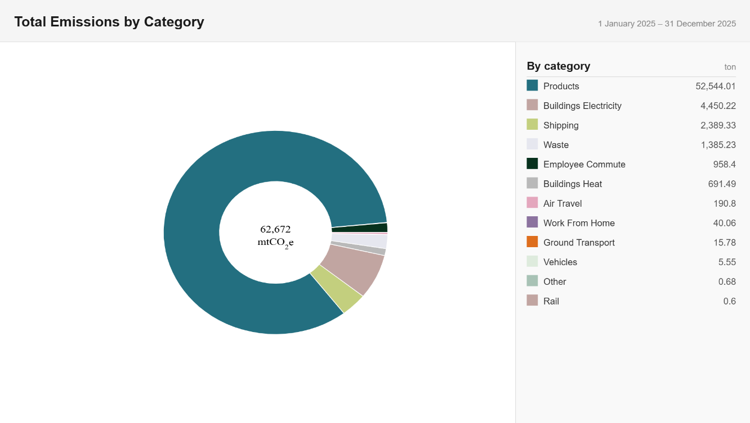
b. Morris Packaging Emissions Breakdown by Scope and Category 2025

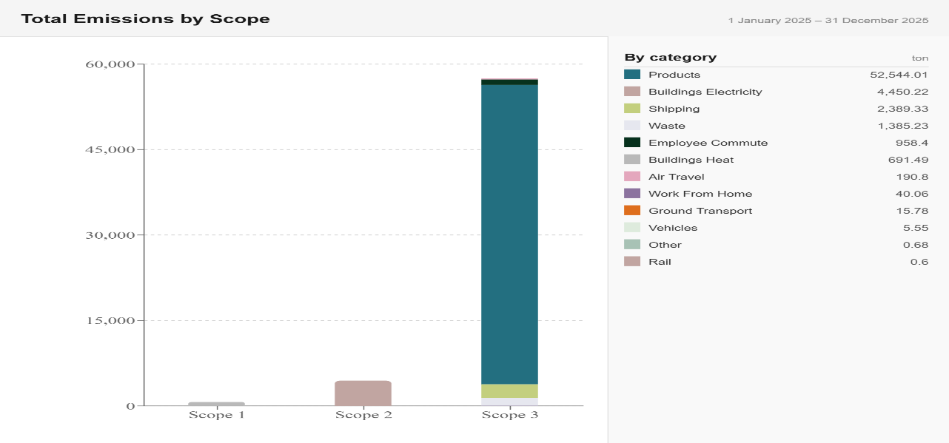

Calculations
- Emissions Methodology by Source: Scope 1 – Building Heat
Emissions Scope | Scope 1
Activity Data | Consumption levels reported by Morris Packaging via GHG Inventory Data  Request collection template.
Emission Factor Sources | DEFRA Emissions Factors 2025
Calculation Details | Consumption values x Emissions factor by fuel type
Additional Details | Detailed calculations and a full list of data sources/activity data available, documented and uploaded to GreenFeet sustainability platform.

- Emissions Methodology by Source: Scope 1 – Vehicles
Emissions Scope | Scope 1
Activity Data | Vehicle usage values reported by Morris Packaging via GHG Inventory Data  Request collection template.
Emission Factor Sources | DEFRA 2025
Calculation Details | Spend based data converted to EUR x Spend based emissions factor
Additional Details | Detailed calculations and a full list of data sources/activity data available, documented and uploaded to GreenFeet sustainability platform.

- Emissions Methodology by Source: Scope 2 – Electricity
Emissions Scope | Scope 2
Activity Data | Consumption levels reported by Morris Packaging via GHG Inventory Data  Request collection template.
Emission Factor Sources | DEFRA Emissions Factors 2022
Calculation Details | Consumption values x Location-based emissions factor
Additional Details | Detailed calculations and a full list of data sources/activity data available, documented and uploaded to GreenFeet sustainability platform.

- Emissions Methodology by Source: Scope 3 – Air Travel
Emissions Scope | Scope 3
Activity Data | Air Travel reported by Morris Packaging via GHG Inventory Data Request collection template.
Emission Factor Sources | DEFRA Emissions Factors 2025
Calculation Details | Total Spend x Emissions Factor.
Additional Details | Detailed calculations and a full list of data sources/activity data available, documented and uploaded to GreenFeet sustainability platform.

- Emissions Methodology by Source: Scope 3 – Water
Emissions Scope | Scope 3
Activity Data | Consumption values reported by  Morris Packaging via GHG Inventory Data Request collection template.
Emission Factor Sources | DEFRA Emission Factors 2025
Calculation Details | Consumption values x Emissions factor by water supply and water treatment
Additional Details | Detailed calculations and a full list of data sources/activity data available, documented and uploaded to GreenFeet sustainability platform.

- Emissions Methodology by Source: Scope 3 – Products
Emissions Scope | Scope 3
Activity Data | Material usage reported by  Morris Packaging via GHG Inventory Data Request collection template.
Emission Factor Sources | Available on Request
Calculation Details | Consumption values x Emissions factor by water supply and water treatment
Additional Details | Detailed calculations and a full list of data sources/activity data available, documented and uploaded to GreenFeet sustainability platform.

g.Emissions Methodology by Source: Scope 3 – Shipping
Emissions Scope | Scope 3
Activity Data | Shipping activity values reported by  Morris Packaging via GHG Inventory Data Request collection template.
Emission Factor Sources | DEFRA 2025, Shipping Vendor calculated emissions
Calculation Details | Weight x Distance x Mode of Shipping x Emissions factor = Output
Additional Details | Detailed calculations and a full list of data sources/activity data available, documented and uploaded to GreenFeet sustainability platform.

h.Emissions Methodology by Source: Scope 3 – Ground Travel
Emissions Scope | Scope 3
Activity Data | Ground Travel spend reported by Morris Packaging via GHG Inventory Data Request collection template.
Emission Factor Sources | DEFRA Emissions Factors 2025
Calculation Details | Total Spend x Emissions Factor.
Additional Details | Detailed calculations and a full list of data sources/activity data available, documented and uploaded to GreenFeet sustainability platform.

- Emissions Methodology by Source: Scope 3 – Work from Home
Emissions Scope | Scope 3
Activity Data | Number of employees working from  home reported by Morris Packaging via GHG Inventory Data Request collection template. Employees were reported by state to take into account local state  emission factors.
Emission Factor Sources | DEFRA Emissions Factors 2025
Calculation Details | Utilized the ‘Homeworking emissions whitepaper’ calculator produced by EcoAct, Lloyds Banking Group &amp; NatWest Group.  Non-respondents were estimated based on response average.
Additional Details | Detailed calculations and a full list of data sources/activity data available, documented and uploaded to GreenFeet sustainability platform.

j.Emissions Methodology by Source: Scope 3 – Commute
Emissions Scope | Scope 3
Activity Data | Employee commute patterns reported by Morris Packaging via GHG Inventory Data Request collection template.
Emission Factor Sources | DEFRA Emissions Factors 2025
Calculation Details | Miles x Emission factor by transport mode, accounting for time and holidays.  Prorated for remaining nonresponses of survey.  Non-respondents were estimated based on  response average.
Additional Details | Detailed calculations and a full list of data sources/activity data available, documented and uploaded to GreenFeet sustainability platform.

