
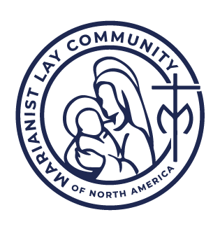
Lay Marianist Formation Program
Self-Guided Retreat

The radical change that our Marianist vocation demands is usually gradual and progressive. It is seldom sudden, and is never violent. It is Mary’s way of forming us.

Fr. Quentin Hakenewerth, SM
A Manual of Marianist Spirituality

Planning the Day

General Instructions: This retreat is intended to take between a half-day to a full-day of time, depending on the pace at which you naturally move through topics and the duration of your break times.

Considerations:
- Location: This self-guided retreat may be taken at any location that is peaceful for you. For some people, this may be your home. For others with busier households, you may wish an alternative location.
- Time: The recommended time for this retreat is approximately 5 hours, but it may take either less or more depending on the pace you wish to move. Most people prefer to begin in the morning, as this allows you to start fresh and not feel rushed. However, you may need to set a different schedule. This is okay. Please do try to set an uninterrupted block of time, as this will create the best atmosphere for the retreat.
- Meals/Snacks: You will likely want to have a snack and/or meal during the retreat, dependent on the time you will be having it. Plan ahead for this so you do not have to have a major interruption such as a substantive meal preparation, going to the grocery, etc.
- Sponsor: It is not required that you check in with your sponsor as part of this retreat. However, some participants may wish to add this component in. If you would like to incorporate one of your check-in times with your sponsor as part of this retreat, recommended times include right before or after lunch, or else at the conclusion of the retreat.

Timetable
Activity | Recommended Duration
Welcome | 10m
Opening Prayer | 10m
Annunciation and Discernment | 30m
Reflective Rest | 1 hour
Lunch / Snack | 30m
Reflection on Community | 1 hour
Reflective Rest | 1 hour
Statement of Intent | 30m
Closing Prayer | 10m

Welcome

Welcome to your self-guided retreat in preparation for making a commitment as a Lay Marianist! You have spent the last few months learning, reflecting, and discerning your future with the Marianist Family. This self-guided retreat is an opportunity to take a brief pause and recollect on the lessons you have learned and the things you continue to hold and ponder in your heart.

This is a self-guided retreat. You are encouraged to follow the format provided here. However, please be free in adapting the retreat as you need. If you feel the movement of the Spirit to stay with one aspect of the retreat, please be encouraged to do so. There is no need to move ahead just to move ahead. Staying longer with one portion may mean that you do not make it through all recommended activities – this is okay. You have found what you needed.

Likewise, if you feel that you are ready to move on quicker than the recommended time, this may also be a movement of the Spirit. Finally, you may wish to adapt one of the elements or even replace it with something else entirely. Pay attention to those feelings and follow them. This is your time with God.

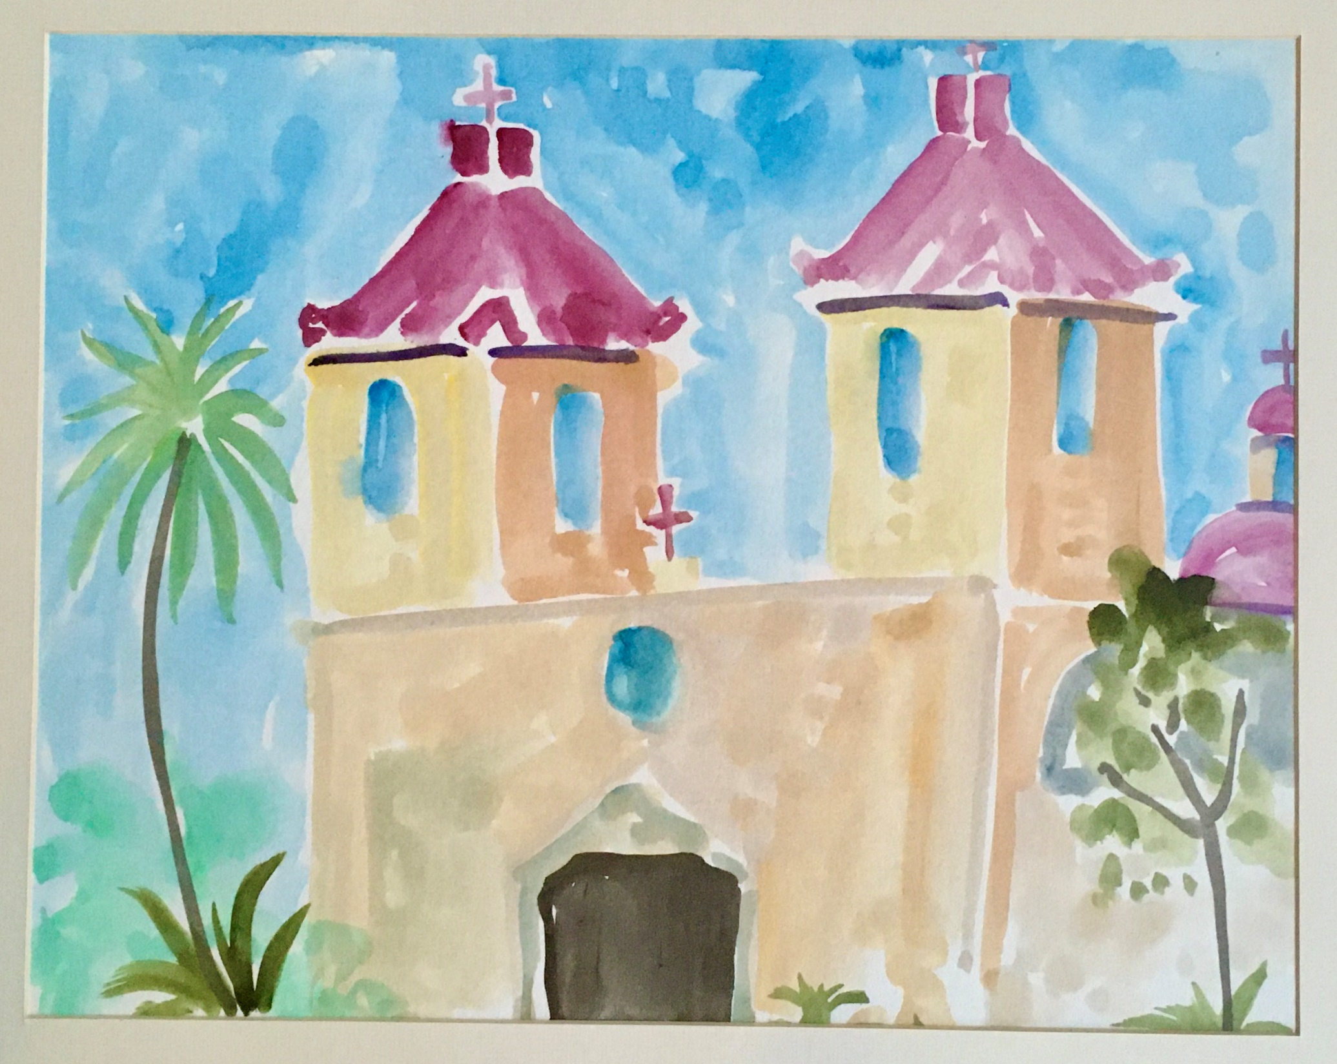
Vocational Discernment

Take a brief moment to center yourself in the presence of God. When you are ready, contemplatively read the story of the Annunciation from Luke’s Gospel. As you do, pay special attention to Mary’s active role in discerning her “Yes” to God’s call.

Contemplative Reading: The Annunciation (Luke 1:26-38)

In the sixth month the angel Gabriel was sent from God to a city of Galilee named Nazareth, to a virgin betrothed to a man whose name was Joseph, of the house of David; and the virgin's name was Mary. And he came to her and said, "Hail, O favored one, the Lord is with you!" But she was greatly troubled at the saying, and considered in her mind what sort of greeting this might be. And the angel said to her, "Do not be afraid, Mary, for you have found favor with God. And behold, you will conceive in your womb and bear a son, and you shall call his name Jesus. He will be great, and will be called the Son of the Most High; and the Lord God will give to him the throne of his father David, and he will reign over the house of Jacob forever; and of his kingdom there will be no end."
And Mary said to the angel, "How shall this be, since I have no husband?"
And the angel said to her, "The Holy Spirit will come upon you, and the power of the Most High will overshadow you; therefore the child to be born will be called holy, the Son of God. And behold, your kinswoman Elizabeth in her old age has also conceived a son; and this is the sixth month with her who was called barren. For with God nothing will be impossible."

And Mary said, "Behold, I am the handmaid of the Lord; let it be to me according to your word." And the angel departed from her."

Reflection Questions

Reflection Questions

Each of the following reflections follows from Mary’s active discernment of her own vocational calling to become the Mother of God. Spend time reflecting on the following questions. If you regularly journal or find writing out your thoughts helpful, be encouraged to do so with these questions.

Reflection 1: “Hail, O favored one, the Lord is with you!"
Chosen among all women to be the mother of God, Mary is the most favored of all humanity. But you are favored by God as well. At the beginning of this formation program, we discussed vocation as the place where your natural gifts – that is, the ways in which you have been favored by God – can meet the needs of the church and world:

- What do you believe are your strongest natural gifts?

- In what ways do your natural gifts align with the Marianist charism and mission?

- In what ways do your natural gifts differ in some way from how Mary tends to work? How can you use these unique attributes to complement and enhance the way the Marianist Family serves in alliance with Mary’s mission in the church and world?

Reflection #2: “But she was greatly troubled at the saying, and considered in her mind what sort of greeting this might be.”
Being recognized as having gifts can generate a wide range of emotions that includes some difficult or negative ones as well. Mary, scripture tells us, was “troubled” at being told she was favored by God.

- As you continue to discern your gifts and vocation in the Marianist Family, what continues to “trouble” you?

Reflection #3: “And Mary said to the angel, "How shall this be?”
Even with the assurance of the angel Gabriel, Mary did not fully understand how her vocational calling could come to be. Rather than turn away from her questions or toss them aside as unimportant, she gives voice to them.

- What question(s) do you still have for God about your vocational call? You will have the opportunity to pray about these questions in the following prayer time.

Reflection #4: And Mary said, "Behold, I am the handmaid of the Lord; let it be to me according to your word." And the angel departed from her."
Mary’s Fiat – her “Yes” to God. But this “Yes” only comes after actually asking her questions and listening for a response. Let us not move in haste towards any decision or commitment. Instead, like Mary, make an authentic discernment by taking the time to ask our questions in a context of prayer.
- At the conclusion of this retreat, you will have the opportunity to draft a statement of intent that will accompany your own “Yes” – if you discern this calling - at our commitment ceremony. At this time, let us turn to prayer.

Prayer

Prayer: Asking and Listening
Prepare yourself by placing yourself in the presence of God. Ask God about the questions you still have. As thoughts or emotions come up, tell God about them. When you feel that you are finished, dwell in God’s presence. When you are finished, thank God for hearing your prayer, and conclude with the following prayer from Thomas Merton:

My Lord God,
I have no idea where I am going.
I do not see the road ahead of me.
I cannot know for certain where it will end.
nor do I really know myself,
and the fact that I think I am following your will
does not mean that I am actually doing so.
But I believe that the desire to please you
does in fact please you.
And I hope I have that desire in all that I am doing.
I hope that I will never do anything apart from that desire.

And I know that if I do this you will lead me by the right road,

though I may know nothing about it.
Therefore will I trust you always though
I may seem to be lost and in the shadow of death.

I will not fear, for you are ever with me,
and you will never leave me to face my perils alone.

Reflective Rest #1 (Recommendation: at least an hour)

Spend some time in a time of solitude. Good options for this time include:
- Walking, stretching, yoga, or other bodily exercise
- A meditative hobby such as gardening, an art or craft, playing an instrument, etc.
- Journaling
- Reading
- Listening to contemplative music
- Relaxing with a warm cup of tea/coffee
- A nap

Lunch / Snack

Depending on when you started and your pacing, it may be time for a snack, lunch, or some other meal. If that time is now, go ahead and take it.
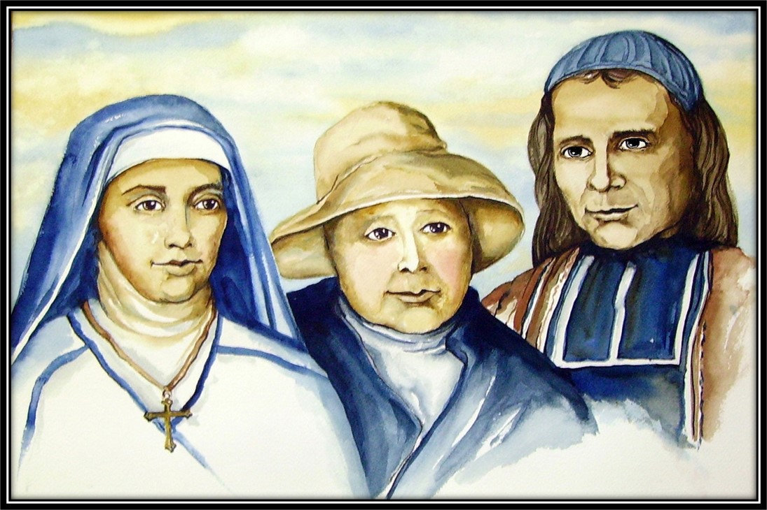
Marianist Community

Each of the Marianist Founders has their own unique story, with lessons that we can still be inspiring today. Read and reflect each of these portions from the life of Chaminade, Adèle, and Marie Thérèse.

Excerpt from: Chaminade: Pragmatist with a Vision, by Joseph Stefanelli, SM

Chaminade had at hand a new means of turning his dream of re-Christianizing France into a reality. Now, instead of hoping to fulfill it by establishing a school for youth, he set about developing a Christian community which would reflect the fullness of the church. Its primary attention would be to the future Church, the young men and young women of the city, but it quickly expanded to include older and married men and women, priests, and former members of religious orders.

On December 8th, 1800, barely a month. After his return, a small group of men determined to dedicate themselves to the re-Christianization of France under the guidance and inspiration of Mary, Mother of Youth. By February 2, 1801, the young men's group was on firm footing with 12 members; by February 2nd of the following year, they membered 100. On March 25, 1801, under the direction of Marie Thérèse de Lamourous, the Young Women's group was established. The other three groups soon followed. Confirmed in his work by a papal decree naming him Missionary Apostolic to all of France, Chaminade continued to expand his Sodality. Soon the oratory became too small.

Several features of this Sodality were new. First of all, it was positively apostolic in its orientation. Not content with developing the personal spiritual life of its members, it undertook, under the auspices of Mary and as sharing in her apostolic mission, a wide range of activities aimed at re-Christianizing the social structures. Moreover, unlike so many previous sodalities, it was open to all. Combining the leadership and exemplarity of an “elite” with the impressive numbers of a “mass movement,” The Sodality was open to all Christians. Thus, in Chaminade's mind, it was to present the imposing spectacle of a nation of saints, a people of God, an authentic Christian community, a miniature Church.

One of Chaminade's favorite expressions was “union without confusion.” Through a highly developed system of interdependence, all classes and conditions of society, all states of life, both sexes, and multiple good works cooperated under his leadership and as equal members of the Sodality (now “of the Madèleine”). Not only did sodalists give outstanding witness to their faith, but their presence and example were also instrumental in raising the spiritual level of Christian life in the parishes to which they belonged. As Cardinal Donnet was to say, at the head of all the good works. In his diocese he found the name of Chaminade.

Reflection Questions

- What do you find inspirational in this story of Fr. Chaminade and the Madeleine Sodality of Bordeaux?
- The Bordeaux Sodality combined personal spiritual growth with apostolic action. What balance do you envision between nurturing your personal faith and engaging in outward-focused mission?
- What practices or structures might help ensure your new community reflects the interdependence and cooperation Chaminade envisioned?

Excerpt from Marie Thérèse de Lamorous: Firm of Hand, Loving of Heart by Joseph Stefanelli, SM.

Just as she was settling down to a peaceful rural life, she was approached by a friend she had met before the revolutionary turmoil - Jeanne Germaine de Pichon, who before the Revolution had devoted her time, her money, her energy, and even her home to the work of rehabilitating prostitutes who wished to leave their former way of life. Now she took up this work again. The need was even greater than before, for the troubles of the Revolution, the expulsion of nuns from their convents, and the death of so many husbands, fathers, and sons in war had driven many women, young and old, to fend for themselves in the streets.

When Jeanne de Pichon first approached Marie Thérèse and asked her to take over the work, the latter rejected the suggestion outright. Given her strict upbringing, this was understandable. She could not see herself working with - much less living with - prostitutes, even repentant ones. Moreover, she believed her family and “her parishioners” at Pian had first claim to her support, and her family protested at the very thought of her moving back to Bordeaux. Nor did Chaminade at first favor, the idea, for he had been counting on her to collaborate in his own apostolic endeavors. On further reflection, however, he left the decision up to Marie Thérèse.

On a cold, wintry day in December of 1800, she agreed to visit the house where Jeanne de Pichon had gathered her small group of penitents. The visit affected Marie Thérèse strangely: while there, she experienced a profound sense of calm, peace, and joy. Not usually hers. Contrary to her expectations, she did not find the presence of the women in any way. Repugnant, but pleasant and comforting. As soon as she left, the former negative feelings returned. As for the women, they agreed among themselves that she was a person who could manage them well and help them in their efforts at reform.

At the end of the month, she was taken ill and was in bed with a fever. On New Year's night, she dreamed of seeing the prostitutes, like shooting stars, falling into hell. As they fell, they called to her for not having helped them while there was still time. Deeply affected, she set out early in the morning for Bordeaux, unthinkingly tucking her nightcap into her pocket. Going first to Chaminade and then Jeanne de Pichon, she asked them to accompany her to the Laplante house, where some 15 women were living.

She met the women and toured the house. As the day and the visit drew to a close, she said goodbye to her two companions, saying simply, “I will stay here.” She did. The date was January 2, 1801. Marie Thérèse spent the second half of her long life helping hundreds of women become virtuous, dedicated, sincere Christians.

Reflection Questions

- What do you find inspiring in this story of Marie Thérèse and the beginnings of her work with the Miséricorde?
- Marie Thérèse initially resisted the call to serve the marginalized but ultimately found peace and purpose in saying “yes.” Have you ever felt hesitant or resistant to a call in your own life? What helped you move forward—or what might help you in the future?
- From her initial declaration that, “I will stay here” until her death, Marie Thérèse was a model of intentionality and stability for the Miséricorde community. How do you embody intentionality and stability?

Excerpt from Adèle: Aristocrat for the Poor by Joseph Stefanelli, SM

Friendship quickly developed between the two young women, one almost 14, the other just passed 18, and their friendship soon enveloped both of their families. Dicherette visited Trenquelléon, met Ducourneau, and chose him as her own spiritual director. Both women were intensely interested in their relationship with God and desired a sure guide on their path. It was Ducourneau who in the next year (1804) proposed to the two women an association of prayer for mutual encouragement and spiritual support. In addition, becoming more aware of the grave and widespread obstacles to Christian living in post-revolutionary France, the Association would devote itself to a variety of works aimed at the re-Christianization of the people.

This association quickly attracted three of Dicherette's sisters, several friends of Ducourneau, and acquaintances of Adèle, especially in the city of Condom, where Adèle went regularly to visit her aunts. With time, the association grew and extended itself throughout southwestern France, covering an area roughly the size of the state of Ohio - nearly 200 mi from north to south, and similarly from east to west. Almost immediately Adèle rose to a position of leadership by the strength of her personality, spiritual maturity, energy, and devotedness. By 1808 there were sixty members; by 1814, some 200.

Through her contact with Chaminade, both Adèle's personal life and her work with the association took a path she never could have imagined. Little by little, the association came to be integrated into the Sodality as one of its subgroups. Although there were some notable differences between the two, there was also a great commonality. The Bordeaux group was mostly urban; its members met frequently in large groups; it embraced all ages, classes of society, and both genders. The association was composed almost entirely of young women, many but not all of them aristocrats or from economically comfortable, bourgeois families. But both the association and the Sodality were active support groups for personal spiritual growth. Both groups engaged in education, religious instruction, and an extensive number and variety of works of Mercy. Both were looked upon with great favor by their respective bishops.

Reflection Questions

- What do you find inspirational in this story of the early Association formed by Adèle?
- Before joining with the Bordeaux Sodality, Adèle’s Association was a widespread network that might translate into what many call a virtual community today. How does Adèle’s model of community building provide inspiration for how friendship and community can be maintained even at great distance?
- Adèle’s Association differed from the Bordeaux Sodality in that most of its members were from a specific peer group, rather than a diverse cross-section of society. What do you see as the strengths and weaknesses of both types of community?

Reflective Rest #1 (Recommendation: at least an hour)

Spend some time in a time of solitude. Good options for this time include:
- Walking, stretching, yoga, or other bodily exercise
- A meditative hobby such as gardening, an art or craft, playing an instrument, etc.
- Journaling
- Reading
- Listening to contemplative music
- Relaxing with a warm cup of tea/coffee
- A nap



Your Commitment

Our final commitment ceremony will be your opportunity to make a one-year commitment as a Lay Marianist. Most Lay Marianists will renew this commitment annually, and some will go one to make an enduring Vow of Stability. However, such decisions remain to you for your ongoing discernment and you do not need to make any indication of your commitment past your first year at this time.

At our commitment ceremony, there will be two components of the commitment you will make. First, you will be asked to state your personal intentions for joining in alliance with Mary as a Lay Marianist. A prompt below will assist you in drafting your statement of intent. The second component of the commitment ceremony will be the commitment itself, which everyone making the commitment will read together.

Statement of Intent

During the ceremony, you will be given time to share a short statement of intent (typically 1-3 sentences). This statement is your opportunity to personalize what making this commitment as a Lay Marianist means to you. While significant because it indicates your intentionality for the year to come, this is not a binding vow or other unyielding promise. The commitment is to living in alliance with Mary, supported by our Marianist spirituality and community – and this may require adaptation and change along the way. Finally, it may be difficult to summarize the entirety of the meaning of this commitment in a short statement. This is natural. Focus on what is most meaningful to you at this time, and know that everything else will come along with you as well.

Drafting Your Statement
Use the space below, or another journal or writing space you prefer, to begin drafting your Statement of Intent that will accompany your commitment as a Lay Marianist.

Community: In one sentence, write what your expectation is for Marianist community in the next year. Your expected relationship to a community might be to continue with an existing MLC that you belong to, to help form an MLC (either with a group that you have in mind, or to start identifying and organizing a new group, or to find and join an MLC (perhaps with the help of your sponsor, MLC-NA, or other members of the Marianist Family).

Mission: Briefly describe how you would like to animate inclusive, life-giving community in the church and world around you in the next year.

Spirituality:
Following in the footsteps of Mary, our Marianist spirituality is a means of increasing the quality of our relationship to God by giving attention to our interior life as well as through our intentional presence to Christ in and through others. Briefly describe how you would like to be intentional about your ongoing spiritual journey over the course of the next year.

Combining into a Statement of Intent:
Using your thoughts from above, draft a 1-3 sentence Statement of Intent that expresses what your commitment to the Marianist charism will mean to you. The ideas you wrote above are good inspirations for this statement, and you may choose to use some or all of them – or you may wish to draft new language. You do not need to follow a specific template, but if it is helpful, you may wish to start by completing the sentence: “As Lay Marianist, I commit myself over the next year to…”

Group Commitment
After sharing your Statement of Intent at the commitment ceremony, everyone will have the opportunity to make their commitment together using the following:

O loving God, we thank You for having called us to be members of the
Marianist Lay Communities and for inviting us to be consecrated to You,
through Mary, and in her spirit of faith and love.

We praise You, for You have always loved us, calling us through Baptism,
strengthening us with Your own Holy Spirit,
and calling us to a deeper faith-filled life through this commitment.

Your Spirit molds us into the likeness of Jesus, Your Son. May we learn each
day to listen more closely and to follow the inspiration of Your Spirit.

Mary, we seek to imitate your faith. With a mother’s love you guide us in our
growth in the likeness of Jesus. Help us to live as you taught your Son to
live; teach us to love all people as Jesus does.

At this moment, we offer ourselves to you
that we may become more like Jesus
and be present in this world with the same disposition that He had.
As you cooperate with God’s plan to bring Christ to the world,
we desire to cooperate in your mission of bring Jesus to everyone
and bringing everyone to Jesus.

We make this commitment to God through you and in your honor, Mary.

May the Father, and the Son, and the Holy Spirit
Be glorified in all places through the Immaculate Virgin Mary.
Amen.

