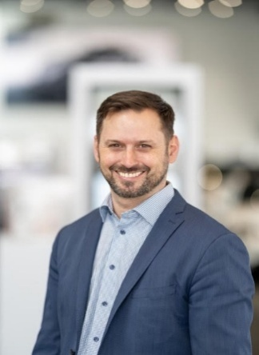**Greg Aguilera**, founder of International Automotive Consulting Ltd., has built a career delivering automotive expertise across global markets. Today, he focuses that experience on the recycling industry in the USA and Canada, providing practical, hands-on EV dismantling courses that give recyclers the skills and safety knowledge to handle electric and hybrid vehicles confidently and compliantly.

**Session Name: Navigating the Future**

Session Description:  This session will focus on TxDMV legislative implementation efforts, operational updates, and stakeholder engagement.

**Roland D. Luna**, Sr. serves as a deputy executive director for the Texas Department of Motor Vehicles (TxDMV). In this role he provides directions to the Vehicle Titles and Registration Division, Motor Vehicle Division, Enforcement Division, Information Technology Services Division, and the Motor Vehicle Crime Prevention Authority.

 Prior to his current role, Roland served as the Director of the Vehicle Titles & Registration Division, and came to TxDMV in August 2020 as Director of the Motor Vehicle Division. Prior to joining TxDMV he served as a State Trooper with the Texas Department of Public Safety and ascended into various commissioned positions, including service as a Criminal Investigations Division Sergeant, Internal Affairs Lieutenant, and service as an Agent on the Protective Detail for Governor Greg Abbott (then Attorney General).

Roland also served in various directorships as a Division Chief with the Texas Alcoholic Beverage Commission, Deputy Inspector General and Chief of Investigations for the Health and Human Services Commission Office of the Inspector General, and Chief Inspector General for the Texas Juvenile Justice Department (TJJD) Office of the Inspector General where he reported to the TJJD Board. His resume includes experience at the local government level, where he served as the Director of Administration for the Williamson County Judiciary. In Roland’s career, he has developed and implemented state-wide compliance, monitoring, regulatory, and investigative initiatives, served on various committees and advisory boards, and provided instruction at conferences, academies, and universities.

 Roland earned a Bachelor of Business Administration from Sam Houston State University and a Master of Arts in Legal Studies from Texas State University. He is certified in mediation and legal research, holds a Texas Commission on Law Enforcement Master Peace Officer License, and is a certified Inspector General. Roland is also a graduate of the Governor’s Executive Development Program.

**Sharon Jones**

Disassembled and Disappeared: Stolen Vehicles Fueling Cartel Crime

Sharon Jones is a Major in the Criminal Investigations Division of the Texas Department of Public Safety, where she has served since 1997. She oversees multiple statewide programs addressing crimes such as vehicle theft, cargo theft, and metal theft. Sharon also serves as a board member of the Motor Vehicle Crime Prevention Authority, where she chairs both the Grants Committee and the Senate Bill 224 Committee.

Her leadership includes drafting legislative proposals and developing statewide policies to enhance public safety. A graduate of the FBI National Academy, Sharon actively contributes to the law enforcement profession through her involvement in organizations such as the International Association of Chiefs of Police. She holds a Bachelor of Business Administration and a Master of Public Administration.

**Peter Jebson (Co-Founder & CEO)**

Peter is one of the co-founders of Salvato, and leads all strategic, commercial, and operational topics for the company. Prior to Salvato, Peter worked on growth strategy for the leading SaaS provider of auto insurance claims technology in the U.S., as well as for one of the largest auto parts recyclers in the U.S. This understanding of both sellers and buyers led Peter to believe there is an opportunity to eliminate unnecessary costs and create a better auction for insurance vehicles, so we launched Salvato to do exactly that.

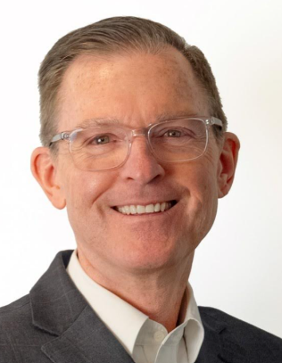

**Dan Oscarson (Head of Global Buyer Development)**

Dan leads global buyer development for Salvato, including all efforts to ensure both domestic and foreign-based buyers have access to quality insurance vehicles with significantly lower fees. Prior to Salvato, Dan spent the majority of his career at Insurance Auto Auctions (IAA) as a Branch Manager, Vice President of Marketing, and most recently as Vice President of Global Buyer Marketing and Vice President of Global Market Development. Since then, Dan has worked abroad for some of the largest global buyers of insurance vehicles, including as Chief Operating Officer at Marhaba Auctions in the U.A.E.

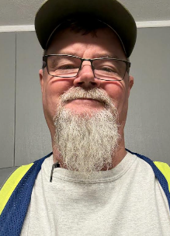**Mark Bell**

I started in the recycling industry in 2016 as an inspector and machine operator. 2019 promoted to Quality inspector and then in 2021 to Lead Inspector for Gerdau Midlothian Scrap Receiving group. Prior to this career I spent 20 years as an industrial contractor. Specializing in Natural gas transmission.

**Images in ICPM and preparing for Car-part.com in 2026**

**Roger Schroder** is a co-founder of [Car-Part.com](http://car-part.com/) and is currently the company's Vice President. Roger has been in the auto recycling industry for over 35 years, and is owner of Foreign Auto Salvage in Fort Wright, Kentucky. He was the manager of Foreign Auto Salvage for many years and continues to serve as a senior officer.

Roger received a bachelor's degree from Thomas More College with a double major in Business Administration and Accounting. He spent 10 years as a special agent with the Treasury Department. Roger is a Fort Wright General for his volunteer work with the city and works with the Fort Wright Business Association. He has also been recognized as an Honorary Colonel by the Kentucky State Police Department.

**Ryan Carrafiello**  
**Director of Corporate Accounts**

Ryan brings specialized expertise in the converter industry, shaped by hands-on experience as a core buyer and early exposure to the scrap business. His in-depth knowledge spans both the refining and retail sectors.

Since joining PMR in 2014, Ryan has focused on building strong supplier relationships by understanding their operations and integrating into their business models. He works closely with partners to develop solutions, set objectives, and achieve monthly targets. At his core, Ryan sees himself as a relationship builder, dedicated to helping converter recyclers succeed.

**Ray Coker** has been the Regional Director of Team PRP for over 10 years, during which he has significantly contributed to the organization's growth from 100 members to nearly 300. Throughout his tenure, he has played a key role in promoting operational consistency among recyclers in terms of how they prepare, package, and ship their materials. Before joining Team PRP, Ray spent 10 years as the General Manager of two automotive auction pools in Mobile, AL, and Pascagoula, MS. Ray and his wife, Sherry, reside in Mobile, Alabama.

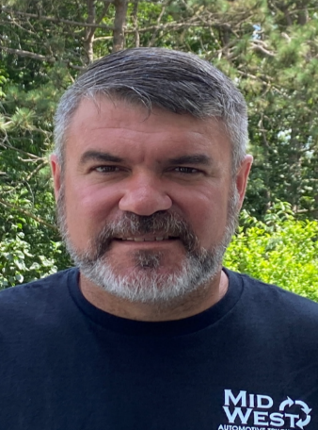

**George Schreiber** – George has worked with Team PRP and its trucking company (dba Midwest Automotive Trucking) since 2017(?). George oversees Team PRP warehouse operations and truck routes in Buffalo, NY, Harrisburg, PA, Fremont, IN, and Team PRP’s busiest hub in Mansfield, OH. George is hands-on and committed to ensuring that brokered parts reach their end destinations undamaged, and constantly works with Team PRP facilities to ensure shipping departments are adhering to Team PRP shipping guidelines and procedures. When he’s not traveling around the country for Team PRP, George makes his home in Olean, NY, with his wife Rachel.

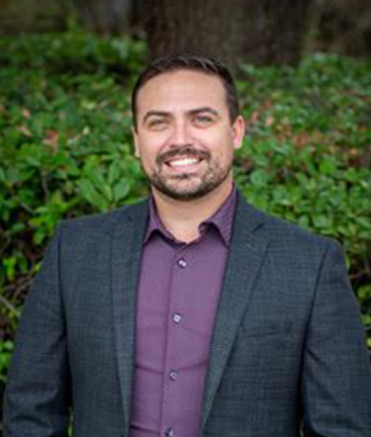

**Michael "Ford" Strawn** has been with the Texas Department of Licensing and Regulation (TDLR) for 9 years, where he has made significant contributions to managing and overseeing the Department’s 38 diverse programs. His role encompasses a broad range of responsibilities, reflecting his deep expertise and versatility in the field.

Ford’s career is marked by his specialization in counterfeiting, fraud prevention, and investigative processes. His extensive background in these areas has been pivotal in enhancing the integrity and effectiveness of licensing processes. Ford’s dedication to public service and regulatory compliance underscores his role as a key player in the Department's mission to protect and serve the people of Texas through rigorous and fair oversight of licensed professions and industries, especially the Used Auto Parts Recyclers industry.

**Maximize Core and End of Life Revenues**

Are you squeezing every opportunity you can out of these vehicles? Identifying, Harvesting, sorting and selling commodities pre-dismantle, post-dismantle and end of life processing while decreasing overhead and improving your bottom line!

**Jeremy Barnett** is currently the Operation’s Manager at Snyder’s Certified Auto and Truck Parts in Holland, TX.

Jeremy began his career with Snyder’s as an Automotive Dismantler in 2009. After his time as a Dismantler, he has also served as an Inventory Technician, Receiving Technician, Dismantling Manager, Inventory Manager, and Commodities Manager.

Prior to beginning his career with Snyder’s Jeremy obtained the rank of Sergeant First Class during his 12 years of Active Duty with the US Army as a Wheeled Vehicle Mechanic. Jeremy has 3 Combat deployments in support of Operation Iraqi Freedom and Operation Enduring Freedom (Afghanistan). He held multiple different leadership positions during his tenure in the army to include Platoon Sergeant, Battalion Motor Sergeant, Battalion Shop Foreman, Battalion Master Driver Trainer, Squad Leader and Team Leader.

Jeremy completed the US Army’s Advanced Non-Commissioned Officers Academy, the Basic Non-Commissioned Officers Academy, Primary Leadership Development Course, Master Driver Course, and Combat Lifesavers Course.

He has been awarded the Meritorious Service Metal, (3) Army Commendations Metals, (4) Army Achievements Medals, and Graduated the Advanced Non-Commission Officers Course, and Primary Leadership development Course as the Distinguished Honor Graduate.

Jeremy and his wife Marscha have been married for 22 glorious years and together have three wonderful children; Ashlynn (20), Carson (18), and Kinley (11)

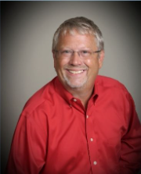

**Mike Kunkel**- Sales are at a crossroads. What does the future look like with AI and expanded electronic procurement look like.”

AI is coming fast, and the OE is looking at the industry as well. Adding to the mainstream acceptance of used auto parts will cause a shift in how we do business. We will discuss some of the possibilities and give some points on how to embrace and how to compete against these things.