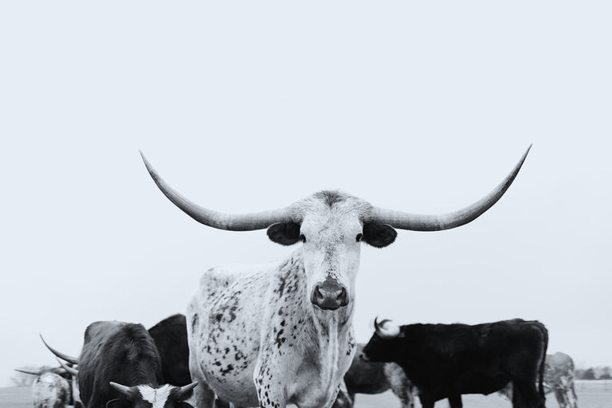
2026
TARA CONFERENCE
&
FOUR-STATE FUSION
TRADE SHOW

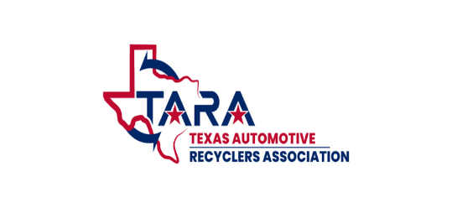

Join us at the
Sheraton Fort Worth
Downtown Hotel
Fort Worth, Texas
August 27, 2026 - August 29, 2026

432-999-3274 www.texasara.com

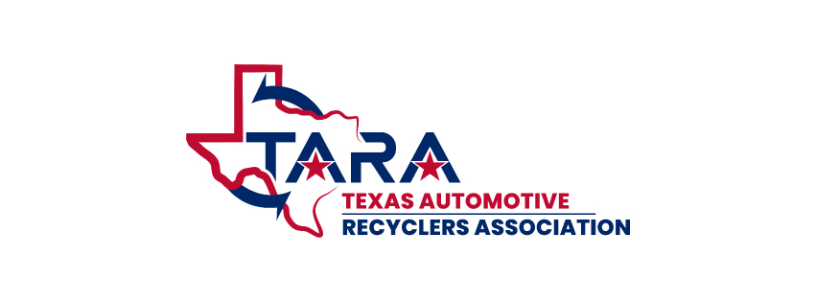

2026 EXHIBITORS REGISTRATION
TARA CONFERENCE AND FOUR-STATE FUSION
(Includes 2 Rep’s, 1 6’ table, Wi-Fi, (Yard Tours)
(Saturday Appreciation Celebration) (Friday Banquet Dinner)
COMPANY NAME_________________________________________________________________________________
ADDRESS________________________________________________________________________________________
CITY, STATE, ZIP___________________________________________ PHONE_____________________________
EMAIL______________________________________________________________________
REP’S NAME FOR BADGES: 1._____________________________________________
2._____________________________________________ 3._____________________________________________
4.____________________________________________ _5._____________________________________________
REGISTRATION TYPE | EARLY BIRD/DESCRIPTION | AMOUNT | QTY | SUB TOTAL
MEMBERSHIP | IF YOU ARE NOT A MEMBER, PLEASE JOIN | $600.00
MEMBER | $750 STANDARD BOOTH  $1500 LARGE BOOTH (4 REPS TWO TABLES)
NON-MEMBER | $1000 STANDARD BOOTH  $2000
ADDITIONAL GUEST  (MORE THAN 2 REPS STANDARD)  ( MORE THAN 4 REPS LARGE BOOTH) | MEMEBERS $250 NON-MEMBERS $350
EARLY BIRD CUT-OFF DATE  08/01/2026 | CORN HOLE TEAM (two player for the $100) | $100.00
 | BANQUET DINNER | $0.00
 | CARD PROCESSING FEE | $25.00 |  | 25.00
 | TOTAL
CHECK ENCLOSED TO: TARA 11209 BUZZARD GULCH DR WACO, TX 76708 CHECK _______________
Card No. ________________________________________________ Card CVV Code ___________
Name on card____________________________________________ Zip Code ___________________ Exp date ____________
For office use: Date paid _____________________________ Paid amount ____________________ Payment method_______________________ Number oF guests_________________Badge list_____________________________ Badges Made ___________________
Signature ______________________________________________________

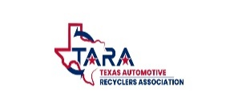


TARA CONFERENCE & FOUR-STATE FUSION TRADE SHOW
SHERATON FORT WORTH DOWNTOWN AUGUST 27TH - 29TH 2026
2026 SPONSORSHIP OPPORTUNITY
$15,000 PLATINUM SPONORSHIP
*2 Custom Poncho shirt, 2 pair of Tecovs boot, two cowboy hats, 2 belts with custom belt buckle, Custom rug.
*Free hotel suite for duration of trade show and conference with welcome gift
*Welcome gift from TARA
*Prime table placement at trade show
*Special recognition on hotel's monitor during entire event
*Exclusive ad on placemats at banquet dinner
*Distribution of company literature/advertisements to all attendees
*Special recognition from President during all events
*Prominent advertising of your business at the show
*Full page advertisement in our Quarterly newsletter
*Logo with a "Thank you" on our website for a year.
$6,000 | PALLADIUM SPONSORSHIP:
*2 Custom Poncho shirt
* Custom rug.
*Free hotel room (2 nights) for duration of trade show
*Welcome gift from TARA
*Prime table placement at trade show
*Special recognition on hotel's monitor during entire event
*Distribution of company literature/advertisements to all attendees
*Logo with a "Thank you" on our website for a year. & prominent advertising of your business at the show

*Full page advertisement in our Quarterly newsletter.
$3,500 | RHODIUM SPONSORSHIP:
*Custom Rug
*Prominent advertising of your business at the show
*1/4 page advertisement in our quarterly newsletter
*Distribution of company literature/advertisements to all attendees
*Logo with a "Thank you" on our website
$2,000 | COPPER SPONSORSHIP:
*Prominent advertising of your business at the show
*1/4 page advertisement in our quarterly newsletter
*Distribution of company literature/advertisements to show attendees
*Logo with a "Thank you" on our website.

Please email your company logo in PNG, PDF, or JPG format only
Each sponsorship will receive exclusive recognition throughout designated sections of the event. Your company name and logo will be prominently displayed on flyers, posters, and select table settings, ensuring visibility. Additionally, sponsors will be acknowledged in announcements by the president and showcased on the event banners.
EVENT SPONSORSHIPS
□ Vendors Appreciation Bar - $4,000.00
□ Lunch with the Exhibitors - $2,000.00
□ Dinner Bar - $4,000.00
□ Banquet Thank You Dinner - 6,000.00
Sponsorship Total $ ____________
Processing Fee for all card transactions $25.00
Amount Due $ _______________

Company Name: _______________________________________
Contact Name: ________________________________________
Phone: ____________________________________
Email: _____________________________________
□ Payment by Check:
Make checks payable to: TARA 11209 BUZZARD GULCH DR WACO, TX 76708
□ Payment by Credit Card:
Name on Card: ___________________________________________
Card Number: ____________________________________________
Exp. Date: _______________ Verification Code: ____________
Signature: _______________________________________________

Date: ____________________TARA reserves the right to make changes to one or all of the above information.

TARA Standard Room Rate
$147.00+ taxes and fees King or Double Occupancy per night

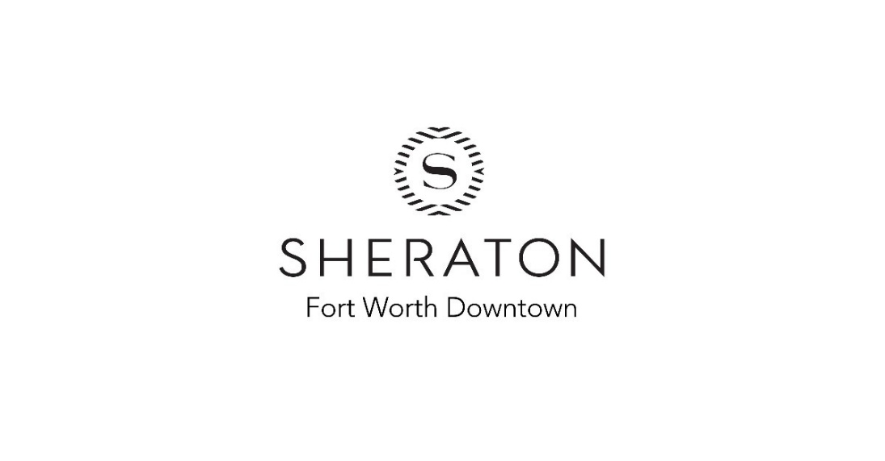
Book your group rate for TARA Annual Conference and Tradeshow 2026
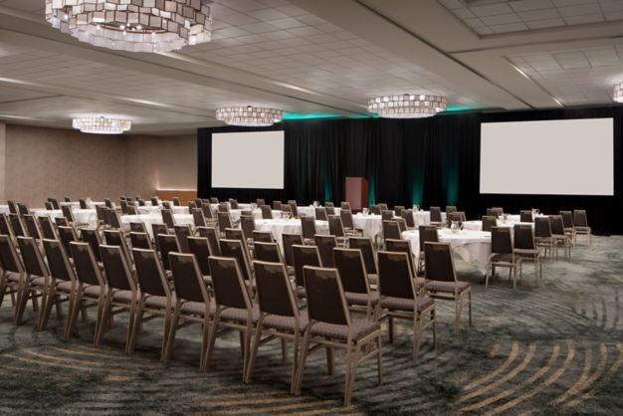
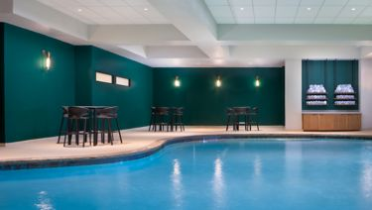

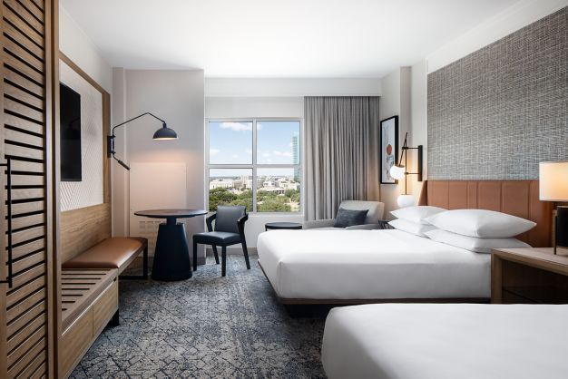
TARA reserves the right to make changes to the above information.

