[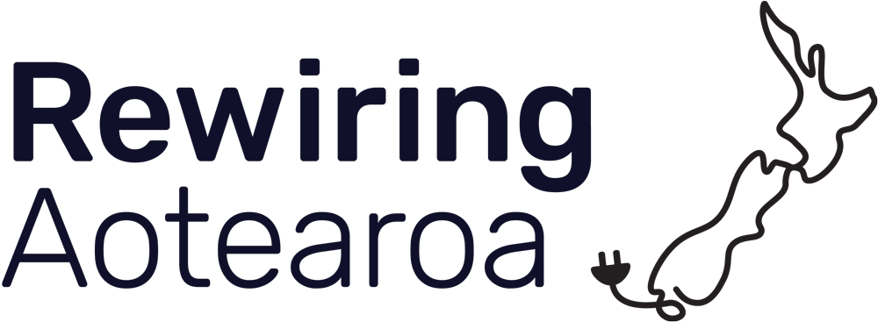](https://www.rewiring.nz/)

PĀNUI PĀPĀHO / MEDIA STATEMENT

**Rewiring Aotearoa commends Electricity Authority for changes that put more power back in customers’ hands.**

**17th July, 2025:** Fairly compensating households, farmers, and businesses with solar and batteries that export power at peak will give customers a fairer deal and give a much needed jolt to a market that has been slow to innovate and make the most of new technology.

The rule changes announced by the Electricity Authority as part of the Energy Competition Task Force are a positive step toward a fairer, lower-cost electricity system for everyone - and another positive signal for New Zealanders to invest in solar and batteries.

Rewiring Aotearoa CEO Mike Casey says the changes provide electricity distribution networks with clarity and reflect the value customers provide to our electricity system by using batteries to help avoid or delay costly infrastructure upgrades that continue to increase consumer bills.

“These changes acknowledge the ability of solar and batteries to lower electricity system costs, which is something we have been saying for a long time. As an example, the batteries on my all-electric orchard could power around 25 homes. This reduces the need for expensive electricity line upgrades. But until now, the role that batteries can play to lower a whole community's infrastructure costs has been largely ignored by incumbent energy companies. This has left untapped peak reduction, energy security, and resilience on the table just because our system hadn’t kept pace with technology.”

The Authority has made it clear that electricity networks must fairly value alternatives to just building more poles and wires and increasing bills. Larger retailers will also have to offer time-of-use plans.

“In an energy system that too often favours incumbent companies over everyday New Zealanders, this is a clear win for all electricity customers - and a sign the regulator is stepping up,” says Casey. “These changes will help slow rising energy costs and deliver long-term benefits for all New Zealanders.”

“We commend the Authority for its courage in putting its foot down on behalf of Kiwis. We need more of it.”

Casey says he is bracing for a bit of toy-throwing from some parts of the sector, because the rule change requires all the networks to do something very different from historical practice.

“We believe these changes can be positive for both sides and we look forward to seeing more networks and large electricity retailers stepping up to the plate and embracing these changes toward an energy system that treats customers as equal market participants.”

“If anyone in the industry thinks these changes are bad for everyday Kiwis, we challenge you to show us the data. We need more open transparent debates in the industry, and they need to be built on data, not incumbent opinion. The energy system is meant to be built for New Zealanders, and building a system designed for the benefit of them should always be the priority.”

The more innovative networks are already leading the way and proving that peak export pricing works and benefits their communities. Here are a few notable quotes from industry players:

*Two-way pricing is a dynamic approach that can significantly enhance the efficiency and fairness of electricity distribution. By implementing two-way pricing, we can move away from traditional volume-based pricing models and instead adopt a more flexible and responsive system. This approach allows for the adjustment of prices based on the time of use, providing clearer signals and rewards for consumers who help ease congestion during peak periods.[1] - Orion*

*We are also introducing credits (negative variable charges) for customers who export power from generation or battery storage at their ICP at peak times to reflect [the] benefit that local supply [provides] into the network in peak periods. This credit reflects the fact that injecting electricity has the same benefit as reducing demand – deferring the need for planned investment. [2] - PowerCo*

*Any delays in Capital renewal to solve for network constraints do benefit all consumers and therefore TLC do agree with cost savings spread across all consumers as an outcome.[3] - The Lines Company*

Payments to customers will be based on long run marginal cost calculations, which should represent the genuine savings to the network from peak-time exports as long as these calculations are done fairly.

“We look forward to the Electricity Authority providing clear guidance on how these costs are to be calculated. The Authority's close monitoring of how export tariffs are calculated and willingness to enforce compliance will be critical to ensuring New Zealanders get a fair deal.”

As the Authority itself put it, these rule changes aim to unlock “benefits from reducing net peak demand and avoiding investments in more expensive traditional network solutions (ie, poles and wires) in the long term”.

“There is a lot of attention on rising electricity prices at the moment and the biggest chunk of those increases in the coming years are expected to come from upgrades to poles and wires, which end up on customers’ bills. The cost of generating and storing electricity has never been cheaper through solar and batteries, but if the price of grid electricity continues to rise at above the rate of inflation, we will make it unnecessarily harder to electrify our economy, so these are important changes to try and slow those price rises.”

“It’s great to see the Authority standing firm and continuing to put the power back in New Zealanders’ hands.”

Casey says he is expecting more positive changes to be announced soon as the Electricity Authority's Energy Competition Task Force continues its work to provide better outcomes for New Zealanders.

*NOTES TO EDITORS:*

*For more information or to arrange an interview, contact Ben Fahy at ben@rewiring.nz or 021 245 4894.*

[*Rewiring Aotearoa*](https://www.rewiring.nz/about-us) *is an independent think / do tank working on energy, climate, and electrification research, advocacy, and supporting communities through the energy transition. The New Zealand-based team consists of energy, policy, communications and community outreach experts and it is funded by New Zealand-based philanthropists including Sir Stephen Tindall, Urs Hölzle and the Whakatupu Aotearoa Foundation.*

1. [www.oriongroup.co.nz/assets/Our-story/Pricing/Orion-pricing-methodology-2025.pd](https://www.oriongroup.co.nz/assets/Our-story/Pricing/Orion-pricing-methodology-2025.pd) page 26
2. [www.powerco.co.nz/-/media/project/powerco/powerco-documents/who-we-are---pricing-and-disclosures/pricing/electricity-pricing/3-electricity-pricing-methodology-and-schedules/11---1-april-2025---31-march-2026/pricing-methodology-1-april-2025---31-march-2026.pdf](https://www.powerco.co.nz/-/media/project/powerco/powerco-documents/who-we-are---pricing-and-disclosures/pricing/electricity-pricing/3-electricity-pricing-methodology-and-schedules/11---1-april-2025---31-march-2026/pricing-methodology-1-april-2025---31-march-2026.pdf) page 13
3. [www.ea.govt.nz/documents/6797/D_The_Lines_Company_2A_2BC_submission_2025.pdf](https://www.ea.govt.nz/documents/6797/D_The_Lines_Company_2A_2BC_submission_2025.pdf) p5