Topic: The Darkest Hour | Term: Summer 1 | Year 5/6 | Duration: 3 weeks
Our Key vocabulary
Word | Meaning | Image
Propaganda | Information of a biased nature used to promote a political cause | 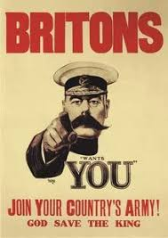
Conflict | A serious disagreement, often an armed struggle, between two or more parties.
Resolution | The act of solving a problem.
Evacuation | The emergency relocation of a group of people due to an imminent or ongoing threat to lives or property. | 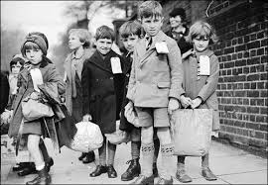
Axis | An agreement between two or more countries which forms a centre for an eventual larger group of nations
Ally/Allies/  Alliance | A state or states formally cooperating with another for a military or other purpose
Air Raid | An attack in which bombs are dropped from an aircraft on to a ground target. | 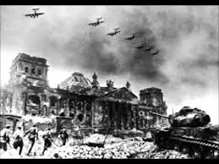
Blitz | An intensive or sudden military attack
Nazi | A member of the National Socialist German Workers’ Party
Battery | A fortified emplacement for heavy guns | 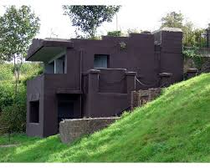
Eden Park Primary School Knowledge Organiser

Focussed Literacy texts:
My Secret War Diary, by Flossie Albright – My History of The Second World War
(Marcia Williams)
The Powerful Knowledge we will take away from this Learning Enquiry (what we will be learning)
- How and why World War II began.
- How the WWII affected Great Britain and the legacy it has left behind.
- To empathise with those caught up in war, and to understand that life is still like this for people today.
- How evacuation, rationing, propaganda and The Battle of Britain affected everyday life for children in Britain
- How to research meaningfully, understanding the difference between primary, secondary and tertiary evidence.
- That events can be presented in different ways in order to colour the response of the audience.
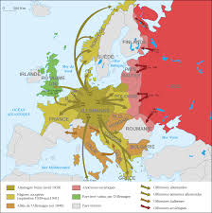
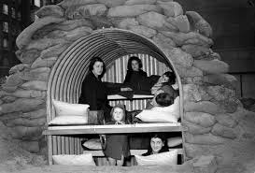
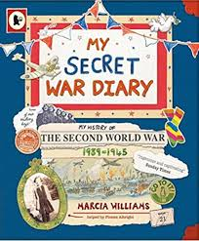
Key Information: Darkest Hour
Dates | Event | Images | Information
1st September 1939 | Hitler invades Poland | 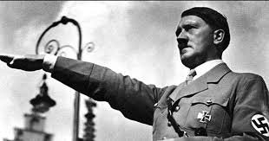 | Following an initial policy of ‘appeasement’ which meant that Britain was allowing Hitler to expand German territory unchecked, the invasion of Poland led Prime Minister Neville Chamberlain to reconsider this position. Two days later, Britain and France declared war on Germany.
1940 | Rationing starts in the UK | 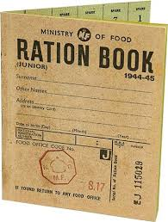 | Aware that one of Germany’s key strategies against Britain was to try to stop food entering the country from abroad, the British Government decided to begin rationing certain types of food to ensure that all people had equal access to basic nutrition.
1940 | Winston Churchill becomes Prime Minister of Britain | 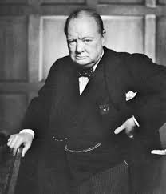 | After a disastrous military campaign in Norway, which Germany had taken using Blitzkrieg tactics, Neville Chamberlain resigned as Prime Minister and Winston Churchill took over the role. Chamberlain served in Churchill’s first cabinet as lord president of the council, but died a few weeks later.
1940 | The Battle of Britain | 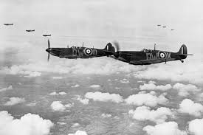 | Following the fall of France, Belgium and Holland, and the evacuation of many British troops from Dunkirk, Hitler expected Britain to seek a peace settlement, but Britain was determined to fight on. Germany felt that removing the threat provided by the Royal Air Force would bring victory, so they built up their air force called the ‘Luftwaffe’. Early use of Radar helped the RAF win the Battle of Britain, from which the Luftwaffe never fully recovered.
1941 | The Blitz continues | 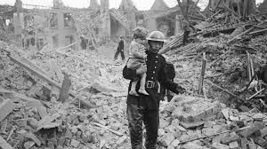 | Even though Britain had managed to repel the German invasion, the remaining Luftwaffe were still regularly bombing British cities. These were often selected if they were important military centres (like Plymouth) or major manufacturing hubs (like Birmingham).
1941 | The Japanese attack Pearl Harbor | 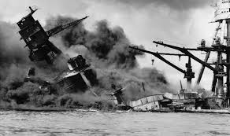 | Pearl Harbor is a naval harbour on the island of Oahu, Hawaii, one of the United States of America. The attack was planned in order to destroy the US Pacific fleet and destroy the morale of the US Navy. In fact, this attack was the event that saw the U.S.A. enter the war having, up to that time, been neutral in its allegiance. It has often been argued that if the USA hadn’t entered the war, the eventual result may have been different.
1942 | Mass murder of Jewish people at Auschwitz begins | 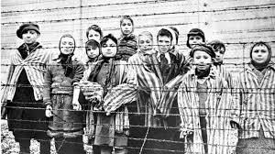 | In one of the most horrific side-stories of the war almost one million Jewish people were put to death in Nazi ‘concentration camps’ at Auschwitz in German-occupied Poland.
1944 | D-Day | 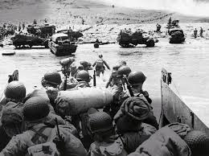 | The Allied troops invade France in ‘The Normandy Landings’ – the largest seaborne invasion in history - and liberate Paris from Nazi control in August
1945 | Germany surrenders | 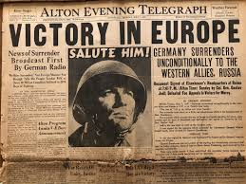 | Auschwitz is liberated by Soviet troops and the Russians reach Berlin, the German capital. Hitler commits suicide and, on 7th May, Germany surrenders -VE (Victory in Europe) Day. After atomic bombs are dropped on Hiroshima and Nagasaki in Japan, by the US military, Japan surrenders on 14th August (VJ Day) and the war is over.

