CURRICULUM DESIGN for SCIENCE
Science INTENT
At Eden Park, our intent is to deliver a high-quality and broad and balanced science curriculum which enables children to confidently explore and discover what is around them, so that they have a deeper understanding of the world we live in and develop a respect for living organisms and the physical environment. We aim to promote positive attitudes to science as an interesting and enjoyable subject, and also to develop pupils` awareness of how science is relevant in our daily lives and plays a pivotal role in shaping the future. The world we live in is constantly changing and pupils need to be equipped with the necessary skills to thrive and be successful in that future.
We aim to instil a passion for science through investigative learning, allowing students to ask questions, explore problems and search for solutions using their creativity. We want them to have no limits to their ambitions and to grow up wanting to be anything from astronauts, forensic scientists, vets or marine biologists.
To achieve this, we will include exciting, practical hands-on experiences that encourage curiosity and questioning. Our aim is that these stimulating and challenging experiences help every child secure and extend their scientific knowledge and vocabulary, as well as promoting a love and thirst for science.
Science IMPLEMENTATION
Science follows the National Curriculum; objectives are delivered through either weekly lessons or a full week topic. The ‘voices’ (which form our disciplinary knowledge) ensure skills specific to being a scientist are taught each and every year, so, wherever possible, the units have a practical element. The curriculum makes use of prior substantive knowledge and provides clear references on how learning will be used in future enquiries.
Science learning is structured around the repeated themes of chemistry, biology, physics and earth sciences. These unit studies are assigned key knowledge and vocabulary to be learnt and understood.
For those children that show a particular enthusiasm for the subject, they have the opportunity to become a ‘Graduate.’ Our Graduation scheme gives children the chance to explore learning beyond the National curriculum. This scheme focuses on Inspirational and Influential people within Science.
Science IMPACT
Impact of teaching and learning will be determined through SLT and subject leader reviews and observations as well assessment carried out through pre and post tasks called “giggle” sheets. This information will be collated in our ‘Quality of Education’ document. We will know we have been successful if children have met their ‘end points’ which are specified in the planning document.
Progression of Knowledge
Our Science curriculum for KS1-KS2 follows four main themes: Earth sciences, Chemistry, Biology and Physics.
There is an expectation that children will use their prior learning to build on as they journey through Eden Park. Children will reach an end point where their understanding of Science has been strengthened and deepened through this purposefully mapped out curriculum.
In Early Years, children will encounter Science through Understanding the World. Here children will look at people and communities and are helped to make sense of their physical world. They will leave Early Years having been encouraged to explore and problem solve. Children are well prepared for their Y1 learning on the weather through their daily discussions and observations of whether conditions and seasons. Year 1 build on this prior learning and extend it through their fieldwork studies. The EYFS curriculum is mindful of how their curriculum can be used to create the foundations of prior knowledge which we build upon as children journey through Year 1 and KS1.
Earth sciences | Chemistry | Biology | Physics
 | Year 1/2A | Year 1/2B | Year 3/4A | Year 3/4B | Year 5/6A | Year 5/6B
 | Plants | Plants | Plants | Living things and their habitats | Living things and their habitats | Living things and their habitats
 | Animals inc Humans | Animals inc Humans | Animals inc Humans | Animals inc Humans | Animals inc Humans | Animals inc Humans
 | Light and Dark | Living things and Habitats | Light | Electricity | Forces | Electricity
 | Materials | Materials | Forces and Magnetism | States of Matter | Properties and changes of materials | Light
 | Seasons | Sound | Rocks | Sound | Earth and Space | Evolution and Inheritance
End points: | By the end of Key Stage 1, children will have been taught:  - Plants: identify some common plants and describe basic plant and tree structure.  - Animals: identify common animals including fish and retiles, and use the terms carnivore, herbivore and omnivore. Notice how offspring grow into adults.  - Humans: Label a human diagram and investigate senses. Understand basic human needs and how to sustain healthy life.  - Materials: name and describe features of a range of common materials and compare their suitability for different uses. Find out how to change shapes of basic materials.  - Seasons: observe and record changes in seasons and weather.  - Living things: study habitats and how animals are suited to them and discuss simple food chains.  - Plants: observe how seeds grow and the conditions that they need. |  | By the end of Key Stage 2, children will build on their prior knowledge of Science and extend this further. Children will have been taught:  - Plants: understand the functions of plant parts, their life cycles and how they sustain life.  - Animals: understand nutrition, and the purpose of skeletons, muscles and major organs.  - Rocks: compare types of rocks and describe fossils.  - Light: recognised how shadows are formed and change, notice reflections and understand how light travels and how we see objects.  - Forces and magnets: investigate friction and magnetism, and used the terms repel and attract. Experiment with other forces including air resistance and water resistance and see how pulleys and levers can increase the impact of a force.  - Living things: group and classify living things, and study how their environment shapes how they behave. Give specific reasons for classifications. Describe basic life cycles and the process of reproduction in some plants and animals.  - Humans: describe the basic parts of human digestion, including teeth, and create simple food chains. Describe the human life cycle. Identify the main parts of the circulatory system and recognise impacts on it (diet/ exercise)  - States of matter: understand solids, liquids and gases as states of matter and observe changes in the states, including the water cycle.  - Sound: understand sound is created by vibration and experiment with pitch and volume.  - Electricity: construct and draw simple circuits, including with lamps motors and switches. Recognise how the objects perform is related to the number of cells used.  - Materials: describe changes such as melting, evaporating and making a solution. Understand materials can change in reversible and irreversible ways.  - Earth and Space: describe the movement of the Earth, moon and other planets relative to the sun in the solar system.  - Evolution and inheritance: recognise how living things change over time and that offspring usually vary from their parent.

The Voices of Science (Disciplinary Knowledge)
Woven through our Science curriculum are our ‘Voices’. It is our intention that the voices are used, where appropriate, during science teaching. Children will therefore encounter these ‘Voices’ repeatedly throughout their time at Eden Park. We have created voices for both working scientifically and for each of the science themes.
Asking questions and recognising that they can be answered in different ways
EYFS | Year 1 and 2 | Year 3 and 4 | Year 5 and 6
-Talk confidently to adults and peers about their family and local community.  -Can talk about people who are familiar to them e.g. police, doctors, teachers etc. | Asking simple questions and recognising that they can be answered in different ways | Asking relevant questions and using different types of scientific enquiries to answer them, making some decisions about the enquiry. | Planning different types of scientific enquiries to answer questions, including recognising and controlling variables where necessary
Making observations and taking measurements
-Explore the natural world around them, making observations and drawing pictures of animals and plants. | Observing closely, using simple equipment | Making systematic and careful observations and, where appropriate, taking accurate measurements using standard units, using a range of equipment, including thermometers and data loggers | Taking measurements, using a range of scientific equipment, with increasing accuracy and precision, taking repeat readings when appropriate
Engaging in practical enquiry to answer questions
-Explore the natural world around them, making observations and drawing pictures of animals and plants. | Performing simple tests  Identifying and classifying | Setting up simple practical enquiries, comparative and fair tests | Planning different types of scientific enquiries to answer questions, including recognising and controlling variables where necessary
Recording and presenting evidence
-Explores the natural world around them, making observations and drawing pictures of animals and plants. | Gathering and recording data to help in answering questions  Use simple features to compare objects and sort them. | Gathering, recording, classifying and presenting data in a variety of ways to help in answering questions  Recording findings using simple scientific language, drawings, labelled diagrams, keys, bar charts, and tables  Look for patterns in data. | Recording data and results of increasing complexity using scientific diagrams and labels, classification keys, tables, scatter graphs, bar and line graphs
Answering questions and concluding
-Can talk about people who are familiar to them e.g. police, doctors, teachers etc.  -Can talk about people who are familiar to them e.g. police, doctors, teachers etc. | Using their observations and ideas to suggest answers to questions, including using simple measurements.  Experience different types of scientific enquiry | Using straightforward scientific evidence to answer questions or to support their findings  Identifying differences, similarities or changes related to simple scientific ideas and processes  Using results to draw simple conclusions, make predictions for new values, suggest improvements and raise further questions | Identifying scientific evidence that has been used to support or refute ideas or arguments  Reporting and presenting findings from enquiries, including conclusions, causal relationships and explanations of and degree of trust in results, in oral and written forms such as displays and other presentations
Evaluating and raising further questions and predictions
-Daily weather conversations and comparisons from yesterday and predictions for tomorrow’s weather. |  | Using results to draw simple conclusions, make predictions for new values, suggest improvements and raise further questions  Using results to draw simple conclusions, make predictions for new values, suggest improvements and raise further questions | Reporting and presenting findings from enquiries, including conclusions, causal relationships and explanations of and degree of trust in results, in oral and written forms such as displays and other presentations  Using test results to make predictions to set up further comparative and fair tests
Communicating their findings
-Talk confidently to adults and peers about their family and local community.  -Can talk about people who are familiar to them e.g. police, doctors, teachers etc.  -making observations and drawing pictures of animals and plants. |  | Reporting on findings from enquiries, including oral and written explanations, displays or presentations of results and conclusions | Reporting and presenting findings from enquiries, including conclusions, causal relationships and explanations of and degree of trust in results, in oral and written forms such as displays and other presentations

 | Develop Biology knowledge | Develop Chemistry knowledge | Develop Physics knowledge | Develop Earth Sciences knowledge.
KS1 | • Identify and name a variety of common animals including fish, amphibians, reptiles, birds and mammals.  • Identify and name a variety of common animals that are carnivores, herbivores and omnivores.  • Describe and compare the structure of a variety of common animals (fish, amphibians, reptiles, birds and mammals, including pets).  • Identify, name, draw and label the basic parts of the human body and say which part of the body is associated with each sense.  • Notice that animals, including humans, have offspring which grow into adults.  • Find out about and describe the basic needs of animals, including humans, for survival.  • Describe the importance for humans of exercise, eating the right amounts of different types of food, and hygiene.  • Explore and compare the differences between things that are living, dead, and things that have never been alive.  • Identify that most living things live in habitats to which they are suited and describe how different habitats provide for the basic needs of different kinds of animals and plants, and how they depend on each other.  • Identify and name a variety of plants and animals in their habitats, including microhabitats.  • Describe how animals obtain their food from plants and other animals, using the idea of a simple food chain, and identify and name different sources of food | •Distinguish between an object and the material from which it is made.  • Identify and name a variety of everyday materials, including wood, plastic, glass, metal, water, and rock.  • Describe the simple physical properties of a variety of everyday materials.  • Compare and group together a variety of everyday materials on the basis of their simple physical properties  • Identify and compare the suitability of a variety of everyday materials, including wood, metal, plastic, glass, brick, rock, paper and cardboard for particular uses. • Find out how the shapes of solid objects made from some materials can be changed by squashing, bending, twisting and stretching. | (Non-statutory)  •What sources of light are. Features of day and night, including temperature.  •Electricity as a source of light  •Observe and describe shadows  •Identify sources of sound  •Identify louder and softer sounds | • Observe changes across the four seasons.  • Observe and describe weather associated with the seasons and how day length varies.
Y3/4 | • Identify and describe the functions of different parts of flowering plants: roots, stem/trunk, leaves and flowers.  • Explore the requirements of plants for life and growth (air, light, water, nutrients from soil, and room to grow) and how they vary from plant to plant.  • Investigate the way in which water is transported within plants.  • Explore the part that flowers play in the life cycle of flowering plants, including pollination, seed formation and seed dispersal.  • Recognise that living things can be grouped in a variety of ways.  • Explore and use classification keys to help group, identify and name a variety of living things in their local and wider environment.  • Recognise that environments can change and that this can sometimes pose dangers to living things.  • Identify that animals, including humans, need the right types and amount of nutrition, and that they cannot make their own food; they get nutrition from what they eat.  • Identify that humans and some other animals have skeletons and muscles for support, protection and movement.  • Describe the simple functions of the basic parts of the digestive system in humans.  • Identify the different types of teeth in humans and their simple functions.  • Construct and interpret a variety of food chains, identifying producers, predators and prey. | • Compare and group materials together, according to whether they are solids, liquids or gases.  • Observe that some materials change state when they are heated or cooled, and measure or research the temperature at which this happens in degrees Celsius (°C).  • Identify the part played by evaporation and condensation in the water cycle and associate the rate of evaporation with temperature.  • Recognise some common conductors and insulators, and associate metals with being good conductors. | •Recognise that they need light in order to see things and that dark is the absence of light.  • Notice that light is reflected from surfaces.  • Recognise that light from the sun can be dangerous and that there are ways to protect their eyes.  • Recognise that shadows are formed when the light from a light source is blocked by an opaque object.  • Find patterns in the way that the size of a shadow changes.  • Compare how things move on different surfaces.  • Notice that some forces need contact between two objects, but magnetic forces can act at a distance.  • Observe how magnets attract or repel each other and attract some materials and not others.  • Compare and group together a variety of everyday materials based on whether they are attracted to a magnet and identify some magnetic materials.  • Describe magnets as having two poles.  • Predict whether two magnets will attract or repel each other, depending on which poles are facing.  • Identify how sounds are made, associating some of them with something vibrating.  • Recognise that vibrations from sounds travel through a medium to the ear.  • Find patterns between the pitch of a sound and features of the object that produced it.  • Find patterns between the volume of a sound and the strength of the vibrations that produced it.  • Recognise that sounds get fainter as the distance from the sound source increases.  • Identify common appliances that run on electricity.  • Construct a simple series electrical circuit, identifying and naming its basic parts, including cells, wires, bulbs, switches and buzzers.  • Identify whether or not a lamp will light in a simple series circuit, based on whether or not the lamp is part of a complete loop with a battery.  • Recognise that a switch opens and closes a circuit and associate this with whether or not a lamp lights in a simple series circuit.  • Recognise some common conductors and insulators, and associate metals with being good conductors. | •Compare and group together different kinds of rocks on the basis of their appearance and simple physical properties.  • Describe in simple terms how fossils are formed when things that have lived are trapped within rock.  • Recognise that soils are made from rocks and organic matter.
Y5/6 | • Describe the differences in the life cycles of a mammal, an amphibian, an insect and a bird.  • Describe the life process of reproduction in some plants and animals. Year 6  • Describe how living things are classified into broad groups according to common observable characteristics and based on similarities and differences, including microorganisms, plants and animals.  • Give reasons for classifying plants and animals based on specific characteristics.  • Describe the changes as humans develop to old age.  • Identify and name the main parts of the human circulatory system, and describe the functions of the heart, blood vessels and blood.  • Recognise the impact of diet, exercise, drugs and lifestyle on the way their body’s function. • Describe the ways in which nutrients and water are transported within animals, including humans.  •Recognise that living things have changed over time and that fossils provide information about living things that inhabited the Earth millions of years ago.  • Recognise that living things produce offspring of the same kind, but normally offspring vary and are not identical to their parents. • Identify how animals and plants are adapted to suit their environment in different ways and that adaptation may lead to evolution. Key Stage 3  • Heredity as the process by which genetic information is transmitted from one generation to the next. • A simple model of chromosomes, genes and DNA in heredity, including the part played by Watson, Crick, Wilkins and Franklin in the development of the DNA model.  • The variation between species and between individuals of the same species means some organisms compete more successfully, which can drive natural selection.  • Changes in the environment may leave individuals within a species, and some entire species, less well adapted to compete successfully and reproduce, which in turn may lead to extinction. | •Compare and group together everyday materials on the basis of their properties, including their hardness, solubility, transparency, conductivity (electrical and thermal), and response to magnets.  • Know that some materials will dissolve in liquid to form a solution, and describe how to recover a substance from a solution.  • Use knowledge of solids, liquids and gases to decide how mixtures might be separated, including through filtering, sieving and evaporating.  • Give reasons, based on evidence from comparative and fair tests, for the particular uses of everyday materials, including metals, wood and plastic.  • Demonstrate that dissolving, mixing and changes of state are reversible changes.  • Explain that some changes result in the formation of new materials, and that this kind of change is not usually reversible, including changes associated with burning and the action of acid on bicarbonate of soda. | • Recognise that light appears to travel in straight lines.  • Use the idea that light travels in straight lines to explain that objects are seen because they give out or reflect light into the eye.  • Explain that we see things because light travels from light sources to our eyes or from light sources to objects and then to our eyes. • Use the idea that light travels in straight lines to explain why shadows have the same shape as the objects that cast them.  •Explain that unsupported objects fall towards the Earth because of the force of gravity acting between the Earth and the falling object.  • Identify the effects of air resistance, water resistance and friction, that act between moving surfaces.  • Recognise that some mechanisms, including levers, pulleys and gears, allow a smaller force to have a greater effect.  •Associate the brightness of a lamp or the volume of a buzzer with the number and voltage of cells used in the circuit.  • Compare and give reasons for variations in how components function, including the brightness of bulbs, the loudness of buzzers and the on/off position of switches.  • Use recognised symbols when representing a simple circuit in a diagram. | •Describe the movement of the Earth, and other planets, relative to the Sun in the solar system.  • Describe the movement of the Moon relative to the Earth.  • Describe the Sun, Earth and Moon as approximately spherical bodies.  • Use the idea of the Earth’s rotation to explain day and night and the apparent movement of the sun across the sky.

 | Year 1 / 2 A
Theme | Plants | Animals inc Humans | Light and Dark | Materials | Seasons
National Curriculum | -Identify and name a variety of common wild and garden plants, including deciduous and evergreen trees.  -Identify and describe the basic structure of a variety of common flowering plants, including trees. | -Identify and name a variety of common animals including fish, amphibians, reptiles,  birds and mammals  -Identify and name a variety of common animals that are carnivores, herbivores and omnivores.  -Describe and compare the structure of a variety of common animals (fish, amphibians, reptiles, birds and mammals, including pets)  -Identify, name, draw and label the basic parts of the human body and say which part of the body is associated with each sense. | Non-statutory  -understand darkness is the absence of light.  - identify and name some sources of light.  - Recognise that they can make a shadow if they bloc the light. | INDOOR  YEAR 1  -Distinguish between an object and the material from which it is made  -Identify and name a variety of everyday materials, including wood, plastic, glass,  metal, water, and rock  -Describe the simple physical properties of a variety of everyday materials  -  Compare and group together a variety of everyday materials on the basis of their  simple physical properties.  YEAR 2  -Identify and compare the suitability of a variety of everyday materials, including wood, metal, plastic, glass, brick, rock, paper and cardboard for particular uses  -Find out how the shapes of solid objects made from some materials can be changed by squashing, bending, twisting and stretching. | -Observe changes across the four seasons  -Observe and describe weather associated with the seasons and how day length  varies.
Specific content  Substantive knowledge | Can you name and describe the parts of a plant?  Can they identify and name a range of common plants and trees?  Can they recognise deciduous and evergreen trees? | Human focus:  Can you name parts of human body of what you can see?  Can they link parts of the body to their senses?  Can they name parts of an animal’s body?  Can they compare the bodies of different animals?  Can they see the difference between human and animal bodies?  Can they sort living and non-living things? | What are sources of light?  Features of day and night, including temperature.  Electricity as a source of light.  Shadows (observe and describe) | Use of different materials  Classifying and grouping  Changing materials by bending etc. | Identify how plants change.  Compare similarities and differences between seasons.  What do we wear in different seasons?
Enquiries and main focus skills  (Though all need to be taught). | Grow beans in transparent food bags to observe roots and shoots.  Ask simple questions  Suggest ways of answering questions  Using their observations and ideas to suggest answers to questions, including using simple measurements | Exploring the outdoor environment to compare and explore living animals. (Minibeasts, pond life)  Measuring hands and feet to compare.  Observing closely, using simple equipment  Identify and classify  Use simple measurement | Draw around your partners shadow. Can you make your shadow match?  Observing different light sources  Can you see in the dark? (Use sensory room, through observations)  Recognise findings.  With prompting, suggest how to record findings | Which roof is waterproof?  Design and build a house for the three little pigs.  Use observations to suggest answers to questions.  Perform simple tests  Observe closely, using simple equipment | Collect photos, create pictures – These can be done at stages throughout the year in a class book.  Use observations for discussions  Gather and record data to help answer questions
Scientists  Red – women in science  Blue – Woman from diverse background  Green – Men from diverse backgrounds | Beatrix Potter  Author & Botanist  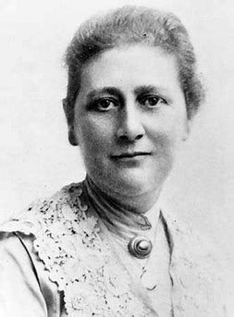 | Chris Packham-Animal Conservationist  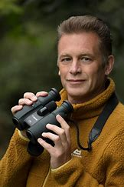 | Percy Shaw - The Cats Eye  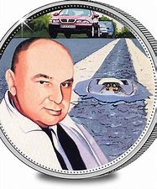 | William Addis  Toothbrush Inventor  Charles Mackintosh  (Waterproof coat)  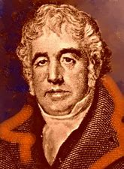  Chester Greenwood-Earmuffs  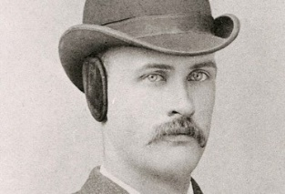 | Dr Steve Lyons  (Extreme Weather)  Holly Green  (Meteorologist)  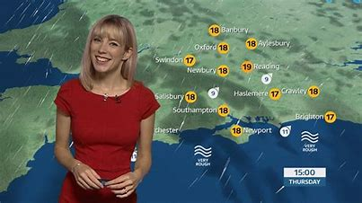
Sequencing knowledge | Prior - Reception  Begin to understand the need to respect and care for the natural environment and all living things.  .-Make observations of animals and plants through pictures, words or photographs.  Future – Year 2 plants. | Prior – Reception - Talk about members of their immediate family and community.  - Name and describe people who are familiar to them.  - Recognise some environments that are different to the one in which they live.  Future – Year 2 animals inc humans. | Prior – Year Rec  Describe what they see, hear and feel whilst outside. Daily weather conversations and comparisons from yesterday and predictions for tomorrow’s weather  Future – Year 3 light. | Prior – Reception  -Explore the natural world around them, making observations and drawing pictures.  -Describe what they see, hear and feel whilst outside.  Future – Year 2 Animals inc Humans | Prior – reception - Explore the natural world around them.  -Describe what they see, hear and feel whilst outside.  -Understand the effect of changing seasons on the natural world around them.  Future - Year 5 Earth and Space
Tier 2 and Tier 3 vocabulary | Names of locally found garden plants / wild plants / flowering plants / trees  Vegetable  Name of plants grown  Leaf / leaves  Flower  Blossom  Petal  Fruit  Berry  Names of vegetables grown  Root  Bulb  Seed  Trunk  Branch  Stem  stalk | Names of common animals – fish, birds etc.  Meat-eaters  Plant feeders  Habitat  Wild animals  Pets  Senses  Hear/hearing  See/seeing  Touch / touching  Taste/tasting  Body parts  Mouth  Head  Body  Neck  Arms  Eyebrows  Eyelashes  Legs  Elbows  Knees  Face  Eyes  Ears  Teeth Wing  Claw  Tail  Beak  Fur  Feather  Fin  Scales | Light  Dark  Shadow  Moon  Movement  Sun  Electricity | Object  Material  Wood  Plastic  Glass  Metal  Solid  Liquid  Gas  Water  Rock  Rough  smooth  Bright / shiny  Dull / dim  Absorbent  Waterproof  Wing  Claw  Tail  Beak  Fur  Feather  Fin  Scales | Season  Autumn  Winter  Spring  Summer  Weather  Names of common weather features  Days  Hours  Months  Hot  Cold
Enrichment: trips, visitors etc | Explore school grounds and WFL garden. | Possible visit from really wild show/petting zoo
Computing Links |  |  | Torches |  | I pads – photos for class book

 | Year 1 / 2 B
Theme | Plants | Animals inc Humans | Living things and habitats | Materials | Sound (non-stat)
National Curriculum | -Observe and describe how seeds and bulbs grow into mature plants  -Find out and describe how plants need water, light and a suitable temperature to grow and stay healthy. | -Notice that animals, including humans, have offspring which grow into adults - human lifecycle and butterfly  -Find out about and describe the basic needs of animals, including humans, for survival (water, food and air)  -Describe the importance for humans of exercise, eating the right amounts of different types of food, and hygiene. | -Explore and compare the differences between things that are living, dead, and things that have never been alive  -Identify that most living things live in habitats to which they are suited and describe how different habitats provide for the basic needs of different kinds of animals and  plants, and how they depend on each other  -Identify and name a variety of plants and animals in their habitats, including microhabitats  -Describe how animals obtain their food from plants and other animals, using the idea of a simple food chain, and identify and name different sources of food. | OUTDOOR  YEAR 1  -Distinguish between an object and the material from which it is made  -Identify and name a variety of everyday materials, including wood, plastic, glass,  metal, water, and rock  -Describe the simple physical properties of a variety of everyday materials  -  Compare and group together a variety of everyday materials on the basis of their  simple physical properties.  YEAR 2  -Identify and compare the suitability of a variety of everyday materials, including wood, metal, plastic, glass, brick, rock, paper and cardboard for particular uses  -Find out how the shapes of solid objects made from some materials can be changed by squashing, bending, twisting and stretching. | -Identify sources of sound  -Identify louder and softer sounds.
Specific content  Substantive knowledge | Living and non-living things  What plants need to grow  Growing from seed and bulbs | Can they describe what animals needs to survive?  Can they explain that animals grow and reproduce?  Can they describe the life cycle of some living things? Human and animal  Can they explain the basic needs of animals, including humans?  Can they describe why exercise and a balance diet are important to humans? | Habitats including micro habitats.  Early food chains  Can they match certain living things to their habitats?  Can they explain the difference between living and non living things?  Can the describe how a habitat provides the needs for a living thing?  Can they describe how plants and animals are suited to their habitats? | Can the distinguish between the object and the material from which it is made?  Can the identify and name a range of materials?  Can they describe the simple properties of the materials?  Can they compare and classify materials based on their properties?  Can they explore how shapes of solid objects can be changed (squashing, bending, twisting, stretching)?  Can they identify and compare the uses of materials? | Can they describe different ways of making sounds? (Hitting, plucking, blowing)  Do they recognise a sound is louder when they are nearer to the source?  (Link to drumming short study)
Enquiries and main focus skills  (Though all need to be taught). | Growing cress with different variables e.g. water, light, heat  Ask simple questions and recognise can be answered in different ways.  Perform simple tests  Gather and record data | Through WFL weekly sessions- butterfly farm or egg incubator to hatch chicks. Or maybe an ant farm.  Observe closely.  Gather and record data to help answer questions. | Going on a bug hunt  Make a habitat or bug hotel  Make a habitat for a tortoise  Identify and classify.  Using observations and ideas to suggest answers to questions.  Use simple features to compare | Sort and group materials according to different properties.  Testing materials to whether they are hard or soft. Trying dent or scratch materials with hammer and nails or potato mashers.  Perform simple tests using simple equipment.  Ask simple questions. | Explore musical instruments  Use observations to answer questions.  Identify and classify.
Scientists  Red – women in science  Blue – Woman from diverse background  Green – Men from diverse backgrounds | Captain Cook- Botanists  Agnes Arber Botanist  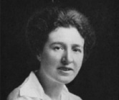  Alan Titchmarsh- Botanist & Gardener  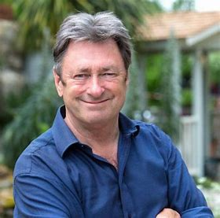 | Florence Nightingale Pioneer of modern nursing in GB  Elizabeth Garrett Anderson - First British female physician and surgeon  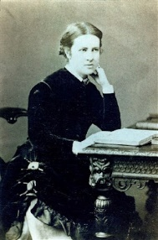  Steve Irwin -Wildlife expert  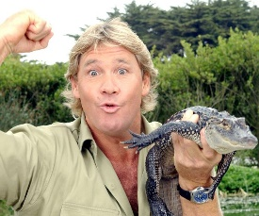  Robert Winston Human Scientist | Rachel Carson- Marine Pollution  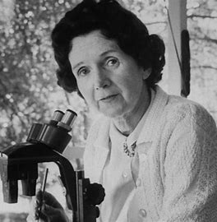  Liz Bonnin Conservationist  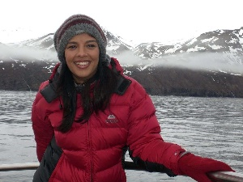  Eugenie Clark- marine biologist  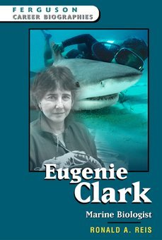 | Charles Macintosh-Waterproof material  John MacAdam- Tarmac  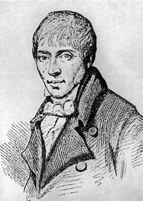 | Alexander Graham Bell -  Invented the telephone  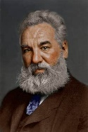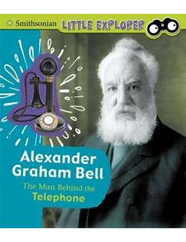  The invention of mobile phones | Science Museum  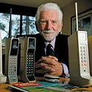  Martin Cooper 1973  Motorola.
Sequencing knowledge | Prior – Year 1 plants  -Identify and name a variety of common wild and garden plants, including deciduous and evergreen trees.  -Identify and describe the basic structure of a variety of common flowering plants, including trees.  Future – Year 3 plants. | Prior – Year 1  Animals inc humans  -Identify and name a variety of common animals  -Identify and name carnivores, herbivores and omnivores.  -Describe and compare the structure of a variety of common animals.  -Identify, name, draw and label the basic parts of the human body link senses.  Future – Year 3 animals including humans. | Prior – Year 1  Animals inc humans.  -Identify and name a variety of common animals  -Identify and name carnivores, herbivores and omnivores.  -Describe and compare the structure of a variety of common animals.  -Identify, name, draw and label the basic parts of the human body link senses  Future – Year 3  Animals inc humans and  Plants. | Prior – Year 1 materials  -Distinguish between an object and the material from which it is made. I  -Identify and name a variety of everyday materials.  -Describe the simple physical properties of a variety of everyday materials.  -Compare and group together a variety of materials.  .  Future – Year 3  Rocks | Prior – Year 1  Animals inc humans  - identify parts of body and link with senses.  Future - Year 4 sound
Tier 2 and Tier 3 vocabulary | As Yr 1 plus:  Seedling  Shoot  Fully grown  Growth  Healthy  Wither  Soil  Earth Water  Light  Hot/cold  Nutrients | As Yr 1 plus:  Adult  Young  Baby  Toddler  Child  Teenager  Grow  Offspring  Survival  Basic needs – water, food, air  Food types – name common eggs  Hygiene  Infection  Exercise  Unhealthy | Living  Alive  Non-living  Dead  Move  Grow  Feed  Breathe  Have young  Needs  Shelter  Heat  Habitats  Conditions  Characteristics  Adaptation  Food chain  Name micro-habitats – log, bush  Describes conditions – damp, dark etc  Food chain  Carnivore  Herbivore  Omnivore  Name local habitats – pond, woodland | As Yr 1 plus:  Man-made  Natural  Describe features of change – pushing / pulling  Suitable  Use / useful  Characteristics  Properties  Rigid  Flexible  Strong  Weak  Reflective  Non-reflective  Transparent  Opaque  Translucent  Shape  Changes  Brittle | Loud  Quiet  Near  Far  Hit  Pluck  Blow
Enrichment: trips, visitors etc | Explore school grounds and WFL garden. | Visit to Paignton Zoo | Paignton Zoo
Computing Links | i-pads – photos of seeds growing over time, timelaps. |  |  | Pages app – present learning. | I pads – mini video of performance/experiment.  I pads measure sound (in health app)

 | Year 3/4A
Theme | Plants | Animals inc Humans | Light and Dark | Forces and Magnetism | Rocks
National Curriculum | -identify and describe the functions of different parts of flowering plants  - explore the requirements of plants for life and growth (recap air, light, water, nutrients from soil, and room to grow from year 2) and how they vary from plant to plant.  -Can they investigate the way in which water is transported within plants?  - explore the part that flowers play in the life cycle of flowering plants, including pollination, seed formation and seed dispersal. | -Identify that animals, including humans, need the right types and amount of nutrition, and that they cannot make their own food; they get nutrition from what they eat  -Identify that humans and some other animals have skeletons and muscles for support, protection and movement | -Recognise that they need light in order to see things and that dark is the absence of  light  -Notice that light is reflected from surfaces  -Recognise that light from the sun can be dangerous and that there are ways to protect  their eyes  -Recognise that shadows are formed when the light from a light source is blocked by  an opaque object  -Find patterns in the way that the size of shadows change. | -Compare how things move on different surfaces  -Notice that some forces need contact between two objects, but magnetic forces can act at a distance  -Observe how magnets attract or repel each other and attract some materials and not  others  -Compare and group together a variety of everyday materials on the basis of whether they are attracted to a magnet, and identify some magnetic materials  -Describe magnets as having two poles  -Predict whether two magnets will attract or repel each other, depending on which  poles are facing. | -Compare and group together different rocks based on their simple physical properties.  -Understand the use of some rocks.  -Recognise that there are different types of rocks and that they are formed in different ways.  -Know how fossils are formed within sedimentary rock.
Specific content  Substantive knowledge | Can they describe the functions of the different parts of plants? Roots to collect water, stem/trunk to transport water around the plant and to support/ hold the plant up, leaves to catch sunlight to produce their food (photosynthesis) and flowers to attract insects for pollination and plant reproduction.  Can they identify what plants needs for life and growth?  Can they explain how the needs and functions of plant parts vary from plant to plant? E.g. insect and wind pollinated plants.  - investigate the way in which water is transported within plants – (Experiment with celery or chrysanthemums and food colouring in water.) | Can they explain the importance of balanced nutritious diet? What benefits does the body gain from the main food groups – Carbs, protein, vits and mins, dairy, fats.  Can they describe how nutrients, water and oxygen are transported within animals and humans? The main organs of the digestive system.  Can the describe the skeletal system of a human?  Can describe the muscular system of a human? Muscles work in pairs. | Can they explain the difference between transparent, translucent and opaque?  Do they recognise how light is reflected from surfaces?  Can they compare the brightness and colour of lights?  Can they explain how bulbs work in an electrical circuit?  Can they explain what dark is? Using words like shadow.  Can they explain why their shadow changes when the light source is moved closer or further from the object? | Can they describe the speed and direction of moving objects?  Can they explain why an object will move faster if it is moving down a hill or a slope?  Can they observe that magnetic forces can be transmitted without contact?  Can they talk about some magnets attract or repel each other?  Can they predict if the magnets will attract or repel depending on which poles are facing each other?  Can they classify which materials are attracted to magnets? Not just metal – iron (and so steel), cobalt and nickel. | Can children compare and group rocks based on their characteristics? Match rocks to their definition depending on their characteristics. Research how the rocks are formed.  Link a study of soils and rocks. Year 3 short geography study is locational weather/ water cycle and suggests a field trip to hound tor or Hallsands (the village that fell into the sea.  Comparison of soils from Devon (e.g. sandy/ red/ clay) or soils from a garden centre.  What causes soils to appear different?  Research how fossils are made.
Enquiries and main focus skill  (Though all need to be taught). | Investigate the way in which water is transported within plants e.g. using coloured dye in split stem white carnations/ celery?  EXPERIMENT – do plants need soil? Does fertilizer make a difference.  Do plants need soil to grow? | STEM  Begin to understand fair testing.  Make systematic observations using simple equipment. | identifying and grouping animals with and without skeletons and observing and comparing their movement; exploring ideas about what would happen if humans did not have skeletons.  Compare/ contrast diets (e.g. their own diet and that of a pet).  Does size of muscle matter?  Children of varying sizes hold a (not too heavy) weight with arms outstretched. Who can hold the longest? Is this always the case? Repeat – discussing fair tests. Measure and record timings. Discuss findings using ‘conclusion’ vocab.  Set up simple and practical enquiries.  Make systematic observations using simple equipment.  With prompting suggest conclusions that can be drawn from data. | Play mirror games to see how light behaves, including how mirrors reverse the image.  Look for and measure shadows as objects are moved towards/ away from a light source. This information can be plotted on a simple graph and would allow for prediction.  Make systematic observations.  Gather and record data about similarities, differences and changes.  Suggest possible improvements. | Using the ramps and then measuring the distance of the travelled car by changing the gradient/surface covering.  Explore how magnets react to each other.  Test materials around the classroom. Observe that contact is not needed for a magnetic force to occur (unlike most forces).  Find a fair way to compare the strength of a magnet. “Are bigger magnets stronger than small magnets?” “Can you make a magnet stronger by adding another magnet?”  Record findings in various ways including tables, charts and graphs.  Use standard units when taking measurements. | Explore and group rocks according to physical properties/characteristics.  Examine and observe surfaces of rocks and how they appear. IVESTIGATE rock surfaces with scratch tests to explore hardness.  Look for signs of rock erosion (e.g. headstones, stone walls – visit to Hallsands). What happens when rocks are rubbed together/ submerged?  Compare a series of types of soil/ magnifying glasses and describe structure/particle size, colour, absorbency and permeability.  Ask relevant questions when prompted.  Set up simple and practical enquiries.  Make systematic observations using simple equipment.  Set up and carry out comparative tests.  Make systematic observations using simple equipment.
Scientists  Red – women in science  Blue – Woman from diverse background  Green – Men from diverse backgrounds | Joseph Banks- Botanist  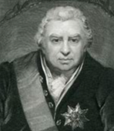  Ahmed Mumin Warfa -  Botanist  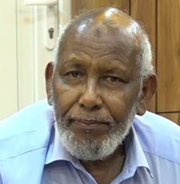  Marianne North- Botanist  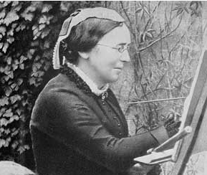 | Marie Curie- Radiation  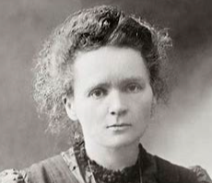  Wilhelm Rontgen - X rays  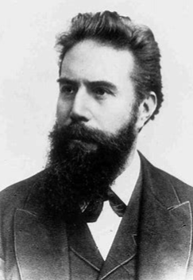  Adelle Davis -Nutritionist  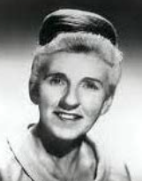 | Justus Von Liebig Mirrors  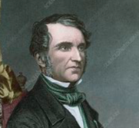  James Clerk Maxwell  (Visible and Invisible  Waves of Light)  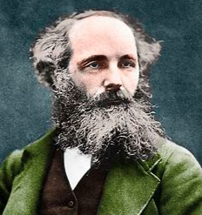 | Andre Marie Ampere-  Electro-magnetism  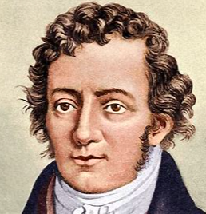  The Wright Brothers  Airplanes  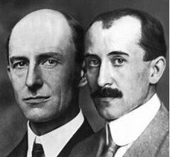  Henry Ford- Cars  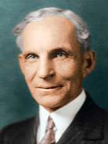 | Mary Anning- Fossil hunter  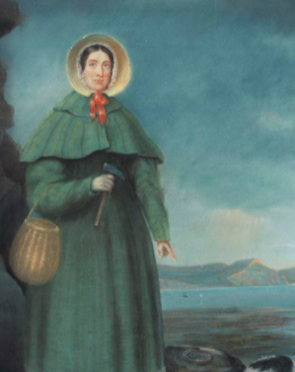  Dr Anjana Khatwa  Geologist  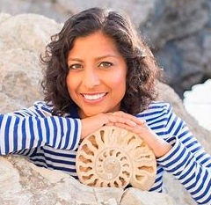  Ursula Marvin- Geologist  Inge Lehrmasn -Earth’s  Mantle  Katia Krafft - Geologist  and Volcanologist
Sequencing knowledge | Prior – Year2 plants  -Observe and describe how seeds and bulbs grow into mature plants.  -Find out and describe how plants need water, light and a suitable temperature to grow and stay healthy.  (Y2 - Living things and their habitats)  -Identify and name a variety of plants and animals in their habitats, including microhabitats.  Future – year 4 Living things and their habitats. | Prior – Year 2 Animals including humans  -Notice that animals, including humans, have offspring which grow into adults.  -Find out about and describe the basic needs of animals, including humans, for survival (water, food and air).  -Describe the importance for humans of exercise, eating the right amounts of different types of food, and hygiene.  Year 2 - Living things and their habitats.  -Describe how animals obtain their food from plants and other animals, using the idea of a simple food chain, and identify and name different sources of food.  Future –Year 4 Animals including humans. | Prior – Year . Light and Dark  - What sources of light are?  Features of day and night, including temperature.  Electricity as a source of light.  Shadows (observe and describe)  Future – Year 6 light | Prior – Year 2 materials  -Identify and compare the suitability of a variety of everyday materials for particular uses  -Find out how the shapes of solid objects made from some materials can be changed.  Future –  Year 4 States of matter  Year 5 Forces | Prior – Year 2 materials  -Identify and compare the suitability of a variety of everyday materials for particular uses.  Future –  Year 5 Earth in Space
Tier 2 and Tier 3 vocabulary | As KS1 plus:  Part  Role  Temperature  Absorb Soil  Well-drained  Fertiliser  Nutrients  Plant life cycle  Transported  Pollination  Seed formation  Seed dispersal | As KS1 plus:  Nutrition  Nutrients  Dietary fibre  Balanced diet  Carbohydrate  Protein  Vitamins  Minerals  Fat  Skeleton  Muscles  Support  Protection  Movement  Brain  Blood vessels  Heart  Skull  Ribs  Spine  Backbone  Joints  Sockets  Tendons | Light  Light source  Names of light sources, torch etc  Dark / darkness  Reflect  Reflective  Mirror  Shadow  Block / absorb  Direction of light Transparent  Opaque  Translucent  Bright  Dim  Light beam  sunlight | Force  gravity  Push / pull  Direction of force  Air resistance  streamlined  Float / sink  Friction  Force-meter  Magnet  Magnetic force  Strength  Attract  Repel  Poles  North pole  South pole  Bar magnet  Ring magnet  Button magnet  Horse-shoe  magnet  Name common magnetic and non-magnetic materials | Rock  Sedimentary  Igneous  Metamorphic  Soil  Clay  Some rock names e.g. flint, sandstone, limestone, granite.  Fossils.
Enrichment: trips, visitors etc |  |  |  | @Bristol | Locational visit, if linked to Geography short study or History unit on the Stone Age.
Computing Links | Google expeditions- plant pollination | Green screen digestive system.  https://www.curiscope.co.uk/products/virtuali-tee |  | Google expedition- magnetism  Science Museum | Google expeditions- fossils  The Natural History museum virtual tour

 | Year 3/4B
Theme | Animals inc Humans | Living things and their habitats | Electricity | Materials/ states of Matter | Sound
National Curriculum | describe the simple functions of the basic parts of the digestive system in humans  identify the different types of teeth in humans and their simple functions  construct and interpret a variety of food chains, identifying producers, predators and prey | recognise that living things can be grouped in a variety of ways  explore and use classification keys to help group, identify and name a variety of living things in their local and wider environment  recognise that environments can change and that this can sometimes pose dangers to living things | identify common appliances that run on electricity  construct a simple series electrical circuit, identifying and naming its basic parts, including cells, wires, bulbs, switches and buzzers  identify whether or not a lamp will light in a simple series circuit, based on whether or not the lamp is part of a complete loop with a battery  recognise that a switch opens and closes a circuit and associate this with whether or not a lamp lights in a simple series circuit  recognise some common conductors and insulators, and associate metals with being good conductors | compare and group materials together, according to whether they are solids, liquids or gases  observe that some materials change state when they are heated or cooled, and measure or research the temperature at which this happens in degrees Celsius (°C)  identify the part played by evaporation and condensation in the water cycle and associate the rate of evaporation with temperature | identify how sounds are made, associating some of them with something vibrating  recognise that vibrations from sounds travel through a medium to the ear  find patterns between the pitch of a sound and features of the object that produced it  find patterns between the volume of a sound and the strength of the vibrations that produced it  recognise that sounds get fainter as the distance from the sound source increases
Specific content  Substantive knowledge | Draw and label the main body parts associated with digestive system. (mouth, teeth, tongue, stomach etc.)  Describe the main function of the organs in the digestive system.  Can they identify the functions of the different human teeth?  Explain the difference between the teeth of herbivores and omnivores.  Explain simple food chains. | Use the local environment throughout the year (e.g. across the seasons) to identify common plants and animals and identify their habitats.  Group wide selections of animals and plants Using classification keys. Ensure using formal groups such as reptiles, mammal, fish, birds and amphibians that have been introduced before.  Discuss invertebrates and vertebrates.  Can they compare the classification of common plants and animals to living things found in other places? (under the sea, prehistoric)  Can the name and group a variety of living things based of feeding patterns? (Producer, consumer, predator, prey, herbivore, carnivore, omnivore (vocab introduced lightly in year 1).  Do they recognise that environments can change and this can sometimes pose a danger to living things? | Explain how electricity is useful to us.  Construct simple circuits and label parts. Convert the construction into a basic circuit diagram with labels. This may remain pictorial at this time.  Test whether materials are conductors or insulators.  Read circuit diagrams to predict and then test to identify if they will work.  Identify changes to the circuit and how this will impact e.g. increasing the number of cells.  Explain an open and closed circuit. | Pupils should explore a variety of everyday materials and develop simple descriptions of the states of matter (solids hold their shape; liquids form a pool not a pile; gases escape from an unsealed container).  Pupils should observe water as a solid, a liquid and a gas and should note the changes to water when it is heated or cooled.  Can they explain what happens to materials when they are heated or cooled?  Can they measure the temperature that different materials change state? E.g. chocolate.  Can they explain the part that evaporation and condensation play in the water cycle. | Can they see and explain how sound is created (using drums/ rice, observing guitar strings making rubber band guitar.)  Can they identify patterns in how sound is produced (volume and pitch) for instance by vibrating rulers on the desk.  Can they see how sound is fainter from a distance and also how long sound takes to travel (e.g. a child hits a drum across the playground and they see the action before hearing the sound)  Can they explain how to change a sound, louder or softer?  Can they describe and explain how a sound travels from a source to our ears?
Enquiries and main focus skill  (Though all need to be taught). | Compare types of teeth from different animals using images. (Paignton zoo have a collection if visiting their education centre).  Investigate the function of teeth using variety of tools to represent teeth, e.g. knife to cut like incisors, old pencil/fork handle to pierce and tear as canines and cube/brick for molar (to mash).  Investigate how teeth can be damages (using eff shells and variety of liquids) and write about good dental health.  Set up simple and practical enquiries  Recording findings using simple scientific language, drawings, labelled diagrams, keys, bar charts, and tables, displays or presentations. | Explore the school grounds and use different classification keys to identify plants.  Make a simple guide to classification.  Create simple guides to preferred animals and their habitats, or a guide to a habitat (e.g. Antarctic)  Observe animals closely in their habitat and investigate preferred habitats e.g. Do woodlice choose a dark or light place in a tank?  Gathering, recording, classifying and presenting data in a variety of ways to help in answering questions  Identifying differences, similarities or changes related to simple scientific ideas and processes  Report findings from enquiries, including oral and written explanations of results and conclusions. | Investigate circuits with switches. How does a switch work?  Investigate materials that will or will not conduct and common features of these.  Test circuits built from diagrams – predicting if they will work, then explain findings.  Asking relevant questions and using different types of scientific enquiries to answer them, making some decisions about the enquiry.  Record findings using simple scientific language, drawings, diagrams, keys, bar charts and tables.  Use results to draw simple conclusions, make predictions for new values, suggest improvements and raise further questions. | Grouping and classifying different materials according to state of matter.  Investigate different boiling/ melting points. (e.g. chocolate/ butter): making rice crispy cakes and explaining the state changes.  Observe and record the speed of evapourating (e.g. in a petri dish or in a playground) and discuss how this process would be slowed down of sped up.  Cloud in a bottle to show water cycle.  Perform simple tests using simple equipment.  Sort and group materials according to different properties.  Take accurate measurements using standard units, where appropriate  Making systematic and careful observations and, where appropriate, taking accurate measurements using standard units, using a range of equipment, including thermometers and data loggers. | Explore musical instruments observing how they make a sound.  Investigate how the sound changes in a series of similar objects (e.g. bottles of water, thick elastic bands) and explain why the changes occur.  Design the best ear defenders/ make ear muffs: test what materials are best suited to dampening sound.  Use observations to answer questions.  Use evidence to support their findings.  Setting up simple practical enquiries, comparative and fair tests  Using results to draw simple conclusions, make predictions for new values, suggest improvements and raise further questions
Scientists  Red – women in science  Blue – Woman from diverse background  Green – Men from diverse backgrounds | Joseph Lister-Antiseptic  Ivan Pavlov- Digestive System Mechanisms  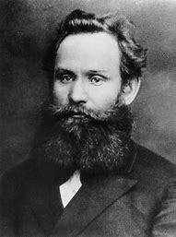  Dr Washington Sheffield- Toothpaste in a tube  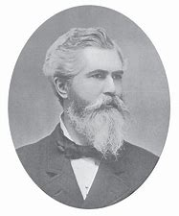 | Jacques Cousteau -Marine Biology  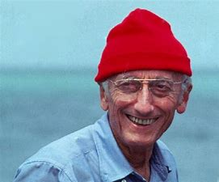  Cindy Looy-Environmental Change and Extinction  Joean Beauchamp Procter Zoologist  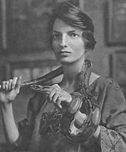 | Michael Faraday- Discovered relationship between magnets and electricity  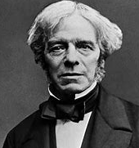  Thomas Edison- Lightbulb  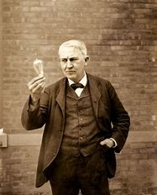  Joseph Swan- Incandescent Light Bulb  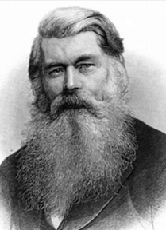 | Joseph Priestly – Discovered oxygen  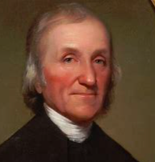  Lord Kelvin -Absolute zero (temperature)  Anders Celsius -Temperature Scale  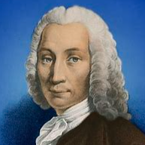  Daniel Fahrenheit-Temperature Scale / Invention of the Thermometer  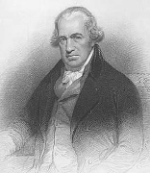 | Alexander Graham Bell -Invented the telephone  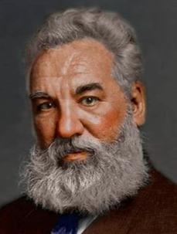  Aristotle - Sound Waves  Gailileo Galilei - Frequency and Pitch of Sound Waves  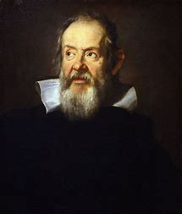
Sequencing knowledge | Prior – Year 2,3  Animals inc humans  Yr2  -Notice that animals, including humans, have offspring which grow into adults.  -Find out about and describe the basic needs of animals, including humans, for survival (water, food and air).  -Describe the importance for humans of exercise, eating the right amounts of different types of food, and hygiene.  Yr3  -Identify that animals, including humans, need the right types and amount of nutrition, and that they cannot make their own food; they get nutrition from what they eat.  -Identify that humans and some other animals have skeletons and muscles for support, protection and movement.  Future – Year 5 animals including humans. | Prior – Year 2,  Living things in their habitats  -Explore and compare the differences between things that are living, dead, and things that have never been alive  -Identify that most living things live in habitats to which they are suited and describe how different habitats provide for the basic needs of different kinds of animals and  plants, and how they depend on each other  -Identify and name a variety of plants and animals in their habitats, including microhabitats  -Describe how animals obtain their food from plants and other animals, using the idea of a simple food chain, and identify and name different sources of food.  Future – Year 5 Living things and their habitats. | Prior – Nursery  – explore how things work.  Future – Year 6 Electricity. | Prior – Year 1 and 2 materials  YR1  -Distinguish between an object and the material from which it is made. I  -Identify and name a variety of everyday materials.  -Describe the simple physical properties of a variety of everyday materials.  -Compare and group together a variety of materials.  YR2  -Identify and compare the suitability of a variety of everyday materials for particular uses  -Find out how the shapes of solid objects made from some materials can be changed.  Year 3 Rocks  -Compare and group together different kinds of rocks on the basis of their appearance and simple physical properties.  -Describe in simple terms how fossils are formed when things that have lived are trapped within rock.  Year 3 Forces and magnets  -Compare and group together a variety of everyday materials on the basis of whether they are attracted to a magnet, and identify some magnetic materials.  Future –Year 5 Properties and changes in materials. | Prior – Year 2 Sound (as a non-statutory unit)  -Identify sources of sound  -Identify louder and softer sounds.  Future – Year 6 Light
Tier 2 and Tier 3 vocabulary | Digestive system  digestion  Saliva  Oesophagus  Stomach  Small intestine  Large intestine  Absorb into blood stream  Swallowing  Chewing  Rectum  Anus  Faeces  Consumer  Predator  Prey  Producers  Canines  Incisors  Pre-molars  Molars  Cavities  Dentine  Plaque  Pulp-cavity  Fluoride  Tooth decay  Gums  Nerves  Enamel | As KS 1 plus  Classification keys  Environment  Fish  Reptiles  Amphibians  Mammals  Birds  Vertebrates  Invertebrates  Human impact  Plant groups (trees, grasses, flowering and non-flowering plants)  Shelter  Heat  Habitats  Conditions  Characteristics  Adaptation  Food chain  Name micro-habitats – log, bush  Describes conditions – damp, dark etc  Food chain  Carnivore  Herbivore  Omnivore  Name local habitats – pond, woodland  reptiles, mammal, fish, birds and amphibians.  invertebrates and vertebrates.  Flowering and non-flowering.  Grasses  Pollution/ deforestation | Electricity  Electrical device / appliances  Mains  Plug  Components  Conductor  Insulator Circuit symbol  Cell  Battery  Wire  Bulb  Switch  Buzzer  Motor  Connection  Electrical / simple circuit  Complete circuit  Closed circuit  Open circuit  Positive  Negative  Crocodile clip | As KS1 plus:  Air  Oxygen  Powder  Grain / granular  Changes state  Gaseous  Particles  Water vapour  Water cycle  Heating /cooling  Degree Celsius  Melt  Freeze  Boil  Evaporation  Condensation  Energy transfer  Describe features of change – pushing / pulling  Suitable  Use / useful  Characteristics  Properties  Solid, liquid, gas  Heating and cooling  Melting, burning evapourating and freezing. | Sound  Sound source  Noise  Vibrate / vibration  Travel  Sound wave  Pitch  Volume  Loud / quiet  Tune  High / low  Echo  Tuning fork  Insulation  Instrument  Percussion  String  Brass  Woodwind  Tunes instrument  Near  Far  Hit  Pluck  Blow
Enrichment: trips, visitors etc |  | Visit to Paignton Zoo | Paignton Zoo education centre  Wild for learning garden  Local woods/beach | Visiting a bakery – Occombe Farm
Computing Links |  |  |  | Pages app – present learning. | I pads – mini video of performance/experiment.  I pads measure sound (in health app)

 | Year 5/6A
Theme | Forces | Animals inc Humans | Living things and their habitats | Properties and changes of materials | Earth and Space
National Curriculum | explain that unsupported objects fall towards the Earth because of the force of gravity acting between the Earth and the falling object  identify the effects of air resistance, water resistance and friction, that act between moving surfaces  recognise that some mechanisms including levers, pulleys and gears allow a smaller force to have a greater effect | describe the changes as humans develop to old age (including puberty). | describe the differences in the life cycles of a mammal, an amphibian, an insect and a bird  describe the life process of reproduction in some plants and animals | compare and group together everyday materials on the basis of their properties, including their hardness, solubility, transparency, conductivity (electrical and thermal), and response to magnets  know that some materials will dissolve in liquid to form a solution, and describe how to recover a substance from a solution  use knowledge of solids, liquids and gases to decide how mixtures might be separated, including through filtering, sieving and evaporating  demonstrate that dissolving, mixing and changes of state are reversible changes  explain that some changes result in the formation of new materials, and that this kind of change is not usually reversible, including changes associated with burning and the action of acid on bicarbonate of soda | describe the movement of the Earth and other planets relative to the sun in the solar system  describe the movement of the moon relative to the Earth  describe the sun, Earth and moon as approximately spherical bodies  use the idea of the Earth’s rotation to explain day and night and the apparent movement of the sun across the sky
Specific content  Substantive knowledge | Explore falling objects/ and look how air resistance impacts on this.  Experience with forces that slow objects down or speed them up (water resistance, friction)  Observe the forces needed to stop an object (e.g. brakes on a bike)  Possible DT link with forces/ levers (mechanisms and mechanical systems) | Pupils should draw a timeline to indicate stages in the growth and development of humans.  They should learn about the changes experienced in puberty.  It may be possible to look at the seven ages of man speech by Jaques (As you like it). Is Shakespeare right? Would we have the same groups? | Use the outside space/ garden of the class to observe changes across time.  Find out about different types of reproduction.  Examine the reproduction on plants (should be revisited from Year 3) | systematic understanding of materials by exploring and comparing the properties of a broad range of materials, including relating these to what they learnt about magnetism in year 3 and about electricity in year 4.  They should explore reversible changes, including evaporating, filtering, sieving, melting and dissolving, recognising that melting and dissolving are different processes.  Can they explain the process of dissolving?  Can they recover a substance from a solution?  Can they decide how a mixture would best be separated?  Pupils should explore changes that are difficult to reverse, for example, burning, rusting and other reactions, for example, vinegar with bicarbonate of soda. | Pupils should be introduced to a model of the sun and Earth that enables them to explain day and night.  Pupils should learn that the sun is a star at the centre of our solar system and that it has 8 planets: Mercury, Venus, Earth, Mars, Jupiter, Saturn, Uranus and Neptune (Pluto was reclassified as a ‘dwarf planet’ in 2006). They should understand that a moon is a celestial body that orbits a planet (Earth has 1 moon; Jupiter has 4 large moons and numerous smaller ones).  Can they identify and explain the movement of the Earth relative to the Sun?  Pupils should find out about the way that ideas about the solar system have developed, understanding how the geocentric model of the solar system gave way to the heliocentric model.
Enquiries and main focus skill  (Though all need to be taught). | Explore falling paper cones or cupcake cases, and design and make a variety of parachutes. Carry out fair tests to determine which designs are the most effective.  They might explore resistance in water by making and testing boats of different shapes.  They might design and make products that use levers, pulleys, gears and/or springs and explore their effects on force and motion. (DT LINK)  Planning different types of scientific enquiries to answer questions, including recognising and controlling variables where necessary  Take precise measurements using standard units.  Record data and results.  Identifying scientific evidence that has been used to support or refute ideas – with prompting, identify not all results are trustworthy. | Research gestation periods on animals and also how long young take to mature to adult hood, compared with humans.  Reporting and presenting findings from enquiries, including conclusions, causal relationships and explanations of and degree of trust in results, in oral and written forms such as displays and other presentations | Observing and comparing the life cycles of plants and animals in their local environment with other plants and animals around the world (in the rainforest, in the oceans, in desert areas and in prehistoric times), asking pertinent questions and suggesting reasons for similarities and differences.  They might try to grow new plants from different parts of the parent plant, for example, seeds, stem and root cuttings, tubers, bulbs.  The school may also have chickens to discuss reproduction.  Can they explore the work of well known naturalists such as David Attenborough and Jane Goodall?  Flower dissection. (lilies are best, daffodils ok)  Recording data and results of increasing complexity using scientific diagrams and labels, classification keys, tables, scatter graphs, bar and line graphs. | carrying out tests to answer questions, for example, ‘Which materials would be the most effective for making a warm jacket, for wrapping ice cream to stop it melting, or for making blackout curtains?’  Observe and compare the changes that take place, for example, when burning different materials or baking bread or cakes. Can they use the terms reversible and irreversible?  They might research and discuss how chemical changes have an impact on our lives, for example, cooking, and discuss the creative use of new materials such as polymers, super-sticky and super-thin materials.  Investigate how to separate mixtures including solutions.  give reasons, based on evidence from comparative and fair tests, for the particular uses of everyday materials, including metals, wood and plastic  Using test results to make predictions to set up further comparative and fair tests  Taking measurements, using a range of scientific equipment, with increasing accuracy and precision, taking repeat readings when appropriate | comparing the time of day at different places on the Earth through internet links and direct communication;  creating simple models of the solar system; constructing simple shadow clocks and sundials, calibrated to show midday and the start and end of the school day;  finding out why some people think that structures such as Stonehenge might have been used as astronomical clocks.
Scientists  Red – women in science  Blue – Woman from diverse background  Green – Men from diverse backgrounds | Isaac Newton- Gravity  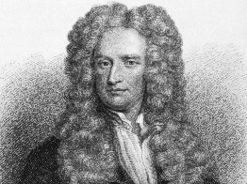  Albert Einstein- The Theory Of relativity  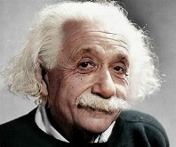  Galileo Galilei - Gravity and Acceleration  Archimedes of Syracuse- Levers | Research scientists working in old age e.g. Alzheimer’s or early life such as premature babies.  Louis Pasteur- Vaccination  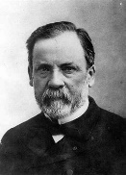  Alexander Fleming- Penicillin  Eva Crane -Reproduction in Bees  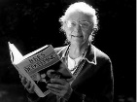 | David Attenborough  Jane Goodall.  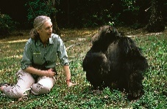  Mangala Mani – Antarctic scientist  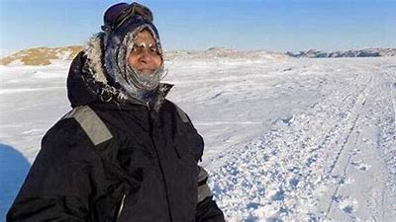 | how chemists create new materials, for example, Spencer Silver and Arthur Fry, who invented the glue for sticky notes  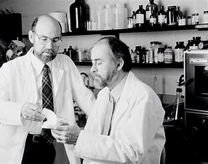  Jamie Garcia (BP website)- Invention of a new plastic  Ruth Benerito, who invented wrinkle-free cotton. | considering the work of scientists such as Ptolemy, Alhazen and Copernicus Heliocentric vs Geocentric Universe.  Margaret Hamilton- Computer scientist (Moon Landings)  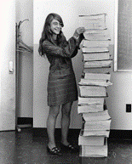  Stephen Hawking- Black Holes  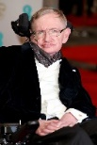  Mae Jemison – Astronaut  Neil Armstrong- First man on the Moon  Helen Sharman- GB astronaut  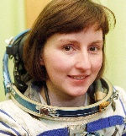  Caroline Herschel- First to find a comet
Sequencing knowledge | Prior: Year 3 forces and magnetism  Future: Year 6 Electricity  POS KS3: Electricity and electromagnetism.  POS KS3 Forces and Motion | Prior: Year 4 Living things and their habitats.  Year 4 animals including humans  Future:  Year 5 Living things and their habitats.  Year 6 Animals including humans . | Prior: Year 4 Living things and their habitats.  also previous Y5 unit Animals, including humans  Future: Year 6 Living things and their habitats | Prior: Year 4 States of Matter  Future: Chemistry is not part of Y6 POS. In KS3 changes of state are examined in terms of the particle model. | Prior: previous earth science unit (rocks Y3, Seasons Y1) and also Light (Y3)  Future: Light Y6. Earth science in not part of Y6 POS, but Space Physics is part of KS3 studies.
Tier 2 and Tier 3 vocabulary | Mechanisms  Air resistance  Water resistance  Levers  Pulleys  Gears  Springs  Drag forces  Transference of force and motion | Human stages of life cycle.  Language associated with puberty (RSE policy also)  Reproduction  Sexual  Asexual  Birth  Fertilisation  Menstrual cycle  Puberty  Eggs  Live young  Egg Cell  Embryo  Ovary  Placenta  Penis  Testes  Vagina  Uterus | reproduction  asexual reproduction in plants, and sexual reproduction in animals.  Major vocabulary around sexual parts.  Anther, stamen, stigma, petal.  Sexual  Asexual  Germination  Pollination/ pollen/ egg cell  Fertilisation  Menstrual cycle  Puberty  Seed dispersal  Seed formation  Stamen  Stigma  Anther  Filament  Style  Sepal  Carpel  Insect | Evaporating  filtering,  melting  reversible and irreversible changes.  Solubility  Electrical conductivity  Thermal conductivity  New material  Buoyancy  suspension  Dissolve  Solution  Soluble  Insoluble  Solute  Solvent  Burning  Rusting  Gas given off Mixture  Filtering  Sieving | Planets  Solar system  Celestial body  Sphere / spherical  Rotation/ revolve  Spin  Phases of moon  Axis / axes  Mercury  Mars  Neptune  Venus  Jupiter  Saturn  Pluto  Uranus  Time zones  Orbit  Elliptical orbit  Shadow clocks  Sundials  Asteroids/ Comets/ Meteors  Galaxy  Light years
Enrichment: trips, visitors etc |  |  |  |  | Planetarium visit
Computing Links | Google expedition- forces |  |  |  | SkyView lite app – shows constellations

 | Year 5/6B
Theme | Electricity | Animals inc Humans | Living things and habitats | Evolution and inheritance | Light
National Curriculum | -Associate the brightness of a lamp or the volume of a buzzer with the number and voltage of cells used in the circuit.  -Compare and give reasons for variations in how components function, including the brightness of bulbs, the loudness of buzzers and the on/off position of switches.  -Use recognised symbols when representing a simple circuit in a diagram. | identify and name the main parts of the human circulatory system, and describe the functions of the heart, blood vessels and blood  recognise the impact of diet, exercise, drugs and lifestyle on the way their bodies function  describe the ways in which nutrients and water are transported within animals, including humans | describe how living things are classified into broad groups according to common observable characteristics and based on similarities and differences, including micro-organisms, plants and animals  Give reasons for classifying plants and animals based on specific characteristics | recognise that living things have changed over time and that fossils provide information about living things that inhabited the Earth millions of years ago  recognise that living things produce offspring of the same kind, but normally offspring vary and are not identical to their parents  identify how animals and plants are adapted to suit their environment in different ways and that adaptation may lead to evolution | -Recognise that light appears to travel in straight lines.  -Use the idea that light travels in straight lines to explain that objects are seen because they give out or reflect light into the eye.  -Explain that we see things because light travels from light sources to our eyes or from light sources to objects and then to our eyes.  -Use the idea that light travels in straight lines to explain why shadows have the same shape as the objects that cast them.
Specific content  Substantive knowledge | Can they identify and name the basic parts of a simple electric series circuit? (cells, wires, bulbs, switches, buzzers)  Can they compare and give reasons for variation in how components function, including bulb brightness, buzzer volume and on/off position of switches?  Can they explain how to make an electrical circuit?  Can they explain the impact of changes in a circuit?  Can they explain the effect of changing the voltage of a battery? | Can they identify and explain the function of the organs of the human circulatory system? (heart, blood vessels, blood, blood pressure, clotting).  Can they identify and explain the functions of the human gaseous exchange system?  Lungs, nose, throat, bronchi, bronchial tubes, diaphragm, ribs, breathing).  Can they name the major human organs?  Can they make a diagram that outlines the main parts of a body?  Research and discuss the effects of drugs and substances on the human body. | Build on learning from year 4 about classification using more detail. Inc micro-organisms, invertebrates and vertebrates. | Building on fossils from Yr3 rocks –  Can they give reasons for why living things produce offspring of the same kind? Can they give reasons why offspring are not identical to each other or with their parents? Look at characteristics of breeds of dogs. What happens if poodles are bred with Labradors?  Can they begin to appreciate that variation in offspring over time can make animals more or less able to survive in particular environments?  Can they explain the process of evolution and describe the evidence for this?  Can they talk about the work and life of Charles Darwin? | Can they explain how light travels?  Can they explain how the human eye sees objects?  Can they explain how different Colours of light can be created?  Can they use and explain how simple optical instruments work? (periscope, telescope, binoculars, mirror, magnifying glass, Newton’s first reflecting telescope)  Can they explain changes linked to light (and sound)?
Enquiries and main focus skill  (Though all need to be taught). | Investigate brightness of bulb/loudness of a buzzer with different numbers of cells in the circuit.  Investigate effect of thickness and length of wires on bulbs and buzzers.  Plan different types of scientific enquiries to answer questions.  Recognise and control variables where necessary.  Report and  presents findings from enquiries in oral and written forms such as displays and other presentation. | Do some interval workouts and monitor each other’s heart rate and breathing rate. Measure and record systematically. Discuss fair testing.  Take measurements with increasing accuracy and precision.  Take repeat readings when appropriate.  Record data and results of increasing complexity using scientific diagrams and labels, classification keys, tables and bar charts. | Use classification systems and keys to identify animals and plants to build on learning from year 4. Should include both vertebrates and invertebrates. Should be able to explain why animals belong to one group and not another.  Can they explore the work of Carl Linnaeus – Pioneer of classification?  Explore helpful and harmful micro-organisms mould investigation with bread in plastic bags.  Identify scientific evidence that has been used to support or refute ideas or arguments.  Reporting and presenting findings from enquiries, including conclusions, causal relationships and explanations of and degree of trust in results, in oral and written forms such as displays and other presentations | Identify scientific evidence that has been used to support or refute ideas or arguments. | Can you make a beam of light travel around a corner to hit a target? (mirrors)  Design and build a periscope using the idea that light travels in a straight line.  They could extend their experience of light by looking a range of phenomena including rainbows, light through prisms, colours on soap bubbles, objects looking bent in water and coloured filters (they do not need to explain why these phenomena occur)  Identifying scientific evidence that has been used to support or refute ideas or arguments.  Report and presents findings from enquiries in oral and written forms such as displays and other presentation.
Scientists  Red – women in science  Blue – Woman from diverse background  Green – Men from diverse backgrounds | Nikola Telsa -AC electric system  Alessandro Volta- Electrical Battery  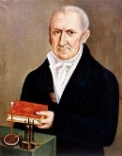  Nicola Tesla- Alternating Currents  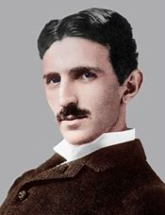  Edith Clarke -Electrical engineer  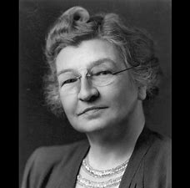 | Leonardo Da Vinci- anatomy  Santorio Santorio-Anatomist  Dr. Katherine Dibb – Expert in Cardiovascular Sciences  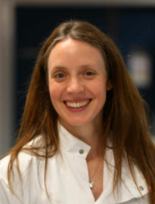  Justus von Liebig- Theories of Nutrition and Metabolism  Sir Richard Doll- Linking Smoking and Health Problems  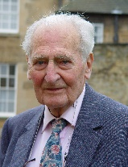 | Carl Linnaeus Classification  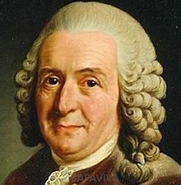  Libby Hyman Classification  Invertebrates | Hippocrates -The Father of Medicine  Charles Darwin- Evolution  Alfred Russell Wallace – naturalist  Rosalind Franklin – DNA  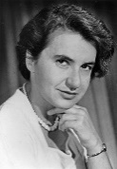  Nettie Stevens – Geneticist  Professor Alice Roberts - Evolutionary biologist  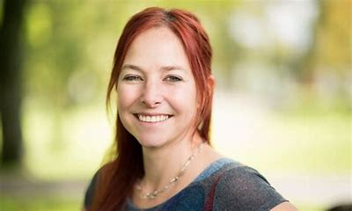 | Thomas Edison -Invented electric light bulb  Patricia Bath (BP website)- saving sight  Thomas Young  (Wave Theory of Light)  Ibn al-Haytham -Light and our Eyes  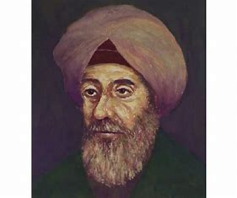  Maria Telkes- Solar energy  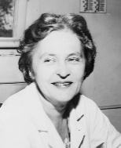
Sequencing knowledge | Prior: Electricity Y4.  Future: POS KS3: Electricity and electromagnetism  DT LINK – moving models/toys | Prior: animals including humans Y5.  Future POS KS3 biology | Prior: Living things and their habitats Y4 and Y5)  Future POS KS3 relationships in an ecosystem | Prior: Rock Y3 (fossils) animals including humans Y5.  Future POS KS3 Genetics and evolution | Prior: Light Year 3  Future : POS KS3 light waves
Tier 2 and Tier 3 vocabulary | As year 4 plus:  Series circuit  Terminal  Voltage  Volume  Current  Resistance  Circuit diagrams | Circulatory system  Blood vessels  Capillaries  Arteries  Veins  Red blood cells  White blood cells  Oxygen  Carbon dioxide  Lungs  Air sacs  Ventricles  Aorta  Wind pipe  Diaphragm  Bronchi  Pulmonary vein / artery  Lifestyle  Drugs  Diet  Heart rate  Clotting  Plasma | As Y4 and Y5 plus:  Evolution  Adaptation  Genes  DNA  Chromosomes  Evolutionary change  Features  Inherit  Inheritance  Environmental conditions  Fossil records  Natural selection  Variation  Reproduction  Competition  Environmental variations  Survival of the fittest | Evolution  Adaptation  Genes  DNA  Chromosomes  Evolutionary change  Features  Inherit  Inheritance  Environmental conditions  Fossil records  Natural selection  Variation  Reproduction  Competition  Environmental variations  Survival of the fittest | Absorption  Transmission  Lenses  Optics  Prism  Rainbow  Refraction  spectrum
Enrichment: trips, visitors etc
Computing Links |  | https://www.curiscope.co.uk/ products/virtuali-tee  As used in year 3 digestion but for other organs, skeletons etc. |  | Natural History Museum- virtual tour  Google expeditions- human cultural evolution  Evolution: Natural selection

