The Primary PE and Sport Premium

Planning, reporting and evaluating website tool

;

"• . ,.
•
Updated November 2025

Commissioned by

Department for Education

Created by
,.,,

e• e YOUTH
P
W .

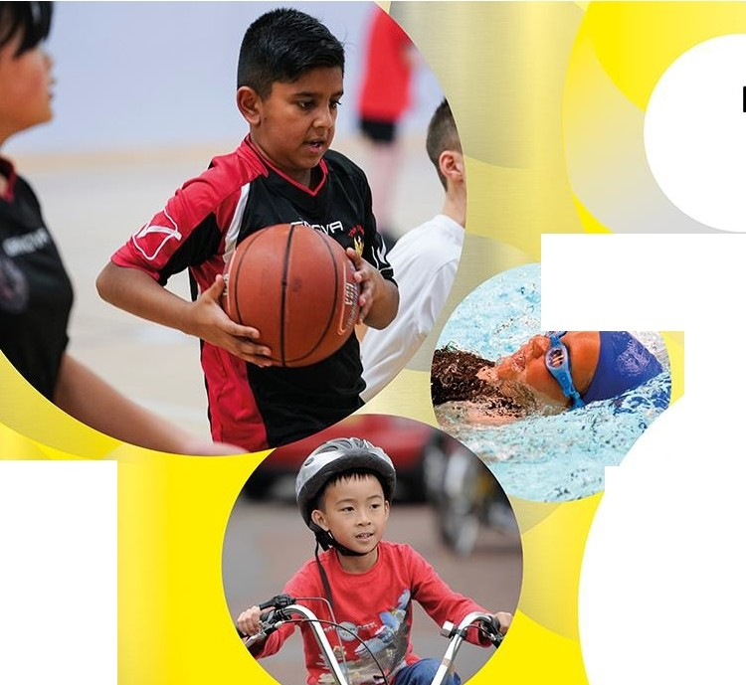
Physical
Education

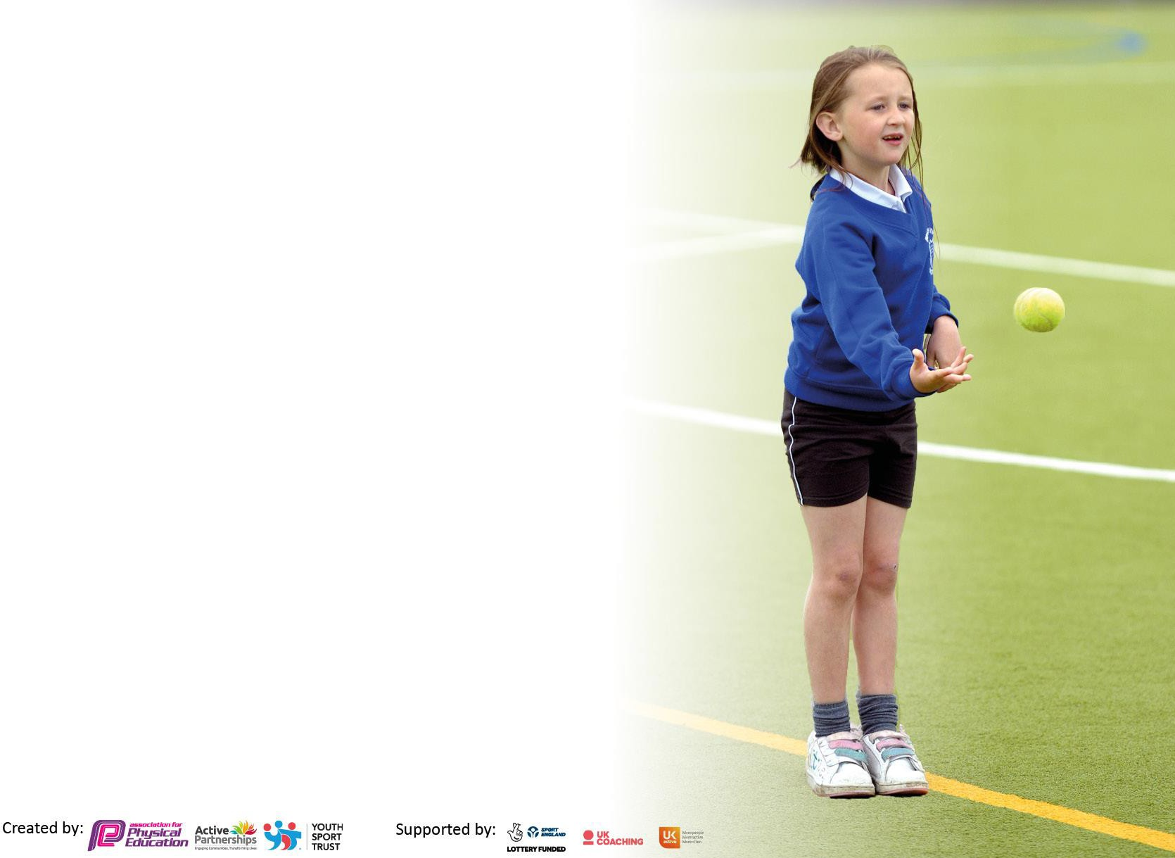
It is important that your grant is used effectively and based on school need. The Education Inspection Framework makes clear there will be a focus on ‘whether leaders and those responsible for governors all understand their respective roles and perform these in a way that enhances the effectiveness of the school’.

Under the Quality of Education judgement, Ofsted inspectors consider:
Intent - Curriculum design, coverage and appropriateness
Implementation - Curriculum delivery, teaching (pedagogy) and assessment
Impact - Attainment and progress

To assist schools with common transferable language, this template has been developed to utilise the same three headings which should make your plans easily transferable between working documents.

Schools must use the funding to make additional and sustainable improvements to the quality of Physical Education, School Sport and Physical Activity (PESSPA) they offer. This means that you should use the Primary PE and sport premium to:

- Develop or add to the PESSPA activities that your school already offers
- Build capacity and capability within the school to ensure that improvements made now will benefit pupils joining the school in future years
- The Primary PE and sport premium should not be used to fund capital spend projects; the school’s
budget should fund these.

Please visit https://www.gov.uk/guidance/pe-and-sport-premium-for-primary-schools for the revised DfE guidance, including the 5 key indicators across which schools should demonstrate an improvement. This document will help you to review your provision and to report your spend. DfE encourages schools to use this template as an effective way of meeting the reporting requirements of the Primary PE and Sport Premium.
We recommend you start by reflecting on the impact of current provision and reviewing the previous spend. Schools are required to publish details of how they spend this funding, including any underspend from 2023/2024,
as well as on the impact it has on pupils’ PE and sport participation and attainment.

We recommend regularly updating the table and publishing it on your website throughout the year. This evidences your ongoing self-evaluation of how you are using the funding to secure maximum, sustainable impact. Final copy must be posted on your website by the end of the academic year and no later than the 31 July 2024.

Details with regard to funding
Please complete the table below.

Total amount carried over from 2023/24 | £0
Total amount allocated for 2024/25 | £19,330
How much (if any) do you intend to carry over from this total fund into 2024/25? | £0
Total amount allocated for 2024/25 | £19,330
Total amount of funding for 2024/25 to be reported on by 31st July 2025 | £19,330
Swimming Data
Please report on your Swimming Data below.

Meeting national curriculum requirements for swimming and water safety.

N.B. Complete this section as best you can. For example, you might have practised safe self-rescue techniques on dry land which you can then transfer to the pool when school swimming restarts.
Due to exceptional circumstances priority should be given to ensuring that pupils can perform safe self-rescue even if they do not fully meet the first two requirements of the NC programme of study
What percentage of your current Year 6 cohort swim competently, confidently and proficiently over a distance of at least 25 metres?  N.B. Even though your pupils may swim in another year, please report on their attainment on leaving primary school at the end of the summer term 2024.  Please see note above | 85%
What percentage of your current Year 6 cohort use a range of strokes effectively [for example, front crawl, backstroke and breaststroke]?  Please see note above | 75%
What percentage of your current Year 6 cohort perform safe self-rescue in different water-based situations? | 70%
Schools can choose to use the Primary PE and sport premium to provide additional provision for swimming, but this must be for activity over and above the national curriculum requirements. Have you used it in this way? | Yes

Action Plan and Budget Tracking
Capture your intended annual spend against the 5 key indicators. Clarify the success criteria and evidence of impact that you intend to measure to evaluate for pupils today and for the future.

Academic Year: 2025/26 | Total fund allocated: £19 330 | Date Updated: September 2025
Key indicator 1: Increase confidence, knowledge and skills of all staff in teaching PE and sport |  |  |  | Percentage of total allocation:
 |  |  |  | 43%
Intent | Implementation |  | Impact
Your school focus should be clear on what you want the pupils to know and be able to do. What do they need to learn and to consolidate  through practice: | Make sure your actions to achieve are linked to your intentions: | Funding allocated: | Evidence of impact:  What do pupils now know and what can they now do? What has changed? | Sustainability and suggested next steps:
To ensure all teaching staff are confident, knowledgeable, and skilled in delivering high-quality PE and sport lessons. This will promote active participation, improve pupil outcomes in physical education, and foster a whole-school ethos of physical wellbeing and enjoyment of sport. | -CPD (Continuing Professional Development) Programme:  Schedule half-termly PE-focused training sessions delivered by PE specialists or external providers.  Topics: Warm-ups, progression of key skills, inclusive practices, assessing PE, using equipment safely.  -Team-Teaching & Coaching:  Partner less confident staff with specialist coaches or experienced teachers for team-teaching sessions.  Observation and feedback model to support skill development.  - PE Lead Support:  PE subject leader to carry out learning walks, offer drop-in support, and create a PE staff toolkit | £2,900 | Increased staff confidence in delivering varied and engaging PE lessons (measured via staff confidence surveys pre- and post-CPD).  Improved quality and consistency of PE provision across year groups.  Greater pupil enjoyment and participation in PE and school sport.  Evidence of progression in pupils’ physical skills and understanding of health and fitness.  A sustainable improvement in staff capacity to deliver PE independently.
Balance ability  Bike ability | All children develop confidence to balance on a bike in EYFS.  All children to ride to a competent level in preparation for secondary school. | No cost as covered by local council | There will be more children prepared to ride a bike due to being successful on a balance bike in EYFS.  There will be an increase in number of pupils riding bikes safely as an active leisure pursuit or travelling to and from school. | Children ready to ride a bike.  Children are more able and confident to ride a bike safely on the road for year 5.

Key indicator 2: The engagement of all pupils in regular physical activity – Chief Medical Officers’ guidelines recommend that  primary school pupils undertake at least 30 minutes of physical activity a day in school |  |  |  | Percentage of total allocation:
 |  |  |  | 19%
Intent | Implementation |  | Impact
Your school focus should be clear on what you want the pupils to know and be able to do. What do they need to learn and to consolidate  through practice: | Make sure your actions to achieve are linked to your intentions: | Funding allocated: | Evidence of impact:  What do pupils now know and what can they now do? What has changed? | Sustainability and suggested next steps:
Increase activity levels during lunchtimes. | The school benefits from a range of durable mobile playground equipment which can be used across the site and therefore accessible to different age ranges and year groups. An up-to-date review for safety purposes is required and we will need to maintain a staggered lunch to best facilitate the use of this equipment. | £1700 (as required) | Activity levels during lunchtimes to be monitored by MDAs/PE Coordinators. Behavior monitored via the usual school reporting channels. Staggered lunch enables safer play for our pupils, thus lowering the number of accidents and incidents due to a wider space to play on. | Continued investment in durable playground  equipment and its upkeep will ensure a longevity of the equipment. The equipment range will increase physical exertion by the pupils as they will want to be physical thus increasing respiratory rates and muscle growth.

Increase daily levels of activities. | Continued delivery of the Daily Mile activities in the playground by all classes. The playground marking already exists for this but sessions will need to be timetabled and the use of additional staffing to ensure safety. | £500 | Daily Mile activities increases physical activities as the children are more active through specified timetable slots. | Providing positive experiences will instill a love of physical activity and engagement thus encouraging a life-long participation and enjoyment of physical activity.
All children able to competently swim 25 metres by Year 6. | Book top-up sessions for any children that do not meet the minimum required during their curriculum swim (in Y3 and Y4). Additional sessions for children in Upper Key Stage 2 as necessary. | £1,155 | Assessment data to be provided by swimming centre. PE coordinator to identify any children for top-up sessions – book sessions and transport. | By using the funding to provide top-up sessions for children, we hope to ensure that every child can swim at least 25 metres by the end of Year 6. This is particularly important considering we are a coastal school and community.
Replenish PE equipment (indoor and outdoor) to accompany the Get Set for PE scheme. | Purchase additional, highly durable equipment. | £6000 |  | Through well-equipped PE lessons, all pupils are able to actively and confidently engage in physical learning.

Key indicator 3: The profile of PE and sport is raised across the school as a tool for whole school improvement |  |  | Percentage of total allocation:
Intent | Implementation | Impact

Your school focus should be clear on what you want the pupils to know and be able to do. What do they  need to learn and to consolidate through practice: | Make sure your actions to achieve are linked to your intentions: | Funding allocated: | Evidence of impact:  What do pupils now know and what can they now do? What has changed? | Sustainability and suggested next steps:
Provide leadership opportunities for pupils across the subject, promoting pupils as role models and identifying successes within their own daily lives. | Develop Sports Leaders across the school in line with new house teams to relaunch this approach of working together for a common goal.  Play Leaders utilized to aid with the younger pupils in the school | £830 (resources  / staff allocation) | PE Coordinator to track participation in the leadership of pupils. | By continually involving the citizenship council, children become trained in supporting their peers.  By utilizing pupils that struggle behaviourally but are seen to have caring and positive role model impact on younger pupils, these pupils will feel a sense of achievement and want to improve.

Access to a broad/ balanced curriculum with high-quality delivery; competitions; opportunities. | Release PE lead to be able to provide training, create development and complete PE admin that allows the organisation of sports festivals/ competitions and also monitors the quality of provision/ teaching. | £2500 | Pupils receive a quality curriculum, with the chance to compete, develop lifelong skills and a love of physical activity, and can trial sports they would not normally encounter. | Having sufficient time to complete all duties necessary to the PE Coordinator role will ensure that every child has access to the best curriculum/ appropriate competition/ leadership opportunities/ further opportunities to be active and healthy.
Positively impact on high quality teaching and learning in PE. All pupils receive daily exercise and at least 2 hours of high quality PE a week. Improve activity levels and develop fundamental movement skills through the delivery of high quality PE lessons. | Renew get Set for PE package.  Embed the package into the curriculum. Use PE leader time to support staff and engage children and parents at home for get set for PE home activities. | £585 |  | Teachers are upskilled in teaching and learning in specific PE units of work as required.

Key indicator 4: Broader experience of a range of sports and physical activities offered to all pupils |  |  |  | Percentage of total allocation:
 |  |  |  | 10%
Intent | Implementation |  | Impact
Your school focus should be clear on what you want the pupils to know and be able to do. What do they need to learn and to consolidate  through practice: | Make sure your actions to achieve are linked to your intentions: | Funding allocated: | Evidence of impact:  What do pupils now know and what can they now do? What has changed? | Sustainability and suggested next steps:
Increase the number of children being exposed to a range of sports activities. | Supporting specialist sports coaches to deliver extra-curricular clubs. In addition, offer extra sports sessions for children during enrichment activities that may include gym, dance, multisport, skipping etc. | £1400 (for resources) | Club enrichment register to be maintained so the take up remains measured and less active children could be targeted if desired. | Employing specialist coaches will ensure that we can diversify our offer to engage as many children as possible.  Providing alternative/positive experiences will encourage children to be lifelong participants.

Increase range of experiences to disadvantaged and SEN children during the school summer breaks through the use of external providers. | Made available through partnership working and external LA grants for hire of hall space.  Work in partnership with relevant bodies and ensure they seek appropriate funding for the hall hire in summer term. | Achieved through further grants. | Pupils will have had opportunities to experience a wider range of sports and activities otherwise not normally available to them. This will enhance life experiences. | Maintain in future through appropriate grants and explore options of activities on offer based on feedback.

Key indicator 5: Increased participation in competitive sport |  |  | Percentage of total allocation:
 |  |  | 11%
Intent | Implementation | Impact

Your school focus should be clear on what you want the pupils to know and be able to do. What do they  need to learn and to consolidate through practice: | Make sure your actions to achieve are linked to your intentions: | Funding allocated: | Evidence of impact:  What do pupils now know and what can they now do? What has changed? | Sustainability and suggested next steps:
Increase the number of children involved in appropriate competition. | Work closely with other schools in the Connect Academy Trust to develop a program of competition (Connect Games), in the Torbay area schools and Plymouth schools. Invest in trophies and cover transport cost. | £500 | Coordinator to monitor participation. Meetings held with PE Coordinators termly. Pupils understand competitive sports, good sportsmanship and see the application of teamwork. | Working closely with our trust schools will mean that we are able to offer a sustainable route for competition for children of all ages and abilities.
Increased participation in competitive sport/ sports day funding. | The provision of equipment, allowing annual sports day to be provided in an off-site location, including safeguarding facilities that are necessary for this opportunity to be delivered at the request of the off-school site.  P.E. lead to liaise with local sporting organizations and ensure sign up to competitive events (football) in local area) | £1000 | Sports day will take place over 2 days as it has previously in an off- site location. This model has been highly successful in the past, increasing attendance and participation whilst maintaining the safety of the children from the supporting school/site. Pupils will be better equipped to handle competition including demonstrating good sportsmanship, understanding gracious winning and how to cope with losing.  Pupils will develop teamwork  skills and understand strategic gameplay. | Maintenance over the coming years will enable sustainability. Broaden sports beyond football if there is the ability and uptake in the local community.

Contribution to the running of the minibus. | In order to attend sports’ festivals, and also, festivals created by the school as part of the curriculum as well as taking teams to play competitive sports outside of school hours. The figure allows for these events to also be staffed, enhancing the  experience for children. | £500 (nominal) | The school has adjusted the provision of the minibus and now is an equal shareholder in access to a shared Torbay bus. It is used particularly to support residential outdoor experiences and off-site PE opportunities and so reduce the burden of cost on parents. | In running the minibus, we will be able to continue to widen the opportunities to our pupils.

Signed off by
Head Teacher: | Adele Clayton
Date: | 25/09/25
P.E. Coordinator | Paul Dixon and Chelsea Rowe
Date: | 25/09/25

