Why some children need
Wellbeing support?

Many children experience difficult times at school. These may include:
*Finding it difficult to manage strong feelings
*Not knowing whom they can turn to at school for support when their feelings are too big to manage.
*Finding it hard to settle in the classroom.
*Difficulties with friendships/social situations.
*Finding break times difficult.

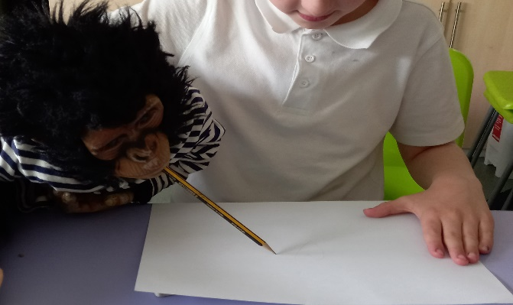

These things can lead to many different feelings, which may seem overwhelming at times. They may include anger, frustration, sadness, anxiety, confusion or loneliness.

All of these feelings are very normal and happen to many children. Our wellbeing team are here to help children learn how to manage their emotions and teach strategies that will help them feel more settled, calm and ready to learn at school.

What do the Wellbeing Team offer?
We work together to help children with their emotional and social development.
We offer practical support after we have identified children’s emotional and social individual needs.
Research has shown that how we behave is linked to how we feel, and our emotions are key to how we learn. By teaching children to recognise and notice their feelings and emotions can help their development and learning. Children sometimes need some extra support with their emotional development; this can be temporary or over a longer period.
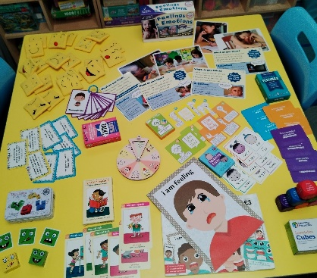

Our team builds positive relationships with children that enables effective working. We ensure all children feel safe, valued, and belong. We use different tools, like Morning Sensory Circuits and Lunch Club making children feel safe and giving them a place to come to settle and calm.

Pastoral Care
Wellbeing Interventions

The sessions may be as a one-to-one session, or within a small group of children with similar needs. We use several interventions chosen individually to meet the child’s personal needs, across KS1 and KS2. Some of the interventions we use are listed below.
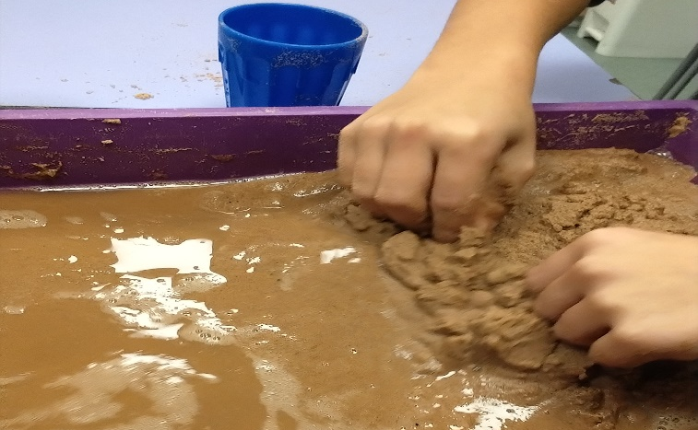

*One to One/Group Wellbeing Check Ins. *Draw & Talk Therapy sessions. *One to One ELSA Intervention. *Sand Tray Therapy sessions. *Lego Therapy sessions. *Puppet work. *Relaxation and guided meditation. *One to One and Group Play Work. *Anger management Work. *Bereavement Support.

Our Wellbeing Team’s vision
Across KS1 and KS2 we help children develop emotionally, to recognise and distinguish their feelings appropriately. To provide support for children who are experiencing emotional, social or behavioural difficulties, in a safe and calm environment with an adult they can build a trusting relationship with, to help develop these skills. We enable children to take pride in their achievements and enhance their self-esteem. Through managing their feelings and develop skills to enjoy and participate in school life, using positive approaches to manage all behaviours. We are also here to support our parents and carers, offering drop-in sessions.

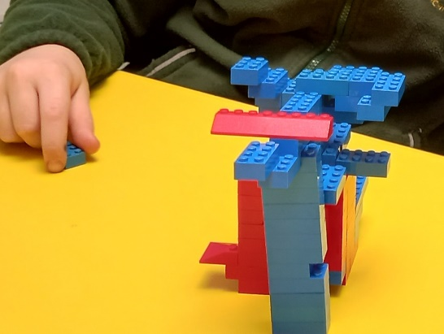

More Information
Our team is made of highly dedicated and experienced individuals who are committed to providing the best education and support for all our children and families.
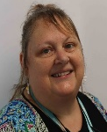
Mrs Ali Black MRS DEE BAOUYAMOURN
WELLBEING Support WELLBEING SUPPORT
ablack@eppsa.org.uk dbouyamourn@eppsa.org.uk

mrs jade bolton mrs leah perkEs
WELLBEING support WELLBEING support

jbolton@eppsa.org.uk lperkes@eppsa.org.uk



MRS CARROL STEPHENS
WELLBEING SUPPORT/DDSL
cstephens@eppsa.org.uk

We are always here to support if you any questions or concerns please don’t hesitate to use our drop-in sessions or contact us by via email or phone, and we will get back to you as soon as possible.

Tel: 01803 854011

Our Wellbeing Team

Promoting Emotional Wellbeing and Social Skills



“Our goal is for each child to be happy, confident, and ready for the day in a safe, secure, caring, and happy place”.

