Eden Park Primary and Nursery School



Online Safety Policy
This policy applies to all members of the school community (including staff, learners, volunteers, parents and carers, visitors, community users) who have access to and are users of school digital systems, both in and out of the school. It also applies to the use of personal digital technology on the school site (where allowed).

1. Scope
This policy applies to all members of the Eden Park community, including staff, pupils, volunteers, parents/carers, governors, visitors, and external providers who access the school’s digital systems, both on and off-site. It also includes the use of personal devices on school premises, where permitted.

2. Aims
• To protect and educate pupils and staff in their use of technology.
• To establish clear expectations for acceptable use of technology.
• To provide guidance for handling online safety incidents.
• To embed online safety throughout the curriculum and staff training.

3. Roles and Responsibilities
Headteacher & Senior Leadership Team
• Ensure a culture of safeguarding that includes online safety.
• Support the DSL and Online Safety Lead in implementing the policy.
• Ensure staff receive relevant training.
Designated Safeguarding Lead (DSL)
• Lead responsibility for online safety.
• Maintain training and understanding of risks and reporting routes.
• Liaise with external agencies where appropriate.
Online Safety Lead (Computing Lead)
• Coordinate the delivery and teaching of Online Safety.
• Support curriculum development and staff CPD.
Governors
• Approve and monitor the Online Safety Policy.
• Appoint a link governor for online safety.
• Ensure that filtering, monitoring, and staff training are in place.
IT Service Provider
• Ensure technical systems are secure and compliant.
• Support the school in implementing filtering, monitoring, and reporting tools.
Teaching & Support Staff
• Model safe and responsible online behaviour.
• Deliver the planned online safety curriculum.
• Report online safety concerns immediately.
Pupils
• Understand and follow the school’s Acceptable Use Agreement.
• Report concerns or incidents to a trusted adult.
Parents/Carers
• Support the school’s online safety practices.
• Reinforce safe online behaviours at home.
Community Users
• Follow the school’s Acceptable Use Agreement when accessing systems.

4. Online Safety Curriculum
Eden Park delivers a progressive, age-appropriate online safety curriculum, computing lessons, and enrichment opportunities such as Safer Internet Day.
Learning objectives cover:
• Safe use of the internet
• Digital citizenship and wellbeing
• Cyberbullying and online relationships
• Reporting and seeking help

5. Acceptable Use Agreements (AUAs)
The school has age-specific AUAs for:
• Staff and volunteers
• Parents/carers
• Visitors and contractors (via Inventry)
These are reviewed annually and signed at the start of each academic year.

6. Filtering and Monitoring
• Filtering and monitoring systems meet DfE standards.
• Alerts and logs are reviewed regularly by the DSL and IT provider.
• Any breaches trigger safeguarding procedures.

7. Managing Incidents
• Incidents are logged and handled by the DSL in line with safeguarding procedures.
• Illegal or serious concerns are reported to police or external agencies.
• A flowchart guides staff through reporting and response steps.
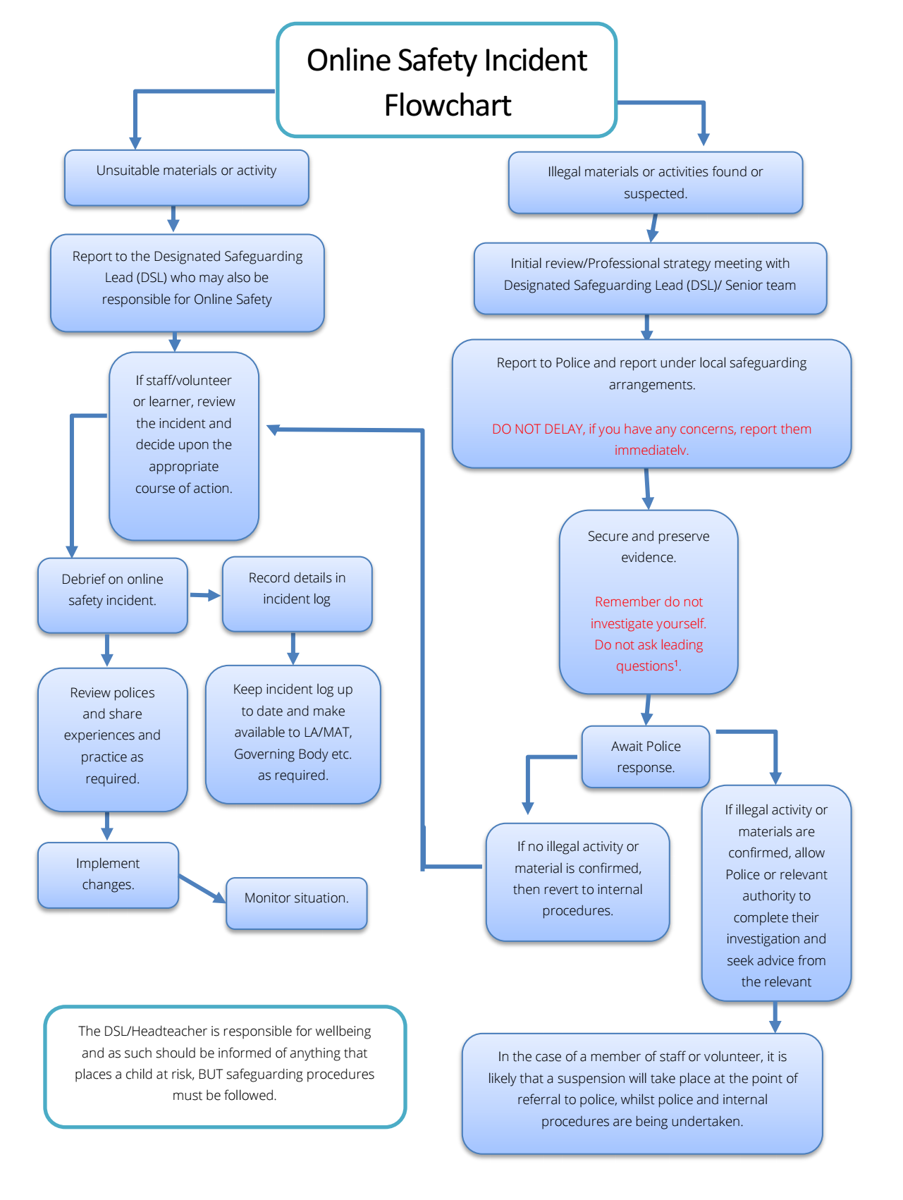

8. Social Media
Staff and pupils are expected to:
• Maintain professional boundaries online.
• Avoid referring to pupils or colleagues on personal accounts.
• Use official school accounts for communication.
The school actively monitors and responds to online commentary affecting its reputation.

9. Data Protection and Digital Media
• Data is handled in line with GDPR and the school’s Data Protection Policy.
• Consent is obtained for images and videos.
• Devices are protected with passwords and encryption.

10. Training and Awareness
• All staff receive annual training on online safety and cyber security.
• Governors receive awareness training with regular updates.
• Families are engaged through newsletters, workshops, and digital platforms.

11. Monitoring and Evaluation
• Termly reporting to governors on incidents, training, and developments.
• Annual policy review and audit.
• Pupil and parent surveys inform future actions.

12. Personal Devices
We do not allow children to use personal devices in school, unless part of an agreement with the SENDCo to meet a particular need (e.g. blood sugar tracker). All children bring phones are expected to hand the phone into a lock box at the start of the day.
Adult Personal devices need to remain in a locked cupboard and should not be used in the presence of children. Personal devices should not be carried, unless with the express permission of the Headteacher for special circumstances.
Under no circumstances should employees use their personal equipment to take images of pupils. If this is required, Employees should seek permission from the senior leadership team in special circumstances.
Employees will need to check that consent has been obtained from the relevant parents before publishing images of any pupils.

13. Artificial Intelligence (AI)
The use of AI is growing rapidly in education and wider society. Eden Park recognises both the opportunities and risks AI can present and will ensure our community is equipped to use it safely, responsibly, and ethically.

Pupils will be taught age-appropriate awareness of AI, including how to recognise AI-generated content, understand its limitations, and avoid misuse.
Staff will model responsible use of AI and ensure it supports, rather than replaces, learning and teaching.
AI tools will not be used to process, store, or generate pupil data without the approval of the Headteacher and in line with Data Protection legislation.
Pupils must not use AI tools to create or share harmful, misleading, or inappropriate content. Any such misuse will be treated as a safeguarding matter.
The school will review emerging guidance on AI in education and update training, curriculum content, and policy accordingly.
Parents and carers will be supported to understand AI and how to help children engage with it safely at home.

14. Pupil Mobile Phones
Eden Park Primary and Nursery School recognises that some pupils, particularly those in Years 5 and 6, may need access to a mobile phone when travelling to and from school independently. However, mobile phones can present a distraction to learning and may create safeguarding, privacy and online safety risks. Our priority is to maintain a safe, focused and distraction-free learning environment for every child.

Who may bring a mobile phone?
- Children in EYFS, Year 1, Year 2, Year 3 and Year 4 are not permitted to bring a mobile phone onto the school site.
- Children must be dropped off and collected by an adult in accordance with the school's arrangements.
- Pupils in Years 5 and 6 may bring a mobile phone to school only where they:
  - walk to or from school independently; and
  - have parental consent to bring a phone to school.
- Parents/carers must complete the school's parental consent form before a pupil brings a mobile phone onto the school site.

Mobile phone expectations
Where a Year 5 or Year 6 pupil is permitted to bring a mobile phone:
- The phone must be switched off completely before the pupil enters the school site.
- On arrival, the phone must be handed in/stored securely in the designated classroom storage area for the duration of the school day.
- Pupils must not access, use or check their phone during the school day.
- Phones must remain switched off and securely stored until the pupil has left the school gates.
- Pupils must not use a mobile phone anywhere on the school site, including the playground, school field or during clubs and activities.
- The school and Connect Academy Trust cannot accept responsibility for the loss of, theft of or damage to any mobile phone brought onto the school premises.

Online safety and misuse
Mobile phones must not be used to:
- access the internet or social media during the school day;
- take photographs or videos of pupils, staff or visitors;
- make or receive calls or messages;
- record or share audio or video;
- access or share inappropriate, harmful or offensive content;
- bully, harass or intimidate another member of the school community; or
- undertake any other activity that breaches the school's Behaviour Policy, Acceptable Use Policy or Online Safety Policy.
Unauthorised possession or use of a mobile phone will be treated as a breach of the school's Behaviour Policy.

Consequences of misuse
The school will respond consistently to breaches of the mobile phone expectations:
First breach
- The phone will be confiscated and securely stored until the end of the school day.
- Parents/carers will be notified.
Second breach
- The phone will be confiscated and returned directly to a parent/carer.
- A meeting with the class teacher will take place to discuss the incident and expectations.
Repeated breaches
- Permission for the pupil to bring a mobile phone to school may be withdrawn.
- Further sanctions may be applied in accordance with the school's Behaviour Policy.
Any misuse involving safeguarding concerns, inappropriate images, online bullying, threats, harassment or other potentially harmful or unlawful activity will be dealt with in accordance with the school's safeguarding and online safety procedures.

Exceptions
In exceptional personal or medical circumstances, the Headteacher may grant permission for a pupil to have access to a mobile phone or to make alternative arrangements.
Requests for an exception must be made in writing by the parent/carer. Where permission is granted, a bespoke plan will be agreed with the school setting out when and how the device may be used.

Working with parents and pupils
The school will ensure that pupils understand the reasons for these expectations and the importance of responsible mobile phone use. Parents and carers are asked to support the school by discussing these expectations with their child and ensuring that any phone brought to school is switched off and handed in/stored as required.
These arrangements form part of the school's wider approach to online safety, safeguarding, behaviour and pupil wellbeing, helping to ensure that pupils can learn safely and without unnecessary digital distraction.

Appendix
Please see Policies • Connect Academy Trust for our Social Media Policy, Data Protection Policy and Safeguarding Policy

