LKS2 Art and Design |  |  | Drawing – Portraiture | Textiles – Weaving | Painting – Acrylic | Sculpture – Clay
Painting  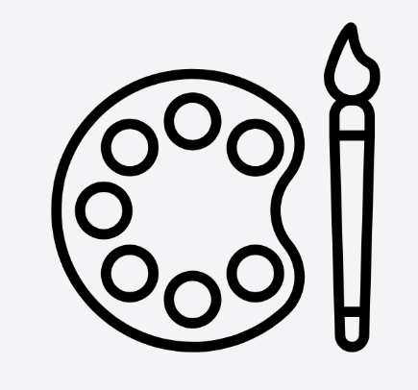 | Substantive | - To refine their use of brushes and tools to apply paint with increasing precision, experimenting with thickness, layering, and direction of strokes to create texture, pattern, and detail.
 | Substantive | - To learn to mix primary and secondary colours to create a wider palette, including tints and shades, and begin to understand how colour can convey mood, atmosphere, and contrast within a composition.
 | Substantive | - To analyse and discuss the work of a range of artists, focusing on painting styles and techniques, and use this understanding to inform and influence their own creative choices.
 | Substantive | - To plan and produce paintings with growing independence, considering elements such as foreground/background, proportion, and balance, to communicate ideas, observations, or narratives effectively.
 | Disciplinary | - I can make informed choices about brush types, tools, and paint application methods, explaining the intended effect and effectiveness.
 | Disciplinary | - I can systematically test, refine, and record colour mixes (including tints, tones, and shades), using this knowledge deliberately to achieve specific visual outcomes.
 | Disciplinary | - I can use subject-specific vocabulary to critique artists’ work, identifying techniques, stylistic features, and intentions, and explaining how these can be adapted or combined within my own practice.
 | Disciplinary | - I can regularly review my work against clear intentions, making thoughtful adaptations to composition, technique, and colour, and providing reasoned feedback on my own and others’ paintings.
Sketching   | Substantive | - To learn how different types of line (e.g. light, bold, continuous, broken) and shapes can be used to represent objects, structure forms, and add detail within observational and imaginative sketches.
 | Substantive | - To explore how light and dark can be created using sketching techniques such as hatching, cross-hatching, and blending, understanding how tone can suggest depth, shadow, and three-dimensional form.
 | Substantive | - To understand the purpose of sketchbooks as a place to record observations, test ideas, practise techniques, and develop concepts over time rather than just producing finished pieces.
 | Substantive | - To investigate how artists use sketching to plan, observe, and communicate ideas, recognising different styles and approaches and how these link to purpose and subject matter.
 | Disciplinary | - I can choose and apply a range of sketching techniques (e.g. varied line, shape construction, mark-making) with increasing control, explaining how these choices help to represent form and detail effectively.
 | Disciplinary | - I can experiment with and refine shading methods (e.g. hatching, cross-hatching, blending), using them deliberately to create depth, contrast, and three-dimensional effects in my drawings.
 | Disciplinary | - I can use subject-specific vocabulary to examine how artists use sketching for observation and idea development, identifying key techniques and adapting these thoughtfully within my own work.
 | Disciplinary | - I can use sketchbooks purposefully to revisit and refine ideas, reviewing my work against intentions, making iterative improvements, and giving reasoned feedback on my own and others’ sketches.
Sculpture  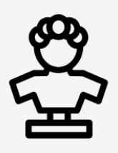 | Substantive | - To learn how sculpture occupies space, recognising how forms can be constructed, combined, and manipulated to create three-dimensional artworks.
 | Substantive | - To develop knowledge of a range of sculptural materials (e.g. clay, wire, recycled materials), understanding their properties and how these affect how they can be shaped, joined, and finished.
 | Substantive | - To understand key processes such as modelling, carving, joining, and constructing, and how these are used to create structure and detail in sculpture.
 | Substantive | - To investigate how artists use sculpture to represent ideas, forms, and meanings, recognising different styles, scales, and purposes in sculptural work.
 | Disciplinary | - I can choose appropriate materials and techniques (e.g. shaping, joining, building) with increasing control, explaining how my choices support the intended form and stability of my work.
 | Disciplinary | - I can develop control when handling materials, refining techniques such as smoothing, cutting, bending, and joining to achieve more accurate and detailed outcomes.
 | Disciplinary | - I can use subject-specific vocabulary to discuss how sculptors work with materials, form, and space, and apply these insights to inform my own creative decisions.
 | Disciplinary | - I can review and adapt my sculptures during the making process, considering structure, balance, and appearance, and provide reasoned feedback on my own and others’ work.
Mixed Media  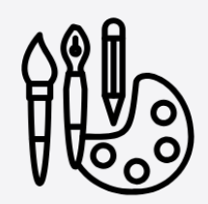 | Substantive | - To learn that mixed media involves combining different materials (e.g. fabric, paper, thread, found objects) and understand how these can be layered and arranged to create varied visual and tactile effects.
 | Substantive | - To develop knowledge of different fabrics and fibres, recognising their textures, flexibility, and suitability for cutting, joining, and decorating.
 | Substantive | - To understand basic techniques such as cutting, stitching, weaving, and attaching, and how these processes can be used to construct and embellish textile pieces.
 | Substantive | - To investigate how artists and designers use combined materials and textile techniques to create meaning, pattern, and texture in their work.
 | Disciplinary | - I can make informed choices about materials and combinations, explaining how layering, texture, and composition support my intended outcome.
 | Disciplinary | - I can practise and refine skills such as cutting, joining, and simple stitching, demonstrating improving accuracy and independence in constructing my work.
 | Disciplinary | - I can use subject-specific vocabulary to evaluate how artists and designers combine materials and techniques and apply these ideas within my own creations.
 | Disciplinary | - I can review my work throughout the process, making adjustments to materials, techniques, and composition, and providing reasoned feedback on my own and others’ pieces.
By the end of LKS2, children should be able to:
- Complete an art portfolio of work, a collection of their strongest outcomes from their art curriculum.
- Learnt to draw portraits with a degree of accuracy.
- Learnt to draw scenes with a degree of technical accuracy, including using perspective.
- Been able to be creative and imaginative with the range of skills that they have learnt.
- Have a sound understanding of some of the works of a wide range of famous artists, including what the artist was trying to achieve.
- Learnt to paint in a range of media including water colours and acrylic, as well as be able to use complimentary colours to enhance their work.
- Used 3D materials for a range of models and artistic pieces. This will have included the use of clay, wire and textiles.
- Used an iPad to manipulate and create digital images.
- Advance their use of stiches and sewing techniques, supported by the DT curriculum.

