KS1 Art and Design |  |  | Painting (Kandinsky) | Observational Sketching | Sculpture | Painting Collage
Painting  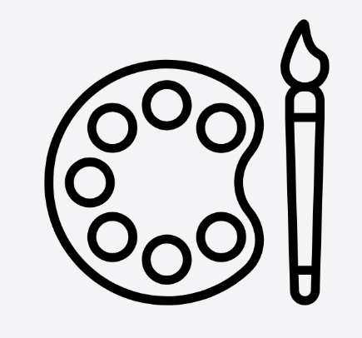 | Substantive | - To use drawing, painting and sculpture to develop and share their ideas, experiences and imagination.
 | Substantive | - To develop a wide range of art and design techniques in using colour, pattern, texture, line, shape, form and space.
 | Substantive | - To learn about the work of a range of artists, craft makers and designers, describing the differences and similarities between different practices and disciplines, and making links to their own work.
 | Disciplinary | - I know how to use different brushes and amounts of water change the effect of paint.
 | Disciplinary | - I know how to hold the paintbrush close to the tip for control and detail; and hold the paintbrush further towards the end for loose mark making.
 | Disciplinary | - I can name primary and secondary colours and how to make the secondary colours by mixing paint.
 | Disciplinary | - I know how to look closely at an artist’s work, talk about how it is made and understand the artistic choices made.
Sketching   | Substantive | - To use drawing, painting and sculpture to develop and share their ideas, experiences and imagination
 | Substantive | - To develop a wide range of art and design techniques in using colour, pattern, texture, line, shape, form and space
 | Substantive | - To learn about the work of a range of artists, craft makers and designers, describing the differences and similarities between different practices and disciplines, and making links to their own work.
 | Disciplinary | - I have begun to apply different tones (dark, mid and light) by utilising a change in pressure.
 | Disciplinary | - I can sketch more fluidly and expressively when using a grip suitable for purpose.
 | Disciplinary | - I can hold the pencil further towards the end for loose sketching.
 | Disciplinary | - I know how to look closely at an artist’s work, talk about how it is made and understand the artistic choices made.
Sculpture  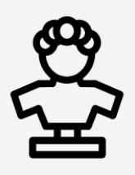 | Substantive | - To use a range of materials creatively to design and make products
 | Substantive | - To use drawing, painting and sculpture to develop and share their ideas, experiences and imagination
 | Substantive | - To learn about the work of a range of artists, craft makers and designers, describing the differences and similarities between different practices and disciplines, and making links to their own work.
 | Disciplinary | - I know how to use techniques such as rolling, cutting, moulding and carving.
 | Disciplinary | - I know how to include lines and texture.
 | Disciplinary | - I know how to use a combination of shapes.
 | Disciplinary | - I know how to look closely at an artist’s work, talk about how it is made and understand the artistic choices made.
Mixed Media  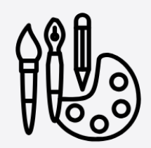 | Substantive | - To use a range of materials creatively to design and make products
 | Substantive | - To develop a wide range of art and design techniques in using colour, pattern, texture, line, shape, form and space
 | Substantive | - To learn about the work of a range of artists, craft makers and designers, describing the differences and similarities between different practices and disciplines, and making links to their own work.
 | Disciplinary | - I know how to use a combination of materials that are cut, torn and glued with increasing awareness of pattern and design.
 | Disciplinary | - I know how to sort and arrange materials with increasing awareness of pattern and design.
 | Disciplinary | - I know how to mix materials to create pattern.
 | Disciplinary | - I know how to look closely at an artist’s work, talk about how it is made and understand the artistic choices made.
By the end of KS1, children should be able to:
- Begin to compile an art portfolio that includes a selection of their strongest work from across the curriculum.
- Observe landscapes and their immediate surroundings with increasing attention to detail and realism.
- Explore and discuss the work of a range of well-known artists, including identifying what the artist was trying to achieve and how they worked.
- Create paintings inspired by the style and techniques of studied artists.
- Design and make simple sculptures using a variety of materials.

