UKS2 Art and Design |  |  | Sculpture – Eva Hesse | Painting – Watercolour | Drawing – Frank Lloyd Wright | Mixed media – Printing
Painting  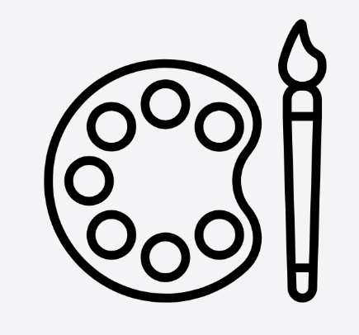 | Substantive | - To know how the amount of water used affects the transparency, strength and flow of watercolour paint, and artists control this to create different effects.
 | Substantive | - To understand how watercolour techniques, such as wet-on-wet, wet-on-dry, layering (glazing), lifting and dry brush, each create distinctive textures and finishes, and artists choose between them for different purposes.
 | Substantive | - To recognise that watercolour paintings are usually planned by working from light to dark because lighter areas are difficult to paint over once darker colours have been added.
 | Substantive | - To know that watercolour artists use colour, composition and controlled techniques to create atmosphere, depth and focus, and that their choices are influenced by their style, subject matter and artistic intentions.
 | Disciplinary | - I can independently select, combine, and refine brush types, tools, and painting techniques, justifying my choices in relation to texture, composition, and intended visual impact, and evaluating their effectiveness as I work.
 | Disciplinary | - I can confidently manipulate colour, systematically mixing and adjusting tints, tones, and shades, and applying more complex colour relationships to achieve precise, controlled, and expressive outcomes.
 | Disciplinary | - I can critically analyse and compare artists’ work using subject-specific vocabulary, explaining how techniques, styles, and intentions are used, and thoughtfully adapting and combining these within my own practice.
 | Disciplinary | - I can independently reflect on, evaluate, and refine my work throughout the process, making purposeful and justified adjustments to composition, technique, and colour, and providing constructive, reasoned critique of my own and others’ paintings.
Sketching   | Substantive | - To recognise that artists use drawing as a way to observe, explore, develop and communicate ideas before creating a final piece, and that sketches do not always need to be finished artworks.
 | Substantive | - To understand that the position of a light source affects where highlights, mid-tones, core shadows, reflected light and cast shadows appear, helping artists create realistic three-dimensional forms.
 | Substantive | - To understand that perspective, proportion and scale help create the illusion of space and realism, and that artists choose whether to follow or deliberately distort these depending on their artistic intention.
 | Substantive | - To recognise how drawing styles have changed throughout history and across cultures, and that artists' choices are influenced by the materials available, the purpose of the artwork and the artistic movement they belong to.
 | Disciplinary | - I can independently select and apply a wide range of sketching techniques (e.g. varied line, construction, mark-making), using them with control and precision to represent form, proportion, and detail effectively.
 | Disciplinary | - I can confidently apply and refine tonal techniques (e.g. hatching, cross-hatching, blending), using a full tonal range deliberately to create depth, contrast, and three-dimensional form.
 | Disciplinary | - I can critically analyse and compare how artists use drawing, using subject-specific vocabulary to explain purpose, technique, and style, and applying these approaches thoughtfully within my own work.
 | Disciplinary | - I can use sketchbooks independently to develop, revisit, and refine ideas, showing a clear process of iteration, and evaluating my work against intentions while providing reasoned feedback on my own and others’ drawings.
Sculpture  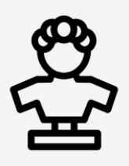 | Substantive | - To understand that sculpture is a three-dimensional art form that occupies space, and that artists consider how their work will be viewed from different angles to create balance, movement and visual impact.
 | Substantive | - To recognise that natural and manufactured materials have different properties that affect how they can be used in sculpture.
 | Substantive | - To recognise how the properties of materials, such as strength, flexibility, weight and durability, influence how sculptures are designed, constructed and displayed.
 | Substantive | - To recognise that sculptors create work for different purposes and audiences, using materials, form and scale to communicate ideas, emotions and meaning.
 | Disciplinary | - I can independently select and combine materials and techniques (e.g. shaping, joining, constructing), justifying my choices in relation to form, structure, and stability, and adapting these as needed.
 | Disciplinary | - I can manipulate materials with increasing precision and control, refining techniques such as cutting, bending, joining, and finishing to achieve accurate, detailed, and stable outcomes.
 | Disciplinary | - I can critically analyse and compare sculptural work, using subject-specific vocabulary to explain how materials, form, and space are used, and applying these insights to inform and improve my own work.
 | Disciplinary | - I can independently review, evaluate, and refine my sculptures throughout the process, making purposeful adjustments to structure, balance, and appearance, and providing constructive, reasoned feedback on my own and others’ work.
Mixed Media  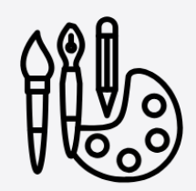 | Substantive | - To understand how visual elements such as colour, pattern, texture, shape and composition work together to create balance, contrast, emphasis and movement within textile and mixed media artwork.
 | Substantive | - To know that printmaking is a process used to create multiple original artworks from one printing surface, and that each print can be unique because of variations in ink, pressure and layering.
 | Substantive | - To recognise that artists combine ink printing with other media, such as drawing, paint, collage or textiles, to add texture, detail and meaning, creating richer and more expressive artwork.
 | Substantive | - To recognise that printmakers from different cultures and historical periods have used printmaking for artistic, decorative and practical purposes, and that their choice of materials and processes reflects the purpose of their work and the technology available at the time.
 | Disciplinary | - I can independently select and combine materials and techniques, explaining how layering, texture, and composition contribute to meaning, purpose, and visual impact.
 | Disciplinary | - I can apply and refine a range of textile techniques (e.g. stitching, joining, weaving) with control, accuracy, and increasing complexity.
 | Disciplinary | - I can critically analyse and compare how artists and designers use mixed media and textiles, using subject-specific vocabulary to explain how materials and processes are combined, and applying these approaches within my own work.
 | Disciplinary | - I can independently review, evaluate, and refine my work throughout the process, making purposeful adjustments to materials, techniques, and composition, and providing constructive, reasoned feedback on my own and others’ outcomes.
By the end of UKS2, children should be able to:
- Complete an art portfolio of work, a collection of their strongest outcomes from their art curriculum.
- Learnt to draw portraits with a degree of accuracy.
- Learnt to draw scenes with a degree of technical accuracy, including using perspective.
- Been able to be creative and imaginative with the range of skills that they have learnt.
- Have a sound understanding of some of the works of a wide range of famous artists, including what the artist was trying to achieve.
- Learnt to paint in a range of media including water colours and acrylic, as well as be able to use complimentary colours to enhance their work.
- Used 3D materials for a range of models and artistic pieces. This will have included the use of clay, wire and textiles.
- Used an iPad to manipulate and create digital images.
- Advance their use of stiches and sewing techniques, supported by the DT curriculum.

