Long Term Curriculum plan for Y5/6 – Cycle B
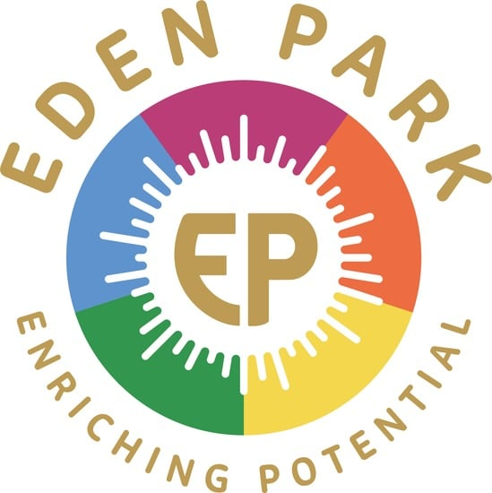

 | Autumn Term 1 | Autumn Term 2 | Spring Term 1 | Spring Term 2 | Summer Term 1 | Summer Term 2
Learning Enquiry  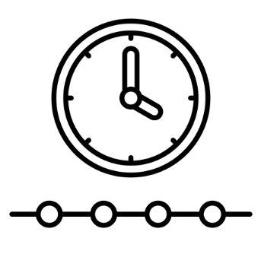  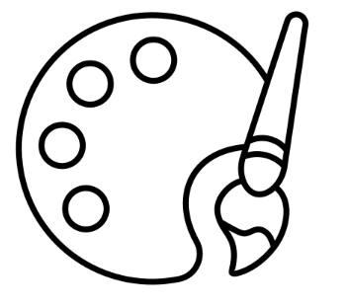   | Nice to Meat you  DT  Ancient Mayans  History | How powerful is nature?  Geography  Entrepreneurs (dragons Den)  Computing | Art and Architecture  Art  Blue Planet II  Geography | Fair Play  Computing  Fair Ground Controller  DT | The Darkest Hour  History  Watercolours  Art | Hawaiian Strings  Music  The show must go on!  Music
Mathematics  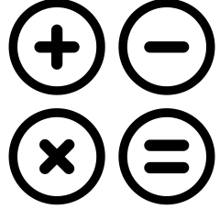 | Year 6 Place value  Four operations  Year 5  Place value  Four operations | Year 6 Fractions  Converting Units  Year 5  Addition and subtraction | Year 6  Ratio  Algebra  Decimals  Year 5 multiplication, division | Year 6  Fractions, decimals and percentage.  Year 5  Fractions, decimals and percentages | Year 6  Geometry  Year 5  shapes, position and direction | Year 6  Problem solving  Year 5  Measurement
Writing   | Incredible Edibles (Instructional)  Is This a Poem? (Poetry) | Extreme Animals (informal Non-Chronological Report)  How the Whale Became (Narrative) | Charles Dickens (Hybrid Text)  The Lost Words (Poetry) | Wallace and Gromit Cracking Contraptions (Information)  Word in Your Ear (Narrative) | My Secret War Diary (Diary) | Anatomy (Formal non-chronological report)
Reading  There will be no order to the reading   | The boy who flew 6  Goldfish boy 5 | Holes 6  Cloud bursting 5 | Journey to Jberg 6  Wolves of Willoughby Chase 5 | The final year 6  The case of the lighthouse intruder 5 | When Hitler stole the pink rabbit 6  Who let the Gods out 5 | Toms Midnight Garden 6  The Nowhere Emporium 6
Science   | Light | Evolution and Inheritance | Electricity |  | Animals, including humans | All Living Things
Religious Education   | Creation and science: conflicting or complimentary? | Why do some people believe in God and some people not? | Why do Hindus want to be good? | What do Christians believe Jesus did to ‘save’ people? | For Christians, what kind of king was Jesus? | How does faith help people when life gets hard?
Physical Education  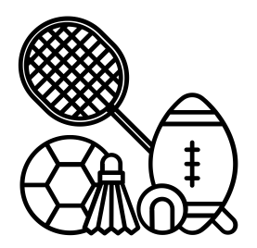 | Tag Rugby  Dance |  | Tennis  Gymnastics |  | Athletics  Fitness | Kwik Cricket  Fitness
PSHE  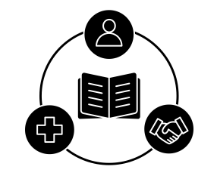 | Relationships Education  Families and people who care for me.  Caring friendships, Respectful, kind relationships Online safety and awareness, Being safe |  | LITWW  Shared responsibilities, Communities  Economic wellbeing: Money  Economic wellbeing: Aspirations, work and career, British Values, Discrimination |  | Health Education  General Wellbeing  Wellbeing online, Basic first aid  Developing bodies.
MFL   | Core Vocabulary  Irregular Verbs | Clothes | At School | Weekend | WWII | Me in the World

