Long Term Curriculum plan for Y3/4 – Cycle B


 | Autumn Term 1 | Autumn Term 2 | Spring Term 1 | Spring Term 2 | Summer Term 1 | Summer Term 2
Learning Enquiry    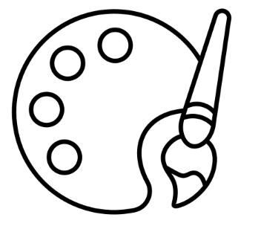   | Long: Design technology – Pneumatics with moving monsters  Short: Geography – Brixham vs. Vito | Long: History – The Romans.  Short: Art – collage and textiles | Long: Music – Keyboards  Short: History – The Vikings | Long: Geography – Spain study  Short: Music | Long: Art - Acrylic painting  Short: Computing – data loggers | Long: Computing – Coding  Short: DT – fish
Mathematics  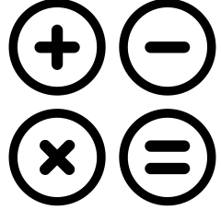 | Year 3:  Number: Place Value  Number: Addition and subtraction  Year 4:  Number: Addition & subtraction | Year 3:  Number: Addition & subtraction  Number: Multiplication and Division A  Year 4:  Measurement:  Area  Number: Multiplication and Division A | Year 3:  Number: Multiplication and Division B  Measurement: Length and Perimeter  Year 4:  Number: Multiplication and Division B  Measurement: Length and Perimeter | Year 3:  Number: Fractions A  Measurement: Mass and capacity  Year 4:  Number:  Fractions  Number: Decimals A | Year 3:  Number: Fractions B  Measurement: Money  Year 4:  Number:  Decimals B  Measurement:  Money  Measurement:  Time | Year 3:  Measurement: Time  Geometry: Shape  Statistics  Year 4:  Geometry:  Shape  Statistics  Geometry:  Position and direction
Writing   | Story:  Book of hope  Betsy Biggalow  A question of history  How to Invent |  | Story:  Paper Bag Prince (Fiction)  Intriguing Animals- Linked to Science (Non-fiction)  Poetry Book (Poetry) |  | Biography:  Meet the Artist! Alexander Calder- Linked to Art (Non-fiction)  King of the Birds (fiction)  Outdoor Wonderland- Linked to Science (non-fiction)  Paint Me a Poem- Linked to Art (poetry)
Reading    Year 3 | 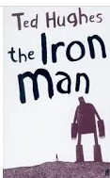  Iron man |  | 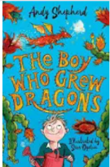  The boy who grew dragons
Reading  Year 4 | 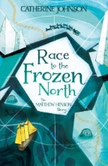  Race to the frozen north  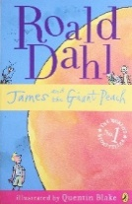  James and the giant peach |  | 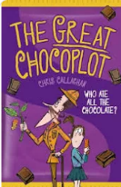  The great chocoplot  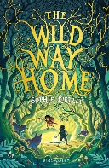  The wild way home |  | 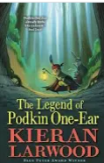  The legend of Podkin one ear  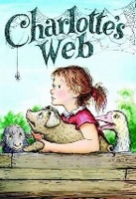  Charlotte’s Web
Science   | Physics: States of matter | Light Y3  and Sound Y4 | Plants Y4 |  | Living Things and their Habitats Y3 | Living Things and their Habitats Y4
Religious Education   | Christianity: What is the ‘Trinity’ and why is it important for Christians? | Hinduism: What do Hindus believe God is like? | Hinduism: What does it mean to be Hindu in Britain today? | Christianity: Why do Christians call the day Jesus dies ‘Good Friday’? | Christianity: For Christians, when Jesus left, what was the impact of Pentecost | Christianity: How and why do people mark the significant events of life?
Physical Education  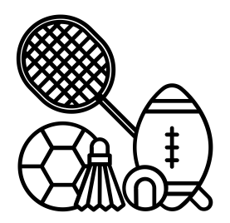 | Outdoor: Football  Indoor: Dance |  | Outdoor: Tennis (net/wall)  Indoor: Gymnastics |  | Outdoor: Athletics  Indoor: Fitness | Outdoor: Kwik Cricket  Indoor: Fitness
PSHE   | Relationship education  In Relationships Education, pupils learn to respect difference in families and friendships, manage conflict and bullying (including online), and understand the core safeguarding message that their body belongs to them. |  | Health education  In Health Education, pupils build their understanding of mental and physical wellbeing, including managing emotions, staying safe online and around water, and maintaining a healthy lifestyle through diet and hygiene. |  | Living in the wider world  In Living in the Wider World, pupils explore shared responsibility for their environment and community, challenge stereotypes about careers, and develop an early understanding of democracy and the law's role in preventing discrimination.
MFL   | Phonics (year ½ recap) | Instruments | Seasons | Vegetables | Presenting myself | Goldilocks

