KS1 Geography |  |  | Weather | Local area including PF  & HF | Brixham Vs Bakau | Oceans & Continents
Locational Knowledge   | Substantive | - Name and locate the world’s seven continents and five oceans
 | Substantive | - Name, locate and identify characteristics of the four countries of the UK:  England  Scotland  Wales  Northern Ireland
 | Substantive | - Name capital cities:  London, Edinburgh, Cardiff, Belfast
 | Substantive | - Identify surrounding seas (e.g. North Sea, Irish Sea)
 | Substantive | - Understand where they live within the UK and the world
 | Disciplinary | - Ask and respond to simple questions about places
 | Disciplinary | - Use simple geographical vocabulary (e.g. country, city, sea, map)
 | Disciplinary | - Locate the 7 continents and 5 oceans on a world map
 | Disciplinary | - Identify locations using maps and globes
Place Knowledge   | Substantive | - Understand features of their local area: Brixham
 | Substantive | - Compare with a contrasting non-European place: Bakau
 | Substantive | - Know similarities and differences in:  Climate  Housing  Jobs  Landscape
 | Disciplinary | - Describe what a place is like using simple words
 | Disciplinary | - Compare two places (similarities and differences)
 | Disciplinary | - Use photos and stories to ask questions about places
 | Disciplinary | - Explain what I notice about different places
Expression  Human and Physical Geography   | Substantive | Identify human features (e.g. houses, roads, shops, harbour)
 | Substantive | Identify physical features (e.g. beach, cliff, river, weather)
 | Substantive | Understand basic weather patterns in the UK
 | Substantive | Know hot and cold places in the world (linked to continents)
 | Disciplinary | - I use simple geographical vocabulary such as:  human feature  physical feature  weather
 | Disciplinary | - I observe and describe the weather
 | Disciplinary | - I group features into human or physical
 | Disciplinary | - I explain how places are different based on features
Geographical Skills and Fieldwork  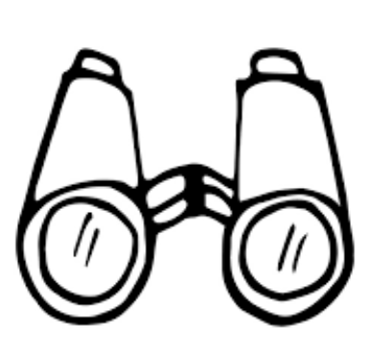 | Substantive | - Know what maps, globes and atlases are used for
 | Substantive | - Understand basic symbols on maps
 | Substantive | - Know simple directional language (near, far, left, right)
 | Disciplinary | - I know how to use world maps, atlases and globes to identify countries and oceans
 | Disciplinary | - I know how to use simple compass directions (N, S, E, W – introduced simply)
 | Disciplinary | - I am able to create simple maps of familiar places (e.g. classroom, school)
 | Disciplinary | - I carry out simple fieldwork in the local area (e.g. observing features, weather)
 | Disciplinary | - I record what I see using drawings, charts or simple sentences
By the end of KS1, children will know the following:
- Know the 7 continents and 5 oceans
- Name and locate the 4 countries of the UK and their capital cities
- Understand where they live within the UK and the wider world
- Describe and compare places, including their local area (Brixham) and Bakau in The Gambia
- Identify and describe human and physical features
- Understand basic weather patterns and differences between places
- Use simple geographical vocabulary
- Use maps, globes and atlases to locate places
- Carry out simple fieldwork and observations
- Ask and answer basic geographical questions

