Year 3/4 |  |  | Spain | Brixham vs Vito, Spain | Brilliant Brazil | Water Cycle
Locational Knowledge   | Substantive | Locate Brazil within South America
 | Substantive | Locate Spain within Europe
 | Substantive | Identify the position of countries using the Equator and hemispheres
 | Substantive | Understand links between location and climate
 | Disciplinary | I use maps and atlases to locate countries and continents
 | Disciplinary | I use geographical vocabulary such as continent, country, hemisphere
 | Disciplinary | I ask questions about where places are and why
 | Disciplinary | I describe locations using map-based language, including 8-point compass directions (N, NE, E, SE, S, SW, W, NW)
Place Knowledge   | Substantive | Study regions of Brazil and Spain
 | Substantive | Compare Brixham and Vito
 | Substantive | Understand similarities and differences in human and physical geography
 | Disciplinary | I compare places and identify similarities and differences
 | Disciplinary | I describe what places are like using evidence
 | Disciplinary | I ask and answer questions about places
 | Disciplinary | I explain how location affects how people live
Expression  Human and Physical Geography   | Substantive | Understand climate zones (tropical and Mediterranean)
 | Substantive | Know features of biomes, including the Amazon Rainforest
 | Substantive | Understand the water cycle (evaporation, condensation, precipitation)
 | Substantive | Identify key physical features (rivers, mountains, coasts) and human features (settlements, land use, population)
 | Disciplinary | - I use geographical vocabulary such as climate, biome, river, population
 | Disciplinary | - I describe and explain physical processes (e.g. water cycle)
 | Disciplinary | - I explain differences between human and physical features
Geographical Skills and Fieldwork  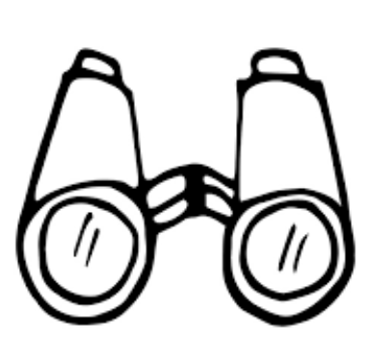 | Substantive | I use geographical vocabulary such as climate, biome, river, population
 | Substantive | I describe and explain physical processes (e.g. water cycle)
 | Substantive | I explain differences between human and physical features
 | Substantive | I use geographical vocabulary such as climate, biome, river, population
 | Disciplinary | I use geographical vocabulary such as climate, biome, river, population
 | Disciplinary | - I describe and explain physical processes (e.g. water cycle)
 | Disciplinary | - I explain differences between human and physical features
 | Disciplinary | - I use geographical vocabulary such as climate, biome, river, population
 | Disciplinary | - I describe and explain physical processes (e.g. water cycle)
 |  | - I explain differences between human and physical features
By the end of Year 3/4, children will know the following:
- Know the location of key countries including Brazil and Spain, and identify them within their continents
- Understand how location (including the Equator and hemispheres) affects climate
- Describe and compare places, including Brixham and Vito, explaining similarities and differences in human and physical geography
- Understand key geographical concepts including climate zones, biomes, rivers, and population
- Know the main features of a tropical rainforest and recognise the importance of the Amazon region
- Understand and explain the water cycle using correct vocabulary (evaporation, condensation, precipitation)
- Identify and describe human and physical features in different environments
- Use a wider range of geographical vocabulary accurately
- Use maps, atlases and globes to locate and describe places
- Use 8-point compass directions to describe location and movement
- Use 4-figure grid references to identify locations on maps
- Interpret and use data such as climate graphs and population maps
- Ask and answer geographical questions, using evidence to support explanations
- Collect, record and present information through fieldwork, maps and diagrams

