Long Term Curriculum plan for Y1/2 – Cycle B


 | Autumn Term 1 | Autumn Term 2 | Spring Term 1 | Spring Term 2 | Summer Term 1 | Summer Term 2
Learning Enquiry    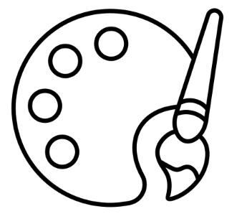   | Geography: Weather | Music: Show | DT: Moving Mechanisms | Computing: Technology around us | History: Castles | Art: painting
Short LE | Music: Glocks | History:  Gunpowder plot  DT: Delightful decorations | ICT:  Moving robots | Geography: Physical / Human features | Art: sketching | DT: Food Tech Smoothies
Mathematics    Year 1 | Place Value (within 10)  Addition (within 10) | Subtraction (within 10)  Shape | Place Value (within 20)  Addition and Subtraction (within 20) | Place Value (within 50)  Length & Height  Mass & Volume | Multiplication & Division  Fractions | Shape  Place Value (within 100)  Time  Money
Mathematics  Year 2 | Place Value  Addition | Subtraction  Shape | Money  Multiplication | Division  Length & Height  Mass, Capacity & Temperature | Fractions  Time | Statistics  Position and Direction
Writing   | Consolidation of EYFS / Year 1 objectives? | Weather  (Non-fiction)  Three Little Pigs (fiction) | Boa’s Bad Birthday (fiction)  What I like (poetry) | Zim Zam Zoom (poetry)  Hidden World  (non-fiction) | Daisy Doodles  (fiction)  Knights (non-fiction) | Don’t Spill the Milk  (fiction)
Science   | Materials | Living things and their habitats | Living things and habitats  Food chains in different habitats | Plants | Plants | Materials
Religious Education   | What does it mean to belong to a faith or belief community? | What do Christians believe God is like? | Who is Jewish and how do they live? (double unit) | Who is Jewish and how do they live? (double unit)  Why does Easter matter to Christians? | Who do Christians say made the world? | How should we care for the world and for others and why does it matter?
Physical Education  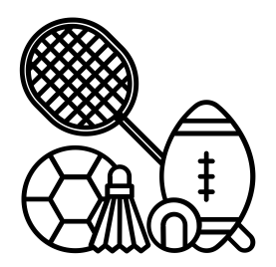 | Indoor PE:  Dance  Outdoor PE:  Football | Indoor PE:  Dance  Outdoor PE:  Football | Indoor PE:  Gymnastics  Outdoor PE:  Tennis | Indoor PE:  Gymnastics  Outdoor PE:  Tennis | Indoor PE:  Fitness  Outdoor PE:  Athletics | Indoor PE:  Fitness  Outdoor PE:  Kwik Cricket
PSHE  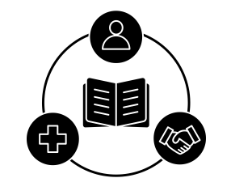 | Relationship Education:  Families and people  Caring friendships | Relationship Education: Respectful, kind relationships  Online safety and awareness  Being Safe | Health Education:  General wellbeing  Wellbeing online | Health Education:  Physical health and fitness  Healthy eating  Basic First Aid | Living in the Wider World:  Shared responsibilities  Communities  Economic wellbeing | Living in the Wider World: Economic wellbeing: aspirations, work and career  British Values  Discrimination

