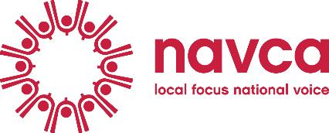
Vision for Volunteering – engagement activity report
Thank you for hosting a workshop to engage people in the Vision for Volunteering. It would be really helpful if you can share any of the findings and discussion, to inform our developing thinking on the Vision and make sure it reflects local perspectives. Please complete this template to tell us what you delivered by way of workshops and engagement events to bring the Vision to life, and email it to comms@navca.org.uk as soon as possible after your event.

If you have a short case study to bring to life what you heard, that would be really helpful. If you would like to report in an alternative format, or have an existing write up you can share, please send us that instead.

Organisation name
Number of events held |  | Number or organisations attended |  | Number of participants attended
Vision theme(s) covered

Summary of the findings/feedback/discussion
[Max 500 words]

What is different as a result of the engagement held; are there any outcomes or actions which have resulted?
[Max 500 words]

