
NAVCA Anti-Racist Group | 3 October 2024

Making the case internally
An example on presenting to senior manager, board and staff on the importance of anti-racist activity – winning hearts and minds.

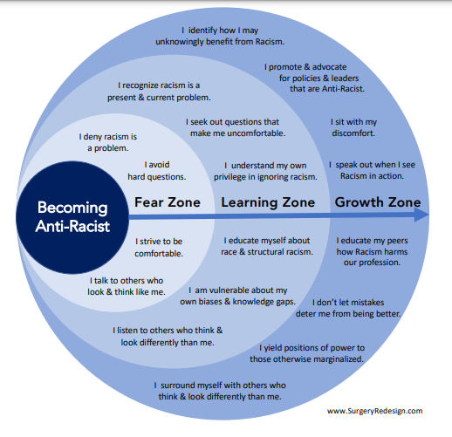

In consideration of the design above, we hope that most organisational representatives present are in the:

Learning Zone
- You recognise racism as a present & current problem
- You seek out questions that make us uncomfortable
- You understand your own privilege in ignoring racism
- You are prepared to educate yourself about race & structural racism
- You are prepared to be vulnerable about your own biases & knowledge gaps
- You are prepared to listen to others who think & look differently from you

The model from Hackney CVS

HR is crucial. Statement from HCVS

‘Human Resources
EDI is embedded in our HR systems. We have updated our recruitment processes to be more inclusive and we ensure that the right people are around the table to interview candidates. Through HR we have established clear lines of accountability, and we continue to update our existing policies and procedures and create new policies that are focused on equality and best practice.

We are clear that our workforce must represent the communities that we serve, and that representation of diverse communities is at all levels of Hackney CVS. We recognise that inequality is systemic and our collective responsibility alongside our communities, the VCS in City and Hackney and our statutory partners is to commit to the dismantling of oppressive systems that prevent equal access to opportunities.’

In conversation with Delia…
Set clear standards for EDI (equality, diversity & inclusion) and ensure your organisation is adhering to them. Implement KPIs, ensure adherence and raise any issues at a senior level. Do your research.

Even black led organisations need to check themselves to ensure adherence and not assume they are adhering, by virtue of having black staff. Humility is key so that community voices can be central to enabling system change Lived experience must inform what you do. We always need to ask, what are we doing internally? Reflexive practice is essential.

Cultural awareness training is crucial (HCVS will begin leading these in Nov ‘24 and they may be hybrid). It is important to look at the power structures within your organisation, to address structural racism. Each organisation needs to ask, 'what are we doing?' Rural areas just saying they don't have a lot of people of colour in the area is not enough.

Consistently assess the implementation of your organisation’s EDI KPIs. It’s important to demonstrate adherence to KPIs, to embed HR practice into EDI KPIs. HR can often uphold/maintain the status quo and would often rather pay off a disgruntled member of staff, rather than address the systemic issues – this should be avoided.

How are appropriate KPIs developed?
Consider the structures within your workplaces. Address lack of representation, staff lacking lived experience, no progression, POC (people of colour) in jobs but not staying because practice is racist (both overtly and covertly).
KPIs developed, must be robust but succinct (6-8 at most), e.g.: HCVS
- Hiring,
- Representation,
- Retention,
- Advancement,
- EDI workshops and staff forum participation,
- Accessibility for disabled staff and customers.

Hiring - being prepared to rerun the recruitment process if not diverse enough.
Without representation racism cannot be addressed, POC need to lead the change.
Retention - need people with cultural experience. Organisations will retain good people if EDI is embedded.
Advancement - should be achievable if other KPIs are enacted and are working.
There needs to be engagement for staff to talk about real issues. Be prepared for difficult conversations that make people uncomfortable. There needs to be openness and authentic engagement.
Accessibility - e.g.: making sure your office building is fit for purpose, inclusive to all - and recognising what the challenges are...and what you will do about it?

Future
Hackney CVS want to develop a toolkit on organisations becoming anti racist, once we are clear that we have our house in order.

NAVCA
Explore the EEDI resources on the NAVCA website: https://www.navca.org.uk/members-area-resources
Submit your own resource: https://www.navca.org.uk/members-area-submit-a-resource
Sign up for next meeting: https://www.navca.org.uk/members-events

Resources shared during the meeting:
- A dialogue of equals: Stafford Scott on community activism: https://www.kingsfund.org.uk/insight-and-analysis/podcast/stafford-scott-community-activism
- https://seriousplay.training/lego-serious-play/
- Akala: https://www.youtube.com/watch?v=fiYI839cr9A

