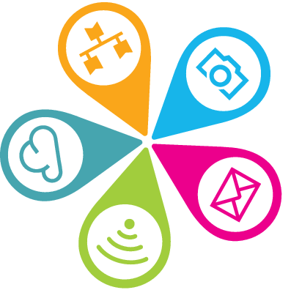 AI tools info sheet
* Please note all pricing mentioned is correct as of Jan 2026 and is subject to change

- Chat GPT
Go to https://chatgpt.com/ to create your account.
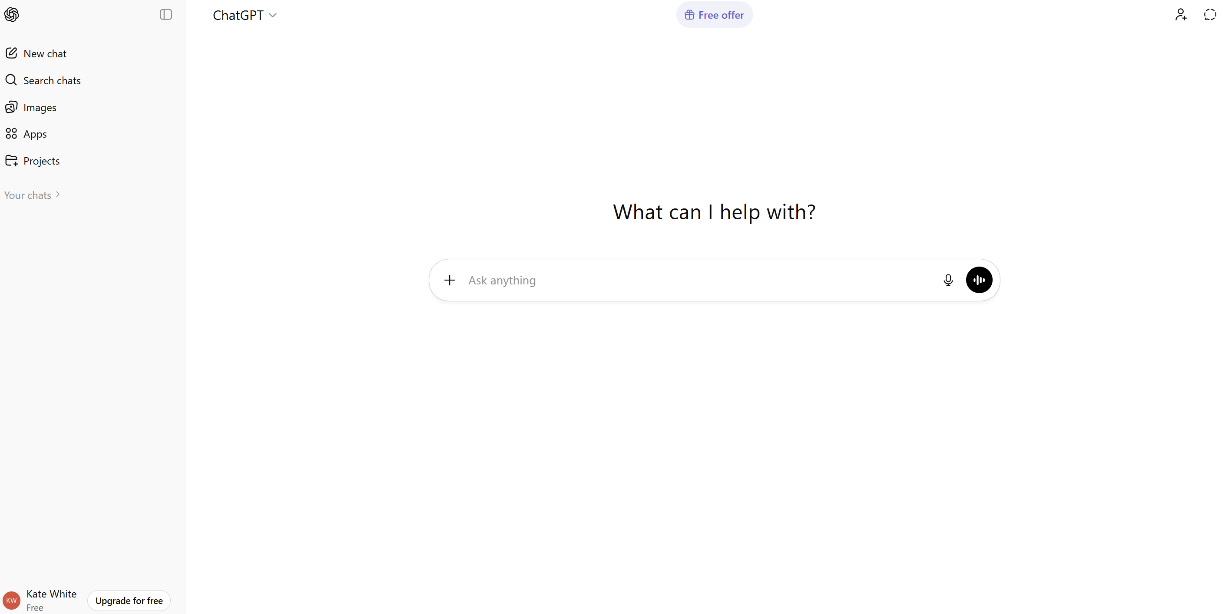
Go to your profile, then click on Settings and go to Data Controls and turn ‘Improve the model for everyone’ to ‘Off’ as by default this is turned on.
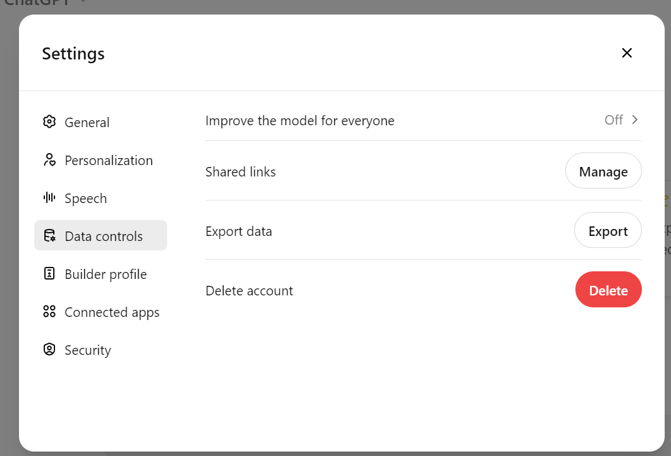
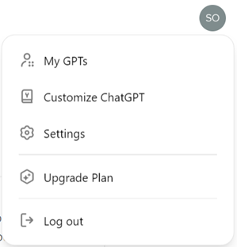

Please note your free ChatGPT account has limitations e.g. restrictions on numbers of images uploaded or created.
Upgrade to ChatGPT Business for $30 per month – apply for a 20% non profit discount here. See also a Features comparison here.

Copilot (with M365 accounts)
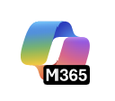
Log on to your M365 account via the browser and you should arrive at the Copilot landing page.

Or click on the Copilot icon wherever you see it.

Toggle the left hand panel on or off using the icon at the top right
Click on the Green shield icon (top left) for info on MS Enterprise Data Protection
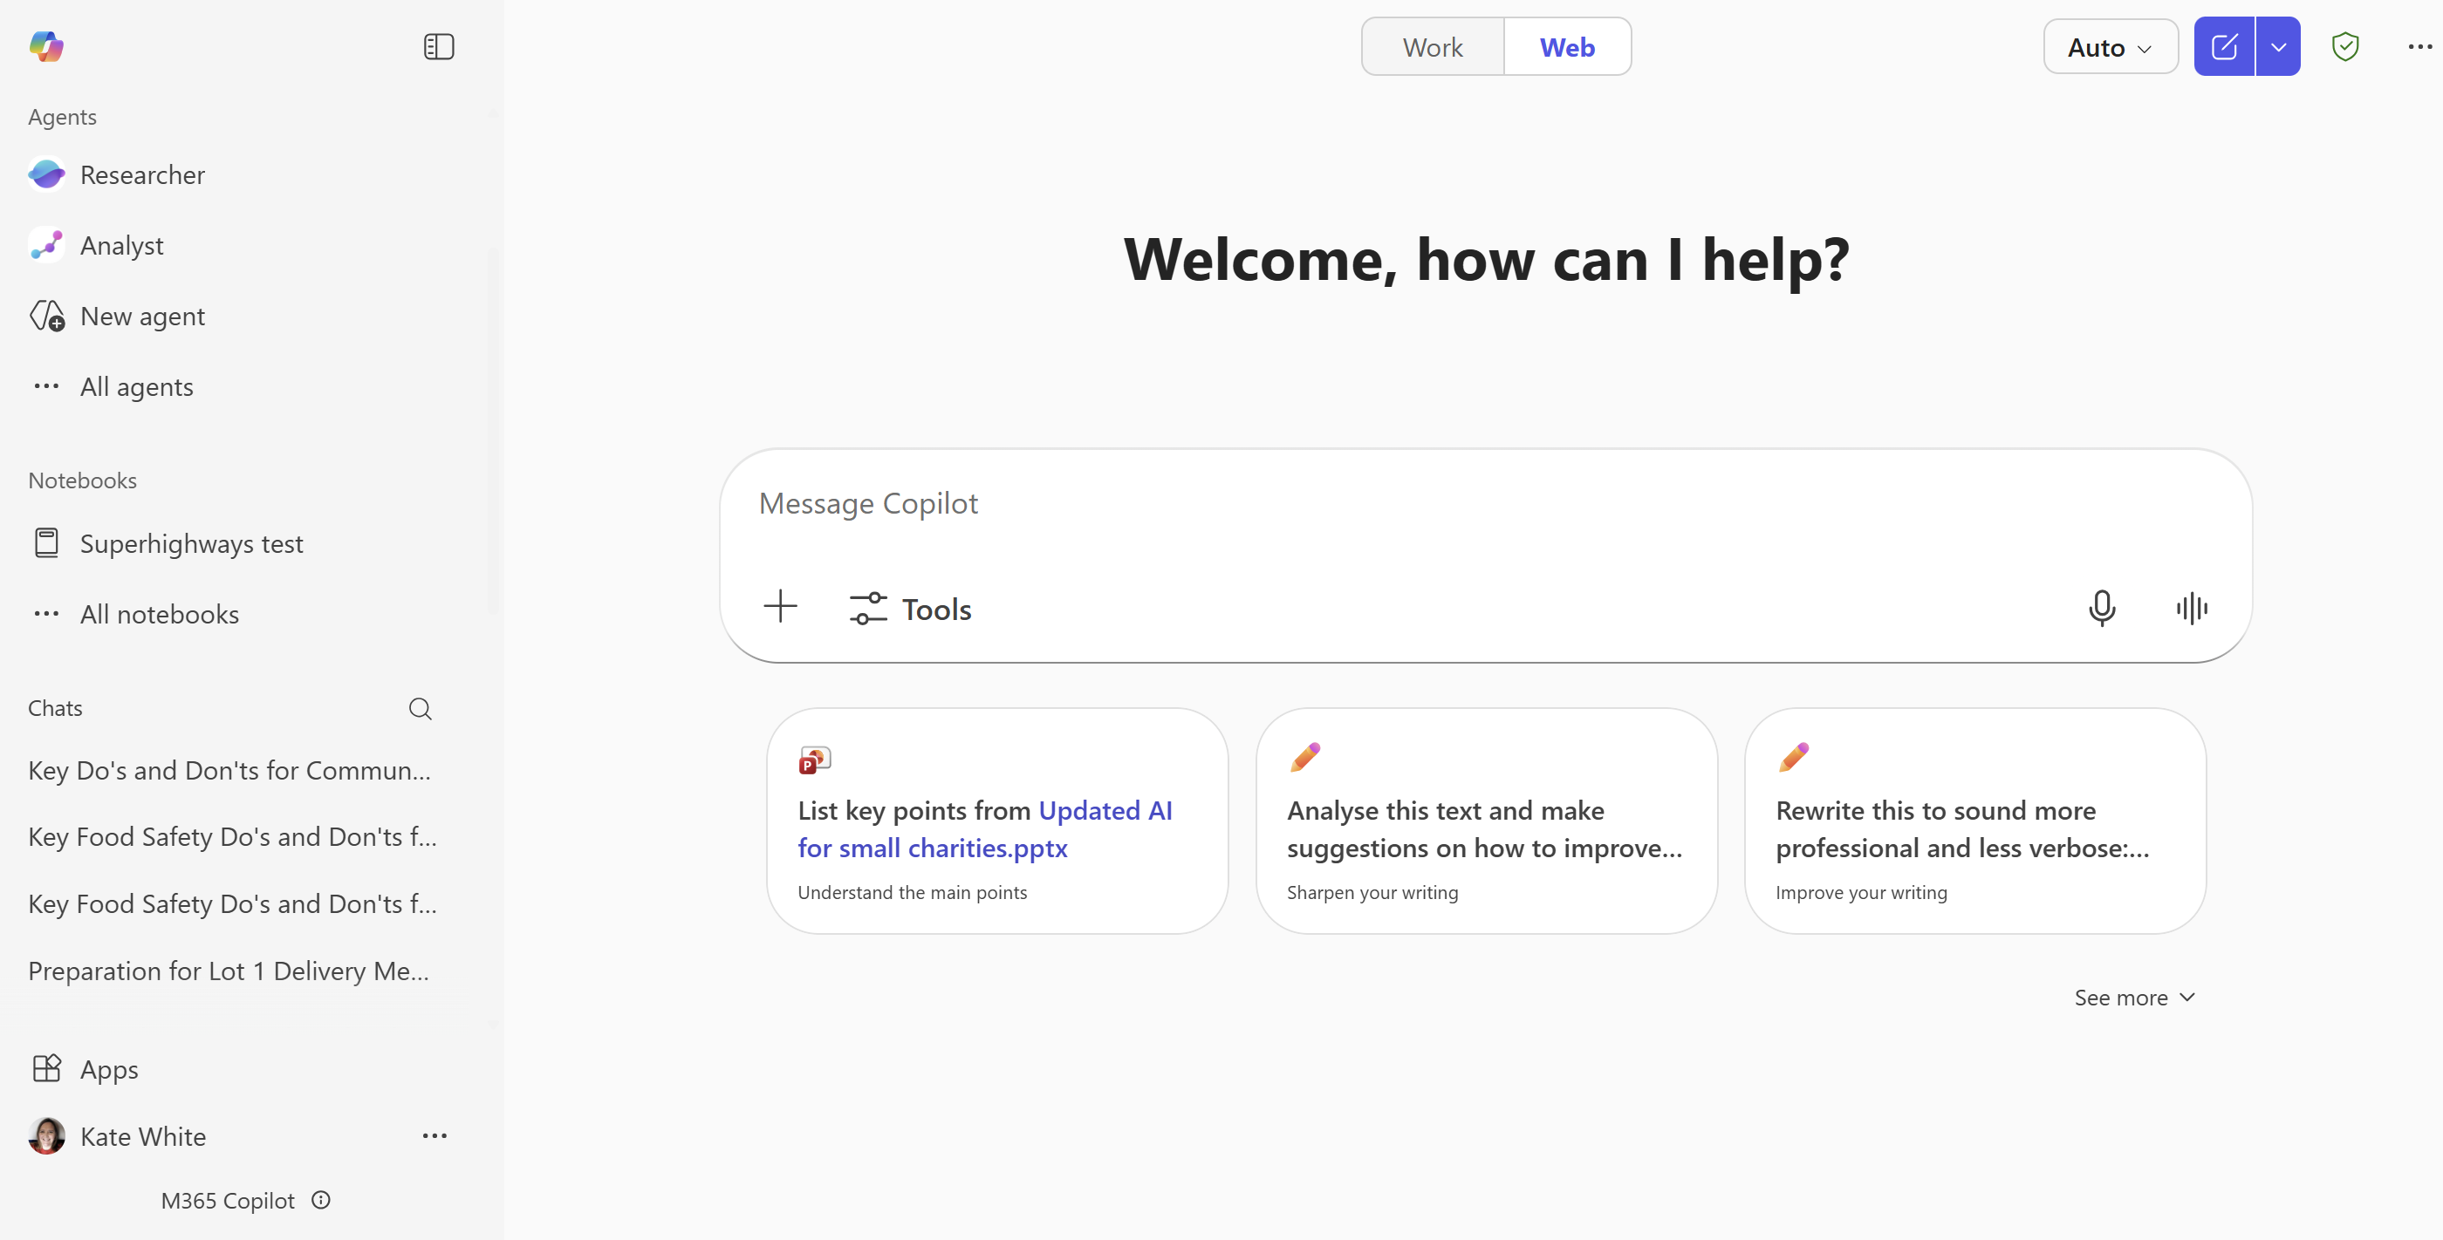
Settings - click on the ellipsis (3 dots) by your name in the bottom left to open and select General, Chat, Privacy and Notfications to check and amend options

Free Copilot Chat is included in all M365 licences and doesn’t train the model (see Green shield link info above).
Paid Copilot licences – additionally allow you to look across files and data in your organisational account that your log in has access to. Toggle to the Work tab to do this (which doesn’t show when using free Copilot licences).
Pricing – opt for M365 Copilot Business licence at £16.91 per month (£193.20 per year)
(To 31st march there's a 15% discount working out at £14.49 per month (£165.60 per year) with the discount seeming to apply for a year up to the next renewal only.)
Previously the nonprofit pricing for M365 CoPilot with 15% discount was the best value option at £235.20 per year (and still will be if you are a large charity with over 300 users)
- Copilot QuickStart Training for Non Profit orgs – free monthly online sessions
- MS Copilot Video Tutorials

- Gemini (with Google Workspace accounts)
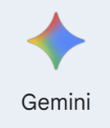
Look for the Gemini logo in your Google app launcher grid (top right)
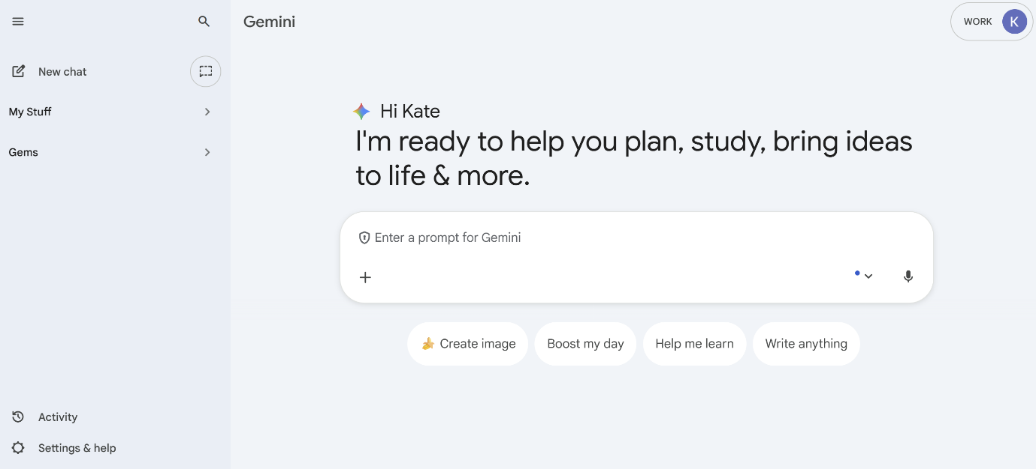

Gemini Activity – info re data handling and chat history etc
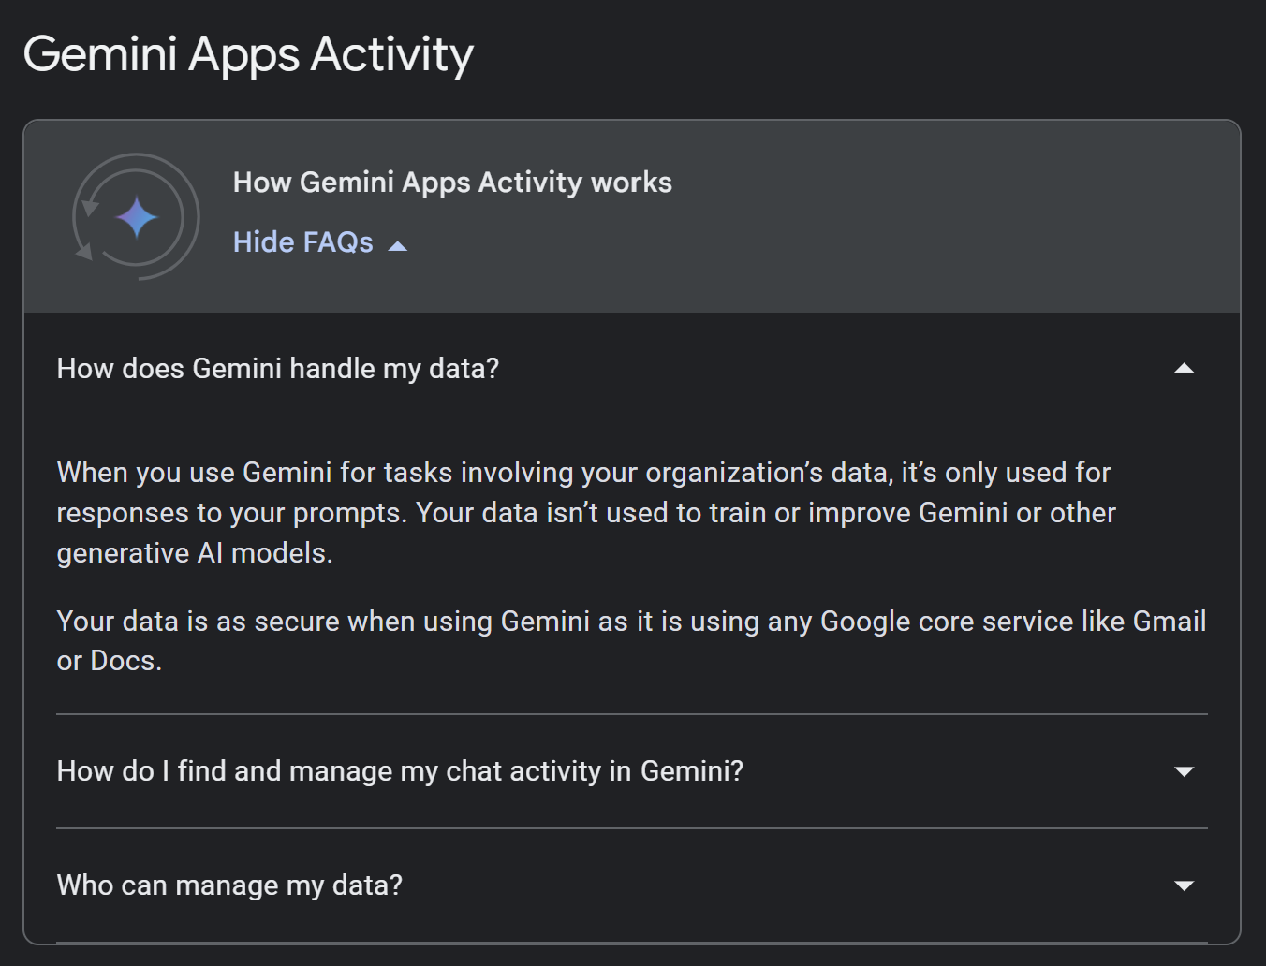
Data handing - ‘Training the model’ turned off for nonprofit free Workspace accounts.
Settings & help – Theme, LM Notebook, Connected Apps (to unlock your connection with Google Workspace e.g. docs, gmail etc - turn on Smart features in relevant other Google products.
Upgrade your Google Workspace for integrated AI in apps e.g. gmail, docs etc – costs from $3.50 a month (75% discount for non profits)

- Explore AI features for different Workspace options
- Google for nonprofits AI resources – including noprofit examples and useful prompt libraries

