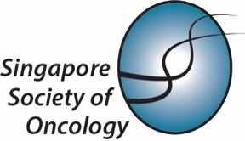

NOTICE OF 44th ANNUAL GENERAL MEETING

21 April 2025

Dear SSO Member,

I am pleased to invite you to attend the Singapore Society of Oncology’s 44th Annual General Meeting (AGM) on:

Date
21st May 2025, Wednesday

Time
18:00 – 19:00 hrs – AGM & Penang Buffet Dinner

Venue
Kings Room, Level 1, Copthorne King's Hotel
(403, Havelock Road Singapore 169632)

AGM Agenda
- Confirmation of minutes of the last AGM (43rd AGM)
- Matters Arising
- President’s Report
- Secretary’s Report
- Treasurer’s Report
- Any Other Business

How to Respond to this AGM Invitation?
Click here to register for AGM and/or Dinner or to decline the invitation: SSO 44th AGM Registration

Membership Renewal
If you have not already renewed your membership, please do so now. You may may payment via Paynow (Scan Paynow QR Code below) and send screenshot of payment proof to sso@singaporeoncology.org so that the secretariat may update your membership records. (Ordinary Membership S$20 / Associate Membership S$10).

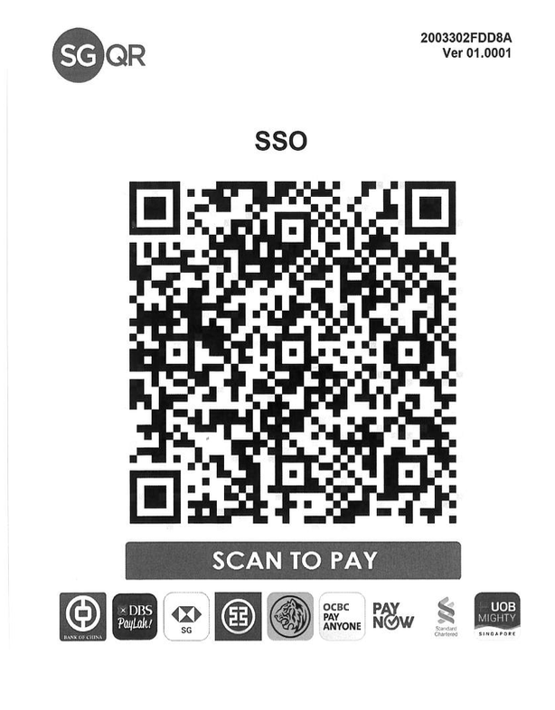

We look forward to seeing you at the AGM!

Yours sincerely,

Dr Tan Hon Lyn
Honorary Secretary
Singapore Society of Oncology

Facebook : https://www.facebook.com/ssoncology/
Website : https://www.singaporeoncology.org/

