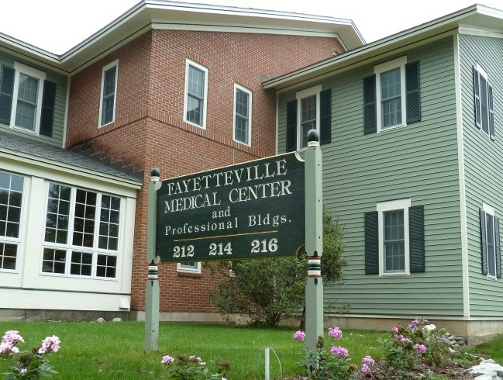

From the North or South

Take 481 to Exit 3E. This will put you on East Genesee Street (Route 5) East.

Bear Left at Lyndon Corners- Towards Fayetteville (DO NOT take Highbridge Rd)

Turn Right at Highbridge STREET, (at 2nd light past Romano Jeep Dealership)

We are located on the right at 212 Highbridge Street, parking in rear

Our office is on the Second Floor

From the East:

Take Route 92 to Manlius

Follow Route 173 out of Manlius

Turn right onto Troop K road

Troop K road will turn into Highbridge Street

We are located on the left at 212 Highbridge Street

Entrance to the parking lot is after the building, parking in rear

Our office is on the second floor

