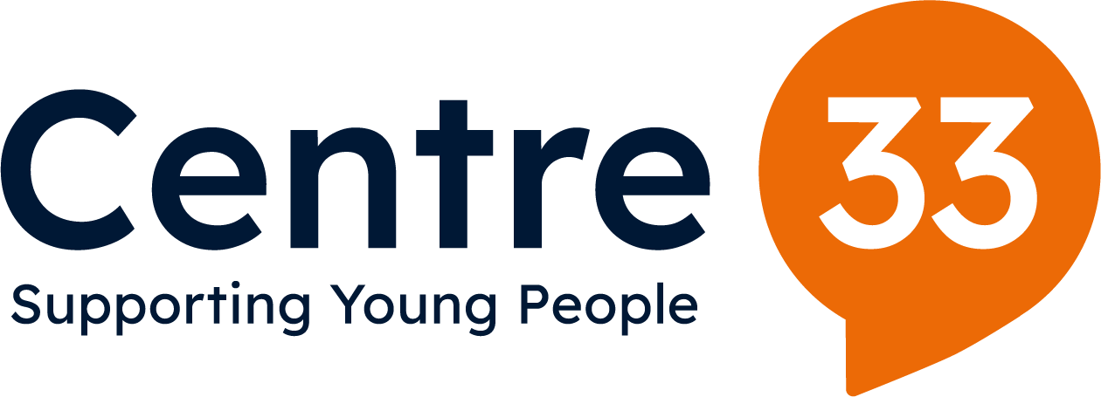

Communications Coordinator

Applicant Information Pack
December 2025


Introduction

I’m delighted you’re considering working with us at Centre 33 within the Communications Team.

Centre 33 has been supporting young people in Cambridgeshire for over 40 years. We work closely with around 4000 young people a year offering a safe space where they can receive free, confidential and professional support in a non-judgemental and welcoming setting. Working across the county, we building local relationships and advocating for young people’s needs in local services and communities.

Centre 33 has been specifically supporting young carers for over 20 years, and have a dedicated team that aims to make sure that young carers have the same life chances, levels of wellbeing and voice as their peers as well as working with them to reduce the negative impact of their caring responsibilities.

By choosing a career with us you will play an instrumental role, alongside our fantastic staff, volunteers and supporters, in helping us to continue towards our vision of a future where all young people are listened to, respected and supported.

Everyone at Centre 33 is passionate about driving positive change to meet the growing need for improved and expanded services to support young people across the county.

I am exceptionally proud to lead Centre 33 and I hope that reading through this pack will inspire you to apply to join us.

Beth Green
Chief Executive Officer

Our History

Centre 33 opened its doors to young people at 33 Clarendon Street on 1stMay 1981. Save the Children funded our first worker, Maggie Hunter and she quickly recruited a team of volunteers to offer counselling, advice and support to meet the needs of young people in Cambridge.

“It was to be a warm and welcoming space for young people where they could come and be listened to without judgement. All the services were to be free and confidential.”

Now in our 42nd year we continue to reflect on what has changed and what has stayed the same over time. We hold true to the founding ethos of Maggie Hunter and her team and still value the rights of young people to have their own space and to be treated as individuals worthy of respect and support.

To date we have closely worked with over 40,000 young people through counselling, support with caring responsibilities, homelessness, sexual health and more.


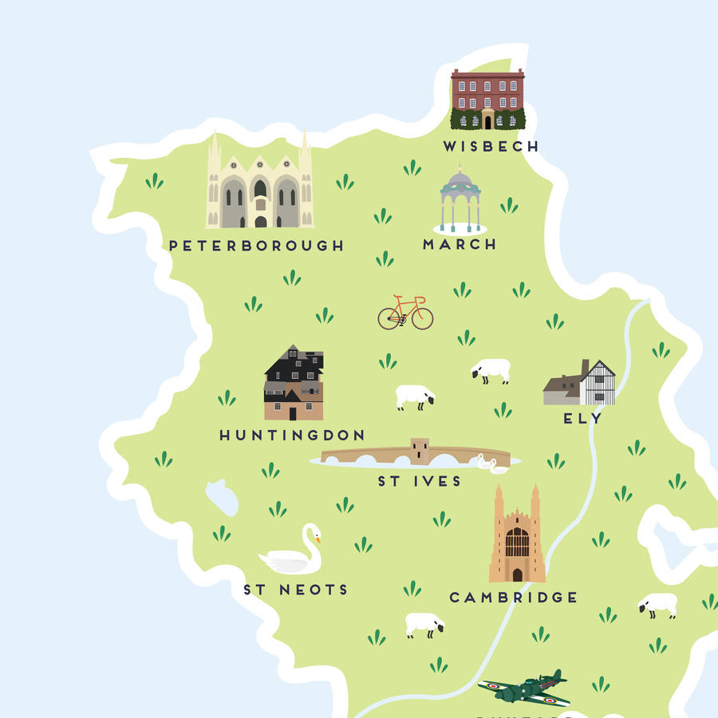
We now operate in 5 parts of the county including Ely, Wisbech, Huntingdon and Peterborough and continue to advocate for young people’s needs in their communities.
Our Vision, Mission and Values

Our Vision is for:

A future where all young people are listened to, respected and supported

Our Mission in Cambridgeshire and Peterborough, is:

- to offer young people support with their practical issues and emotional needs that is free, confidential, empowering, easy-access and high quality.
- to actively work with other local services so that young people’s needs are met, and their voices are heard.

We work closely to these Values:

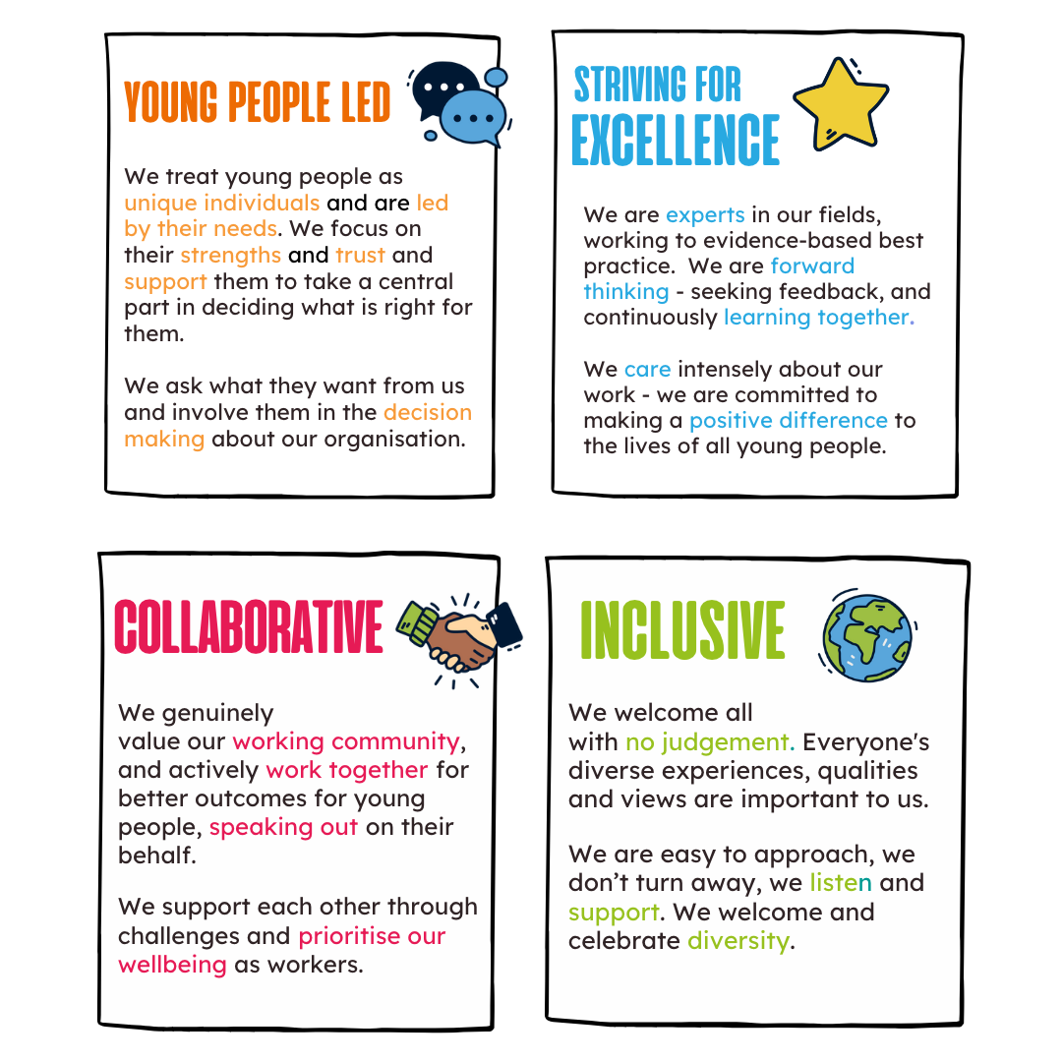
Strategic Plan Goals

Our Strategic Plan outlines our four strategic goals for the next five years. These have been developed through a process of consultation and review with young people, staff and wider stakeholders in the sector.

The goals build on the strong foundations of Centre 33’s work and understanding of local needs developed over 40 years; including the significant work of the last three years:

- Delivering support to more young people, with increasingly complex needs from a wider geographical area.
- Responding and adapting our services and ways of working in response to COVID-19.
- Working with local partners to strengthen the local system of support for young people, through sharing best practice/data, co-production, and capacity building.
- Strengthening our central resources in admin, HR, data, evaluation, communications and fundraising.
- Rapidly growing our income and delivery teams to meet the above demands.

Our four strategic goals fall into areas of impact and areas that enable the impact of our work.

Impact Goals

All young people across Cambridgeshire and Peterborough can receive holistic support that is accessible, high quality, impactful, targeted and led by them. |  | Centre 33 advocates for positive change for young people through dissemination of knowledge and best practice, and collaborative working to ensure high levels of understanding of their needs and clear pathways of support.

Enabling Goals

Centre 33’s workforce and governance is high quality, stable and diverse: working in quality community-based hubs and practices. |  | Centre 33 has financial stability over at least a five- year period; achieved through a clear vision, adequate resources, compliance with best practice and legal requirements; and an established funding mix.

Communications Team Structure

Head of Communications, Operations & Projects

Communications Coordinator

Communications Coordinator
Job Description – 2025

Key Terms and Conditions

Hours | Minimum 3 days (22 hours), Maximum full time (35 hours)
Duration | Maternity cover from February 2026
Responsible to | Head of Operations, Communications and Projects
Location | Based in one of the Centre 33 offices, with some travel around Cambridgeshire and Peterborough

Purpose of the Role
To amplify Centre 33’s transformative work with young people by developing and delivering a dynamic communication framework. This role ensures our messaging is clear, impactful, and relevant, engaging diverse audiences through creative storytelling and effective communication across all channels.
To work to Centre 33’s values of being inclusive and specialist; supportive and non-judgemental; and collaborative and accountable.

Principle duties

- To be the main person co-ordinating all communications across Centre 33 including responding to requests, ensuring high standards of external communications and supporting individuals and teams to use communications well in their daily roles.
- Ensuring our materials (physical and online) are well organised, easy to find and use and looked after.
- Act as a brand guardian, ensuring consistent use of logos, typefaces, tone of voice, and other branding elements across all channels.

Design and print
- To lead the creation of printed marketing and promotional materials, liaising with external print and design organisations where necessary.
- Managing the supply and use of printed material across the organisation.
- Ensuring a high standard of material is being used across Centre 33 including presentations, signage, displays, internal documents and notices.
Digital and online communications
- Managing the Centre 33 website, ensuring content is current, accurate, and engaging. Working with teams to develop new content.
- Managing our social media channels, producing relevant, impactful content, ensuring that young people’s voices are centred and organisation priorities and messages are well represented.
- Ensuring via digital moderation that platforms are managed in line with Centre 33’s social media policy.
- Creating or facilitating the creation of high-quality, multi-media content that tells the stories of young people and highlights our impact, working collaboratively across Centre 33 to ensure the work of the whole team is communicated and show casing it digitally and via other means.
- Using analytics tools to monitor the performance of digital channels, providing insights to guide future content and campaigns.
- Developing strategies to grow our digital audience and strengthen online engagement with young people, donors, and partners.

Campaigns and Fundraising
- Collaborating with the fundraising team to deliver integrated multi-channel campaigns that engage donors and supporters, including newsletters, our winter fundraising appeal and yearly Impact Report.
- Working on 2026 events and priorities including our 45th birthday, the launch of the new Cambridge hub, VIP visits and more.
- Supporting the development and delivery of advocacy and outreach campaigns, targeting harder-to-reach communities or one-off projects.
Internal comms
- Supporting the Head of Communications to develop impactful and efficient internal communications including weekly news, use of Teams, internal signage etc.

Public Relations and partner communications
- Responding to media requests and generating positive press coverage through press releases, social media, and networking.
- Providing guidance and support to teams managing PR and media enquiries.
- Producing 2 schools’ newsletters and 1 GP newsletter across the year.
Collaborative working
- Working closely with service teams to create content that reflects their priorities and strengthens connections across the organisation.
- Engendering ownership and enthusiasm for communications in Centre 33 teams via training, collaborative work etc.
- Building relationships with external partners, media outlets, and stakeholders to enhance Centre 33’s visibility and influence.
- Collaborating with young people to co-create compelling content, such as video stories, newsletters, and testimonials.
- Maintaining a good understanding of young people’s issues in the sector and work collaboratively with partners when required, amplifying issues where they are relevant.

Other
- To carry out any other required administrative tasks associated with communications.
- To occasionally travel to hubs within the county and to occasionally work unsociable hours.
- You will attend a range of events including staff meetings, training days, and the AGM if required.

Communications Coordinator
Person Specification – 2025

We are looking for a warm and approachable team player who can inspire and motivate others and works well under pressure.

Criteria | Essential | Desirable
Communications, marketing and delivery | - Excellent literacy and skills in copy writing, understanding the Centre 33 tone of voice and how to communicate our messages.  - Good visual sense re. what makes a striking image, or piece of content and will resonate with our audiences.  - Experience producing designed material.  - Understanding of Centre 33’s diverse stakeholders and confidence to communicate our messages with them in ways that are impactful and appropriate.  - Capable and confident using information technology including social media, mailing platforms and willingness to learn. | - Ability to take a good photograph and/or film short scenarios for use in communications  - Experience working with design software and/or liaising closely with designers  - Skills in video editing, and visual storytelling and/or liaising closely with freelancers
Personal Qualities | - Ability to work under own initiative to achieve results organise a complex workload and work to agreed goals.  - Creative and innovative outlook particularly with regards to communicating with young people  - Ability to work under pressure, to meet deadlines and produce high-quality results  - Excellent interpersonal skills, comfortable and enthusiastic working in teams and collaboratively with partners  - Good understanding of and interest in the local mental health landscape, particularly for young people in Cambridgeshire and Peterborough  - A commitment to equal opportunities, diversity and confidentiality. | - Experience using communications with young people  - Experience of successful partnership working and ability to influence others  - Knowledge of the mental health and social care landscape, particularly for young people in Cambridgeshire and Peterborough.

The successful candidates will receive a range of benefits including:
- competitive salary
- generous pension contribution
- excellent on-going training and development opportunities
- support from an established and reputable team
- company sick pay post probationary period
- team days and activities
- wellbeing focus
- regular line management
- flexible working
- 25 days holiday increasing to 30 after 5 years’ service (plus bank holidays)
- holiday buy
- paid long service sabbatical leave
- employee referral scheme
- employee assistance programme

All roles at Centre 33 may involve access to information about young people and as such all new employees and volunteers will be subject to an enhanced DBS check. Having a criminal record will not necessarily bar you from working with us. This will depend on the nature of the position and circumstances and background of your offences.

Further Information

Equality, Diversity, Inclusion and Belonging at Centre 33

Centre 33 is committed to encouraging equality, diversity and inclusion among our workforce and users, and eliminating unlawful discrimination. The aim is for our workforce to be truly representative of all sections of society and for each employee, volunteer and service user to feel respected.
Our over-arching goals are:
- We encourage equality, diversity and inclusion in the workplace and create a working environment free of bullying, harassment, victimisation and unlawful discrimination, promoting dignity and respect for all, and where individual differences and the contributions of all staff are recognised and valued.
- We commit to actively reaching out to all communities of young people, investigating how we can welcome them to our services and breaking down any barriers to access.
- We commit to challenging instances of any power imbalances that may leave some people in our services or on our team at risk of harm or disadvantage.
- We commit to valuing and improving diversity in our workforce, governing body and volunteer base–we want to reflect the communities we work with.
- We commit to using language and communications that don’t alienate, discriminate against or misrepresent any group.

Safeguarding Statement, Rehabilitation of Offenders Act 1974

All staff and volunteers at Centre 33 undertake an enhanced DBS Check. Having a criminal record will not necessarily bar you from working with us. This will depend on the nature, circumstances and background of the offenses. If you have a criminal conviction, other than those spent under the terms of the Rehabilitation of Offenders Act 1974, please contact hr@centre33.org.uk and they will confirm the process for confidentially informing us.

