

Team Lead (North)

Applicant Information Pack
January 2026


Introduction

I’m delighted you’re considering working with us at Centre 33 within the Mental Health and Counselling Team.

Centre 33 has been supporting young people in Cambridgeshire for over 40 years. We work closely with around 4000 young people a year offering a safe space where they can receive free, confidential and professional support in a non-judgemental and welcoming setting. Working across the county, we building local relationships and advocating for young people’s needs in local services and communities.

By choosing a career with us you will play an instrumental role, alongside our fantastic staff, volunteers and supporters, in helping us to continue towards our vision of a future where all young people are listened to, respected and supported.

Everyone at Centre 33 is passionate about driving positive change to meet the growing need for improved and expanded services to support young people across the county.

I am exceptionally proud to lead Centre 33 and I hope that reading through this pack will inspire you to apply to join us.

Beth Green
Chief Executive Officer

Our History

Centre 33 opened its doors to young people at 33 Clarendon Street on 1stMay 1981. Save the Children funded our first worker, Maggie Hunter and she quickly recruited a team of volunteers to offer counselling, advice and support to meet the needs of young people in Cambridge.

“It was to be a warm and welcoming space for young people where they could come and be listened to without judgement. All the services were to be free and confidential.”

Now in our 42nd year we continue to reflect on what has changed and what has stayed the same over time. We hold true to the founding ethos of Maggie Hunter and her team and still value the rights of young people to have their own space and to be treated as individuals worthy of respect and support.

To date we have closely worked with over 40,000 young people through counselling, support with caring responsibilities, homelessness, sexual health and more.


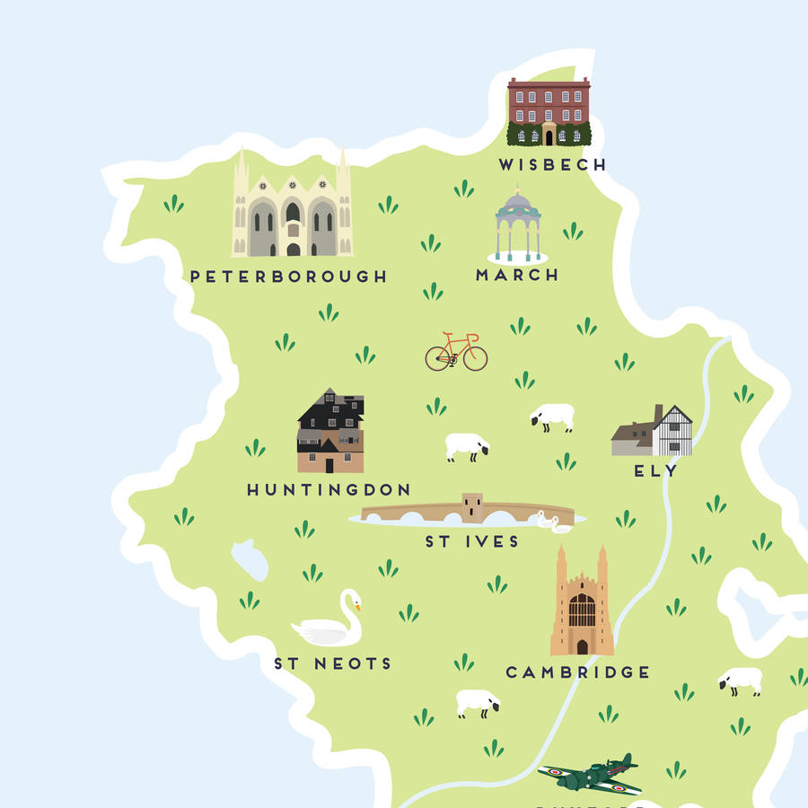
We now operate in 5 parts of the county including Ely, Wisbech, Huntingdon and Peterborough and continue to advocate for young people’s needs in their communities.
Our Vision, Mission and Values

Our Vision is for:

A future where all young people are listened to, respected and supported

Our Mission in Cambridgeshire and Peterborough, is:

- to offer young people support with their practical issues and emotional needs that is free, confidential, empowering, easy-access and high quality.
- to actively work with other local services so that young people’s needs are met, and their voices are heard.

We work closely to these Values:

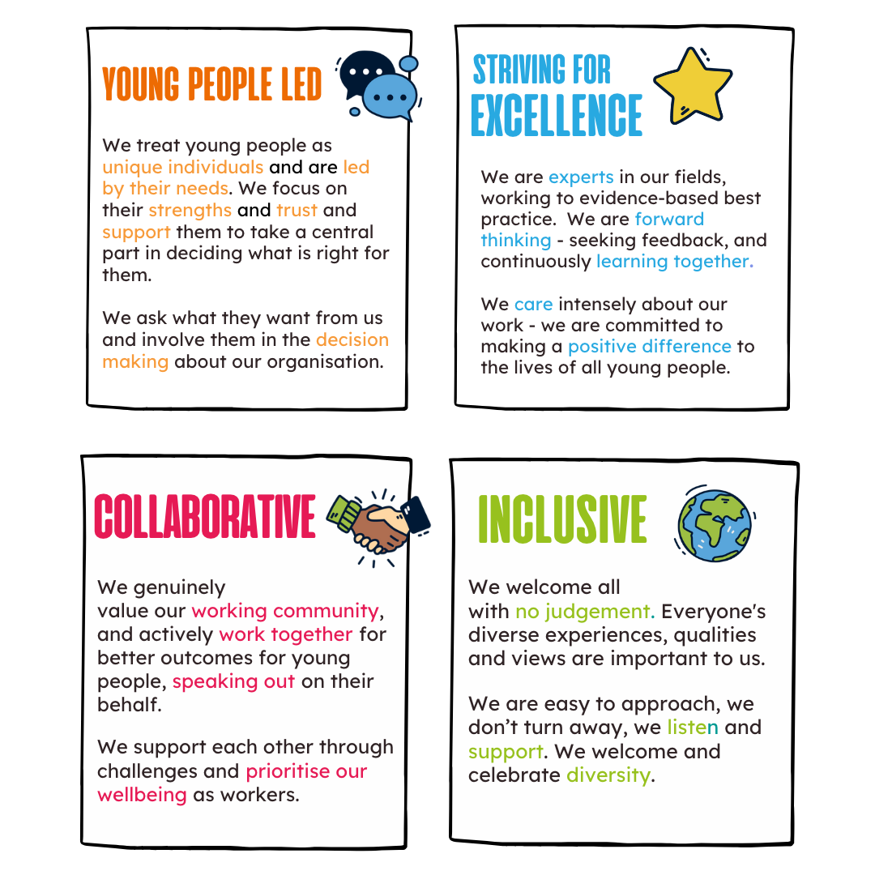
Strategic Plan Goals

Our Strategic Plan outlines our four strategic goals for the next five years. These have been developed through a process of consultation and review with young people, staff and wider stakeholders in the sector.

The goals build on the strong foundations of Centre 33’s work and understanding of local needs developed over 40 years; including the significant work of the last three years:

- Delivering support to more young people, with increasingly complex needs from a wider geographical area.
- Responding and adapting our services and ways of working in response to COVID-19.
- Working with local partners to strengthen the local system of support for young people, through sharing best practice/data, co-production, and capacity building.
- Strengthening our central resources in admin, HR, data, evaluation, communications and fundraising.
- Rapidly growing our income and delivery teams to meet the above demands.

Our four strategic goals fall into areas of impact and areas that enable the impact of our work.

Impact Goals

All young people across Cambridgeshire and Peterborough can receive holistic support that is accessible, high quality, impactful, targeted and led by them. |  | Centre 33 advocates for positive change for young people through dissemination of knowledge and best practice, and collaborative working to ensure high levels of understanding of their needs and clear pathways of support.

Enabling Goals

Centre 33’s workforce and governance is high quality, stable and diverse: working in quality community-based hubs and practices. |  | Centre 33 has financial stability over at least a five- year period; achieved through a clear vision, adequate resources, compliance with best practice and legal requirements; and an established funding mix.

Mental Health and Counselling Team Structure

Team Lead
Job Description – 2026

Key Terms and Conditions

Hours | Full time (35 hrs per week)
Duration | Permanent
Responsible to: | Head of Services
Main Accountability: | Project workers, Volunteers, Administrators
Locations | North or South Based
Purpose of the Role
The Someone To Talk to Team Lead (Mental Health) will lead and oversee the staff and volunteers working across Centre 33’s hubs in the North or South locality team. They will work closely with the other Team Leads, and will jointly ensure the multidisciplinary teams deliver excellent, safe, impactful and responsive services to young people.
The Someone to Talk to Team Lead (Mental Health) will bring expertise and leadership around the Centre 33 Mental Health offer and within the context of the wider mental health system.
The Team Leads will provide support with case allocation, reflective practice, risk management and Safeguarding. They will develop strong relationships with local organisations to ensure effective joint working and support for young people. The Team Lead (Mental Health) will retain a small caseload to support YP with more complex needs. The Team Lead will provide day to day designated Safeguarding leadership across the locality team, supported by the Head of Service and Director of Services.
This role will work to Centre 33’s values of being young people led, collaborative, inclusive and striving for excellence.

Principle duties

Leadership and management

- Support a team culture of warmth, respect, best practice, good communication and shared risk management.
- Support a learning culture within your specialism; identify training needs and contribute to the development of an internal training programme and knowledge sharing. Ensure staff and volunteers receive the necessary resources and knowledge to effectively perform their role.
- Provide line management to the staff, ensuring that there is a positive working culture and that performance management issues are actively addressed at the earliest opportunity; and that induction, supervisions, appraisals and operational meetings take place.
- With the staff that you manage ensure robust, consistent and ethical work with young people.
- Ensure the staff/volunteers you manage have SMART objectives that meet contract needs and organisational vision, and staff are accountable to them.
- To work closely with the Heads of Service and Senior Leadership team in relevant issues of human resource, volunteer management and recruitment/induction as directed.
- Deliver direction to the day-to-day operational teams in your locality on safeguarding decision making, acting as day-to day-designated Safeguarding Lead for the locality, together with the Head of Service.
- Support strategic direction of the services by attending Services Management meetings and helping to shape the services.
- Deliver scheduled out of hours Safeguarding support as part of the Management phone rota, which includes supporting staff from across the organisation.
- Respond to areas of need and support developments to meet these needs including reporting to Heads of Service to inform future bids and report on current funded work.
- Support the delivery of effective Reflective Practice for the service teams

Service Delivery

- Ensure the delivery of an excellent, safe, responsive and value for money service to young people in line with the strategic plan, leadership from the Senior Management Team and learning from best practice including external quality standards.
- Model, embed and ensure that therapeutic practices both individually and within the wider team are of excellent quality and aligned with the BACP Ethical Framework/AFC Core Competencies/Centre 33 values.
- With support from the Head of Service/Clinical Leads, ensure the needs and progress of any clients at particular risk or with complex issues are regularly monitored and reviewed, and relevant external agencies are involved and escalating internally as appropriate.
- Support a strong culture of risk management across all delivery and ensure that all work is carried out within C33’s policies and procedures.
- Deliver direction to the day-to-day operational teams in your locality on safeguarding decision making, acting as day-to-day designated Safeguarding Lead for the locality, together with the Head of Service/Clinical Leads.
- Ensure that young people are actively, imaginatively and meaningfully involved in the shaping, delivery, review, evaluation and promotion of the work.
- Support Heads to ensure the service is thoroughly monitored and evaluated, that the service becomes more impactful and efficient in response to what monitoring and evaluation shows, and that service evaluations inform the further development of existing and new services
- Ensure client notes are recorded accurately and quality data collection is maintained across your teams, with support from Heads of Service/Data and Quality Team.
- Continually develop internal processes and proactively communicate these processes to other staff and volunteers.
- To advocate on behalf of young people and represent them across forums.
- To have access to and be competent in use of SystemOne and LiquidLogic
- To be available to support the YOUnited team on an ad-hoc basis (attendance at MDT for example)
- Continue to provide a small caseload of direct client work within your team

Communications and Stakeholder Engagement

- Maintain a good knowledge and understanding of young people’s support services in the statutory and voluntary sector
- Establish and maintain excellent working relationships with local organisations & individuals, developing good co-working relationships where appropriate.
- Represent and promote needs of young people/Centre 33 in local networks or initiatives to share our experiences and also to bring learning back to the organisation as appropriate
- Ensure staff and volunteers are aware of local and national initiatives, best practice and relevant legislation within your specialism.
- Act as an advocate for Centre 33, representing the charity at fundraising opportunities & events as directed.

Organisational

- Be mindful of resources within the organisation and prioritise the available resources appropriately
- Represent Heads of Service on internal or external matters, when appropriate.
- Any other duties, as appropriate to role, as agreed by Centre 33 Head of Services.
- Receive regular managerial supervision with the Heads of Services
- Contribute to a range of agency events including staff meetings, strategic planning, Away Days, AGMs and county-wide meetings.

The postholder may be expected to undertake other duties from time to time, under the direction of the Heads of Services, relevant to the grading of the post.

Team Lead
Person Specification – 2026

Criteria | Essential | Desirable
Leadership | - Excellent communication skills with a range of stakeholders  - Willingness to develop leadership skill  - Experience of leading a team or service  - Experience and confidence in advising/Supporting colleagues with Safeguarding concerns including leading the process to refer on when appropriate  - Experience of people management.  - Experience of complex risk management  - Experience of supporting teams with complex caseloads  - Experience in delivering MH focussed services or projects | - Experience in delivering open access, person centred support services or projects  - Experience of managing Multi-Disciplinary service teams  - Experience of identifying and delivering (or sourcing) appropriate training and development opportunities for a team of frontline facing staff  - Experience of group facilitation
Service Development | - Ability to co-ordinate a complex team workload within time limits.  - Ability to initiate new areas of work and to make suggestions or proposals to your manager  - Excellent communication skills both verbally and in written communications (internally & externally).  - An understanding of and commitment to the promotion of Equal Opportunities.  - Experience of implementing health and safety procedures and policy including writing risk assessment for safe working in hubs and community settings | - Experience of working in the voluntary sector.  - Experience of monitoring and evaluating services and using evaluation evidence to make improvements.  - Experience of involving service users in commenting on, changing and planning services
Working knowledge of young people | - A recognised Level 4 or above qualification in a field relevant to this role ie. Counselling/CWP/Youth work/Social Work OR significant experience and relevant training in a field related to this role.  - Experience of working with vulnerable young people who are experiencing mental health difficulties - ability to encourage, motivate and support  - Sound knowledge of statutory services (including targeted support, social care and mental health services) their function and appropriate referral procedures.  - Experience of client assessment and risk assessments.  - Ability to enable people to identify their long-term goals and the steps they might need to achieve them  - A working understanding of a range of therapeutic interventions  - Substantial experience and knowledge of child protection and safeguarding procedures for children and young people up to the age of 25.  - An ability to reflect on your professional practice and to proactively seek resources and support for personal development. | - Experience of using a range of Routine Outcome Measures
Personal Qualities | - Ability to demonstrate working within Centre 33’s values within- practice Young people led, collaborative, inclusive and striving for excellence  - Positive, self-motivated, pro-active and flexible.  - A trustworthy and effective team member.
Other | - Strong IT literacy in general (and specifically Word, Excel and Outlook).  - Experience of using web-based Management Information Systems;  - Full drivers licence and access to a car.  - Willingness and ability to travel to different locations within Cambridgeshire and Peterborough.
All roles at Centre 33 may involve access to information about young people and as such all new employees and volunteers will be subject to an enhanced DBS check. Having a criminal record will not necessarily bar you from working with us. This will depend on the nature of the position and circumstances and background of your offences.

Further Information

Equality, Diversity, Inclusion and Belonging at Centre 33

Centre 33 is committed to encouraging equality, diversity and inclusion among our workforce and users, and eliminating unlawful discrimination. The aim is for our workforce to be truly representative of all sections of society and for each employee, volunteer and service user to feel respected.
Our over-arching goals are:
- We encourage equality, diversity and inclusion in the workplace and create a working environment free of bullying, harassment, victimisation and unlawful discrimination, promoting dignity and respect for all, and where individual differences and the contributions of all staff are recognised and valued.
- We commit to actively reaching out to all communities of young people, investigating how we can welcome them to our services and breaking down any barriers to access.
- We commit to challenging instances of any power imbalances that may leave some people in our services or on our team at risk of harm or disadvantage.
- We commit to valuing and improving diversity in our workforce, governing body and volunteer base–we want to reflect the communities we work with.
- We commit to using language and communications that don’t alienate, discriminate against or misrepresent any group.

Safeguarding Statement, Rehabilitation of Offenders Act 1974

All staff and volunteers at Centre 33 undertake an enhanced DBS Check. Having a criminal record will not necessarily bar you from working with us. This will depend on the nature, circumstances and background of the offenses. If you have a criminal conviction, other than those spent under the terms of the Rehabilitation of Offenders Act 1974, please contact hr@centre33.org.uk and they will confirm the process for confidentially informing us.

