

(Someone to Talk to) Lead Service Administrator

Applicant Information Pack
March 2026


Introduction

I’m delighted you’re considering working with us at Centre 33 within the Someone to Talk to Service Administration Team.

Centre 33 has been supporting young people in Cambridgeshire for over 40 years. We work closely with around 4000 young people a year offering a safe space where they can receive free, confidential and professional support in a non-judgemental and welcoming setting. Working across the county, we building local relationships and advocating for young people’s needs in local services and communities.

By choosing a career with us you will play an instrumental role, alongside our fantastic staff, volunteers and supporters, in helping us to continue towards our vision of a future where all young people are listened to, respected and supported.

Everyone at Centre 33 is passionate about driving positive change to meet the growing need for improved and expanded services to support young people across the county.

I am exceptionally proud to lead Centre 33 and I hope that reading through this pack will inspire you to apply to join us.

Beth Green
Chief Executive Officer

Our History

Centre 33 opened its doors to young people at 33 Clarendon Street on 1stMay 1981. Save the Children funded our first worker, Maggie Hunter and she quickly recruited a team of volunteers to offer counselling, advice and support to meet the needs of young people in Cambridge.

“It was to be a warm and welcoming space for young people where they could come and be listened to without judgement. All the services were to be free and confidential.”

Now in our 42nd year we continue to reflect on what has changed and what has stayed the same over time. We hold true to the founding ethos of Maggie Hunter and her team and still value the rights of young people to have their own space and to be treated as individuals worthy of respect and support.

To date we have closely worked with over 40,000 young people through counselling, support with caring responsibilities, homelessness, sexual health and more.


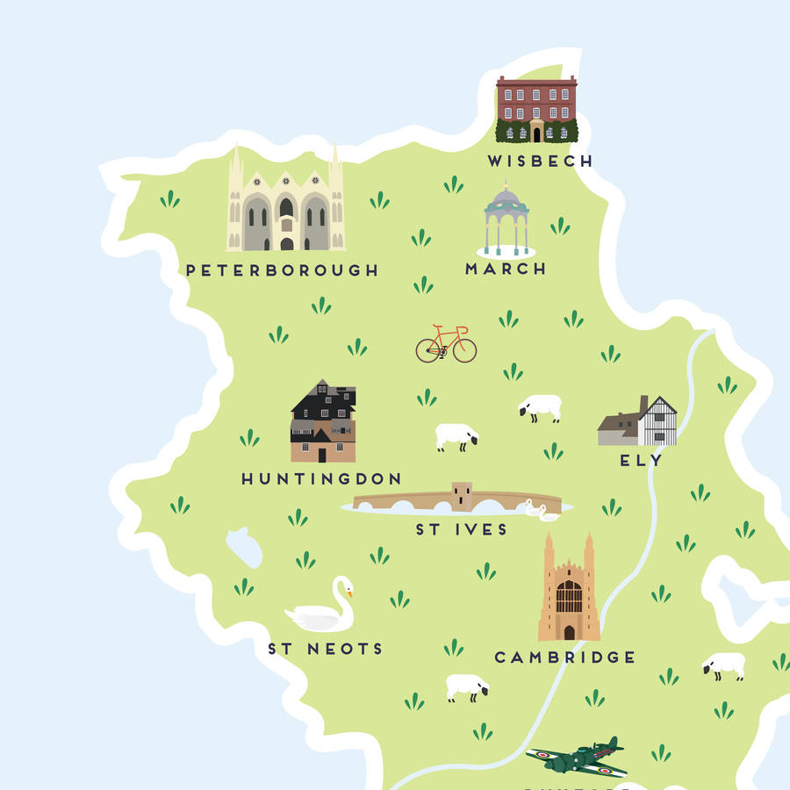
We now operate in 5 parts of the county including Ely, Wisbech, Huntingdon and Peterborough and continue to advocate for young people’s needs in their communities.
Our Vision, Mission and Values

Our Vision is for:

A future where all young people are listened to, respected and supported

Our Mission in Cambridgeshire and Peterborough, is:

- to offer young people support with their practical issues and emotional needs that is free, confidential, empowering, easy-access and high quality.
- to actively work with other local services so that young people’s needs are met, and their voices are heard.

We work closely to these Values:

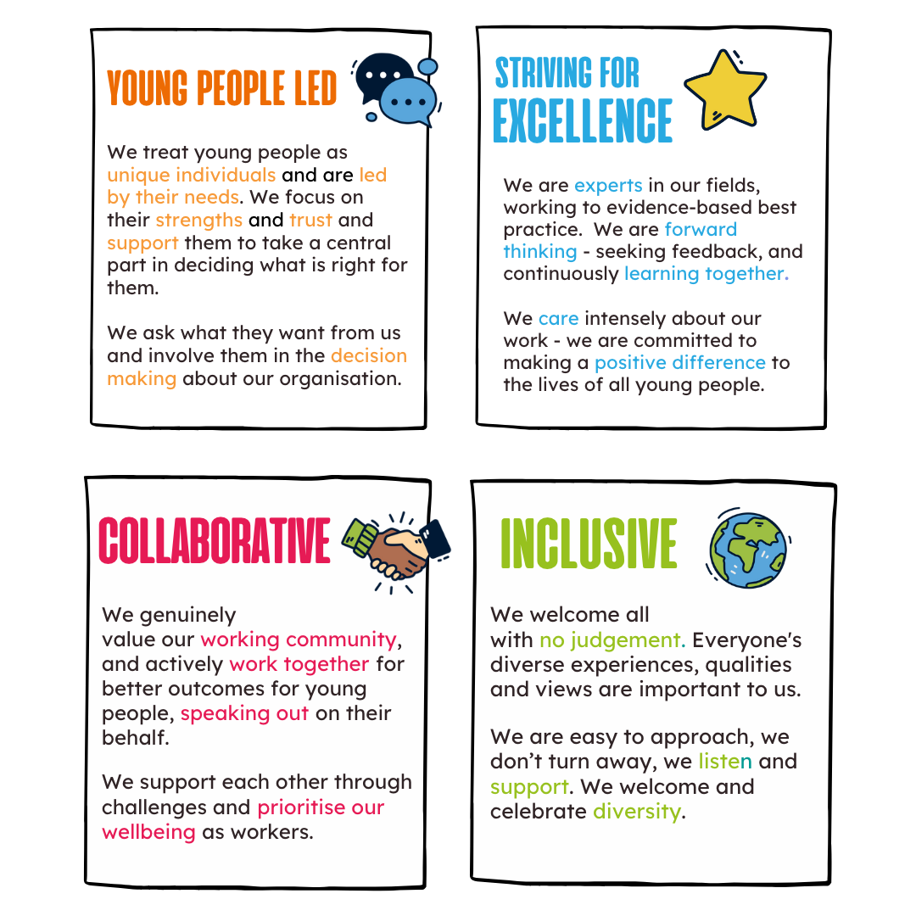
Strategic Plan Goals

Our Strategic Plan outlines our four strategic goals for the next five years. These have been developed through a process of consultation and review with young people, staff and wider stakeholders in the sector.

The goals build on the strong foundations of Centre 33’s work and understanding of local needs developed over 40 years; including the significant work of the last three years:

- Delivering support to more young people, with increasingly complex needs from a wider geographical area.
- Responding and adapting our services and ways of working in response to COVID-19.
- Working with local partners to strengthen the local system of support for young people, through sharing best practice/data, co-production, and capacity building.
- Strengthening our central resources in admin, HR, data, evaluation, communications and fundraising.
- Rapidly growing our income and delivery teams to meet the above demands.

Our four strategic goals fall into areas of impact and areas that enable the impact of our work.

Impact Goals

All young people across Cambridgeshire and Peterborough can receive holistic support that is accessible, high quality, impactful, targeted and led by them. |  | Centre 33 advocates for positive change for young people through dissemination of knowledge and best practice, and collaborative working to ensure high levels of understanding of their needs and clear pathways of support.

Enabling Goals

Centre 33’s workforce and governance is high quality, stable and diverse: working in quality community-based hubs and practices. |  | Centre 33 has financial stability over at least a five- year period; achieved through a clear vision, adequate resources, compliance with best practice and legal requirements; and an established funding mix.

Job Title: Lead Service Administrator

Key Terms and Conditions
Hours | 28- 35 hours per week. Predominately between the hours of 9.30-5.30pm with some Saturday working based on a rota.
Duration | Permanent
Responsible to | Head of Service/ Service Administration Development Lead
Locations | This role requires working every day from our Centre 33 hubs. Our hubs are in Peterborough, Huntingdon, Cambridge, Ely and Wisbech.  The candidate will have a base in Peterborough, Huntingdon or Cambridge with regular travel across the other hubs.
Purpose of the role
This role is to lead a team of Service Administrators to ensure that every young person receives a high level of service and teams are well supported to deliver this service. You will understand all areas of service delivery , including but not limited to handling incoming communication and enquiries from service users and external agencies via our frontline telephone, email, WhatsApp and text streams, providing admin support during our drop in services, as well as supporting referrals, bookings and managing waiting lists for our services to be able to provide cover for all roles for absence. You will provide admin and PA support to Service Delivery Leadership Team to promote effective systems.
Principle Duties
Management of Service Administrators
- Work and rota planning of service delivery administrators to ensure robust service delivery
- Provide line management to service administrators
- Work closely with the Service Administration Development Lead with aligning services, developing new systems and standard operating procedures
- Providing training and upskilling to staff to promote efficiency
- Acting as an advocate for the service administrators to develop team dynamic

Service Admin
Providing day to day support to the service administrators, in particular during times of absence, who are responsible for the following tasks:
- Dealing with general enquiries from the public, service users, external partner agencies via telephone, email, WhatsApp, and Text. This will include talking / responding to young people who are contacting us for support around their mental health, sexual health, or housing needs amongst other sensitive issues, and will occasionally include young people who are distressed.
- Receiving incoming referrals and entering them into the internal client pathway
- Booking, management and changes/cancellations to of appointments and room bookings, including liaising with parents, young people and counsellors
- Management of the counselling waiting list, including reviewing data on wait times to provide up to date information
- Regularly monitoring and updating our room and appointment booking system to ensure appropriate and efficient use of available appointments
- Acting as a receptionist on the frontline, welcoming young people into the building and managing the waiting room to ensure a welcoming atmosphere and that the first point of contact with Centre 33 is a positive experience
- Monitoring and managing incoming communications, including ensuring emails, messages and post are passed on to the appropriate people in a timely way.
- Supporting the wider organisational admin team with any outstanding tasks including cover for holidays
- Ensure a safe, welcoming space in the hubs for young people, visitors and staff
- Bookings of external room hire as appropriate.

Service Delivery Leadership Team Support
- Providing support to a small team of service managers to ensure they can carry out their roles effectively
- Inbox and diary management
- Administration of documentation such as assisting with documentation for quality audits
- Management of hub cover and management phone rota
Other
- Working closely with the data and operations team to ensure systems and processes are efficient, well understood and fit for purpose
- Visit other hubs and service delivery administrators on a frequent basis
- Attend and participate in team and organisational meetings, training days and events, as required.
- Undertake any other duties, as appropriate to role, as agreed by Centre 33 Heads of Service.
- Undertake all duties in accordance with Centre 33 policies and procedures.
- Proactively working with the wider organisational team to ensure our hubs are safe and welcoming spaces
Person Specification
Criteria | Essential | Desirable
Experience | - Experience of working in a senior administration role  - Experience of people management  - Experience of working with CRM databases and client records  - Experience of working with a confidential environment  - Experience in supporting the development of standard operating procedures | - PA experience  - Experience with using Charity Log and/or System One  - Experience of working with vulnerable young people and assessing risk
Ability | - Ability to plan and manage varied workloads for both yourself and the wider teams  - Ability to lead teams, advocate and show value for the work undertaken  - Excellent skills in using Microsoft office, as well as training others  - Willingness to embrace other IT systems as required.  - Ability and enthusiasm to implement new systems and process to improve efficiencies.  - Ability to manage change. | - Skills in data analysis and acting on results  - Excellent skills with multiple CRM databases
Personal Qualities | - Agile and self motivated  - Confident in making suggestions and develop new initiatives to improve service admin delivery  - Emotional intelligence in leadership  - Ability to prioritise and be agile  - Nonjudgmental attitude  - Self-motivated | - Understanding of the issues facing young people

The successful candidates will receive a range of benefits including:
- competitive salary
- generous pension contributions
- excellent on-going training and development opportunities
- company sick pay post probationary period
- team days and activities
- wellbeing focus
- flexible working
- 25 days holiday increasing to 30 after 5 years’ service
All roles at Centre 33 may involve access to information about young people and as such all new employees and volunteers will be subject to an enhanced DBS check. Having a criminal record will not necessarily bar you from working with us. This will depend on the nature of the position and circumstances and background of your offences.

Further Information

Equality, Diversity, Inclusion and Belonging at Centre 33

Centre 33 is committed to encouraging equality, diversity and inclusion among our workforce and users, and eliminating unlawful discrimination. The aim is for our workforce to be truly representative of all sections of society and for each employee, volunteer and service user to feel respected.
Our over-arching goals are:
- We encourage equality, diversity and inclusion in the workplace and create a working environment free of bullying, harassment, victimisation and unlawful discrimination, promoting dignity and respect for all, and where individual differences and the contributions of all staff are recognised and valued.
- We commit to actively reaching out to all communities of young people, investigating how we can welcome them to our services and breaking down any barriers to access.
- We commit to challenging instances of any power imbalances that may leave some people in our services or on our team at risk of harm or disadvantage.
- We commit to valuing and improving diversity in our workforce, governing body and volunteer base–we want to reflect the communities we work with.
- We commit to using language and communications that don’t alienate, discriminate against or misrepresent any group.

Safeguarding Statement, Rehabilitation of Offenders Act 1974

All staff and volunteers at Centre 33 undertake an enhanced DBS Check. Having a criminal record will not necessarily bar you from working with us. This will depend on the nature, circumstances and background of the offenses. If you have a criminal conviction, other than those spent under the terms of the Rehabilitation of Offenders Act 1974, please contact hr@centre33.org.uk and they will confirm the process for confidentially informing us.

