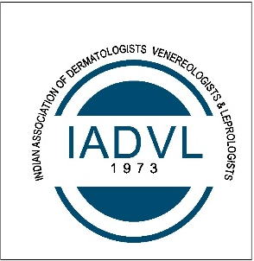
INDIAN ASSOCIATION OF DERMATOLOGISTS, VENEREOLOGISTS AND LEPROLOGISTS
Referral Certificate

This is to certify that I know Dr_____________ since________years. I recommend him/her to be the below member of IADVL.
Life Member
Provisional Life Member
Associate Life Member
International Life Member

Proposed by:
- Name _________________________
- LM NO _______________
- E-mail id ____________________
- Contact No. _________________

Signature of Proposer__________________
Seconded by:
- Name __________________________
- LM NO ______________
- E-mail id ____________________
- Contact No. _________________

Signature of Seconder__________________

