During the project GM will have cameras installed in all halls where the machine installation is ongoing.
Gyllensvaans Möbler AB
Storgatan 6, 52195 Kättilstorp
Company Reg. No. 5561226811
CEO: Eric Gyllensvaan
Contact Information for Data Protection Inquiries
Email: anders@gyllensvaan.se
Phone: +46 515 86440
Purpose of Surveillance
Used to prevent crime, investigate incidents and accidents, and ensure compliance with applicable regulations.
Retention Period
Recordings are stored for a maximum of 3 months.
Access to Recorded Material
Only accessible to individuals with security clearance.

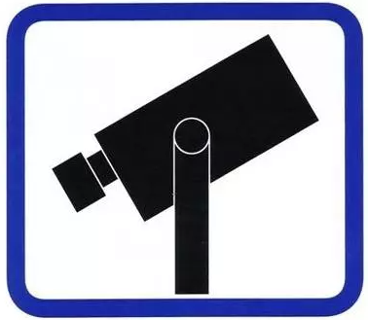
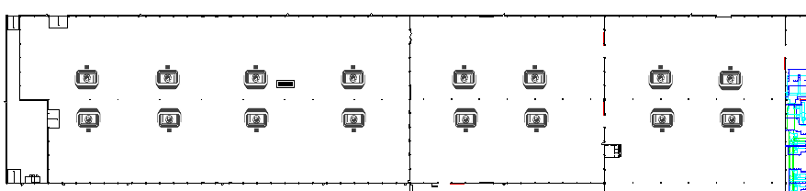
Video surveillance

