When you arrive to Gyllensvaans Möbler as an external worker for the first time, it is mandatory to go to the main entrance and report there. Please respect the Office opening hours 06:30-16:00 Mon-Thursday and 06:30-13:00 Friday.

You will state your name at the front desk, and they will give you an Rfid tag. This tag gives you entrance to the building and the possibility to clock in and out.

You also need to present the form, if you didn´t mailed it in advance, and also if you have any certificates.

You will receive Swedish certificates for those that is needed.

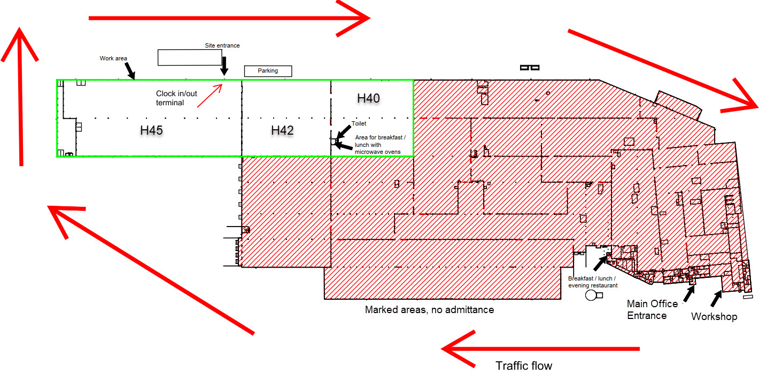

You can work all days around the clock, we prefer no work at night.

If you should lose your tag, contact main office to get a new one.

If you need an internet connection, use the WIFI with the name **INTERNET** and the password **gyllaudi**.