You should familiarize yourself at your workplace with the location of the nearest evacuation route, emergency exits, fire alarm button, and where to find fire extinguishers.
All personnel are responsible for keeping exits and emergency exits clear, and for ensuring that alarms and fire equipment are not obstructed.
No smoking or open flames is allowed. Hotworks is described in another document.
If the fire alarm should sound, there is two different signals:
____ ____ ____ Prepare to evacuate
____________________ Evacuate

Evacuation Routes
In case of fire, gas leak, or other hazards, evacuation routes are marked with evacuation symbols.
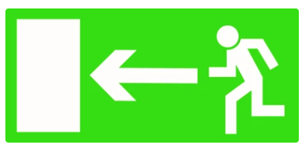

Assembly Point
The assembly point is the parking lot outside the main office.
All personal and external, must familiarize themselves with the location of the nearest evacuation route, emergency exits, fire alarm buttons, and fire extinguishers at their workplace.
