GENERAL HEALTH AND SAFETY PROCEDURES

## All companies and employees working at this site must actively participate in health and safety procedures and comply with applicable laws, regulations, and instructions.

General Rules for Health and Safety

## All contractors must follow the safety procedures applicable to the worksite.

## All incidents or faults must be reported immediately to the head project leader and the safety representative.

## Mobile phones may not be used in areas where attention is required, such as when working at heights or with machinery.

## Smoking is only permitted in designated areas and is strictly prohibited indoors.

Personal Protective Equipment (PPE)

## Provided by each respective employer/contractor.

## High-visibility clothing or vest must always be worn on the upper body as the outermost layer.

## Safety shoes with steel toe caps are mandatory.

## Hearing protection, respiratory protection, safety glasses, etc., must be used where required.

Cleaning

Each team is responsible for cleaning its own work area and for sorting and transporting waste to the designated container.

If a contractor fails to maintain a good cleaning standard, Gyllensvaans Möbler may carry out the cleaning at the contractor’s expense..

## http://www.gossman.se/akla/bilder/91166.3.jpghttp://www.tryggsaker.se/cache/65/600x600-AKLAIII.jpg Injury and Illness

#### First Aid

#### Familiarize yourself with the locations of first aid equipment.

#### It is available at the entrance and by the restroom (Old Shipping Office).

#### First aid for burns = orange bag

First aid for serious injuries = green bag

 In the event of an injury, the safety representative must be called.

*Eye Wash Station*

Eye wash stations are located at the forklift charging area.

If you need to use an eye wash station, always remain there until help arrives.

Find out where the nearest emergency shower is before starting your work.

#### SC-Slide-1Cardiopulmonary Resuscitation (CPR)

In the event of cardiac arrest, CPR must be started immediately.

Anyone can use the defibrillator—just follow its instructions.

The defibrillator is located at the old shipping office.

Psychosocial Work Environment

Harassment, discrimination, and other inappropriate behavior are strictly prohibited.

We show respect for one another..

Alcohol and Drugs

## Alcohol and drugs are prohibited in the workplace.

## Personnel under the influence of alcohol or drugs will be immediately removed from the site.

## If an employee discovers that someone is under the influence, the person must be removed and management must be informed.

## Gyllensvaans Möbler may conduct random alcohol and drug tests.

Employee Areas

## Everyone is responsible for keeping staff areas clean and tidy.

## Parking is only allowed in designated areas.

Tools and Machinery

## Tools must be CE-marked and/or type-approved.

Fall Hazard

## Only authorized personnel may assemble, modify, or move scaffolding.

## Work involving fall protection equipment must never be performed alone. A rescue plan must be in place before work begins.

## Fall hazards should primarily be managed using railings, guards, or technical solutions.

## Secondarily with collective protection, and only as a last resort with personal fall protection equipment.

## Fall protection is mandatory when working in lifts (e.g., scissor lifts, boom lifts).

## Ladders may only be used in exceptional cases where no safer alternatives are possible.

## Forklifts

## You must wear safety shoes when operating a forklift.

## There must never be more than one person on the forklift.

## You must never walk under the forks or the pallet.

## Do not place any trash or objects on the forklift while it is charging.

## Blue light on forklifts:

## The blue light is used to signal that a forklift is reversing. This is implemented to reduce the risk of collisions.

## It is forbidden to talk on the phone while operating a forklift.

Aerial Work Platforms (AWPs)

When working with boom lifts and scissor lifts, fall protection must be used.

Fall protection equipment for lifts is stored at the lift charging station.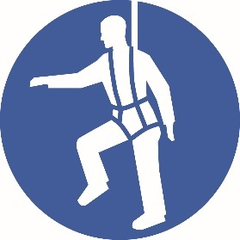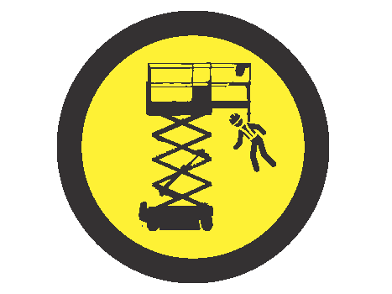

Emergency

Call 112 and request an ambulance. Be prepared to provide the following information:

* Who you are and where you are calling from
* What has happened
* Type of injury or medical issue

If You Need to Provide an Address Storgatan 6

52195 Kättilstorp

Coordinates: RT90:

X: 6437012, Y: 1376192

WGS84:

Lat N 58° 2′ 23″Lon E 13° 42′ 32″

Decimal:

58.0398, 13.7089