In Hall 45, three charging spots is located at the wall to Hall 42.

Keep the area around the forklift clean and free from flammable things during charging.

Do not move the barriers around the charging stations

En bild som visar krets, Färggrann, skärmbild, Elektrisk ingenjörskonst

AI-genererat innehåll kan vara felaktigt.

En bild som visar byggnad, mark, inomhus, vägg

AI-genererat innehåll kan vara felaktigt.

**Battery water.**

|  |  |
| --- | --- |
| Once a week the responsible company for each forklift must check the level of water in the battery.   1. Place the pallet with water on the forks 2. Lift the pallet to get pressure of the water. 3. Connect the to the automatic filling system on the battery. This is located under the seat or behind a hatch or on the left side. Same position as the loading inlet. 4. The battery is levelling the water automatically. | The water is located at charging station 1 and 2.  En bild som visar flaska, mark, av trä  AI-genererat innehåll kan vara felaktigt. |

**Safety equipment.**At charging station 1 and 2 necessary safety equipment is placed to be used.

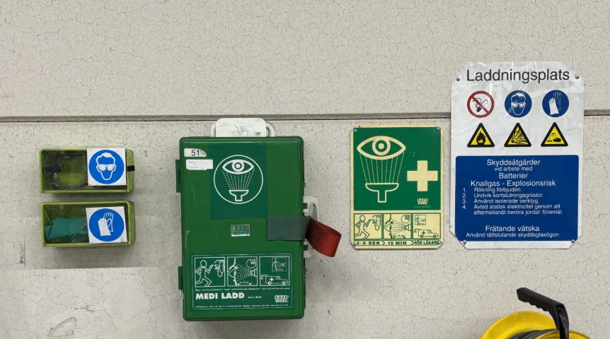

If there are any problem, contact your supervisor.