Hot work refers to tasks that involve open flames, sparks, or high heat, such as welding, cutting, grinding, or soldering. These activities can pose a serious fire risk if not properly managed.

Key points:
A hot work permit is required before starting any hot work. The checklist is on this site.
The work area must be cleared of flammable materials or properly protected.
Fire extinguishing equipment must be available nearby.
A fire watch must be in place during and after the work is completed.
Only trained and authorized personnel may perform hot work.
Always follow your company’s safety procedures and national regulations to prevent accidents and ensure a safe working environment.
Always fill in the checklist and give it to your supervisor who will store it.

Area for Hotwork in Hall 40
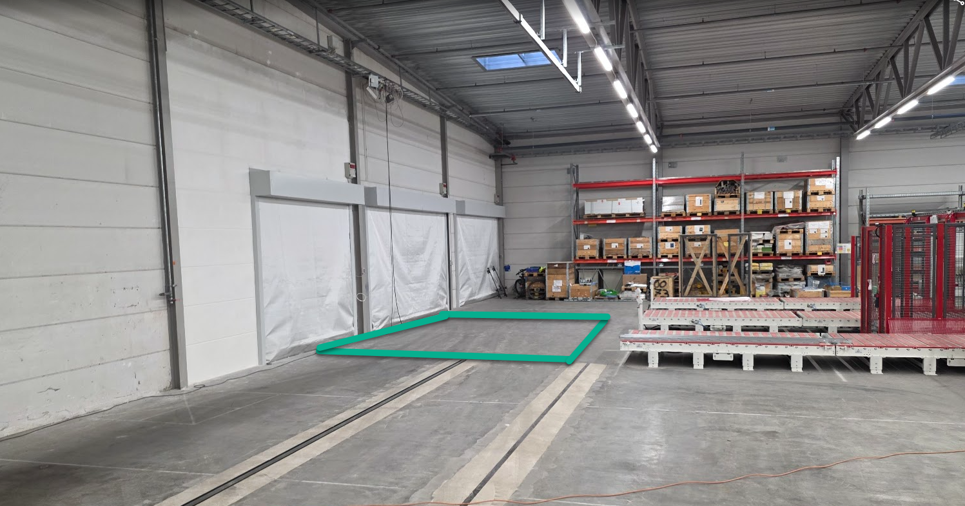
This area must not contain any flammable material like pallets or well!
If not, it is always ok to perform hotwork here.

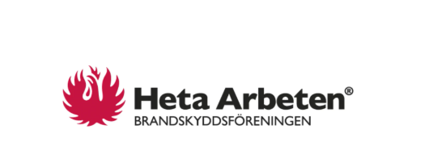
More information:
Swedish authority “Brandskyddsföreningen”
https://www.hetaarbeten.se/en/

