United Way

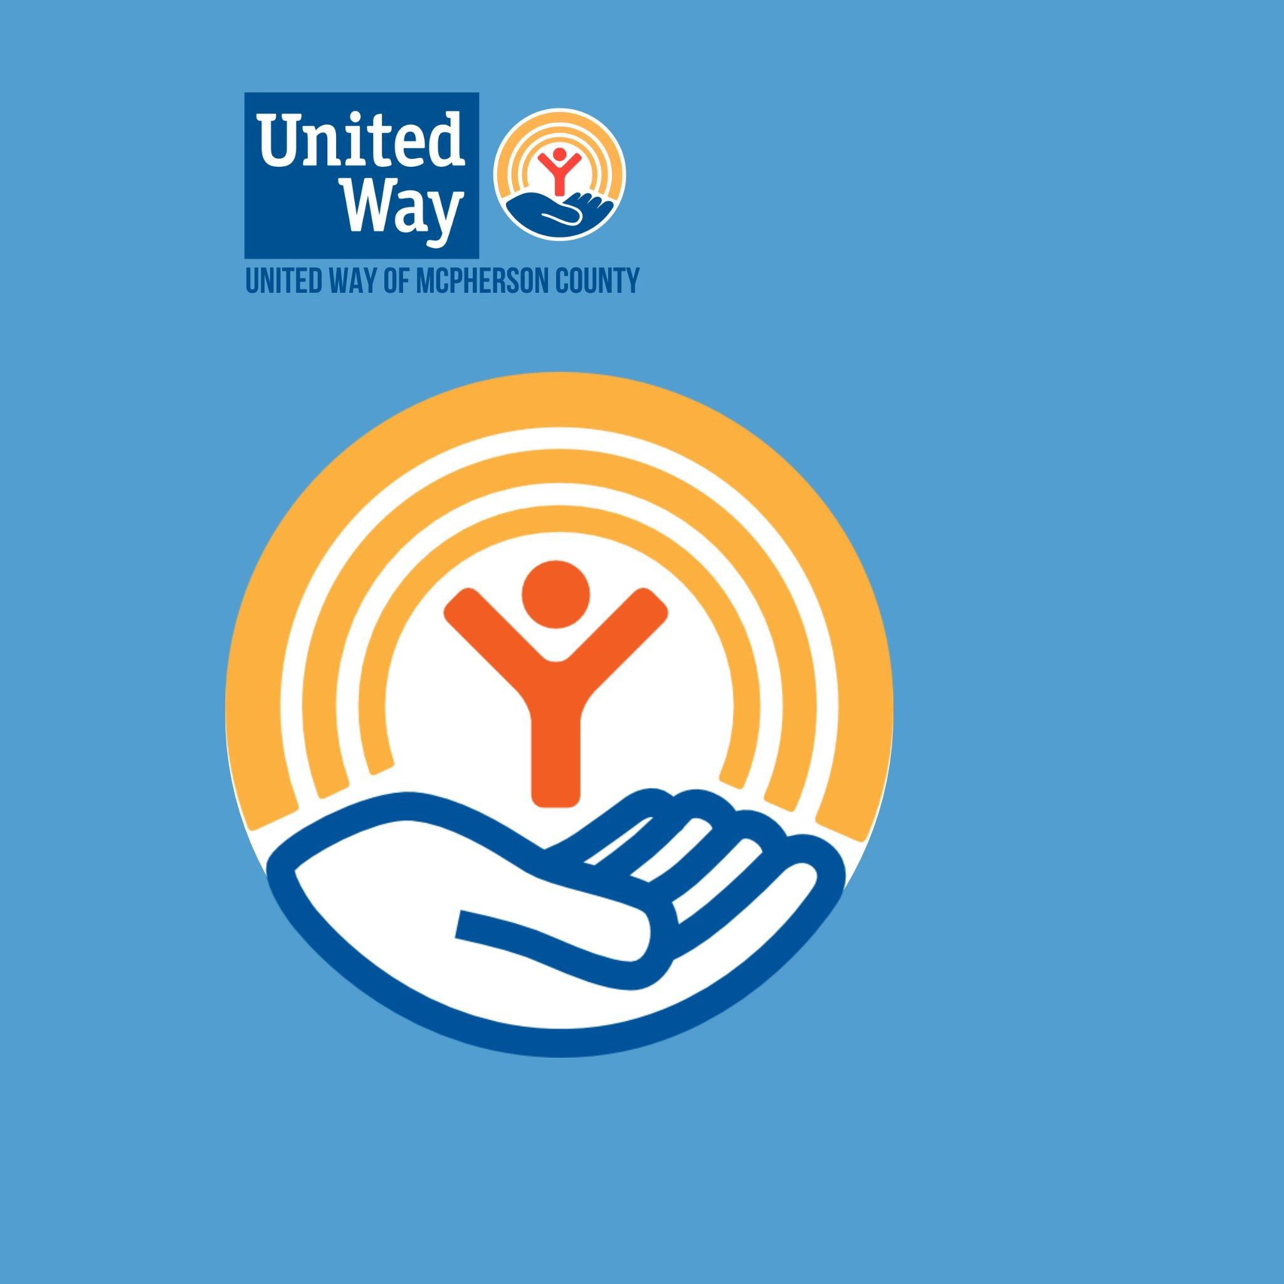
REQUEST FOR 2026 FUNDING: OVERVIEW

APPLICATION DEADLINE: Friday, January 16, 2026, 5:00 p.m.

PROGRAM APPLICATION

United Way of McPherson County accepts applications for PROGRAM funding that addresses at least one (1) of four (4) PRIORITY AREAS as identified by the United Way of McPherson County Board of Directors to accomplish overall community impact goals. Funding requests must be for a specific PROGRAM associated with a non-profit human service organization providing services in McPherson County. A budget worksheet must be submitted with the funding request demonstrating the organization’s overall operating budget and the program budget. The Allocations Committee appointed by United Way of McPherson County will review each program application and the impact it has on the community and its residents. The funding request must address one of the four (4) PRIORITY AREAS as defined below:

PROVIDING BASIC NEEDS | Assure access to basic needs including housing, food, clothing, healthcare, affordable transportation and safety/security
PREPARING FOR LIFE | Assure that all children develop physically, intellectually, emotionally and socially in a safe, nurturing environment
REBUILDING LIVES | Help people live healthy, functional lives through emergency assistance, support and counseling
BUILDING SELF-RELIANCE | Empower citizens with information and access to resources to become self-reliant

INSTRUCTIONS

Review the criteria to determine funding eligibility. Complete and submit the following documentation:
ONE (1) FILE INCLUDING: FOR 2026 PLEASE SUBMIT ALL THE DOCUMENTS LISTED BELOW
- Copy of IRS letter granting the agency’s 501(c)3 status
- Copy of current bylaws and current board members
- Copy of a complete financial statement of the agency’s most recent fiscal year (audited if available)
- Copy of most recent IRS 990 (if your organization files one)
- Copy of organization budget for current fiscal year
- Copy of previous years ’program budget (actual)
- Copy of projected program budget specific to the program(s) for the current application year
- Signed Anti-Terrorism Compliance Measures form (Page 5)
- Signed Annual Statement of Agreement (Pages 3-4)
- Completed Part I – Agency & Program Profile (Page 6)
- Completed Part II – Program Grant Application (Page 7)

*These documents MUST be submitted together as a PDF and emailed to uwmc@unitedwaymcpherson.org.
With permission a copy may be hand delivered or mailed to the UWMC office. This paper copy must have NO staples and no more than one paper clip or binder clip to hold it all together.

FAILURE TO INCLUDE ANY OF THE INFORMATION OUTLINED ABOVE COULD RESULT IN THE REJECTION OF THE AGENCY’S
APPLICATION. For more information, contact United Way of McPherson County at uwmc@unitedwaymcpherson.org 620.241.5152. Application deadline: Friday, January 16, 2026, 5:00 p.m

ALLOCATIONS PROCESS
All applicants will be invited to an interview with the Allocations Committee comprised of board members and citizen volunteers. The 20-minute session will allow opportunity for further program description and clarification of details. Application submission and the interview process does not guarantee funding approval. The 20-minute session includes time for presentation and for questions. It is recommended that you leave at least 5-10 minutes for questions. The interview process is subject to change.

Proceeding the interview, The United Way of McPherson County Allocations Committee will make a recommendation regarding the funding level for each program to the United Way of McPherson County Board of Directors. All decisions of the Allocations Committee shall be subject to the approval of the Board of Directors. The partner agency will receive written notification of the final allocations awarded.

PROGRAMS NOT ELIGIBLE FOR FUNDING

- Those programs which are political in nature, including agencies that exist solely as advocates for special interest groups.
- Those programs that provide services only to the members of a particular religious group or which exist to advocate particular religious beliefs.
- Those programs that exist solely as a forum for the presentation of cultural or artistic achievements.
- Those programs that are considered a capital improvement project i.e. a new building, a building addition or a remodeling project
- Those programs that are designated as an investment strategy i.e. endowment funds or fundraisers.
- Any other program the United Way of McPherson County Board of Directors considers inappropriate for United Way support.

REQUEST FOR FUNDING 2026: ANNUAL STATEMENT OF AGREEMENT
The purpose of this agreement is to define a cooperative and mutually beneficial relationship between United Way of McPherson County and its partner agencies providing funded programs so that they may achieve a purpose common to all stakeholders including donors, clients, partner agencies and United Way of McPherson County. This agreement is to be signed annually by both parties before allocations may be released. All funding is contingent on the availability of funds; nothing in this document is to be construed as a guarantee of funding.

SECTION I: GENERAL PRINCIPLES

- United Way of McPherson County and the Partner Agency agree to maintain a policy of “non-discrimination” in compliance with federal and state guidelines and/or regulations.
- United Way of McPherson County and the Partner Agency agree to conduct operations subject to sound budget controls and fiscal procedures.
- United Way of McPherson County and the Partner Agency agree that in the event United Way of McPherson County is unable to meet its financial obligation to the Partner Agency, the Partner Agency will receive an amount as determined by the United Way of McPherson County Board of Directors with no right to appeal.
- United Way of McPherson County and the Partner Agency will work together at campaign time to ensure a successful drive. United Way of McPherson County will seek the support of the Partner Agency and the Partner Agency will provide whatever assistance is requested of them including providing volunteers, planning tours and/or assisting with campaign activities.

SECTION II: UNITED WAY OF MCPHERSON COUNTY AGREES
- The allocation for the Partner Agency program for the 2025 allocation year shall be paid on a quarterly basis, payable the fifteenth beginning in March, upon receipt of the Partner Agency’s designated documents as required by United Way of McPherson County.
- To promote and support the Partner Agency and the agency’s services throughout McPherson County.
- To extend to the Partner Agency the benefit of United Way experience and assistance when requested.
- To give the Partner Agency adequate notification and time to prepare for the annual membership review and allocations process.

SECTION III: THE PARTNER AGENCY AGREES

- To be registered with the IRS as a 501(c)3 organization, providing health and human care programs for residents of McPherson County.
- To notify United Way of McPherson County in writing of any major changes to its services or its ability to carry out its mission including but not limited to change in location, director or programs.
- To provide reporting as requested by United Way of McPherson County throughout the funding year.
- To use no funds allocated to the Partner Agency from the United Way of McPherson County for any activity, service or program other than that for which it was requested unless otherwise approved by the United Way of McPherson County Board of Directors.
- To refrain from any fundraising activities that directly compete with United Way of McPherson County’s fundraising initiatives.
- At no time will the Partner Agency conduct workplace campaigns, defined as mass fundraising solicitations of individuals in the workplace setting.
- Unexpended allocated funds will be returned to United Way of McPherson County.
- By accepting allocated funds, United Way of McPherson County has the right to use the Partner Agency’s name in all marketing materials.
- To display the United Way of McPherson County insignia on all printed and website material and to promote the interests of United Way of McPherson County in all its publicity and/or news releases. The Partner Agency will include

the fact that it is a United Way of McPherson County Partner Agency in all news and public presentations. Failure to comply with this provision could result in loss of funding in subsequent years.
- To register service information with 2-1-1, a United Way hotline for those seeking assistance and/or volunteer opportunities.

SECTION IV: UNITED WAY OF MCPHERSON COUNTY AND THE PARTNER AGENCY AGREE

- To maintain a responsible management, governing board and staff to administer its program.
- To have a financial management system that meets the basic standards of accounting, but not limited to, a complied annual financial report and monthly financial reports to their Board of Directors.
- To cooperate with other agencies to prevent duplication of effort and to promote efficiency and economy of administration.
- That the Partner Agency shall present to United Way of McPherson County its funding request for that fiscal year together with such background information and materials as requested by the United Way of McPherson County Allocations Committee.
- A committee comprised of United Way of McPherson County board members and citizen volunteers will review each program application for partnership with United Way of McPherson County. Programs sponsored by the Partner Agency must address at least one (1) of the four (4) United Way of McPherson County priority areas.
- The United Way of McPherson County Allocations Committee will make a recommendation regarding the funding level for each program to the United Way of McPherson County Board of Directors. All decisions of the Allocations Committee shall be subject to the approval of the Board of Directors.

SECTION V: BREACH BY THE PARTNER AGENCY

Breach by the Partner Agency of any of the provisions of this agreement may result in termination of this contract or reduction of allocation by United Way of McPherson County after a full review of all facts. If the Partner Agency feels United Way of McPherson County has breached any part of this agreement, it can call for a hearing in writing to the president of the United Way of McPherson County Board of Directors. The United Way of McPherson County Board of Directors will schedule a hearing within two weeks after receipt of the request.

SECTION VI: COOPERATION

In order to best serve the citizens of McPherson County, Kansas, the spirit of this agreement is one of complete cooperation between United Way of McPherson County and .
Agency Name

Partner Agency Board President Signature | Date |  | United Way Board President Signature | Date
Partner Agency Treasurer Signature | Date |  | United Way Allocations Chair Signature | Date
Partner Agency Director Signature | Date |  | United Way Director Signature | Date

REQUEST FOR 2026 FUNDING: ANTI-TERRORISM COMPLIANCE MEASURES
In compliance with the USA Patriot Act and other counterterrorism laws, United Way of McPherson County requires each Agency to certify the following:

“I hereby certify on behalf of Click here to enter text., that all United Way of McPherson County funds and donations will be used in compliance with all applicable anti-terrorist financing and asset control laws, statutes and executive orders.”

Print Name: Click here to enter text. Title: Click here to enter text.
Signature: Date: Click here to enter text.

PART I

REQUEST FOR 2026 FUNDING: AGENCY & PROGRAM PROFILE
AGENCY PROFILE | Agency Name: Click here to enter text. Contact Name: Click here to enter text. Street Address: Click here to enter text. Mailing Address: Click here to enter text. Email Address: Click here to enter text. Phone Number: Click here to enter text. Web Site Address: Click here to enter text.
PROGRAM NAME | Provide the name of the PROGRAM for which your agency is requesting funds:  Click here to enter text.
COMMUNITY IMPACT | Select the PRIORITY AREA(S) that best describes the impact your PROGRAM will have on McPherson County:  - Providing Basic Needs  Addresses access to basic medical, mental and dental care; food security; protection from abuse/violence; and/or access to resources  - Preparing for Life  Addresses parent education; life skills; mentoring; academic improvement; wellness including nutrition and exercise; availability of early childhood education; quality day care; cultural awareness and citizenship; and/or child safety and security  - Rebuilding Lives  Addresses abuse, neglect and domestic violence; behavioral health crisis and recovery; community disaster and response; and/or poverty  - Building Self-Reliance  Addresses public transportation; independent living services; full and enriched quality of life; access to community services; and/or wellness including nutrition and exercise
PROGRAM BUDGET | Total Program Budget: $Click here to enter text.  Amount Requested from United Way: $Click here to enter text.

REQUEST FOR 2026 FUNDING: PART II – PROGRAM GRANT APPLICATION
The following section should address specific details regarding the PROGRAM for which your agency is requesting funds. The description should NOT be of your overall agency unless there is a direct correlation. Type responses in the text box provided; use additional space as needed.

- What services does the PROGRAM offer? Click here to enter text.

- How is the program consistent with the designated United Way PRIORITY AREA(S)? Click here to enter text.

- Why is the PROGRAM needed in McPherson County? Provide existing agency data, waiting list, U.S. Census records or other dependable research to substantiate your claim.
Click here to enter text.

- What is the targeted population for the PROGRAM? Click here to enter text.

- Demonstrate PROGRAM ACCESSIBILITY by highlighting program fees.

  - Is participation in the program free of charge? Click here to enter text.
  - What percentage of the clients participates in the program free of charge? Click here to enter text.
  - Is participation in the program fee based? Click here to enter text.
  - If the program is fee based, are charges based on a sliding scale? Click here to enter text.

- What are the expected outcomes for the PROGRAM? Click here to enter text.

- How will the progress and success of the PROGRAM be measured? Click here to enter text.

- What aspect of the PROGRAM is most important in terms of creating sustained changes in clients ’lives? Click here to enter text.

- Demonstrate PROGRAM UTILIZATION by highlighting McPherson County residents served:

  - How many individuals are currently on a waiting list for the program? Click here to enter text.
  - What is the projected number of individuals to be served by the program during 2026? Click here to enter text.
  - How many estimated individuals were served by the program during 2025? Click here to enter text.
e. How many individuals were served by the program during 2024? Click here to enter text.

  - Identify by community the estimated number of individuals served during 2024:

COMMUNITY | NUMBER SERVED
Canton | Click here to enter text.
Galva | Click here to enter text.
Inman | Click here to enter text.
Lindsborg | Click here to enter text.
Marquette | Click here to enter text.
McPherson | Click here to enter text.
Moundridge | Click here to enter text.
Roxbury | Click here to enter text.
Windom | Click here to enter text.

- How will United Way funding be used specifically for the PROGRAM? Click here to enter text.

- If funding is not granted for the PROGRAM at the requested level, how will the PROGRAM be affected in terms of the targeted outcomes?
Click here to enter text.

- What amount does your agency currently have in reserve? What is the agency’s policy for holding and using reserve funds?
Click here to enter text.

- How will your agency market the PROGRAM throughout McPherson County? Click here to enter text.

- Describe how a $100 cash donation can be used to assist with PROGRAM expenses. Click here to enter text.

- Give one descriptive example of how the PROGRAM has helped a McPherson County resident. The success story may be used in marketing tools to demonstrate how donations to United Way of McPherson County make a positive impact on community needs. Change all names used in the agency story to protect client identities.
Click here to enter text.

- List the agency’s current board members and officers; include terms of service. Click here to enter text.

- Outline the 2025 meeting schedule for the agency’s Board of Directors.

