Virtual Assistant Onboarding Email Template Pack
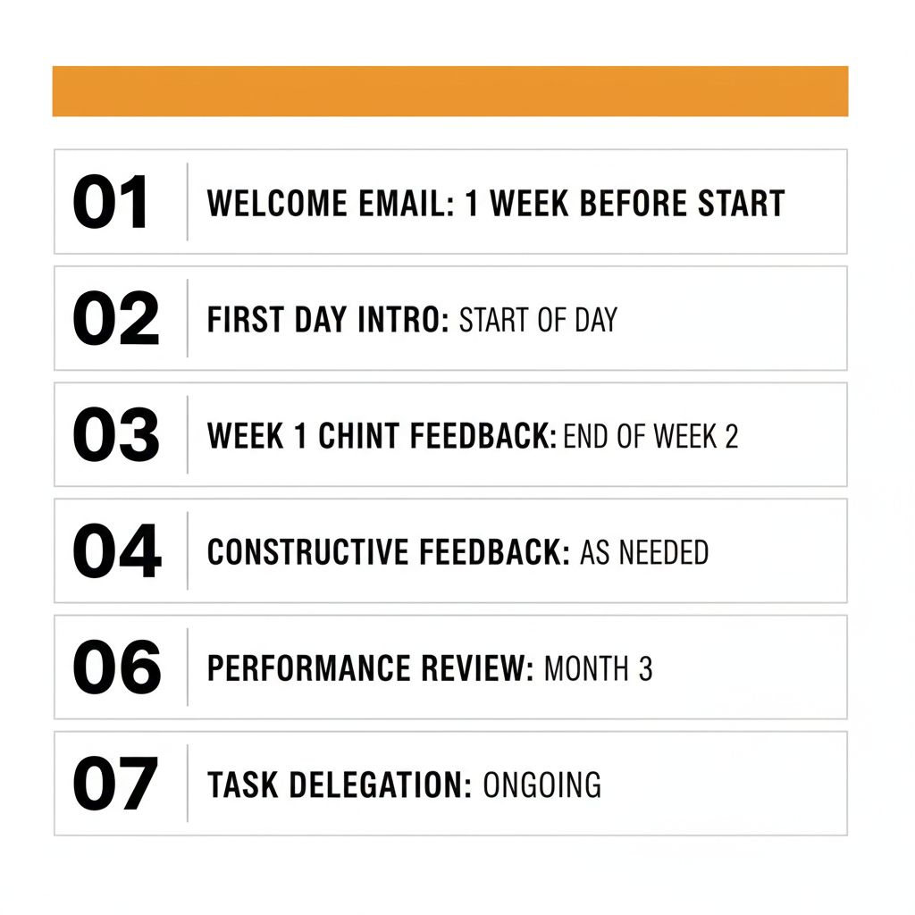

Template 1: Welcome Email (Pre-Day 1)

Subject: Welcome to [Company Name] – Your Start Date is [Date]!

Hi [VA Name],
We're thrilled to welcome you to the [Company Name] team! We're looking forward to working with you and are confident you'll be a great addition to our organization.
Your official start date is [Day], [Date] at [Time] [Time Zone]. Here's what to expect on Day 1:
Day 1 Schedule:
• [Time]: Welcome call with me (60-90 minutes) – Zoom link: [LINK]
• [Time]: Tools setup and access verification (screen-share session)
• [Time]: Team introductions and first small task
Before Day 1, please:
☐ Confirm you've received access to your [Company] email: [email@company.com]
☐ Join our Slack workspace using this invite: [LINK]
☐ Review the onboarding folder here: [LINK TO GOOGLE DRIVE/NOTION]
☐ Ensure your laptop, internet, and backup power (if needed) are working properly
If you have any questions before your start date, please don't hesitate to reach out. Looking forward to meeting you on [Day]!

Best regards,

Template 2: Day 1 Agenda

Subject: Day 1 Agenda – Let's Get Started!

Hi [VA Name],
Happy first day! Here's our agenda for today:
[Time] – Welcome & Orientation (60-90 min)
• Personal introductions and company background
• Your role: responsibilities, success metrics, growth opportunities
• Communication expectations and working hours
• Team structure and who you'll work with
[Time] – Tools Setup (45-60 min)
• Verify access to all systems (email, Slack, project management, CRM)
• Set up password manager and two-factor authentication
• Walk through file storage structure and primary tools
[Time] – First Task & Documentation Review
• Review onboarding folder and SOPs
• Complete first small task: [DESCRIBE TASK]
At the end of the day, please send me a quick message letting me know: (1) How you're feeling about Day 1, and (2) Any questions that came up.

Excited to get started with you!

Template 3: Weekly Check-In Template

Subject: Weekly Check-In – [Date]

Hi [VA Name],
Looking forward to our weekly check-in today at [Time]. Here's our agenda:
1. Wins This Week (10 min)
• What went well? What are you proud of?
2. Challenges & Blockers (15 min)
• What's been difficult or frustrating?
• Where do you need support or clarification?
3. Goals for Next Week (10 min)
• What are your top 3 priorities?
4. Feedback & Growth (10 min)
• Constructive feedback on recent work
• What can I do differently to support you better?

Please come prepared with your wins, challenges, and priorities. See you at [Time]!
[Your name]

Template 4: Positive Feedback Email

Subject: Great Work on [Task/Project]!

Hi [VA Name],
I wanted to take a moment to acknowledge the excellent work you did on [specific task/project].
What stood out:
• [Specific thing #1]: [Why it was great]
• [Specific thing #2]: [Impact it had]
• [Specific thing #3]: [What you appreciated]
This level of [quality/attention to detail/proactive communication] is exactly what makes you such a valuable team member. Keep up the fantastic work!

Best,
[Your Name]

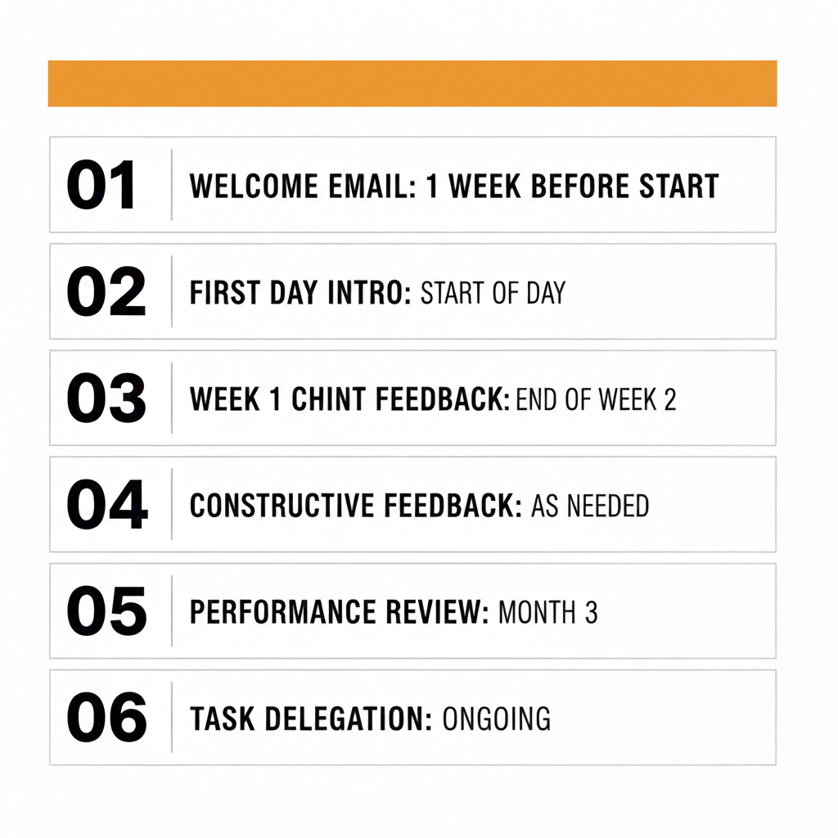

Template 5: Constructive Feedback Email

Subject: Feedback on [Task] – Let's Adjust Our Approach

Hi [VA Name],
I wanted to share some feedback on [specific task] to help us improve going forward.
What happened:
[Describe the situation objectively: When X happened...]
The impact:
[Explain the impact: This caused Y, which meant Z...]
Going forward:
[Provide clear guidance: Next time, please... / I'd like us to... / Let's adjust by...]
I know you're committed to doing great work, and I'm confident this adjustment will help us both succeed. Please let me know if you have any questions or if there's anything I can do to support you in this.

Best,
[Your Name]

Template 6: 30-Day Review Invitation

Subject: 30-Day Performance Review – Let's Celebrate & Plan Ahead

Hi [VA Name],
Congratulations on completing your first month with [Company Name]! I'd like to schedule a 30-day performance review to reflect on your progress, celebrate your wins, and set goals for the next 60 days.
Meeting Details:
• Date: [Date]
• Time: [Time] [Time Zone]
• Duration: 60-90 minutes
• Zoom link: [LINK]
Agenda:
1. Wins & accomplishments from your first month
2. Areas for growth and development
3. Your self-assessment: challenges, wins, support needs
4. Goals and priorities for Months 2-3
To prepare, please reflect on:
• What has been most challenging for you?
• What do you feel most confident about?
• What could I do differently to support you better?
• Where do you want to grow in this role over the next 3-6 months?
Looking forward to our conversation!
Best,
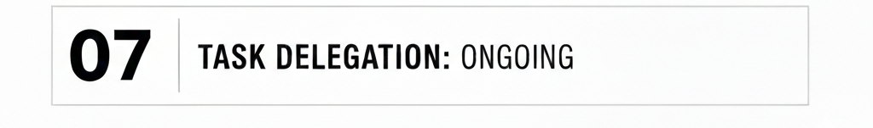

Template 7: Task Assignment Template

Subject: New Task: [Task Name] – Due [Date]

Hi [VA Name],
I have a new task for you. Here are the details:
Task: [Task Name]
Context:
[Explain why this task matters, what it's part of, and any relevant background]
Deliverable:
[Describe exactly what you need: format, content, specifications]
Deadline:
[Date and Time] [Time Zone]
Resources:
• [Template/example link]
• [SOP or reference documentation]
• [Any other relevant files or links]
Success Criteria:
[How will we know this is done well? What should be included/avoided?]
Please let me know if you have any questions or need clarification on anything. You can reach me on Slack or email.
Thanks!
For more onboarding resources, visit:
www.sharkhelpers.com/onboarding-resources

