Completing the Employee Reimbursement Claim Form
This claim form should be used to request reimbursement for eligible expenses such as meals (when not provided during training), mileage, rideshare or other transportation costs, luggage fees, etc. Please note that hotel incidentals are not reimbursable.
- Open the Training Packet (attached to Calendar invite) to find the Expense Summary Page.
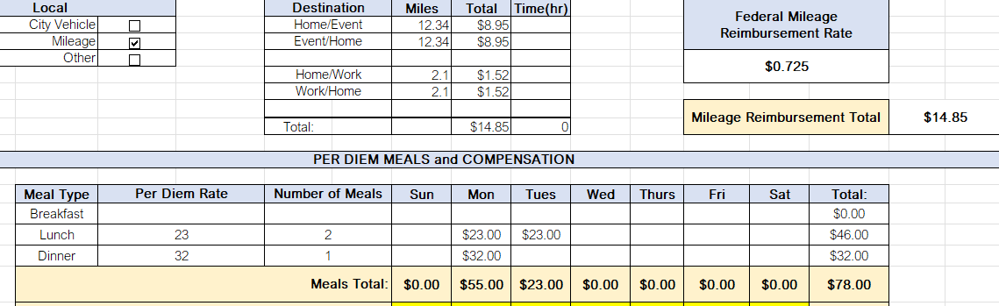
- Download and complete the Claim Form.
  - Use the most current Finance-issued Claim Form, available under Useful Links at the top of this page or at:
AtWork > Want To… > Forms/Templates > Finance folder > Claim Form
  - Complete the form as follows:
    - Claimant and Address: Enter your name and address.
    - Needed By: Enter the date the reimbursement is needed (typically the next available payroll run)
    - Date: Enter the date each expense was incurred.
    - Expense Details: List all applicable expenses: For mileage, calculate round-trip miles × current IRS mileage rate. For meals, list the number and type (breakfast, lunch, dinner) and use the appropriate GSA M&IE rates.
    - Cost Allocation: Enter the appropriate GL and JL keys.
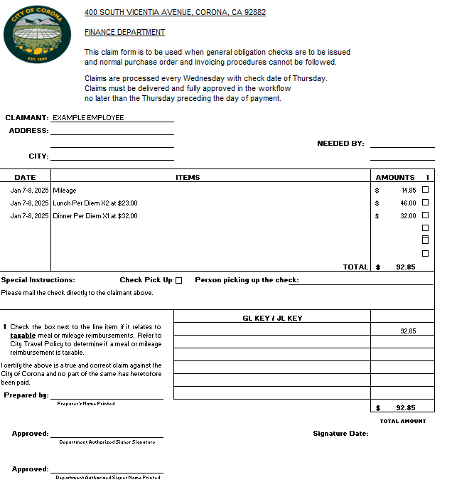
- Attach supporting documentation
  - Attach a copy of the approved Advance Travel Request packet.
  - Include itemized receipts, invoices, or records to substantiate your reimbursement.
  - Meal receipts are required only if requesting reimbursement based on actual costs. Meal reimbursements are limited to the GSA per diem rate.
(Refer to the Travel Policy Section 6.3 for full guidelines.)
- Obtain the supervisor’s signature of approval on the claim form
- Submit the claim form
  - Scan and email the approved claim form to Francine.Virrey@coronaca.gov; Traci.Milbrandt@CoronaCA.gov; Cindy.McLain@CoronaCA.gov
  - Copy the Front Desk at Utilities@CoronaCA.gov

City policy requires that employees submit reimbursement requests within 15 days of incurring the expense.

