3 Bedrooms | 2.5 Bathrooms | 3 Car Garage

The Rockingham

Plans, specifications, included features, available options and elevations are subject to change without notice. Front elevations and floor plans are artist drawings and may not be completely accurate.
Builder License #BC627670.



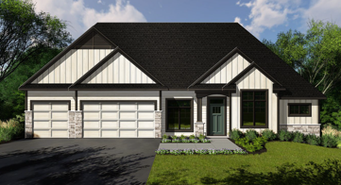
Elevation A
3,508 finished square feet
3 Bedrooms | 2.5 Bathrooms | 3 Car Garage

The Rockingham

Plans, specifications, included features, available options and elevations are subject to change without notice. Front elevations and floor plans are artist drawings and may not be completely accurate.
Builder License #BC627670.

