**TABLE OF CONTENTS**

1. Executive Summary
2. *Canadian Tire Group of Companies Objectives*
3. *Purolator and Canada Post Objectives with alignment to CTC’s Key Players*
4. *Team overview from Purolator and Canada Post*
5. Overview of the Canadian Tire Group of Companies
6. *Company History and Description of the Business*
7. *Company Revenues with our GOC*
8. *Description of their Business from an FGL, MARK’s and Canadian Tire perspective*
9. Opportunities and Solutions
10. *Market Analysis and Competition*
11. *Seasonality of the Business*
12. *Risk Factors as defined by CTC*
13. *Sales Strategies for the Current Year*
14. *What we offer in terms of products/services/solutions to increase sales in 2014 and beyond?*
15. Critical Success Factors and Competition for Purolator, CPC and SCI
16. *Implementation Plan for Success*
17. Appendix
18. *Summary*
19. *Executive Bios*
20. *Graphs and Charts*

# ***I.*** ***Executive Summary***

The purpose of this business plan is to secure growth opportunities for Purolator, Canada Post and SCI within the Canadian Tire group of companies (FGL, MARK’s and Canadian Tire). Our propensity to win is far greater when we work collaboratively to earn business and preserve, grow and deepen existing relationships within the Canadian Tire group of companies.

The bid strategy formulated in this plan will clearly articulate which GOC products we will want to offer to meet which needs, and how we will avoid intra-GOC conflict.  You will see an Account Plan for each of the Retailers on the collaboration list along with an implementation plan.

Vision: By focusing on high quality and engaging value based solutions, Purolator and CPC will become the strategic platform for evolution. Greater choice, information and convenience are also increasing competition for the Canadian Tire Group of Companies (known at CTC) in the Canadian marketplace. Together, we can “engineer their vision” and help to establish new channels of revenue growth with our own group of companies as the premier solution provider.

Sales are projected to incrementally have slow growth in 2014 as CTC builds their vision around their late to market E-Commerce offering, and then grow at 20% in years 2-5. This growth forecast is based on the assumption that Canadian Tires acts on these key opportunities as assessed by our own GOC:

* Redesign, upgrade and marketing of the Internet store for FGL.
* Launch of E-Commerce platform for Canadian Tire.
* Adding additional product lines and growing new ones (for example: Grocery).
* Creation of an Omni-Channel presence and more social media marketing.

* Optimization of inventory purchasing, management and tracking.

## ***i. Canadian Tire Group Of Companies Objectives (referred to as CTC)***

As outlined by their CEO last year, Stephen Wetmore, Canadian Tire is focusing their initiatives on growth opportunities. Their initiatives are similar to our own at Canada Post and Purolator are outlined below. Canada Post and Purolator can support many of these visions through our innovative solutions. New store openings mean more LTL movements throughout Canada, the continued development of

*Strengthen core retail*

* Continue roll-out of new concept CTR stores
* Open 90 Smart store retrofits and 10 Smart store replacement or expansions
* Open three new Small Market stores and two Small Market replacement stores
* Continue to execute strategies to deliver an enhanced in-store customer experience at Canadian Tire
* Deliver training for continuous learning and development of front-line staff
* Continue to roll-out a comprehensive merchandising and marketing strategy in the Living category

*Align all business units to reinforce the core*

* Evaluate and implement an enhanced loyalty program, employ customer-centric retailing and integrate with existing marketing programs
* Expand e-commerce and investigate cross-business integration opportunities
* Design an integrated online/digital experience across various retail banners
* Continue to enhance store networks to drive an enhanced Customer

Experience

* Drive growth in the Retail segment with the integration and development of FGL Sports Continue to focus on driving sales
* Expand Financial Services through continued growth of portfolio of services and managed growth of receivables

*Build a high-performing organization*

* Advance key productivity and efficiency initiatives
* Embed merchandise productivity key capabilities (technology and process) to sustain benefits into the future
* Implement key initiatives within the CTR Change Program
* Drive business sustainability as a business strategy
* Enhance key sustainability metrics and reporting
* Continue to integrate sustainability into business operations, increasing both cost avoidance and revenue from business sustainability initiatives

*Create new platforms for growth*

* Explore new avenues for growth and new business developments
* Continue to identify and evaluate opportunities to enhance our growth and profitability

Stephen G. Wetmore, CEO: 5 drivers for Canadian Tire’s growth in 2014

1.       E-Commerce Launch & Growth *(We can jointly deliver on this)*

2.       Further Penetration into new business markets (LTL and Vendor Drop Ship from Purolator)

3.       Continued growth of existing customer base within all business units (our sales strategy is aligned)

4.       Expansion into new markets (Sport Chek, Marks) (store openings mean new revenue streams)

5.       Canadian Olympic Partnership, Jumpstart Program growth

*\*\*See Fiscal results in the Appendix of this document*

## ***ii. Purolator and Canada Post’s GOC objectives with alignment to CTC’s***

Both Purolator and CPC have extensive relationships within CTC (Canadian Tire Group of Companies). Further details regarding these relationships along, with targeted key players are outlined in the team overview section of this document. Our collaborative mission is to persist in being the Canadian Tire Group of Companies main supplier supporting their growth initiatives taking into account all lines of business and solutions from Purolator, SCI and Canada Post.

We will achieve this through collaboration, customer focus and strategically aligning Canadian Tire's business objectives to our own. We will create a bid strategy that positions us as the supplier of record for FGL, CTC and Mark's. The customer's decision process needs to be clearly understood, so that we can identify exactly who the individuals are that are involved. Each one of these individuals needs to be accessed by the coordinator (James DeMarco).

In addition, it is essential to understand what the bid evaluation criteria is as it pertains to each initiative, so that we can shape our solutions appropriately. Even better, at times there is an opportunity to shape the customer’s thinking, through providing new information and ideas. We will work collaboratively within the Solution Selling framework to ensure we are driving that vision.

It is only by having trusting, open relationships that our Group of Companies team can properly understand exactly what the customer’s issues and hot buttons are. This understanding will help us develop our Win Strategy throughout 2014 and beyond.

Our established relationships will allow us to communicate with CTC early in the procurement process to ensure that there is a full understanding of what makes our solution the best. The ultimate goal with Canadian Tire and its banners is to create the circumstance that the customer has a predisposition to select our solutions, prior to the start of any formal procurement process.

* Maintain or exceed in year 1 the recent CI growth of 2.5% with targeted growth revenues of $1 million in 2014 and $2 million plus in 2015-2016 (for the entire Canadian Tire Group of Companies)
* Realize an annual sales growth rate of 10% in year 1 and 20% in years 2-5, reaching over $5 million in sales by the end of year 5 (for the CTC GOC)
* Improve gross margins by the end of year 5 by adding additional lines of business
* Redesign and upgrade the Internet e-commerce store by the end of year 2
* Enhance SCI, Canada Post and Purolator relationships among all levels of the organization by the end of 2014.
* Establish relationships with decision makers in FGL, Mark's and CTC that we do not currently have. Conversely, we need to introduce one another to key decision makers (for example: Purolator introducing Canada Post to Key contacts in Operations/Logistics/Supply Chain and being inclusive on regularly scheduled meetings).
* Ensure we deliver, measure and communicate the return on business value of our collective solutions.
* Negotiate optimal agreements with that allow us to improve margins, hold down costs, and maximize the control of our solutions.
* Implement a state-of-the-art, E-Commerce solution that supports both a B2B and B2C solution.
* Expand our penetration of product lines by offering a collaborative approach with sales team calls that include CPC, Purolator and SCI.
* Cross-train employees on product features and solution features that we might not already be aware of.
* Train an existing employee, or hire from outside, a dedicated internal advisor.
* Continue to build a reliable operations infrastructure that is ready to serve customers, prepare accurate billing and accounting, follow up on orders and shipping, manage E-Commerce, and maintain a close watch on all activities of FGL, Mark's and CTC.
* Purolator currently holds a 25+ year business partnership with Canadian Tire Corp. (CTC) and 20+ year partnership with Marks & FGL Sports
* Purolator fully supports the CTC, Marks & FGL Sports national carbon footprint of 1,300+ retail locations (all combined) through all lines of business & services:
* Express & Ground Courier, Domestic & Cross Border LTL / TL, Specialized Services (Project based services), Purolator International (Customized project based services), E-Commerce fulfillment & Supply Chain Integration
* There is a team of 20+ people lead by one National Account Executive that is committed to servicing CTC, Marks & FGL Sports on a daily basis nationally. Purolator has a very strong business partnership with all 3 companies totaling an annual spend of $24M+
* Our relationships are going to give us the upper hand in achieving a "first-in" winning solution.

## ***iii. Team Overview from Purolator and Canada Post with Key Players***

The overview below displays our joint propensity to win based on the current initiatives that we have all discussed with the CTC group of companies. You will see that if we all work in collaboratively with FGL, Mark’s and Canadian Tire, we can offer a customized solution for their needs based on our line of business. For example: Canada Post’s B2C E-Commerce solution is superior to Purolator’s, which would of strong value to the customer. However, Purolator is going to be at the forefront in devising a solution for their White Glove Customer Service and enhanced weekend deliveries, while SCI will be partnering (if the decision is made) for an ammunition storage project.

*\*\*Terms Below are aligned with Solution Selling techniques are can be described in the following manner:*

*POWER SPONSOR - In a position to make buying decisions and orchestrate events*

*SPONSOR – Can internally sell and provide us with valuable information to provide access to a power figure*

*STAKEHOLDER – Instrumental in the sales cycle, benefiting from the solutions provide valuable insight / information*

**SPONSORS:** (CTC): Neil McKenna, John Salt, Mike Medline, Greg Hicks, Duncan Fulton ; (FGL Sports): Keith Lambert ; (Marks): Harry Taylor

**POWER SPONSORS:** (CTC): Gary Fast, Dan Chan, Terry Garner, Rob Brace ; (Marks): Ian Gilbart, Paul Fazio ; (Pro Hockey Life): Robert Ziedel

| **STAKEHOLDER** | **CPC/Purolator** |
| --- | --- |
| Stephen Wetmore, CEO | Both GOC’s will hold the relationship |
| **Allan McDonald - President, Canadian Tire Retail** | Both GOC’s will hold the relationship |
| Mike Medline **- President, Canadian Tire Corporation** | Both GOC’s will hold the relationship |
| Harry Taylor - **Chief Operating Officer, Mark's** | Both GOC’s will hold the relationship |
| John D. Salt - **Senior Vice-President, Supply Chain** | Both GOC’s will hold the relationship |
| Duncan Fulton - **Chief Marketing Officer, FGL Sports & Mark's** | Both GOC’s will hold the relationship |
| TJ Flood - **Senior Vice-President, Marketing, Canadian Tire** | Both GOC’s will hold the relationship |
|  |  |

***Canadian Tire Retail E-Commerce Executive Team;***  
• TJ Flood, SVP Marketing  
• Jim Kozak, VP of Customer Programs   
• Shawn Farmer, AVP Digital Operations

***The Canadian Tire Supply Chain team lead by;***  
• John Salt, SVP  
• Dan Chan, VP, Logistics   
• Gary Fast, AVP International Operations and Support  
*\*\*See Org Chart in the Appendix for more detail*

*Purolator and Canada Post’s Key Player’s*

Patrick Nangle and Jacques Cote will need to be introduced to Stephen Wetmore, Mike Medline and Allan McDonald, as we currently do not have the executive relationships at this level on the Purolator side of business. Canada Post may? An introduction to Harry Taylor and Duncan Fulton will be necessary.

We also require regular and active communication amongst David Hughes and Serge Pitre occur with John Salt, TJ Flood and Dan Chan (there may be others that we identify throughout our investigative process).

Kim Richards and Larry Bines will be a regular part of conversations with Gary Fast, Shawn Farmer and Jim Kozak. James, Jordana, Steve, Marcie and Jamie will be regular fixtures in pertinent growth meetings with sales, marketing, supply chain and logistics, while we continue to expand our interactions.

Strength of sale checklists for each opportunity and line of business under the Canadian Tire banners will be shared with both Canada Post and SCI in order to gauge our representation with Power and identification of Pain. Without this, we will not be able to accurately assess the needs and build a solution that will benefit all parties. For now, we will be reliant on one another to share information about the E-Commerce opportunity in order to create our SOS and Pain Chain for this open business initiative.

# ***II. Overview of the Canadian Tire Group of Companies***

Canadian Tire Corporation, Limited offers a range of products and services through retail brands and banners in Canada. Its Retail segment operates general merchandise retail stores in the living, fixing and playing, and automotive categories under the Canadian Tire banner; a chain of 87 automotive hard parts specialty stores under the PartSource banner; and as a retailer of gasoline with a network of 299 retailer-operated gas bars, including 294 convenience stores, 80 car washes, and 90 propane stations. This segment also operates clothing and footwear retail stores that consist of 347 corporate and 39 franchise stores providing industrial wear, men’s and women’s casual wear, and footwear under the Mark’s, Mark’s Work Wearhouse, and L’Equipeur banners.

In addition, Mark’s offers E-Commerce retailing through its Website; conducts a business-to-business operation under the Imagewear name; and engages in retailing sporting goods through 283 corporate and 212 franchise stores.

As of February 21, 2013, the company operated approximately 1,700 retail and gasoline outlets. Canadian Tire Corporation has a strategic partnership with Senators Sports & Entertainment. The company was founded in 1922 and is based in Toronto, Canada.

2013 Financials: $11.62 Billion in 2013 and Stock Price = $99.85 (current valuation)

1. ***Canadian Tire’s Company History and Description of CTC’s Business***

**General Merchandise   - Seasonal Goods   - Automotive Hard Parts   - NEW: Groceries, Appliances**

Canadian Tire Corporation, Limited was incorporated under the laws of the province of Ontario by letters patent dated December 1, 1927 and is governed by the Business Corporations Act (Ontario). The corporate structure of CTC, including its principal subsidiaries and their applicable governing corporate jurisdictions, is as follows:

**Canadian Tire Corporation, Limited**(Ontario)

| **Canadian Tire Financial Services Limited** (Ontario) | **Canadian Tire Real Estate Limited** (Ontario) | **FGL Sports Ltd.** (Alberta) | **Mark's Work   Wearhouse Ltd.** (Alberta) |
| --- | --- | --- | --- |

**Canadian Tire Bank**(Canada)

**CT Real Estate  
Investment Trust**(Ontario)

Each of CTFS, CTB, Canadian Tire Real Estate Limited ("CTREL"), FGL Sports and Mark's is wholly-owned, either directly or indirectly, by CTC. CTC holds, indirectly, an approximate 83.1% effective interest in CT REIT, an unincorporated closed-end real estate investment trust established on July 15, 2013 pursuant to a Declaration of Trust under, and governed by, the laws of the Province of Ontario, as amended and restated as at October 22, 2013. CTC's interest in CT REIT is through ownership of 59,711,094 units of CT REIT and all of the Class B limited partnership units of CT REIT Limited Partnership, which are economically equivalent to and exchangeable for units of CT REIT.

## ***ii. Company Revenues within our own GOC***

### *\*\*Canada Post YOY Revenues can be included, but were not available at the time of this document’s creation.*

### ***Figure 1: 2013 Purolator Overall revenues with CTC***

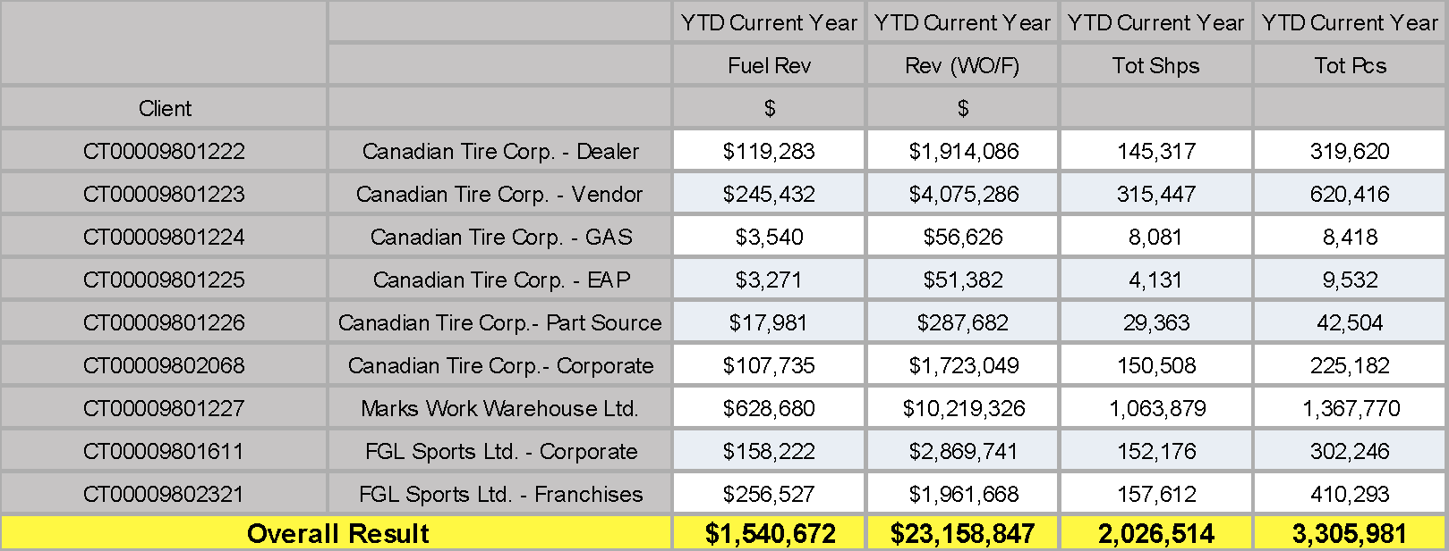

### ***Figure 2: 2012 Purolator Overall revenues with CTC***

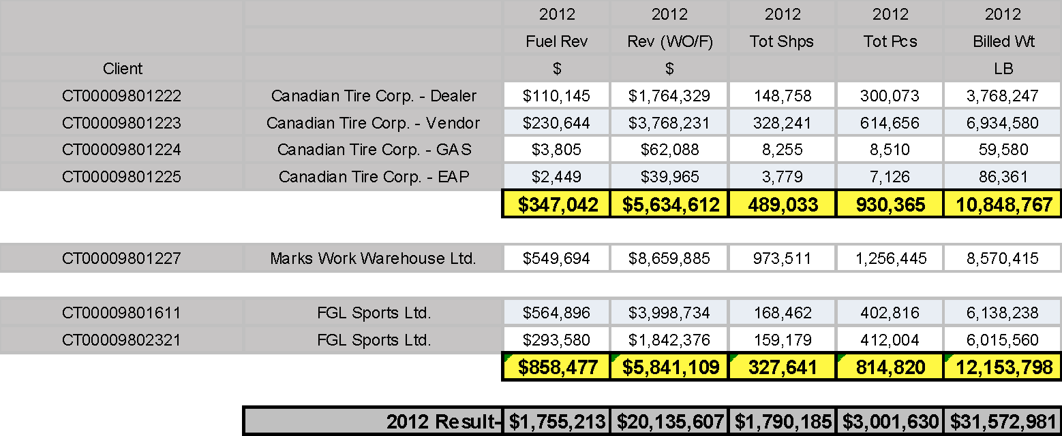

### ***Figure 3: 2011 Purolator Overall revenues with CTC***

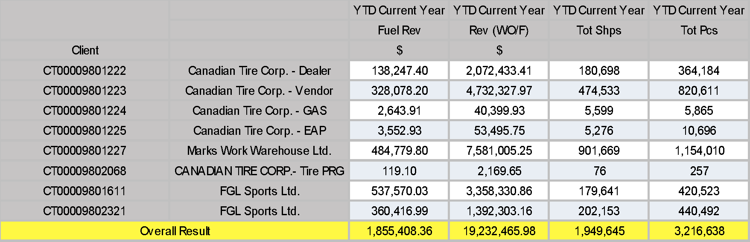

***iii.Description of their Business from an FGL, MARK’s and Canadian Tire perspective***

**CTC** has been in business for over 90 years, offering a range of products and services to Canadians through a portfolio of the leading retail banners in Canada including Canadian Tire®, Mark's®, Sport Chek® and Sports Experts® .CTC's retail business is supported and strengthened by its financial services business which markets financial and other products and services including credit cards, in-store financing, product warranties and retail deposits. CTC also holds an approximate 83.1% effective interest in CT REIT, which owns 258 commercial properties consisting largely of stand-alone Canadian Tire stores, properties anchored by a Canadian Tire store and containing one or more stores operating under other Canadian Tire banners and/or third party tenants, a distribution centre and development lands.

Significant Sponsorships – In 2012, CTC entered into a sponsorship agreement with the Canadian Olympic Committee pursuant to which it has been granted “Premier National Partner” status as a sponsor of the Canadian Olympic Team. The sponsorship allows Canadian Tire, Sport Chek and Sports Experts to participate in marketing and promotional activities relating to the Olympics and Olympic team athletes for a period ending in 2020. CTC also entered into a number of partnerships with major Canadian sports organizations.

Capital Expenditures – During the last three years, CTC has focused capital investment on real estate investments and investments in technology. With the completion of the information technology infrastructure builds for the Automotive business and the Loyalty Program (currently in its first phase), the 2014 information technology project agenda will continue further investments in information technology and digital initiatives both in the Company’s store network and legacy systems that support the Company’s operations.

**FGL Sports**  
FGL Sports, formerly known as The Forzani Group Ltd., was acquired by CTC in August 2011 and is the largest sporting goods retailer in Canada, selling footwear, sports equipment and apparel. Since the acquisition, FGL Sports has continued to focus on driving sales, expanding its successful "store within a store" concept, seeking innovative and new ways to connect with customers and realizing the synergies identified during the acquisition.

In May, 2012, FGL Sports announced an accelerated growth strategy for its corporate banners that focuses on aggressive expansion of Sport Chek and other key banners. As part of the strategy, FGL Sports is expanding its footprint significantly. Outside of Quebec, Sport Chek will be the key “super brand.” FGL Sports will also grow Atmosphere as its outdoor lifestyle banner across the country.

In total, it intends to add more than 100 new retail stores, or approximately 1.4 million square feet of net new retail selling space, over a five-year time period. In particular, 1 new concept lab store was opened in 2013 and a further 2 large, urban flagship Sport Chek stores are planned in 2014. The retail expansion will also include an aggressive “super branding” strategy to build brand affinity and customer loyalty. Also as part of its strategy, FGL Sports initiated a banner rationalization program pursuant to which a number of under-performing, nonstrategic corporate banners such as Sport Mart and Athlete’s World closed.  
  
   
Since CTC’s acquisition, FGL Sports has opened approximately 13 franchise and 64 corporate stores, relocated and renovated 30 franchise and 13 corporate stores and closed 20 franchise and 134 corporate stores, primarily as part of the banner rationalization program.

CTC’s Canadian Olympic Team and Sports Association partnerships launched early in 2013 are intended to help FGL Sports solidify its positioning in the sporting goods market. On August 12, 2013, CTC announced that it had completed the purchase of Pro Hockey Life.

**Mark’s**  
Mark’s is one of the largest specialty apparel retailers in Canada, offering casual and industrial clothing and footwear to men and women for work and leisure. During the past three years, Mark's has continued to build its brand by pursuing its strategic initiatives, the three most significant of which were re-branding its stores, expanding its business to business sales through its Imagewear division, and launching and developing an improved e-commerce capability.

Rebranding – The re-branding initiative involves truncating the name of Mark’s Work Wearhouse stores to simply “Mark’s” and includes a new logo, tagline, colour scheme and font, a better customer experience in stores including more outfit based merchandising, more and better showcasing of merchandising, wider aisles and cleaner sightlines, brighter interiors, larger fitting rooms, interactive features and greater style and fashion in casual apparel and footwear assortments. It also includes increased marketing to build awareness of Mark’s as a casual apparel and footwear retailer in addition to the very strong awareness of Mark’s as an industrial apparel and footwear retailer.

E-commerce – In 2011, CTC invested in a new e-commerce platform, [www.marks.com](http://www.marks.com), which became operational in the fall of that year. In 2012, it enhanced the visual look and feel of the site and increased the site’s features, interactive capabilities and integration with social networking sites. The e-commerce upgrade also improved in-store availability of product offered on the site and resulted in faster fulfillment and delivery of e-commerce orders.

Mark’s other strategic initiatives during the past three years included further development of its four merchandising divisions (industrial wear and accessories, footwear, men’s apparel and women’s apparel), gross margin rate improvement through better sourcing and improved gross margin management tools, increased consumer awareness of the Mark's brand and the “Ready For This” message, and store network expansion. Over the past three years, Mark’s has opened 13 new corporate stores, relocated/renovated 24 corporate stores, bought back 7 franchise stores and closed 7 franchise and 10 corporate stores. As at the end of 2013, there were 385 Mark's stores (348 corporate and 37 franchise stores), of which 65 were co-located within Canadian Tire stores.

Key Initiatives – Canadian Tire has built market share in key categories within its “***Driving”, “Living”, “Fixing”, “Playing” and “Seasonal & Gardening”*** categories, with the result that it currently holds a leading market position in many of its categories. Its strong marketing capabilities have continued to evolve Canadian Tire’s brand and product marketing activities and to expand those activities across marketing mediums.

**Driving** – During the past three years, Canadian Tire has focused significant resources on the integration of, as well as the strengths and opportunities for, its automotive assets with the goal of establishing its identity as “Canada’s Automotive Authority.” As part of this effort, the automotive business has created a new set of skills and specialties within its team and has rolled out training to the front line staff in the automotive management system (part of the Automotive Infrastructure initiative) and the front line staff in tires and preventative maintenance. Canadian Tire has also worked to expand its reach beyond automotive enthusiasts by sourcing and developing exclusive and innovative products that meet the needs of all Canadian drivers.

In 2011, Canadian Tire launched its “Tires Online” program, which allows customers to select and purchase a wide assortment of regular and special order tires and wheels online for pick up in Canadian Tire stores. To improve the in-store experience for drivers, Canadian Tire developed a “tire wall” which provides increased product information and visibility to customers. Canadian Tire published two issues and distributed approximately 4.5 million copies of a new Canadian Tire Automotive catalogue to showcase its hard parts assortments.  
  
   
Canadian Tire has continued to invest in new technology and supply chain infrastructure and has expanded the warehouse capacity of designated PartSource stores across Canada to drive growth at Canadian Tire and PartSource. PartSource is currently used by approximately 278 Canadian Tire stores for emergency auto parts deliveries. In 2012, it developed the “Super Satellite” format, which has replaced investments in new Hub Stores, and in 2013 Canadian Tire converted all remaining PartSource stores to the corporate store model from the franchise model.

Petroleum has continued the execution of its plans over the past three years, which has included opening new gas bar sites, re-branding gas bar sites of competitors, retrofitting convenience stores to a new convenience store design and upgrading and building new gas bar kiosks. During that time, Petroleum also introduced new state-of-the-art gas bars and associated convenience centres located along Ontario highways (Highway 401 and Highway 400), of which 19 were in operation as at the end of 2013.

Over the past three years, Petroleum has opened 17 new gas bars (including 11 highway locations), rebranded 12 competitor sites, upgraded branding at 96 locations and performed major rebuilds at 12 gas bars. As at the end of 2013, 300 gas bars, 295 convenience stores and kiosks, 82 car washes, 5 vehicle lubrication facilities and 89 propane stations carried Canadian Tire brands. All of the gas bars are operated by independent retailers pursuant to agreements governing the sale of petroleum products under the Canadian Tire and Gas + names and logos.

**Living –** This category includes cookware, home organization and small appliances and is core to the Canadian Tire business as it is a fundamental part of the shopping experience Canadians have come to expect from Canadian Tire. While continuing to bring Canadians the latest and most innovative product assortment, Canadian Tire is also focused on evolving the in-store customer experience to provide Canadians with everything they need for the jobs and joys of life in Canada. Canadian Tire has continued to expand the product assortment available in its “Living” departments as well as invest in the physical layout of the Canadian Tire store to ensure that the strength of its exclusive, national and private label brands are highlighted.

Building on its success from prior years in the home organization solutions and products area, Canadian Tire has continued to focus on organization solutions and expanded the presence and impact of storage and organization assortments. In 2011, Canadian Tire added a wider assortment of products from brands such as KitchenAid, Cuisinart, Lagostina and Miele. In 2013, Canadian Tire rolled out a new strategy for its “Living” category focused on the “home manager” with expanded assortments, inspirational displays and improved product adjacencies. Drawing on the findings from the kitchen program pilot, Canadian Tire integrated these into a national store redesign to deliver improved product assortment and customer experience.

In 2012, Canadian Tire has also launched a services business which initially was limited to a driving school pilot and the provision of certain home services including garage door opener, HVAC and central vacuum installation services. Since the launch, the home services business has expanded to include services such as painting, roofing, windows and doors, landscaping, kitchen and bath refacing, garage doors, flooring, carpet cleaning, gazebos, BBQ gas lines, play sets, toilets and faucets, window ACs, flat panel TVs, portable shelters and electric fireplaces.  
Fixing – Canadian Tire has improved signage and simplified navigation in its hardware departments. It has also made investments to upgrade its in-store paint technology, installing modern automatic paint tinters and increasing employee training. Since 2012, Canadian Tire has expanded its paint selection to include an exclusive top quality brand, Benjamin Moore, across its store network. Canadian Tire intends to continue to develop its product assortment in the “Fixing” category.

**Playing –** Over the past three years Canadian Tire has grown its fitness business through an expanded store presence, a balanced emphasis between equipment and accessories and focused promotional activity. Following a successful test in 2011, Canadian Tire rolled out a hunting and fishing “store within a store” concept in key markets. As at the end of 2013, Canadian Tire launched 17 Fishing ProShop, 66 Hunting ProShop and 37 combined Fishing and Hunting ProShop concepts.

These concepts have helped Canadian Tire be more locally relevant with its customers by having customized store assortments for their regional needs and customized regional floor plans. In addition, Canadian Tire has continued to expand its selections of sporting goods. As part of its focus on hockey merchandising, Canadian Tire benefits from CTC’s continued sponsorship arrangements with the National Hockey League® and with all-star hockey player Jonathan Toews. Partnerships with the Canadian Olympic Committee and key sports associations introduced in 2013 are intended to help Canadian Tire build on its positioning in its heritage sports business.

# ***III. Opportunities and Solution***

We must provide Canadian Tire with an Omni-channel solution that addresses their immediate need for an E-Commerce solution as well as increased services for weekend shipments. The main focus of our long-standing partnership in 2014 is to continue to further penetrate the banners and find new ways to deepen our partnership with CTC and their THREE business units for long term strategy and partnership growth.

* Align Purolator, CPC and SCI into the existing business partnerships for the BEST overall solution & customer experience for CTC & GOC’s.
* Conduct monthly Business Reviews with all companies, so that everyone is properly aligned, and the expectations for current service and new partnerships are being moved forward in the most aligned manner.
* Create quarterly Executive Reviews with CTC Senior Stakeholders / Power to ensure partnership on both sides is intact and aligned
* Work collaboratively to make our overall solution seamless. There is no need to illustrate or shows a divide between Purolator & Canada Post. The BEST overall solution is the solution the customer needs, regardless of who acquires the business.
* The applicable “lead” on the account needs to drive 100% transparency to the Canadian Tire Group of Companies as well as our own.

# ***i.. Market Analysis and Competition***

Mark’s operates 385 stores across Canada under the Mark’s Work Wearhouse, Mark’s and Work World banners. As at the end of 2013, the number of stores operating under each banner was as follows:

*Retail Banner Number of stores*  
Mark’s corporate stores 348  
Mark’s franchise stores 36  
Total 385

As at the end of 2013, the number of stores operating under each franchise retail banner was as follows:  
*Retail Banner Number of stores*  
Sports Experts 72  
Intersport 45  
Atmosphere 41  
Hockey Experts 17  
S3 9  
Total 184

As at the end of 2013, the number of stores operating under each corporately owned retail banner was as follows:  
*Corporately owned Retail Banners Number of stores*  
Sport Chek 171  
Atmosphere 25  
Pro Hockey Life 23  
National Sports 18  
Total 237

Canadian Tire is one of Canada’s most shopped general merchandise retail banners. Its stores are easily identified by the Canadian Tire name and trade-mark and have established a strong reputation and high recognition throughout the communities they serve. The retail selling space of Canadian Tire stores ranges from approximately 3,200 square feet to approximately 88,700 square feet and, as at the end of 2013, totaled approximately 20.2

2013 Annual Information states 2 million square feet across all 491 stores. Canadian Tire stores are located in each of the provinces and territories in Canada (except Nunavut) as follows:

*Number ofProvince or Territory Canadian Tire stores*  
British Columbia 52  
Alberta 54  
Saskatchewan 14  
Manitoba 14  
Ontario 202  
Quebec 98  
New Brunswick 19  
Nova Scotia 21  
Prince Edward Island 2  
Newfoundland and Labrador 13  
Yukon 1  
Northwest Territories 1  
Total 491

*Major Competitors*

*Wal-Mart Stores, Inc.* Operates retail stores in various formats worldwide. The company operates in three segments: Walmart U.S., Walmart International, and Sam's Club. It operates retail stores, restaurants, discount stores, supermarkets, supercenters, hypermarkets, warehouse clubs, apparel stores, Sam’s Clubs, neighborhood markets, and other small formats, as well as walmart.com; and samsclub.com.

The company’s stores offer meat, produce, deli, bakery, dairy, frozen foods, alcoholic and nonalcoholic beverages, and floral and dry grocery; health and beauty aids, baby products, household chemicals, paper goods, and pet supplies; and electronics, toys, cameras and supplies, photo processing services, cellular phones, cellular service plan contracts and prepaid service, movies, music, video games, and books. Its stores also provide stationery, automotive accessories, hardware and paint, sporting goods, fabrics and crafts, and seasonal merchandise; pharmacy and optical services, and over-the-counter drugs; shoes, jewelry, accessories, and apparel for women, girls, men, boys, and infants; and home furnishings, housewares and small appliances, bedding, home décor, outdoor living, and horticulture products.

Revenues in 2013 were $17.5 Billion

*Target Corporation.* Incorporated on February 11, 1902, sells a range of assortment of general merchandise and food in its stores. The Company’s general merchandise and CityTarget stores offer a food assortment on a smaller scale and its SuperTarget stores offer a line of food items comparable to traditional supermarkets. The Company operates in three segments: U.S. Retail, U.S. Credit Card and Canadian.

The Company’s U.S. Retail Segment includes all of its United States merchandising operations. The Company’s U.S. Credit Card Segment offers credit to qualified guests through its credit cards: the Target Credit Card and the Target Visa. Its Canadian Segment includes costs incurred in the United States and Canada related to its Canadian retail market entry. As of February 2, 2013, the Company had 1,778 stores in 49 states and the District of Columbia. It also owns three distribution centers in Canada, with a total of 3,963 thousand square feet.

Revenues in 2013 were operating at a $1 Billion (US) loss

*Home Hardware:* Home Hardware Stores Limited retails housewares, hand and power tools, plumbing and electrical supplies, paint and painting supplies, and sporting goods in Canada. It also retails giftware and seasonal items, including lawn and garden supplies; lumber and hand tools; and building materials, including ceiling supplies, drainage and fence products, farm and ranch products, insulation and masonry products, roofing products, sidings, and yard buildings.

Home Hardware released version 1.0 of their E-Commerce launch in the fall of 2013. They plan a full launch in 2014 with Fed Ex as their main partner. Revenues are not shared as this is a privately held corporation.

*Home Depot* : The Home Depot, Inc. operates as a home improvement retailer. Its stores sell building materials, home improvement products, and lawn and garden products, as well as provide installation, home maintenance, and professional service programs to do-it-yourself, do-it-for-me, and professional customers. The company’s installation programs include products, such as carpeting, flooring, cabinets, countertops, and water heaters.

It serves home owners, professional remodelers, general contractors, repairmen, small business owners, and tradesmen. As of March 13, 2013, the company operated 2,257 retail stores in 50 states, the District of Columbia, Puerto Rico, U.S. Virgin Islands, Guam, 10 Canadian provinces, and Mexico. The Home Depot, Inc. was founded in 1978 and is based in Atlanta, Georgia

Revenues in 2013 were $74.75 Billion

*Lowe’s Companies, Inc*. Operates as a home improvement retailer. It offers products for maintenance, repair, remodeling, and home decorating. The company provides home improvement products under the categories of plumbing; appliances; tools and outdoor power equipment; lawn and garden; fashion electrical; lumber; seasonal living; paints; home fashions, storage, and cleaning; flooring; millwork; building materials; hardware; and cabinets and countertops.

It also offers installation services through independent contractors in various product categories; repair services; and MyLowes, an online tool that manages, maintains, and enhances homes

*Revenues in 2013 were $50.52 Billion*

*RONA inc.* Engages in the distribution and retail of hardware, home improvement, and gardening products in Canada. It offers bathroom, construction, decoration, hardware, outdoor and garden, electricity and lighting, paint, plumbing, kitchen, garage and workshop, and storage and cleaning products; and doors and windows, flooring and ceramic tiles, tools, and gift cards, as well as heating, ventilation, and air conditioning (HVAC) products.

The company also provides installation services and construction plans. As of March 11, 2013, it operated approximately 800 corporate, franchise, and affiliate stores; and a network of 14 hardware and construction-materials distribution centers, as well as approximately 60 sales outlets and 4 distribution centers for plumbing and HVAC market. The company was formerly known as The Ro-Na Dismat Group Inc and changed its name to RONA inc. in 1998

*Revenues in 2013 were $4.85 Billion*

*Sears Canada Inc.* Operates as a multi-format retailer in Canada. The company operates department stores that offer women’s apparel, men’s and children’s apparel, nursery products, cosmetics, jewelry, and footwear, and accessories; and home and hardlines, including home furnishings and mattresses, home decors, lawn and garden products, hardware products, electronics and leisure products, and seasonal products, as well as provides appliances comprising refrigeration, laundry, ranges, floor care, and sewing products.

*Revenues in 2013 were $4.07 Billion*

*Leon’s Furniture Limited*, Operates as a retailer of home furnishings, electronics, and appliances in Canada. The company offers furniture for living rooms, bedrooms, mattresses, dining, entertainment/wall units, occasional tables, and home office; and mattresses, including twin sets, full sets, queen sets, and king sets.

It also provides appliances comprising washers and dryers, refrigerators, freezers, ranges, microwaves, and dishwashers; and electronics, such as televisions, home theatre/audio, and Blu-ray players. The company owns a chain of 42 retail stores under the Leon’s Home Furnishings Super Stores name and 3 retail stores under the Appliance Canada name, as well as operates leons.ca, an e-commerce Internet site. Further, it has 27 franchisees operating 32 Leon’s Furniture franchise stores. Leon’s Furniture Limited was founded in 1909 and is headquartered in Toronto, Canada.

*Revenues in 2013 were $720 Million. The Brick falls under this company with $1.38 Billion in 2013 revenues.*

*Best Buy Co Inc*. Operates as a retailer of consumer electronics, computing and mobile phone products, entertainment products, appliances, and related services primarily in the United States, Europe, Canada, and China. The company's stores offer video products, including televisions, e-readers, navigation products, digital cameras and accessories, digital camcorders and accessories, and DVD and Blu-ray players; and audio products, such as MP3 players and accessories, home theater audio systems and components, musical instruments, and mobile electronics comprising car stereo and satellite radio products.

*Revenues in 2013 were 50.2 Billion*

*Costco Wholesale Corporation* Engages in the operation of membership warehouses. The company offers branded and private-label products in a range of merchandise categories.

*Revenues in 2013 were $105.16 Billion*

*The TJX Companies, Inc.* Operates as an off-price apparel and home fashions retailer in the United States and internationally. Its stores offer family apparel, including footwear and accessories; home fashions, such as home basics, accent furniture, lamps, rugs, wall decor, decorative accessories, and giftware; jewelry and accessories; footwear; children’s furniture; and seasonal and other merchandise. The company operates its stores under the T.J. Maxx, Marshalls, Winners, HomeSense, HomeGoods, and T.K. Maxx trademarks.

*Revenues in 2013 were $25.88 Billion*

***ii. Seasonality of the Business and Risk***

CTC derives a significant amount of its retail revenue from the sale of seasonal merchandise. Canadian Tire experiences quarterly fluctuations in revenues with the strongest results typically in the second and fourth quarters (subject to unusual fluctuations as a result of atypical weather), primarily due to the seasonal nature of some of its merchandise and the timing of marketing programs.

Canadian Tire experiences a degree of sales volatility from abnormal weather patterns and mitigates the risk, to the extent possible, through the breadth of its product mix as well as effective procurement and inventory management practices. Similarly, the FGL Sports and Mark's businesses are seasonal with the strongest results typically in the fourth quarter. FGL Sports and Mark's attempt to minimize the impact of the seasonality of their businesses through detailed sales reporting, merchandise planning modules and by altering its merchandise mix at certain times of the year to reflect consumer demand.

Any decrease in retail sales due to a slower holiday shopping season, unseasonable weather conditions, economic conditions or otherwise, could adversely affect business performance within the Retail segment. The following tables show the quarterly financial performance within the Retail segment over the last two years.

***iii. Risk Factors as defined by CTC***

CTC recognizes the importance of protecting and maintaining its brand as a valuable business asset. Brand and reputational risk is viewed as a consequence of each of the 11 principal risks and, accordingly, is an important consideration in the assessment of each principal risk. The effective management of CTC’s principal risks, both individually and collectively, will help maintain, promote and grow CTC’s brands and maintain its reputation.

CTC is exposed to a variety of risk factors and has identified 11 principal risks inherent in its businesses. The relative seriousness of these inherent principal risks is impacted by the external environment and CTC’s business strategies and, therefore, will vary from time to time.

**Marketplace** – Change in economic conditions, competitive landscape, domestic or international political environments, the demographics of the Canadian population, consumer behaviour, weather patterns, and the introduction of new 'technologies' may result in a negative impact on CTC’s revenue, market share, operating margins, and/or ability to achieve its strategic objectives.

**Execution of Strategy –** Failure to identify, plan, resource, execute, and achieve the full benefits of strategic initiatives may have a negative impact on CTC’s revenue, market share, operating margins, or investor confidence.

**People** – External pressures and/or ineffective internal human resource practices can negatively impact CTC’s ability to attract and retain sufficiently appropriately skilled people who have the expertise to support the achievement of CTC’s strategic objectives.

**Key Business Relationships** –The scope, complexity, materiality and/or criticality of key business relationships which include, partnerships, and affiliations with such parties as dealers, agents, franchisees, vendors, suppliers, and other third parties, may affect customer service, procurement, product and service delivery, and can potentially result in legal disputes which may have a significant negative impact on CTC’s earnings, and cost of operations.

**Technology** – Failure to invest in technology, ensure the availability, recoverability, and security of systems, infrastructure, and information may result in corruption or loss of data, regulatory related issues, litigation, or prevent CTC from achieving its strategic objectives.

**Operations** – Failure of CTC’s business operations and processes may have an adverse effect on CTC’s ability to support its key business objectives. Failed processes in terms of design, integration, and/or execution may result in incremental financial expenditures, losses, theft or fraud, damages to assets, poor service delivery, negative customer experiences or regulatory related issues.

**Financial Markets** – Fundamental changes in the economic environment, significant events or volatility in the financial markets could result in the lack of: (i) sufficient capital to absorb the impact of unexpected losses; and (ii) sufficient liquidity or financing to fund operations and strategic initiatives. Furthermore, significant volatility in exchange rates and interest rates could have an adverse impact on product pricing, gross margins, net interest expense or impact the value of real estate related investments and on CTC’s share value. In addition, inappropriate hedging strategies for mitigating foreign exchange, interest rate and equity exposures may cause a significant negative impact on CTC’s earnings.

**Business Continuity** – Unplanned events or prolonged business interruptions may compromise the safety of employees or customers, prevent CTC from communicating with its customers, employees, stakeholders and shareholders, and limit CTC’s ability to provide products and services, resulting in a financial loss.

***iv. Sales Strategies for the Current Year (2014)***

*CANADA POST - Sales Strategies Underway for 2104*

Canadian Tire Retail E-Commerce:(Estimated + $1MM Parcel)

Canadian Tire Corporation has signaled their desire to launch an E-Commerce channel; however the Dealer Association has not approved an E-Commerce channel with a Direct to Consumer delivery model. While at a corporate level there is a strong desire to move to Omni-channel, the belief at the franchisee level is that B2C E-Commerce would cannibalize store revenue as opposed to grow overall in store revenue. As a result in Q4 2013, Canadian Tire began testing a Direct to Store E-Commerce model in 30 stores, wherein the consumer can order online, for pick-up at a designated store of the consumer’s choice with orders fulfilled from store inventory.   
                                                                    
In August 2013, Patrick Jobidon, CPC GM Parcel Sales and GOC and Purolator Sales met with Shawn Farmer, AVP Digital Operations and Gary Fast, AVP Int’l Transportation Operations and their team to review CTC’s E-Commerce strategy. CTC’s team emphasized that CTC was moving to a “deliver to the store” model using their own internal fleet, but was open to exploring B2C options and any research that quantitatively supported the value of Omni-channel as a driver of sales across channels.

Canada Post was invited to a follow up meeting in December 2013, to review our Deliver Tonight solution, where CTC shared with us their challenges with their Franchisee’s. There was significant discussion on the various E-Commerce business and delivery models, Delivery Tonight, and Canada Post GOC capabilities.  Canadian Tire attendees included the SVP Marketing, and several VPs and AVPs from the Operations, Logistics, and Transportation teams.  CTC expressed great interest in participating on our Canada Post’s E-Commerce Innovation Awards Customer Panel in 2014.

CTC’s executive team has asked that Canada Post work with them to help develop a road map that ad-dresses their challenges. Because the Dealers hold so much influence, and Dealer Relations are a corpo-rate priority, resolving this issue in a thoughtful and strategic manner will be of paramount importance before they can determine their E-Commerce strategy.  
Canada Post to further support Canadian Tire’s Drive to Store/Acquisition Strategy: (Estimated growth opportunity +$2.5MM)

In October 2013, an Executive Meeting was conducted to review the Strategic Marketing plans with Canadian Tire’s SVP of Marketing and various Marketing team members.  The Canadian Tire executives reiterated the importance of Black Friday acquisition strategy and the importance of Canada Post in particular to meet delivery requirements for flyer distribution.  Canada Post managed the campaign through positive monitoring and achieved a delivery performance of 99.5%.  Anecdotally, Canadian Tire was thrilled with the results and had the single biggest sales day of the year on that weekend.

As a result of this the SVP Marketing has indicated that Canada Post has the opportunity to be the preferred distribution method of their seasonal mini-catalogues from the current network of distributors and community newspapers.  Canada Post is working on a pricing strategy to support this opportunity and secure the distribution.

*CPC and Purolator to support FGL/Sportchek.ca rebranding Opportunity:*(Estimated $500k TBD at Jan 21st meeting)

FGL Sports is re-branding their online offering at [www.sportchek.ca](http://www.sportchek.ca). They are also interested in exploring how they can optimize the Canada Post GOC network and E-Commerce web services integration (Canada Post and Purolator) for online orders.

On January 21st Purolator and Canada Post will be meeting with all key internal stakeholders at FGL, led by Keith Lambert (Senior Vice-President, Supply Chain & Merchandise Management) as well as the E-Commerce team that would be responsible from an IT / programming perspective. The goal of the meeting for CPC is exploratory and will be to better understand FGL’s strategic focus and direction and to best position CPC’s GOC in a consultative process.

Canada Post has extensive executive alignment and relationships with all major departments in each of the various Canadian Tire Retail business units. These strong executive level relationships exist in several business units including: Marketing, Customer Programs, Digital Operations, Supply Chain, Logistics, Flyer Distribution Logistics, Corporate Security and International Operations and Support to name a few.

From an E-Commerce perspective, Canada Post was Canadian Tire’s primary carrier for 95% B2C distribution before Canadian Tire decided to move away from a transactional E-Commerce site in 2009. Canadian Tire Re-tail E-Commerce strategy and decision making continues to be owned by Canadian Tire Marketing with three groups supporting the strategic work.

*PUROLATOR – Sales Strategies Underway for 2104*

*National LTL Solution National network:* Single source provider EOY 2014 LTL

*Ammunition Project*: Store and distribute dangerous goods -SCI / Purolator  
*Vendor Direct Program Integration with internal CTC systems*: Single source provider EOY 2014 Courier

*White-Glove Customer Service Project :* Underway with Shirley Shields. Canadian Tire has requested a dedicated customer service representative 24/7 to service all operations needs

CTC has a large and progressively interactive market to capture through E-Commerce. They fully understand the business needs to move to a more SO-LO-MO configuration (Social, Local, Mobile). They need to determine internally the best course of action to complete this:  
**1) Direct to store (customer pick up)  
2) Store fulfillment to customer  
3) 3PL fulfillment to customer**

The Canadian Tire Dealers Association (CTDA) is a large internal political challenge that CTC Corporate is faced with, and all parties need to come to the best resolution for the customer before anything can implemented with CPC or Purolator. We have very little influence over which method they decide to enact upon, but we can provide data, research and best practices to influence them.

The Dealer’s influence over any final decisions in the future regarding E-Commerce is critical. Our goal is to work with the CTC executives to provide market research, best practices and quantitative data that supports over all benefits of Omni-channel. As the Omni-channel solution gains popularity with E-Commerce retailers, CTC may wish to expedite the implementation of their own Omni-channel platform to remain relevant and leading in the retail industry. Through our leadership in the E-Commerce space we can help CTC build their internal business case together as a consultant and partner to enable them to act.

Purolator currently holds a 25+ year business partnership with Canadian Tire Corp. (CTC) and 20+ year partnership with Marks & FGL Sports. Purolator fully supports the CTC, Marks & FGL Sports national carbon footprint of 1,300+ retail locations (all combined) through all lines of business & services.

We will continue to utilize the solution selling approach in our long and short-term plans for growth with Canadian Tire, FGL and Marks.

At anytime, you can see the activity of the accounts within Salesforce.com from a Purolator perspective.  You will also be aware of the forecast, stages in the selling cycle and any Mutual Action Plan with date specific timelines for our growth goals

Our main area of Growth to focus on in 2014-2015 is E-Commerce and Omni-Channel fulfillment among all 3 CTC banners.

***iv. What we offer in terms of products/services/solutions to increase sales in 2014 and beyond?***

**FGL**

* Express & Ground Courier
* Domestic LTL
* Specialized Services (Project based services)
* Purolator International (Customized project based services)
* E-Commerce fulfillment & Supply Chain Integration from both Canada Post and SCI

**MARKS**

* Express & Ground Courier
* Domestic LTL
* Specialized Services (Project based services)
* Purolator International (Customized project based services)
* E-Commerce fulfillment & Supply Chain Integration

**CANADIAN TIRE**

* CTC’s Acquisition strategy : CPC provides the critical targeting data as well as distributes Un-addressed Admail to drive store and website traffic (2013 spend of $12.5MM)
* CTC Bank and CTC Retail Marketing and Loyalty programs:  CPC supports development and final delivery execution of Canadian Tire’s direct marketing programs to their customer base through Unaddressed Admail and Addressed Admail service offerings. (2013 spend of $2.6MM)
* Digital communication strategy: CPC manages CTC Bank’s electronic invoicing through ePost.  (2013 spend of $240K)
* Distribution of CT Bank Credit Cards:  CPC manages the distribution of all CTC Bank Credit Cards (2013 transaction mail spend of $16.7MM) and Gift Cards online through Xpresspost and expedited services (2013 spend of $197K).
* Corporate Risk Management: Canada Post continues to be engaged with Canadian Tire’s Corporate Security executive team, sharing postal code data to mitigate non-receipt fraud for both Lettermail and Xpresspost distribution of their credit cards. This relationship with Corporate Risk has proved to be an asset as Canadian Tire examines the E-Commerce security requirements. CPC’s Parcel LOB Executives are directly engaged with this CTC team.
* Express & Ground Courier
* Domestic LTL
* Specialized Services (Project based services)
* Purolator International (Customized project based services)
* E-Commerce fulfillment & Supply Chain Integration

***IV. Critical Success Factors and Competition for our own GOC***

One of the most pressing concerns for Purolator and Canada Post is our speed to market. Canadian Tire is an organization with multiple layers that requires a detail oriented approach with our initiatives. We need to provide data, analytics and case studies whenever possible to prove our solution is the most viable one. While CTC works slowly on decisions that involve the dealer network to vote, they can work quite quickly on projects that are driven from the top down (for example: White Glove Customer Service or Domestic LTL expansion).

Canada Post, SCI and Purolator’s next steps will be to review our KPI’s with each line of business that we plan to penetrate this year and beyond. Time Management, Communication and a healthy understanding of CTC’s financial indicators: for example, working capital, acceptable ratios (in particular debt to equity ratios), profit margins, cash flow, receivables and more are keys to our success.

What would our competitors say about Purolator, CPC and SCI?  
**Competitor #1 – Federal Express**  
Fed Ex has been the international provider for CTC for a long time, but cannot penetrate the current domestic business CTC has with Purolator due to the long standing relationship, national service we provide every day. They understand fully that we cover the country better than anyone, and also realize how close we are with CTC throughout all depts.

**Competitor #2 - UPS**  
They have no penetration of this account currently, but can easily present value through pricing as they have done with some of our other customers recently. We are not aware of the current relationships that they may or may not have and this requires further investigation.

**Competitor #3 – Transforce Group**  
They have a long relationship with CTC on the LTL business through companies they have acquired in 2011-2013. They have NO business on the domestic courier front. They also understand fully that CTC is one of our top accounts, and we are very engrained with CTC throughout all depts.

*Competitors’ Relationships and Solutions*

Our Competitors’ Relationships and Solutions History with the Account. Transforce Group has a long relationship with CTC on their LTL business through companies they have acquired in 2011-2013. They have no business on the domestic courier front currently, but this requires further investigation.

Federal Express - Has been the international provider for CTC for a long time, but has not penetrated the current domestic business CTC has with Purolator.

**Most Significant Account Risk:**The biggest challenge or risk that we face is the CTDA. They hold the “political hammer” within CTC, and hold all the power when it comes to the final “say” on any opportunity that the Corporation wants to move forward on – ie: E-Commerce Launch, weekly tires replenishment, inbound distribution of product to stores, gift cards just to name a few.

# ***ii. Implementation Plan*** ***for Success***

It is crucial that we continue to use Solution Selling techniques to identify each opportunity and track the sales cycle. We will be using the principles of the “Competitive Strategy Selector” to guide us through our bids for each potential line of business within every CTC banner.

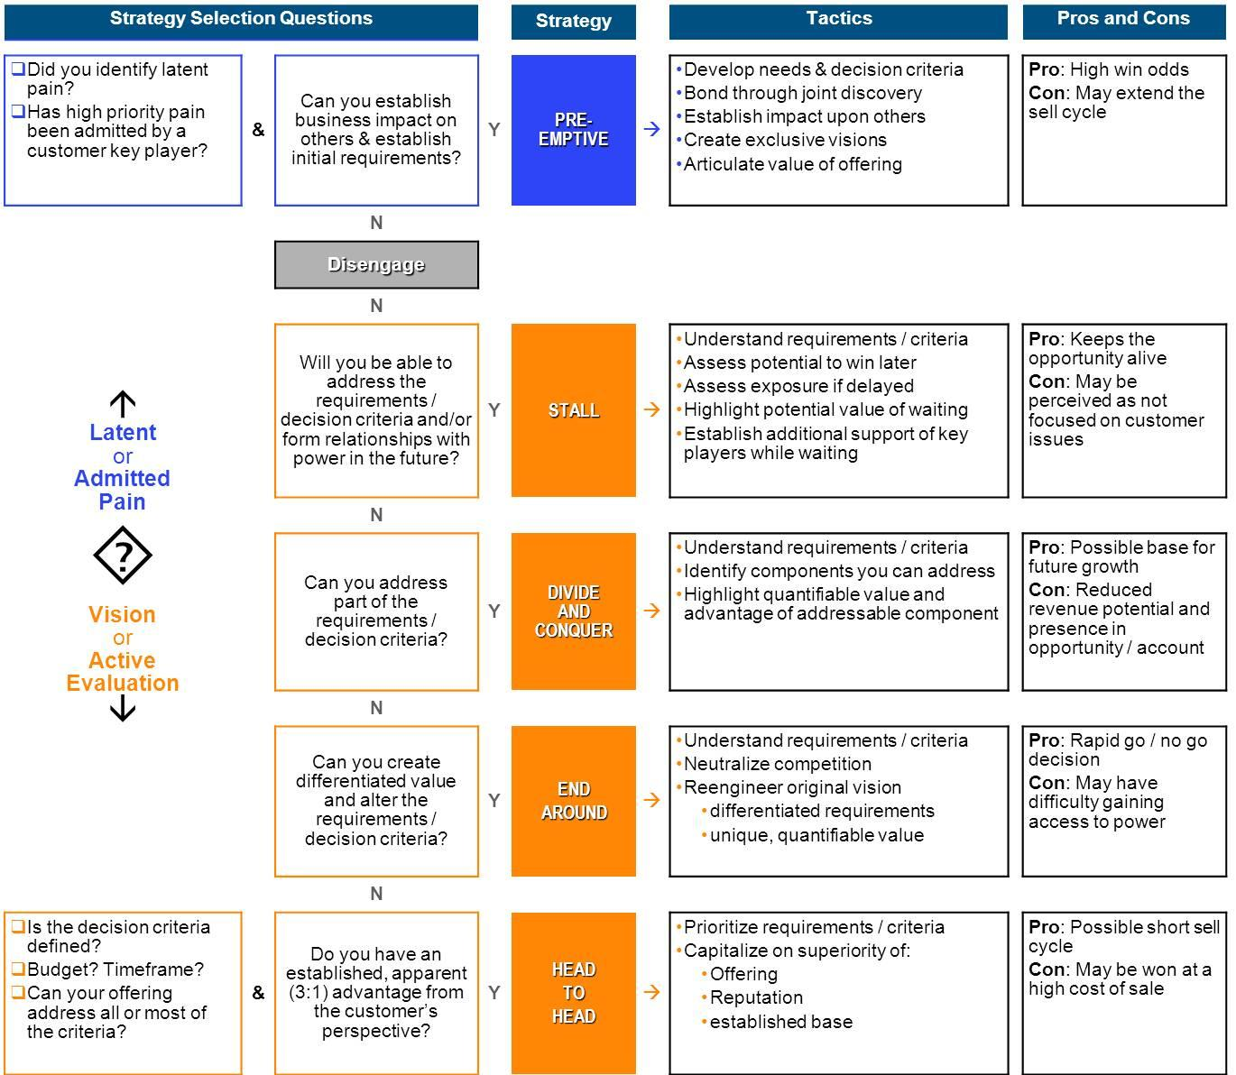*Strategy Selector Tool*

* Developing services and solutions that enhance the shopping experience.
* Provide CTC with analytical data to help them in their decisioning on an E-Commerce solution.  They have requested market analysis from other successful Omni-channel retailers to provide to their own dealer network
* Training and developing customer service and operations in order to effectively service the customer.
* Increase awareness of Canadian Tire within the retail consumer marketplace through aligning ourselves with their key initiatives and revenue drivers
* Develop future sales opportunities that allow for continued growth of the business partnering with technology providers.
* CPC and Purolator have leveraged our executive engagement to support SCI introductions
* CPC has pro-actively engaged with our SCI and Purolator partners to share account insight and to ensure the lines of communication have been open with our effort to optimize our value proposition to the client.  
  • Because Forzani’s understands CPC’s unique E-Commerce B2C offering, their executive team has engaged CPC to support the business fit. While the initial Purolator supply chain parcel business evolved over time to currently include B2C E-Commerce, Forzani’s is now reviewing its E-Commerce channel and has asked for CPC’s engagement while they conduct a thorough review of their E-Commerce B2C business needs.

The accompanying milestone table highlights our plan with specific dates. This schedule reflects our strong committment to organization and detail.  Milestone responsibility is assigned to the functional departments in the company - Sales, Marketing, HR, Operations, and President's Office.

The Milestone table reflects critical dates for the acquisition and takeover schedule, systems reviews and upgrades, the website re-design and deployment, the retail store relocation, and new product identification and rollout.  We also define our target dates for policy definition and implementation as well as documented employee training and evaluation processes.

***V.Appendix***

1. ***Summary***

The sumamrisar

1. ***Executive Biographies***

**Stephen Wetmore**

**Chief Executive Officer  
Canadian Tire Corporation, Limited**

Stephen Wetmore is the Chief Executive Officer of Canadian Tire Corporation, Limited. Stephen has successfully led a number of public companies and managed complex businesses in different industries, including telecommunications, information technology and transportation.

The breadth and depth of Stephen’s experience has been shaped by his varied executive responsibilities. With many years of experience working in Europe, as well as coast to coast in Canada, Stephen has been responsible for regional, national and international business operations. He has successfully created new and market-changing organizations, built brands, managed relationships and distribution channels and throughout all of his roles has demonstrated a passion for customer service and innovation.

Most recently, Stephen helped to create and served as the first President and CEO of Bell Aliant, one of North America’s largest regional telecommunications providers and one of the largest publicly-traded business income trusts in Canada. As Vice Chairman, Corporate and Group President, National Markets with Bell Canada, Stephen was involved in virtually all facets of the organization, overseeing operations across the country and leading corporate functions including finance, marketing and purchasing.

In addition to his extensive experience in telecommunications and information technology, Stephen also has ten years in healthcare, seven years in public accounting and two years in transportation as President of Air Atlantic.

In addition to serving as an independent member of the Board of Directors of Canadian Tire since 2003, Stephen has served on numerous public company Boards and educational and charitable organizations across Canada. Stephen was also recently named 18th on the Globe and Mail’s 50 Most Powerful People in Canadian Sport,   on the heels of Canadian Tire Corporation’s partnership with the Canadian Olympic Team. He is married with one daughter.

**Allan MacDonald**

**President, Canadian Tire Retail**

Allan MacDonald was appointed President of the iconic, 91 year old business – Canadian Tire Retail – in May 2013.  Responsible for over 485 ‘red triangle’ retail store locations across Canada, Allan oversees all aspects of the Company’s operations including merchandising, marketing, supply chain, information technology, Automotive, digital and social integration, store operations and Dealer relations.

Since joining Canadian Tire Corporation in 2008, Allan has played an instrumental role in helping Canadian Tire stay on offense, applying innovative thinking and exceptional execution to drive growth across the organization. Prior to his appointment as Chief Operating Officer, Allan led the turnaround of Canadian Tire’s heritage Automotive business and was the vision behind innovative concepts like the Company’s online tire business.

Allan has taken on varied and increasingly senior roles at the Corporation, affording him a depth of experience and unique perspective on all aspects of Canadian Tire’s business.  He has visited suppliers around the world and learned the intricacies of the Company’s sourcing and supply chain capabilities. As Chief Marketing Officer, Allan led Canadian Tire’s digital engagement and marketing efforts and was behind Canadian Tire’s latest award-winning advertising campaign, introducing Canada to the “CT Guy,” as well as the Company’s new digital catalogue, The Canadian Way.  His time with the Company has also enabled him to work closely and build strong relationships with its Dealer and vendor communities.

Prior to joining Canadian Tire Corporation, Allan held senior roles at Bell Canada, Aliant Inc. and British Telecom in the United Kingdom. Allan holds a Bachelor’s degree in Business Administration from Acadia University and an MBA from Henley Management College in England.  He is married with one son.

**Michael Medline,**

**President, Canadian Tire Corporation**

Michael Medline, Canadian Tire Corporation (CTC), is responsible for overseeing the operations of all CTC business units, including Canadian Tire, Financial Services, FGL Sports and Mark’s, as well as Corporate Affairs and Technology.

Michael has had an impressive 13-year career with Canadian Tire, having played a significant role in helping the Company stay on offense through innovative thinking and strong industry knowledge. He has extensive experience in building and transforming businesses, brands and customer experience to drive growth and value, and has led the Company in a number of high-profile projects, including the successful acquisition and subsequent integration of Mark’s Work Wearhouse in 2001 and the restructuring of Canadian Tire Retail’s Automotive unit in 2009. Michael is also the driving force behind FGL Sports’ growth strategy for its key banners, including: Sport Chek,  Sports Experts, National Sports, Pro Hockey Life, Intersport and Atmosphere – which incorporates an aggressive five year store expansion plan.

Prior to his current appointments, Michael held a number of progressively senior roles with the Company, including President of Canadian Tire Automotive and Dealer Relations, Chief Corporate Officer and President for Diversified Business and President of Dealer Relations and Diversified Business.

Michael holds an MBA from the College of William and Mary in Virginia, an LL.B. from the University of Toronto, and a BA from the University of Western Ontario. In addition to his leadership roles, Michael is on the Board of the Retail Council of Canada and has been a board member of Canadian Tire Bank, Jumpstart, and Pan Asia Paper Company.

**Harry Taylor**

**Chief Operating Officer, Mark's**

Harry Taylor is the Chief Operating Officer of Mark’s, headquartered in Calgary, Alberta. An executive with 20 years at retail apparel and packaged goods companies, Mr. Taylor has responsibility for all operations at Mark’s with a mission to drive growth through all the company’s business segments.

Mr. Taylor was most recently Senior Vice-President, Financial Planning and Analysis, and was responsible for overseeing all aspects of financial planning, analysis and performance management, providing financial and business counsel to Canadian Tire’s division and function leadership.

An experienced finance executive with significant background in retail and consumer goods, Mr. Taylor came to Canadian Tire from his previous role as the Chief Financial Officer of the distinguished Canadian luxury apparel and accessories retailer, Holt Renfrew Limited. Mr. Taylor joined Holt Renfrew after a year as Senior Vice President of Operations for The Home Depot Canada. Prior to that, Mr. Taylor spent 11 years working in the United States in senior financial and strategy positions with The Home Depot and PepsiCo. Before moving to the U.S., Mr. Taylor was the Chief Financial Officer of Frito-Lay Canada and held consulting and client service positions with McKinsey & Company and Ernst & Young.

**John D. Salt**

**Senior Vice-President, Supply Chain   
Canadian Tire Corporation, Limited**

John Salt is the Senior Vice-President of Supply Chain. In this role, John is responsible for overseeing the flow of goods and supporting flow of information between Canadian Tire’s merchandise suppliers and the retail stores. Since taking this role in 2009, John has been instrumental in upgrading the systems supporting the operations of Canadian Tire’s Logistics and Transportation functions and has deployed upgraded technology within the distribution centres to improve quality and productivity. Most recently, John led the restructuring of the automotive supply chain in support of the Company’s automotive infrastructure initiative.

Prior to his current role, John was Vice-President of Distribution, Operations Planning and Express Auto Parts. In this role he had responsibility for oversight of Canadian Tire’s two regional distribution centres, the operations planning centre and the three auto parts depots. Previous roles with Canadian Tire include directing the operations of the A.J. Billes Distribution Centre and the Logistics team that managed Supplier Performance, Channel Enablement, Electronic Commerce and Offshore Supply Chain Operations.

Prior to joining Canadian Tire, John had a distinguished career in the consulting and manufacturing industries with a primary focus on operations management.

John holds an MBA from York University and a Bachelor of Technology degree in Industrial Engineering from Ryerson Polytechnical Institute.

**Duncan Fulton**

**Senior Vice-President, Communications and Corporate Affairs, Canadian Tire Corporation**

**Chief Marketing Officer, FGL Sports and Mark's**

Duncan Fulton is Senior Vice-President of Communications and Corporate Affairs at Canadian Tire Corporation and Chief Marketing Officer of FGL Sports and Mark’s. Duncan is a member of the Canadian Tire, FGL Sports and Mark’s executive teams and works across all the company’s business areas, including Canadian Tire Retail, Automotive, Part Source, Petroleum, Financial Services and the company’s charity, Jumpstart. Duncan currently represents the company as a board member of the Canadian Chamber of Commerce and is also on the Board of One X One, a non-profit foundation committed to supporting, preserving and improving the lives of children at home in Canada, Haiti and Africa.

Before joining Canadian Tire, Duncan was the General Manager and Senior Partner of the Toronto flagship office of international public relations company, Fleishman-Hillard Communications. Prior to Fleishman-Hillard, Duncan was a communication advisor and press secretary for Canadian Prime Minister Jean Chrétien. Duncan was also Communications Director for the Minister responsible for the Canadian International Development Agency (CIDA), Press Secretary for Premier Dalton McGuinty and communication assistant for Premier Frank McKenna.

**TJ Flood**

**Senior Vice-President, Marketing, Canadian Tire Retail**

TJ Flood is the Senior Vice-President of Marketing at Canadian Tire Retail and is responsible for overseeing the business’ brand and primary customer communications channels. TJ manages a broad portfolio that includes strategic marketing functions, online and digital communications as well as accountability for the iconic Canadian Tire flyer and loyalty programs. In his new role, TJ will champion the “We All Play for Canada” initiative and creation of marketing campaigns that resonate with consumers across traditional and digital platforms.

Before becoming Senior Vice-President of Marketing, TJ held various positions at Canadian Tire, including Vice-President of Merchandising, where he ran the successful Living division. Under his leadership, the division launched successful new strategies that grew the living and backyard businesses and reoriented household goods to more prominence within the stores.

Prior to joining Canadian Tire, TJ acquired significant packaging goods experience by holding senior positions at Cadbury Adams USA.

TJ holds an Honours degree in business from Western University and an MBA from Richard Ivey School of Business.

TJ is married with three children and, in his spare time, he coaches rep hockey and baseball

*\*\*\*Quarterly Results as posted by Canadian Tire’s fiscal report YOY (2013-2012)*

| (C$ in millions) |  |  | **2013** |  |  |  |  | **2012** |  |  |
| --- | --- | --- | --- | --- | --- | --- | --- | --- | --- | --- |
| **Q1** | **Q2** | **Q3** | **Q4** | **Total** | **Q1** | **Q2** | **Q3** | **Q4** | **Total** |  |
| Revenue1 | $ 1,174.3 | $ 1,668.2 | $ 1,479.6 | $ 1,593.4 | $ 5,915.5 | $ 1,184.8 | $ 1,651.3 | $ 1,395.4 | $ 1,548.2 | $ 5,779.7 |
| % of full year Revenue | 19.9% | 28.2% | 25% | 26.9% | 100.0% | 20.5% | 28.6% | 24.1% | 26.8% | 100.0% |
| **FGL Sport's Quarterly Results** |  |  | **2013** |  |  |  |  | **2012** |  |  |
| (C$ in millions) | **Q1** | **Q2** | **Q3** | **Q4** | **Total** | **Q1** | **Q2** | **Q3** | **Q4** | **Total** |
| Revenue | $ 367.4 | $ 337.4 | $ 432.8 | $ 519.2 | $ 1,656.8 | $ 341.8 | $ 335.2 | $ 429.1 | $ 444.2 | $ 1,550.3 |
| % of full year Revenue | 22.2% | 20.4% | 26.1% | 31.3% | 100.0% | 22.0% | 21.6% | 27.7% | 28.7% | 100.0% |
| **Mark's Quarterly Results** |  |  | **2013** |  |  |  |  | **2012** |  |  |
| (C$ in millions) | **Q1** | **Q2** | **Q3** | **Q4** | **Total** | **Q1** | **Q2** | **Q3** | **Q4** | **Total** |
| Revenue | $ 194.1 | $ 237.0 | $ 210.4 | $ 419.3 | $ 1,060.8 | $ 191.5 | $ 222.4 | $ 200.2 | $ 402.5 | $ 1,016.6 |
| % of full year Revenue | 18.3% | 22.3% | 19.8% | 39.5% | 100.0% | 18.8% | 21.9% | 19.7% | 39.6% | 100.0% |

*Canadian Tire Organizational Chart to Supplement the Key Players List*

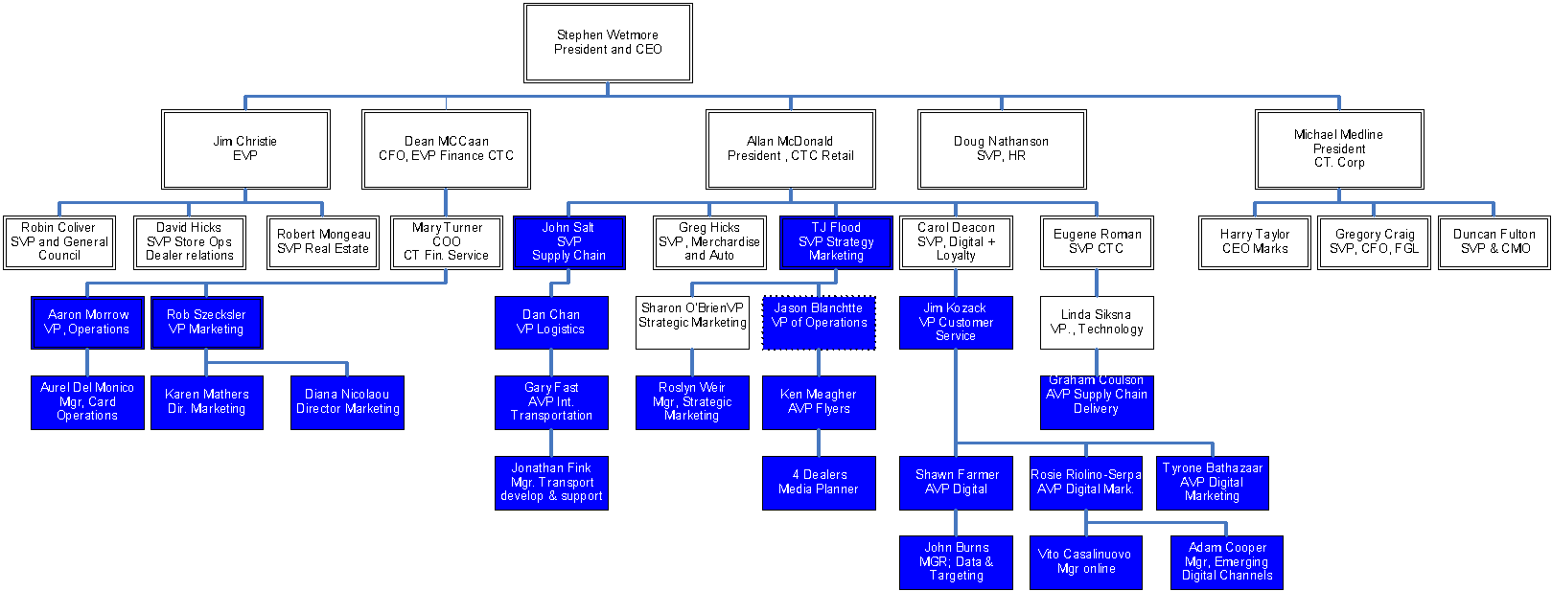

### ***Table: Internal Mutual Action Plan for next steps***

| *Milestones* |  |  |  |  |  |
| --- | --- | --- | --- | --- | --- |
|  |  |  |  |  |  |
| Milestone | Start Date | End Date | Budget | Manager | Department |
| Meeting with Larry, Kim, Jamie and Jordana | 3/5/2014 | 3/5/2014 | $0 | Jordana Matsos | National Accounts |
| Review of the Account Plan with CPC/SCI/Purolator | 3/10/2014 | 3/14/2014 | $0 | James DeMarco | National Accounts |
| Introductions to CTC Key Stakeholders | 3/24/2014 | 4/4/2014 | $0 | James DeMarco/Steve Eggers | Sales |
| Discussions and Review of E-Commerce Strategy to date | 4/21/2014 | 4/25/2014 | $0 | James DeMarco/Steve Eggers | Sales |
| Data Collection and Research on Omni-Channel Approach | 5/5/2014 | 5/22/2014 | $0 | James DeMarco/Steve Eggers | Sales |
| Re-Group with SCI/Puro/CPC | 5/30/2014 | 5/30/2014 | $0 | All parties | Sales |
| Bi-Weely Calls with SCI/CPC/Purolator | 3/15/2014 | 12/31/2014 | $0 | All parties | Sales |
| Monthly Visits with SCI/CPC/Purolator to review status | 4/1/2014 | 12/1/2014 | $0 | All parties | Sales |
| Executive Updates | 3/25/2014 | 12/1/2014 | $0 | James DeMarco/Steve Eggers | Sales |
| Canadian Tire monthly meetings | 4/1/2014 | 12/31/2014 | TBD | All Parties | Sales |
| Internal individual updates | 3/10/2014 | 12/31/2014 | $0 | All Parties | Sales |

### ***Table: Canadian Tire’s Q4 Results YOY***

| **OPERATING RESULTS\***  **13 WEEKS ENDING DECEMBER 28,2013** | **04 2013** | **CHANGE**  **VS.**  **04 2012** | **FY 2013** | **CHANGE**  **vs.**  **FY 2012** |
| --- | --- | --- | --- | --- |
| **CONSOLIDATED RESULTS** |  |  |  |  |
| Retail sales' | $3,981.1 | 5.5% | $13,225.3 | 3.1% |
| Revenue | $3,328.7 | 5.1% | $11,785.6 | 3.1% |
| Gross margin dollars | $1,082.5 | 8.9% | $3,722.3 | 6.4% |
| EBI1DA1 | $381.0 | 12.9% | $1,235.7 | 8.6% |
| Effective tax rate (%)  Net income attributable to owners of the Company | 28.0%  $187.8 | 15.2% | 28.1%  $561.2 | 12.5% |
| Net income attributable to non-controlling interests | $3.2 |  | $3.2 |  |
| Basic earnings per share attributable to owners of the Company | $2.34 | 16.9% | $6.96 | 13.5% |
| Diluted earnings per share attributable to owners of the Company | $2.32 | 16.4% | $6.91 | 13.3% |
|  |  |  |  |  |
|
|  |  |  |  |  |
| **SEGMENTED RESULTS** |  |  |  |  |
| **Retail Segment** |  |  |  |  |
| Retail sales growth | 5.5% |  | 3.1% |  |
| Revenue | $3,048.5 | 5.1% | $10,691.6 | 3.0% |
| Gross margin dollars | $904.9 | 9.4% | $3,011.9 | 6.2% |
| EBITDA1 | $270.4 | 4.4% | $841.2 | 5.3% |
| Income before income taxes | $192.8 | 24.5% | $463.6 | 15.9% |
|  |  |  |  |  |
|  |  |  |  |  |
|  |  |  |  |  |
|  |  |  |  |  |
|  |  |  |  |  |
|  |  |  |  |  |