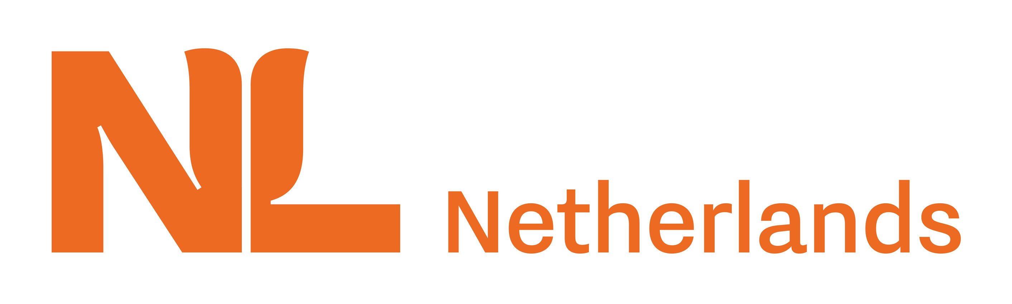 | 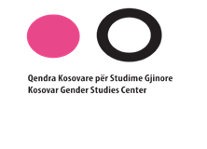 | 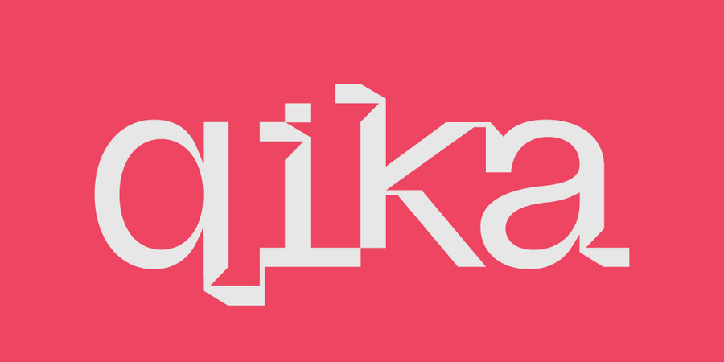
Terms of Reference (ToR) for Expert/Company for Branding, Design, and Production of Awareness Materials
“Empowering Women in the Labor Market”

About the organization:
Kosovar Gender Studies Center seeks a society based on individual and group rights, where gender equality and mainstreaming are included in all spheres of life, under strict enforcement of laws, and where women can achieve self-realization and personal and professional development.
The mission of the Kosovar Gender Studies Center is to mainstream gender in all sectors of Kosovar society by increasing gender awareness, enhancing the focus on gender issues in Kosovo’s educational system, developing gender studies, and ensuring the inclusion of gender-sensitive policies in all aspects of life. Since its establishment in 2003, KGSC has contributed to gender mainstreaming and the achievement of gender equality in all spheres of life. KGSC was established to draft and ensure the inclusion of gender-sensitive policies in all sectors of life, to increase awareness, knowledge, and understanding of gender issues in Kosovo, and to develop gender studies in Kosovo further.
About the project:
Kosovar Gender Studies Center is implementing the project "Empowering Women in the Labor Market”, in partnership with QIKA, supported by the Embassy of the Netherlands in Kosovo. This project aims to empower unemployed women by providing comprehensive training programs tailored to enhance their skills and readiness for the job market. By focusing on skill development, mentorship, and networking opportunities, we aim to bridge the gap between women and the demands of the labor market. Our strategy focuses on empowerment, creating a sustainable pathway for these women to secure employment, contribute to the private sector, and drive economic growth while ensuring inclusivity and gender equality. Additionally, we will simultaneously work with women employed in the private sector to empower them in addressing gender-based discrimination and other issues concerning women occurring in the labor market.

Context and Objective of the ToR
The purpose of this ToR is to engage a qualified branding expert or design/production company to conceptualize, design, and produce high-quality promotional and visibility materials that will visually represent and promote the project’s message on women’s rights in the labor market and women’s economic empowerment.
The branding and designs must be creative, professional, gender-sensitive, empowerment-oriented, and aligned with KGSC and donor visibility requirements.
Responsibilities:
The selected expert/company will be responsible for the following tasks
- Branding Concept Development
- Create a unified branding concept inspired by themes of women’s empowerment, gender equality, labor rights, and economic participation.
- Develop a visual identity aligned with KGSC and donor branding guidelines.
- Propose color palettes, typography, and visual elements suitable for awareness and advocacy campaigns.

- Design of Promotional Materials

- Materials may include (but are not limited to):
- Flyers & leaflets
- Banners & roll-ups
- Tote bags
- Notebooks
- Social media graphics (optional, if requested)
- Stickers, postcards, or other small materials
- Design responsibilities:
- Develop draft designs for each product type;
- Integrate empowering messages on women’s labor rights;
- Prepare print-ready files in required formats;
- Ensure accessibility, clarity, and high visual impact.

- Branding and Accessibility

- Incorporate feedback from KGSC staff and project partners;
- Make revisions as requested until final approval;
- Ensure compliance with branding, donor visibility, and gender-sensitive communication standards.

Expected Deliverables:
- Branding concept package (visual identity, style direction, color palette);
- Draft designs for all promotional materials;
- Final print-ready designs approved by KGSC;

The assignment is expected to be completed within 15 days of the contract signing.
Specific deadlines for drafts, approvals, and delivery will be agreed upon with KGSC.

Qualifications, experience, and skills:
- Proven experience in branding, graphic design, and production of promotional materials;
- Strong portfolio demonstrating creativity and professionalism;
- Experience working with NGOs, international organizations, or public institutions (asset);
- Understanding of gender equality, women's rights, or social-impact communication (asset);
- Ability to ensure gender-sensitive, inclusive, and empowering visual communication;
- Capacity to deliver within tight timelines and high-quality standards.
- Ensure that a gender-sensitive approach is seamlessly integrated into the production of all materials.
- Demonstrate a child-friendly approach in the materials provided.

The selected expert(s) and/or company must carry out the assignment in full compliance with KGSC’s Protection from Sexual Exploitation, Abuse, and Harassment (PSEAH) Policy and Code of Conduct.

Application process
Interested companies are invited to submit the following documents:
- Financial offer (in EUR);
- Portfolio or examples of previous relevant video work (links acceptable).
Application deadline: 6 February 2026
Submit electronically to: qksgj_kgsc@yahoo.com

