 Resident Summer Camp General Information

- When to apply...Because enrollment is limited, we suggest making applications as soon as possible. Previous students have preference, but must have applications in by the end of January.

- How are campers placed in groups...Campers are placed in cabins by ages, in their lessons by ability.

- Cabins...Each air-conditioned cabin sleeps 6 girls in bunk beds, plus a counselor, and has its own bath.

- Laundry...A laundry service picks up clothing in the middle of each session.

- Entertainment...Radios are provided in the cabins. Campers may bring radios for their own room and use.

- Beach Day...During each session, there is a field trip to the beach.

- Swimming...There is a fenced in swimming pool by the cabins for daily use.

- Medical...Great physicians and an excellent hospital are within a 15-minute drive of Foxfield.

- Meals...Meals are carefully planned to provide a nutritious, well balanced diet. We must be notified in advance if your child is a vegetarian. We are not able to accommodate any other dietary restrictions. Please call to discuss.

- Spending Money...The Head Counselor maintains a “bank” for each camper. Please leave spending money in small denominations only (dollar bills are best). There are soda machines at Foxfield and a snack bar at the beach, along with a trip to local tack store for those campers who are interested. The ice cream man also makes frequent stops here.

- Bringing a horse to camp...Campers may bring their own horse for an additional $300 per session. Stalls are limited and are on a first-come basis. Price includes individual box stall and alfalfa hay fed twice per day. Different diet, extra feed or grain must be provided by the camper and brought in covered containers with name and lock. Campers with their own horses must bring a tack box, saddle and bridle. There is a storage room available for the saddle and bridle. Foxfield is not responsible for lost, stolen, or damaged tack, etc. Horses must vacate stalls by 10am the day after camp ends. Every horse must have a health certificate stating that all shots are current.

- Airport pick-up...Airport pick-up is available from Burbank Airport only for an additional fee of $150.00. Please have arrival time between 12 noon and 2pm on Sunday. Either call the office at 805-495-5515 or email ride@foxfield.com with flight information at least 2 weeks before session begins.

- After camp...If you would like your camper to be taken to Burbank Airport at the end of camp, make reservations between 9-11am on the morning following the last day of the session. This service is available for a additional fee of $150.00.

- Phone calls...We discourage phone calls, but if you must talk to your camper, please call during meal times (8-9am, 12 noon-1pm, 6-7pm) because they are out with the horses at the other times. Campers are not allowed to bring cell phones to camp. If they do, they will ebb collected and returned at the end of the sessions.

- Email and fax...We ask that you not visit or take children out at mealtime. Feel free to email your camper at ride@foxfield.com or fax 805-497-1799. Campers do not have access to computers but the messages are printed and distributed during meal times.

- Mailing instructions...Campers welcome packages. Due to the fact that we are on a ranch we have some limitations. Please, no chewing gum and limit the snacks that you send. We are unable to store and protect food from the critters and ants. In addition, being on a ranch also inhibits the mail delivery from the post office, so please send them via carriers such as UPS, FedEx, Airborne, etc. to our street address 1250 E. Potero Rd., Westlake Village, CA 91361. Mail cards and letters to Foxfield P.O. Box 3576, Westlake Village, CA 91359.

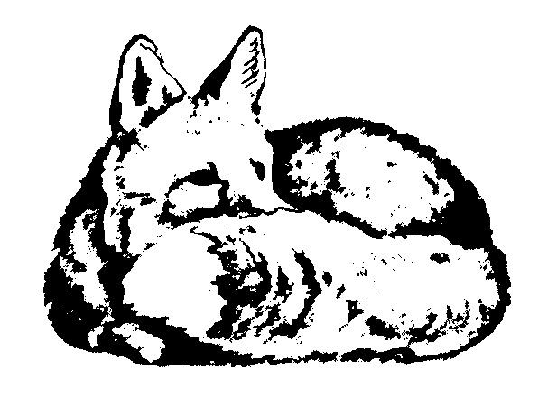
Foxfield Riding School PO Box 3576
Resident Summer Camp Westlake Village, CA 91359
(805) 495-5515
www.foxfield.com

WHAT TO BRING

Clothing

2 pair pajamas
8 pair underpants
8 pair socks
5 pair jeans (fewer if camper has riding pants)
Tee shirts
2 polo shirts if camper doesn’t have ratcatchers
Shorts
Sweater
Sweatshirt
Jacket
Bathing suit
Beach towel
Sneakers

Bedding
Lightweight sleeping bag
OR

Toiletries

Toothbrush & toothpaste
Laundry bag with name
Washcloths
3 bath towels
Shampoo
Sunscreen – A MUST!!
Hairbrush & comb

Riding Clothes & Equipment

Regulation hard hat (no bicycle helmets)
Riding crop
Jodphurs or breeches (OPTIONAL)
Riding jacket for show (OPTIONAL)
White shirt or ratcatcher (OPTIONAL)
Paddock or tall boots (OPTIONAL)
______ Safety Vest (OPTIONAL)
2 sheets, 2 pillowcases & 2 blankets
(pillow and bedspread will be provided)

Stables

All grooming tools, saddles, bridles, etc., will be provided for school horses.

ARRIVAL/DEPARTURE

- Arrival: Sunday between 2-3 pm.
- Camp Horse Show: 2-5 pm on the last day of camp.
- Departure: After the awards ceremony and spaghetti dinner following the camp show (about 6:30 pm).
(Note: Campers going to Burbank Airport with Foxfield stay over until the following morning.)
- Session 3 additional horse shows: SumFun – Saturday afternoon; Foxfield Summer (rated) - Saturday & Sunday
(Prize lists will be mailed prior to the shows; participation is optional.)

CAMPERS MAY BRING THEIR OWN EQUIPMENT, BUT EVERYTHING MUST BE CLEARLY LABELED WITH NAME. FOXFIELD IS NOT RESPONSIBLE FOR LOST OR DAMAGED TACK OR CLOTHING.

No refunds for camp once summer has started.

