8th of June 2026 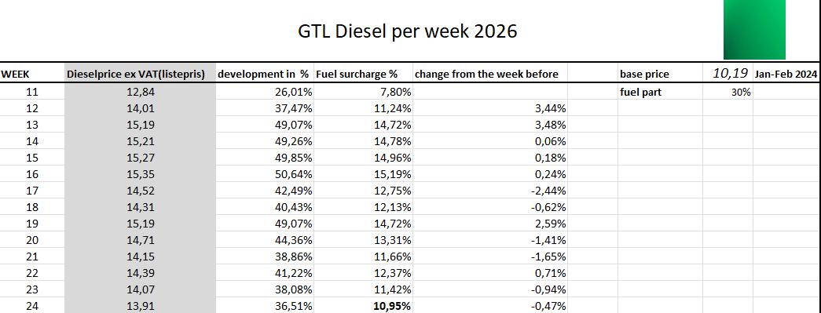
Dear Client and Partners
Due to the ongoing war in the Middle East and the closure of the Strait of Hormuz, global fuel markets have experienced significant disruption. As a result, diesel prices have increased sharply in recent days.
These circumstances are beyond our control and qualify as force majeure. Due to this development, the Diesel Oil Surcharge (DOT) will be adjusted effective 8th of june, reflecting a 10.95% increase.
We understand that such adjustments may impact planning and costs, and we appreciate your understanding during this exceptional situation. This adjustment allows us to continue ensuring the stability of our operations and to maintain reliable, high-quality transport services.
Should you have any questions, please do not hesitate to contact us.
Kind Regards
-GTL

