Anachem Annual Business Meeting
February 19, 2026
President’s Report – Ratandeep S Kukreja

Objectives:
This report summarizes Anachem activities and accomplishments for 2025 calendar year. Eighty-five years ago, the founding members of Anachem (The association of Analytical Chemists) defined the objectives of the association as follows:
“the objectives of the organization shall be: [a] To foster analytical chemistry and its advancement by means of meetings, papers, reports and discussions. [b] To give technical or professional support to public programs and community improvement projects. [c] To aid the professional advancement of its members and to improve their proficiency.” (Taken from the ANACHEM Constitution; Nov. 7, 1955 version)
In recent years those objectives have been pursued by a small group of dedicated volunteers who serve on the Board of Directors and in other capacities. Those volunteers are to be commended for their successful efforts during the past year. Because of their work, Anachem continues to provide valuable service to the regional community of professional analytical chemists, students, and other individuals concerned with the art and science of chemical analysis.

Board of Directors and Associates
The current list of directors is included in Table 1, below.
Table 1. Anachem Board of Directors
Officer | Name/s | Current Professional Employment
President | Ratandeep Kukreja | General Motors
Vice President | Kendra Evans / Irfana Muqbil | University of Detroit Mercy / Lawrence Technological University
Secretary | Matthew J. Fhaner | University of Michigan - Flint
Treasurer | Katherine Lanigan | University of Detroit Mercy
Resident Agent | Felix Schneider | Food and Drug Admin. (retired)
Industrial Liaison | Mike Iglehart | BASF
Website and Communications | Kendra Evans / Danielle Maxwell / Jamie Socia | University of Detroit Mercy / University of Detroit Mercy / General Motors
Symposium Program | Mary T. Rodgers | Wayne State University
Member at Large | Marwa Abdel Latif | University of Detroit Mercy
Member at Large | William Collin | General Motors
Member at Large | Dragan Isailovic | University of Toledo
Member at Large | Jamie Socia | General Motors
Member at Large | Misle Tessema | NASA
Member at Large | Andre Venter | Western Michigan University

This year the Board of Directors wishes to thank Keith and Christine Olson for their many years of dedicated service to Anachem. Keith decided to retire from Anachem after the 2025 Symposium. Both Keith and Chris were active members of the team and provided value added input till their retirement day. Keith was President and Treasurer for Anachem for many years until I took over the President’s role in 2021, and Katherine took over the Treasurers responsibilities in 2023.
We would also like to acknowledge and thank the following board members for stepping up and supporting various activities that were not part of their office duties:
- Matthew Fahner and Katherine Lanigan – for updating Anachem’ s Operation Manual that needed thorough review and many changes to roles, responsibilities and operations. The new Operations Manual was reviewed and approved through majority voting at Monthly Board Meeting.
- Katherine Lanigan – While maintaining communications through Anachem website is part of her office’s responsibility, working on building a new website required Kendra to put extra volunteer hours and efforts in collaborating with the site designer to create and then to fix all the bugs that showed up after the site went online. Thanks to all her hard work we had a working website in time for the authors to submit their abstracts.
- Jamie Socia – Danielle had to step away from her responsibilities of communications via Mail Chimp due to other higher priorities. Jamie stepped up to support this effort and did a great job.
- Will Colling – Mike Iglehart was unavailable during Anachem Symposium and Will took over his responsibility of coordinating with suppliers and getting them set-up at the symposium venue.

Monthly Meetings
Since Covid-19, most of the Anachem meetings happen virtually. In 2025, except for one Board meeting that was organized at University of Detroit Mercy, all Board Meetings were held virtually over Zoom (Thanks to Matthew Fhaner for scheduling the Board Meetings).
No Monthly Educational Seminars were organized in 2025.

Anachem Fellow Awards
In 2025 Dr. Mary T. Rodgers, Professor of Analytical and Physical Chemistry at Wayne State University and Visiting Scientist, FELIX Laboratory, Radboud University, The Netherlands, alongside Dr. Matthew Fhaner, Associate Professor of Analytical Chemistry, Department of Chemistry/Biochemistry and Associate Director Academic Program, College of Innovation and Technology, The University of Michigan-Flint, were nominated by Prof. Dr. Katherine Lanigan and unanimously approved for 2025 Anachem Fellow Award for their years of dedicated service to Anachem.
The ANACHEM Fellow Award originated in 1971 to show appreciation to a member or members who have provided long and meritorious service to the organization. The normal procedure is for a committee composed of the elected Officers and the Resident Agent to nominate possible candidates. The Board of Directors votes on the choices at a regular Board meeting.
A special Anachem Fellow Award Dinner hosted at Hong Hua Fine Chinese Dinning, Farmington Hills, Michigan on November 14th, 2025, was a well attend even with friends and families gather to celebrate the awardees.

2025 Anachem Symposium – November 6, 2025
The major event during the year was the regional Anachem Symposium on November 1st organized at VisTaTech Center, School Craft College, Livonia, Michigan. The symposium included two educational workshops, parallel oral sessions, a poster session, an exhibit, An award session in honor of the Anachem awardee and a plenary lecture by our 2025 Anachem Award Recipient – Prof. Dr. Mary T. Rodgers, Wayne State University, Detroit, MI. Full program guide on the 2025 Anachem Symposium is available at https://www.anachem.org/symposium.
Below is the technical program overview
 | Room 1  VT550 | Room 2  VT460 | Room 3  VT425 | Room 4  W210B
Morning Session  8:30 – 10:30 AM | Anachem  Award Session | Advances in Academic Research  I | Analytical Chemistry Education | Educational Workshop
Plenary Session  11:30 AM – 12:30 PM | Mary T. Rodgers
Afternoon Session  1:30 – 3:30 PM | Advances in Academic Research  II | Advances in Academic Research  III | Advances in Academic Research  IV | Educational Workshop
Poster Session
3:30 – 5:00 PM
Exhibit Hall
DP500ABCD

A total of about 160 people participated in the symposium of which about 80 were students, another 50 were professors, academic professionals and industry representatives. We had 12 exhibitors (24 people), a number lower than the desired number of 16 – 20. In 2026, we plan to reach the exhibitors well in advance to give them enough time for planning. In 2025, the low number of exhibitors can be attributed to other local and regional conferences that usually do not occur in November but for some reason they happened around our conference time in 2025.
A total of 10 Student awards of $100 each were presented to outstanding oral and poster undergraduate, graduate and, post graduate presentations. Thors eLearning Solutions sponsored 2 Oral Presentation awards while the rest of the awards were sponsored by Anachem. 3 $25 Raffle tickets were also sponsored by Anachem. We also received in kind donations and financial donations from Anachem Board Members for which we are very grateful and thank all those who contributed.
Special thanks to all the committee members and judges for their support for 2025 Anachem Symposium. Below, Table 2 lists all the committees, members and judges.
Table 2: 2025 ANACHEM SYMPOSIUM COMMITTEE
Program Committee | Mary T. Rodgers – Chairperson  Kendra R. Evans  Matthew J. Fhaner  Dragan Isailovic  Katherine Lanigan
Facilities and Registration Committee | Felix Schneider – Chairperson  Marwa Abdel Latif  Kendra R. Evans  Katherine Lanigan  Irfana Muqbil  Ratandeep Singh Kukreja
Exhibits and Workshops Committee | Mike Iglehart – Chairperson  Will Collin
Website and Communications Committee | Danielle Maxwell – Chairperson  Kendra R. Evans
Session Moderators | Zachary J. Devereaux  Matthew J. Fhaner  Dragan Isailovic  Colin F. Poole  Mary T. Rodgers  Liangliang Sun  Andre Venter
Workshop Organizers | Eric M. Pavlic  John Wright
Academic Oral Session Judges | Ruth Ann Armitage  Kendra Evans  Paul Schmitt  Zhe Wang
Undergraduate Poster Judges | Katherine Castronova  Mario Cornejo  Kevin Metz  Sethma Wijesinghe
Graduate Poster Judgers | Marwa Abdel Latif  Will Colin  Matt Fhaner  Jon Kirchoff  Ashley Lalonde  Kate Lanigan  Irfana Muqbil  Paul M. Stemmer
Special Thanks to Volunteers Who Assisted at the Symposium | Chris Olson  Keith Olson

Financial Information:
Overall, financially, we had another year of losses, $3477.71 (summary report Table 3 below). The Board of members have discussed strategies to not just decrease the expense but also to increase the revenue in 2026.

Table 3. Summary of financial activities for calendar year 2025.
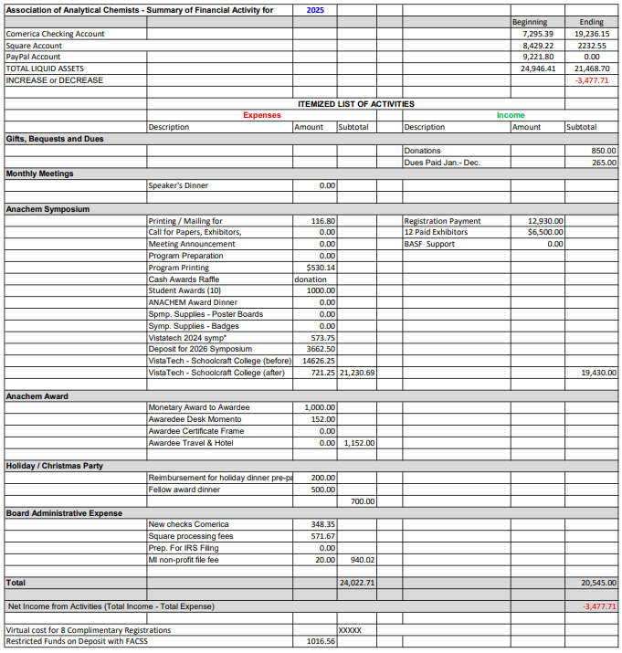
The government tax forms were filed electronically in 2025 to maintain the nonprofit status of the association. The federal tax form (Form 990-N) was filed for the association (EIN: 38-2425017). The Michigan “2025 Domestic Nonprofit Corporation Information Update” was also filed for the Association of Analytical Chemists, Inc. (ID No. 865131) by the Anachem Treasurer.

Respectfully Submitted,
Ratandeep S Kukreja
February 19, 2026

