March 16, 2026

UPDATE: CMS RADV Audits

University of Michigan Health Plan (UM Health Plan) is required to participate in all regulatory and audit requirements for all contracts/years of coverage regardless of our non-renewing status. These audits are in progress and are expected to continue through 2027, requiring medical record retrieval as part of the audit. The audits do NOT affect your reimbursement from UM Health Plan.

In May 2025, the Centers for Medicare & Medicaid Services (CMS) announced a significant expansion of its Risk Adjustment Data Validation (RADV) auditing efforts for Medicare Advantage (MA) plans. CMS is auditing all eligible MA contracts for payment years 2018 through 2025. CMS has shortened the timeline to complete each year’s audit from >12 months to 5 months. The most recent audit initiation timelines provided by CMS are as follows:

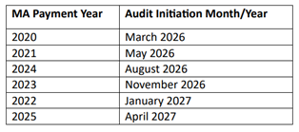

The chart requests for these audits will include dates of service from the years 2020 through 2025. Providers will be notified individually with specific details on members, dates of service, and documents to send.

Regardless of the timeframe requested, providers will be required to comply with all terms of their participation agreement with UM Health Plan that were effective at the time of the service rendered. As outlined in the providers’ participation agreement, payor shall have access to all records related to the obligations and health services being audited for ten (10) years following termination. Provider shall provide records to UM Health Plan within fourteen (14) calendar days from the date the request is made.

Medical records may be provided in the following ways:

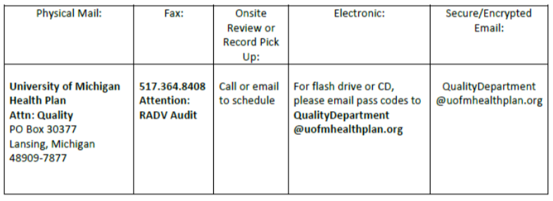

If you have any questions, please contact the Quality Department by email at QualityDepartment@uofmhealthplan.org or by phone at 517-364-8518.

Thank you for your prompt attention to UM Health Plan’s upcoming medical records requests to support our mandatory participation in these RADV audits

