Public Guide for Product Categorization Letters (PCL) Application
- Verify whether your intended product or product category appears in the latest “List of Products that are not coming under the purview of Medical Devices as per the NMRA Act” available on the NMRA website before completing the application
- If your intended product or product category is available in the list, do not apply for product categorization.
- Please refer figure 1 below before applying to product categorization letters
- The importation of products intended strictly for research purposes from government, semi-government, or university institutions requires a letter issued by the Secretary to the Ministry, Head of the Department, or Vice Chancellor of the University. This letter must clearly state that the imported products will be used solely for research purposes.
- Submit one application per product
- Application submissions- only on Tuesdays (working days only).
- Fill out the required Google Form prior to submission. The link is available on the NMRA website
- Applications status will be published in the Google Sheet. The respective link is available on the NMRA website.
- PCLs are issued manually; no email notifications will be sent.
- Cancellation of a PCL application can be done by submitting a request letter addressed to the CEO/Chairman, NMRA, by email to: pcl@nmra.gov.lk- Subject line: “Cancellation of PCL – Company Name – Reference Number” Or by submitting the request letter by hand including the reason.
- Documents should in a lace file (figure 2) and in front of the file must include product name, market authorization holder /applicant name, contact number and email address

Lace file- figure 2
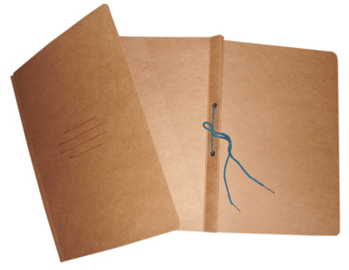
Figure 1 Organization Chart for the Need of Product Categorization or Product Registration

