Haylo Labs Acquires Plessey Semiconductors to Supercharge UK’s Role in the Future of AR/VR and Optical Computing
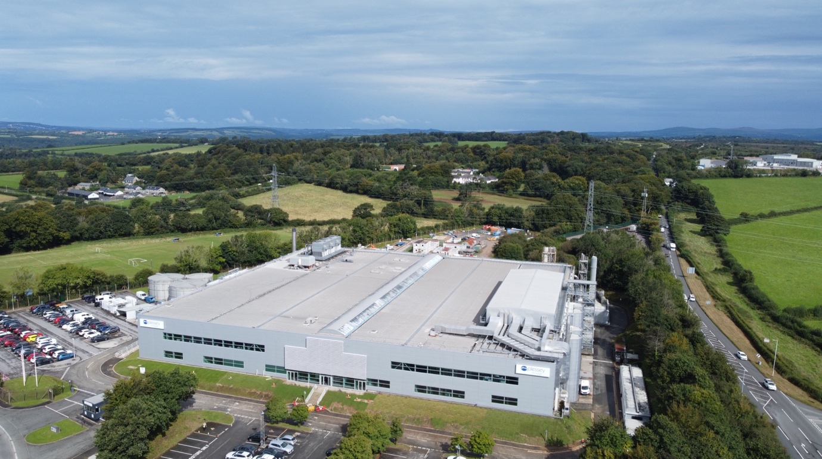
London / Plymouth, [20th August 2025] – Haylo Labs has acquired Plessey Semiconductors, the UK’s leading innovator in microLED display technology.
Haylo Labs has committed to investing over £100 million in the UK over the next five years to scale Plessey’s manufacturing capacity and grow the highly skilled workforce in Plymouth and beyond.
The acquisition strengthens the UK’s position as a global leader in immersive computing and next-generation technology. The international microLED market is forecast to grow from £2.7 billion ($3.7 billion) in 2024 to over £592 billion ($800 billion) by 2034 – driven by demand across augmented reality (AR) and virtual reality (VR), automotive displays, premium consumer electronics such as virtual reality headsets and smart glasses, and optical computing.
This comes at a pivotal moment for the sector where these technologies are becoming embedded in everyday products, driving demand for advanced, ultra-efficient displays and optical computing units to unprecedented levels.
Founded in 1956, Plessey Semiconductors is one of Europe’s oldest semiconductor companies and the world’s most technically advanced microLED business.
With a 270-strong team, Plessey has developed a fully integrated platform capable of designing, manufacturing, and engineering next-generation display technologies entirely in-house, a rare global capability. This end-to-end control, combined with a strong intellectual property portfolio, uniquely positions Plessey to lead the scaling of microLEDs from laboratory innovation to high-volume production.
Haylo Ventures, a venture operator dedicated to building and scaling world-class deep tech businesses, established Haylo Labs to focus specifically on the microLED, optical compute, and interconnect sectors.
David Hayes, Chief Executive and Co-Founder of Haylo Labs, said: “This is a defining moment for British tech. Plessey has built the world’s most advanced microLED platforms, with the highest efficiency to date, and is one of the only facilities in the world that can offer customers an end-to-end design and manufacturing facility with technology and talent that surpasses rivals anywhere globally. This acquisition is not just about backing British innovation — it’s about unlocking its global potential in one of the fastest-growing markets over the next decade.”
Luke Pollard MP, Member of Parliament for Plymouth Sutton and Devonport, said: “This acquisition is fantastic news for Plymouth and the UK’s technology sector. Plessey is a true British success story with a rich heritage, and this significant investment promises to secure and create skilled jobs in the region while positioning the UK at the forefront of semiconductor innovation.”
Rebecca Smith MP, Member of Parliament for South West Devon, said: “This important investment in Plessey will secure Plymouth’s position as a global leader in manufacturing some of the most advanced and in-demand technology in the world. The UK must remain at the forefront of this fast-growing industry so that we can continue to compete on the international stage. This deal will help us do that.”
Fred Thomas, Labour MP for Plymouth Moor View, said: “Plymouth’s manufacturing businesses are booming at the moment, and this acquisition of Plessey is further evidence of that. This investment means more highly skilled jobs for people in Plymouth — it’s fantastic news for the city.”
A microLED is a breakthrough display technology where each pixel is a microscopic LED. Imagine taking a modern 65” HD TV and shrinking it to fit inside half your phone’s SIM card. To put it into perspective, you could fit around 50 microLEDs across the width of a single human hair. Their unique ability to emit light directly at the pixel level results in displays that are brighter, sharper, smaller, and dramatically more energy-efficient than existing technologies – making them essential for a new era in computing.
The processes and tools used to fabricate microLEDs can also be repurposed to create optical processing units (OPUs), which are ideally suited for performing the complex mathematical calculations required by AI operations that currently consume vast amounts of energy.
Optical Computing Units (OCUs) represent a new generation of light-based chips that are faster, cooler, and more energy-efficient than today’s silicon devices. Plessey is committed to building the hardware of the future, leveraging its expertise to develop real-world optical computing solutions at scale.
Claire Valoti, Co-Founder of Haylo Labs, added: “This acquisition is about enabling the future of AI-powered devices that are lightweight, energy-efficient, and wearable in the real world. The UK has the opportunity to lead, not follow, the next wave of global computing. Our investment will fuel innovation and expand the local talent pool, creating opportunities at a time when skilled jobs in advanced manufacturing are critically needed.”
Keith Strickland, Chief Executive of Plessey Semiconductors, said: “The Haylo Labs acquisition will accelerate Plessey’s commercial scaling, bringing transformative microLED and optical computing technologies to the global market. We are focused on expanding our manufacturing footprint here in Plymouth and strengthening our engineering talent pool. This investment underscores our commitment to sustainable growth and innovation in the UK.”

