**Welcome to Year 3**

**Teaching Team:**

Teachers: Miss Smith & Mrs Vaudin/ Mrs James HLTA: Mrs Holten

TAs: Miss Dott, Mrs Aquilina & Mr Williams

**Key Information for this year:**

* Our P.E. sessions will happen on a Tuesday (outdoor) and a Wednesday (indoor). Children wear their kit to school (house t-shirt, plain black shorts / jogging bottoms, trainers, school jumper or plain black zip up top).
* One pair of stud earrings can be worn but removed / covered on P.E. days. No other jewellery please.
* Updates of key learning can be found on our school website: <https://www.leigham-primary.plymouth.sch.uk/> Menu / Learning / Class Pages / Year 3.
* Children can bring a drink to school each day to keep in the classroom and fruit to have at snacktime.
* Ensure all personal belongings are named.

**Key Dates for Year 3:**

Autumn Learning Together Session (Orienteering) - Tuesday 21st October 2025 at 2pm

Larch Spring Learning Together Session (Printing) - Tuesday 3rd March 2026 at 2:15pm

Spruce Spring Learning Together Session (Printing) - Wednesday 4th March 2026 at 2:15pm

Summer Class Assembly - Friday 19th June 2026 2:30pm

**Home Learning:**

Reading: Please encourage your child to read their reading book to you four times a week. Once your child feels confident and ready, they can take their AR quiz. They will write their book level and percentage score in their reading record. Keep an eye on this and discuss your child’s reading with them. Please also record any reading that they do at home.

Menu of Activities: Your child will receive a menu of home learning activities that can be completed during each half term. Learning can be brought into school on the last week of each half term and will be celebrated in class. The menu is also on the school website.

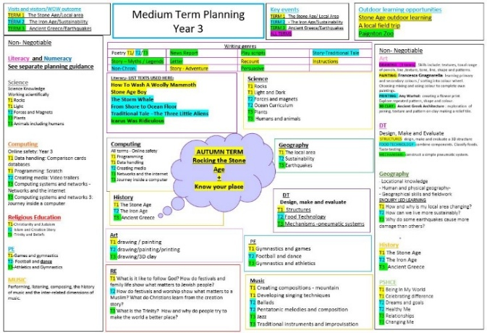**Medium Term**  **Plan: Menu of Activities:**