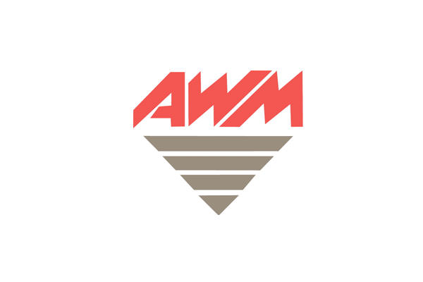

**Relationship:** Sheen Fleet

**Accident Management:** No accident management in place - responsibility of store managers

**Insurer:** Marsh

**Excess:** $500

**Sheen Excess Reduction Offer:** $300 per claim

**Pricing:** no pricing agreements in place

**Decals / Signwriting:** No specific requirement for decal supplier

**Replacement Vehicle:** AWMaccept Sheen accident replacement vehicles – commercial likely required (tray / van)

**Communications:** All store communication directly with AWM store manager or vehicle driver

**Escalation Point:** Sheen Fleet

**Process:**

1. Inspect vehicle & take images
2. Advise AWM store manager whether claim is required or under excess costings
3. AWM store manager to lodge the claim and provide directly to Sheen store

**Notes:**

AWM store managers are responsible to lodge claims on behalf of their store