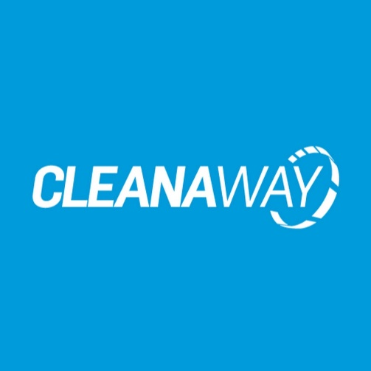

**Relationship:** Sheen Fleet

**Accident Management:** Innovation Group

**Insurer:** n/a

**Excess:** Self Insured

**Sheen Excess Reduction Offer:** n/a

**Pricing:** Sheen Fleet Pricing Schedule

**Decals / Signwriting:** No specific requirement for decal supplier

**Replacement Vehicle:** Cleanawayaccept Sheen accident replacement vehicles

**Communications:** All store communication directly with Cleanaway vehicle driver

**Escalation Point:** Contact Sheen Fleet

**Process:**

1. Required information: ask driver which department/plant they are from and who they are submitting their estimate to internally at Cleanaway
2. Inspect vehicle & take images
3. Notify Sheen Fleet via email ([fleet@sheengroup.com.au](mailto:fleet@sheengroup.com.au)) that you have a Cleanaway vehicle and which department it is from
4. Sheen Fleet team member will advise who to submit the estimate to

**Sheen Arrangement with Cleanaway for Truck Damage to Public Vehicles**

Sheen have an arrangement with Cleanaway to repair vehicles damaged by their trucks across multiple municipal contracts – generally these will come across the Sheen Fleet desk first though if anyone presents to your store after an incident with Cleanaway, please follow this process:

1. Collect customer information, address of incident, take images of vehicle
2. If required, you can put the customer into a Sheen accident replacement vehicle
3. Prepare estimate & send to [fleet@sheengroup.com.au](mailto:fleet@sheengroup.com.au) with all information captured above
4. Sheen Fleet will assist in submission of the estimate or advise on next steps